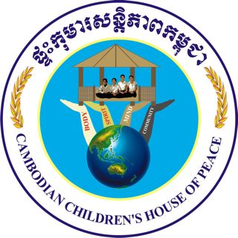

DECEMBER 2011 REPORT

Dear Supporters and Friends,
Thank you so much for your continued generous support of the Cambodian Children’s House of Peace (CCHP), known as ““Santepheap.” Thanks to your gifts, we have had a stable source of funding for our greatest expense, $1200 for food for 33 children and staff.

When we began this project three years ago, all of the children who came to us from the villages were very stunted in their growth and had the swollen bellies and bare ribs that indicate malnourishment. New children who join us over the years are likewise in need of food for healthy growth and development, which is essential for a good education.
Over these three years, the children have all grown, achieving their normal height and weight for their age – no more bare ribs! They get plenty of exercise as well, and are thriving in school performance as a result of your support.
The first photo on our Global Giving page is a little 10-year old girl who came to us a year ago, an orphan whose parents had died from AIDS. She was very undernourished and small, but smiling and happy to have a new home. Now, just one year later, she has grown to normal height and is succeeding in school – thanks to you!
A boy who came to us two years ago was not only malnourished, but suffered a systemic disease that required frequent hospitalizations during the year. Now that he has a nutritious diet, he has recovered a great deal, and this past year had no hospitalizations! This is the kind of impact your generosity has made for the children of Cambodia.
CLEAN WATER SUPPLY
Your donations have also made it possible for us to install a water-supply system so that all the children can have access to potable water. The system costs US$540 including installation and other supplies. The system will ensure sustainability of clean and potable water for years. This was a great addition to our home, eliminating the necessity to purchase 5-liter bottled water at a significant monthly cost. Thank you!

The future of Cambodian recovery will be in the hands of this generation of children. Yet, there is much poverty and lack of nutrition and education in the countryside villages of these children. The Cambodian Children's House of Peace was founded to address the educational needs of these children, and proper nutrition is essential for their success and health. Your support is essential for us to achieve that goal. Once again ~
THANK YOU!
www.santepheap.org

