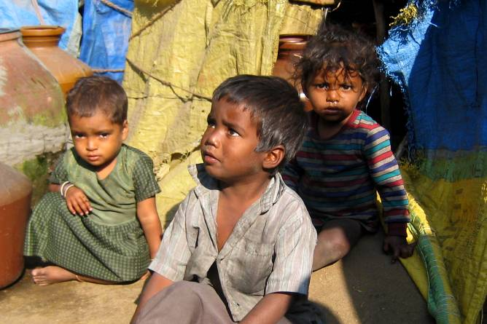
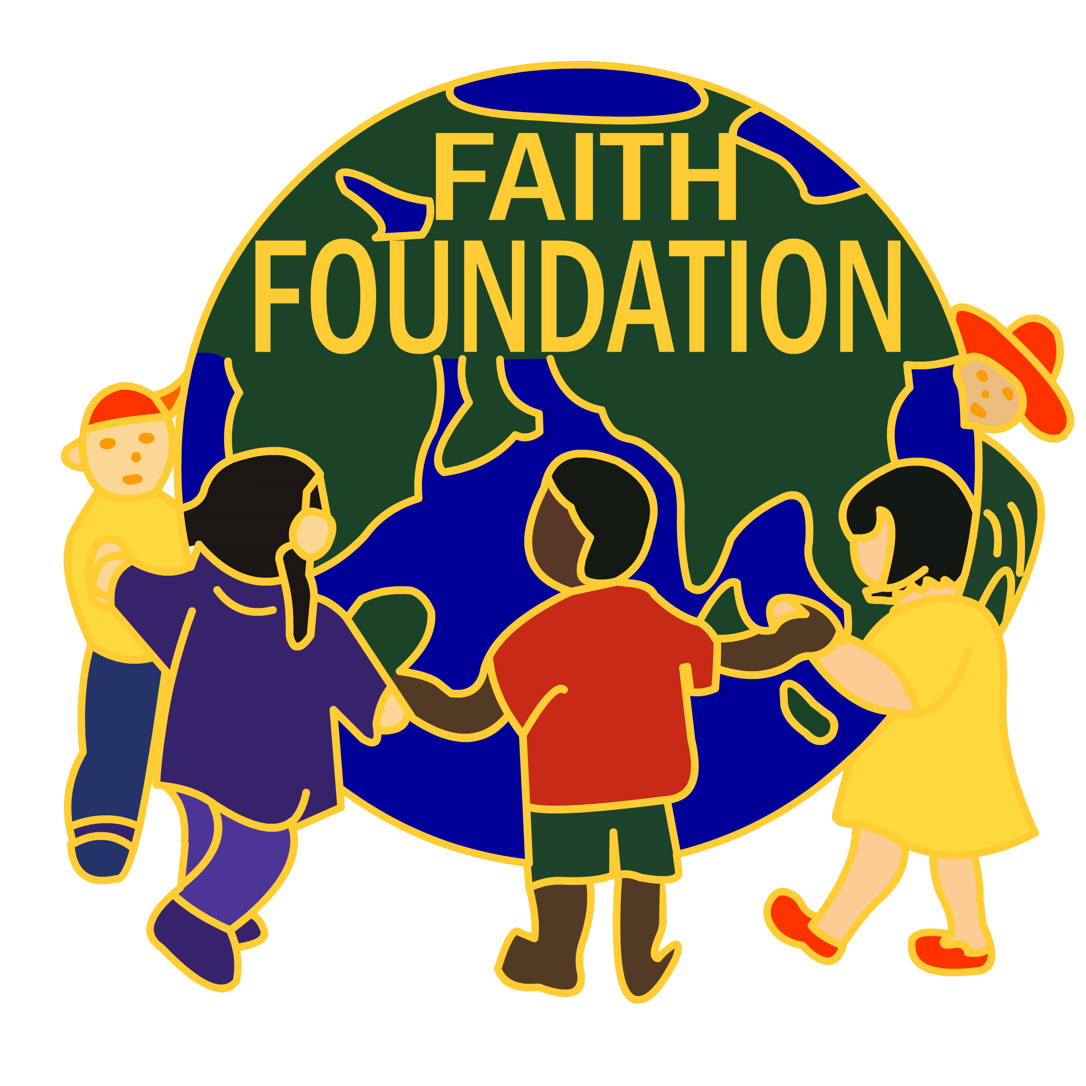
FAITH FOUNDATION | Provide a  Home for India’s Orphan and Neglected Children

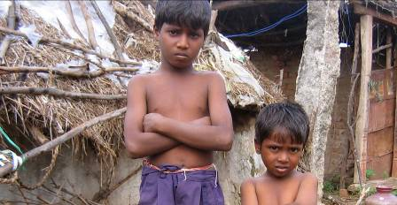
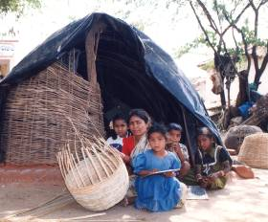

Faith Foundation
Creating Better Lives……

Proposal for Provide a Home for India’s Orphan and Neglected Children
For the Period from 1-4-2011 to 31-3-2016

- BASIC DETAILS

Name of the Program: | FF Children Home’s
Location: | Andhra Pradesh, India
No. of Homes: | 5 Homes
Strength: | 500 children
Implementing Agency: | Faith Foundation
Principal Contacting Officer: | Mr. Anthony Praveen Kumar Gaddam  Director, Faith Foundation  Plot # 109, Road No.3  West Marredpally  SECUNDERABAD – 500 026  Andhra Pradesh, India  Ph: +91 40 27700373/27700500,  Fax: +040 -27700511  Email: admin@faithindia.in  anthony@faithindia.in
Budget : | $ 998,657
Period : | 01-04-2011 to 31-03-2016 (5 Years)

- BACKGROUND / PROBLEM STATEMENT:

India, one of the largest democracies in the World has a Population of 1.2 billion. Most of the people in India are living below the poverty line and are facing many problems, viz., lack of food, shelter, health care, education and un-employment and thus the people live in utter poverty. Poverty has always been recognized as the major cause of death and disability. Poverty brings on lack of safe Drinking Water, inadequate food, poor health care and poor education. All these will have effect on health.

Andhra Pradesh is the fifth largest State in India in Population and area. As per reports the population is about 80 millions. The poverty situations in Indian context, reflects in the State of Andhra Pradesh. The families in rural areas are normally large and often face the problems and the earning members of the family unable to cope up with the situations. Some times they may not get work to earn. Eventually they migrate to other places in search of livelihood or starve to meet death or disease. The struggle of the poor starts in the womb. The child in the womb suffers from the consequences of malnutrition in the mother. The children too suffer from severe malnutrition, stunted growth and development. At birth, the poor new born is likely to suffer. There is no proper trained person to attend at the delivery. The family cannot afford to get a trained birth attendant. Sometimes mother dies due to crude delivery practice; the child becomes an orphan or semi-orphan. Childhood of poor brings on more diseases, fevers of all kinds, dysenteries and gastro-enteritis, whooping cough, measles and worm infections. Several Indian children are in the State of degradation and misery.

- THE NEED

poverty has always been recognized as the major cause of death, disease and disability. Now the World Health Organization (WHO) came out with the statement the Poverty is the ‘ruthless killer’. Large families in rural areas often face these problems and the earning members of the family unable to cope-up with the situations and survival becomes difficult. The relief often comes in the form of death leaving the children as orphans and destitute. These starving children without shelter, food and clothing roam along the streets.

As there is prevailing drought situation, the people in rural areas migrate to other places in search of their livelihood; the children will be left along with the older people at home. As they starve the older children forced to do child labour to earn some thing to support their parents. Even otherwise, at home the parents force the children to become earning members as there is poverty doubled by the large families and the income earned by the parents is not sufficient.

We propose to this opportunity for 500 children during this Project Fy 2011-2016. The children are in 5 Homes situated in backward areas in Andhra Pradesh.

- OBJECTIVES AND ACTIVITIES

OBJECTIVES : | ACTIVITIES
- To provide an opportunity for children to live in congenial atmosphere with parental love.  - To provide food, shelter, education for 500 orphans, semi-orphan and destitute children in 5 Homes in Andhra Pradesh.  - To provide medical care to the children.  - To bring up the children in Christian nature and good discipline to become good citizens.  - To make the children to learn basic new skills to live on their own. | To achieve the mentioned objectives following activities will be implemented during the Program period.  There are 5 Homes situated in Andhra Pradesh to cater the needs of 500 poor and destitute children. These children poverty are provided with food, shelter, education and clothing. The children attend the School regularly and coaching is arranged to strengthen their academic achievements. The children attend Local Schools for their education and provided with Text Books, Note Books, Pens and Pencils in the Home. Children are provided with square meal three times a day. Eggs, Meat /Chicken are given once a week.  Health of the children is taken care and special attention is given for those who are weak by providing special medical care. Annual Medical check up has been conducted in the home by a qualified Medical Doctor for all the children in the Homes. This Medical Team will provide medical assistance including Medical Kit with simple medicines for the children.  The children are being brought up under strict discipline. The children are being taught and given guidance for their spiritual growth and to have saving knowledge of our Lord Jesus Christ. The children attend Sunday School, Youth Fellowship and Worship Service regularly.

5. INPUT AND OUTPUT
INPUT | OUTPUT
SHELTER & FACILITIES:  - Plates /Glass Tumblers  - Blankets  - Trunk Boxes  - Mats/Carpets  - Accommodation  - Electricity  FOOD:  - Food Stuffs and Provisions  - Firewood/ Cooking Vessels  - Supplies | 500 Children have access for food, shelter education and live in better environment.
EDUCATION :  - Books, Slates, Pens, Pencils, etc.,  - School Fee  - Examination Fee  - Tutors | - 500 Children will attend School regularly and got better education and acquired knowledge.  - 90% children are promoted into new classes.  - 500 Children will get an opportunity to live on their own with dignity.
HEALTH:  - Medicines/Medical Care Kit  - Doctor | - 500 Children are keeping in good health
CLOTHING:  - School Uniform  - Home Uniform  - Stitching charges | - 500 Children have access for School uniform, so that they are having equal opportunity with other children.
EXCURSION & RECREATION :  - Festivals/ National Events  - Excursion  - Birthdays | - 500 Children acquire knowledge about National events and visit important historical places of interest.
HOME IMPROVEMENT  FACILITIES  - Replacement of torn out Blankets  - Replacement of worn out Cooking vessels, plates and glasses  MAINTENANCE AND SUPERVISION:  - Superintendent  - Warden  - Helper  - Cook  - Photos  - Travel  - Honoraria/Salaries | - 500 Children have improved facilities for their better living.  - Children are brought up in good environment with discipline.

6. RESOURCES:

Our Organization is having wealth of Human Resources to undertake this Program in the form of Superintendents who are Volunteers to maintain, supervise Homes and look after children in addition to Wardens, helpers, Tutors and Cooks.

We have also efficient experienced Office Staff who are involved in undertaking Homes work, viz., receiving, scrutinizing letters, reports from the children and meeting other requirements of FF from time to time..

Supervisor has been appointed to monitor the FF Homes work with the assistance of Home Supervisor.

Funding Agency/
Donors
Children Homes

Children / Beneficiary
Faith Foundation

7. BUDGET

FF Children Home’s Programme
BUDGET
For the Period from 1-4-2011 to 31-3-2016
Activities / Inputs | 2011 - 2012 | 2012 - 2013 | 2013 - 2014 | 2014 - 2015 | 2015 - 2016
Activities / Inputs | Strength (500)
Activities / Inputs | Amount
Activities / Inputs | In $ USD
Food Stuffs(Rice, Food Grains, Provisions, Oil, Vegetables, Meat, etc.,) | $ 115,873 | $ 118,190 | $ 120,553 | $ 122,964 | $ 125,423
Firewood | $ 10,575 | $ 10,786 | $ 11,007 | $ 11,227 | $ 11,451
Supplies (Soaps, Oils, etc.,) | $ 6,716 | $ 6,850 | $ 6,987 | $ 7,126 | $ 7,268
Books (Fee, Stationery, etc.,) | $ 9,650 | $ 9,843 | $ 10,039 | $ 10,239 | $ 10,443
Children's School Uniform | $ 9,570 | $ 10,048 | $ 10,550 | $ 11,077 | $ 11,630
School Bag and Shoe, Blanket | $ 7,222 | $ 7,366 | $ 7,513 | $ 7,663 | $ 7,816
Postage & Courier and Telephone | $ 650 | $ 660 | $ 675 | $ 690 | $ 700
Establishments (Blankets, Cooking vessels, plates and glasses | $ 4,230 | $ 1,000 | $ 1,000 | $ 1,000 | $ 1,000
Repairs and Maintenance | $ 525 | $ 525 | $ 525 | $ 525 | $ 525
Photography | $ 250 | $ 250 | $ 250 | $ 250 | $ 250
Utilities (including Electrical charges) | $ 700 | $ 725 | $ 750 | $ 775 | $ 800
Travelling Expenses | $ 650 | $ 675 | $ 700 | $ 725 | $ 750
Medical Expenses including medicines | $ 550 | $ 600 | $ 600 | $ 650 | $ 650
Excursion and Recreation | $ 2,000 | $ - | $ - | $ 2,000 | $ -
Miscellaneous | $ 300 | $ 300 | $ 300 | $ 300 | $ 300
Salaries | $ 17,500 | $ 18,375 | $ 19,293 | $ 20,257 | $ 21,269
Rent | $ 6,700 | $ 7,035 | $ 7,386 | $ 7,755 | $ 8,142
TOTAL | $ 193,661 | $ 193,228 | $ 198,128 | $ 205,223 | $ 208,417
GRAND TOTAL |  |  |  |  | $ 998,657

