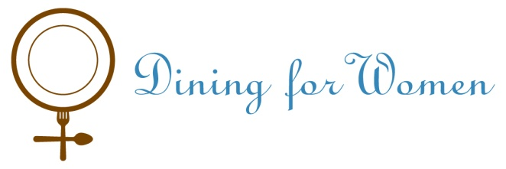
Dining for Women’s – Mercy Beyond Borders Project (MBB)
Against great odds, women the world over do take initiative, working hard to lift their families up from extreme poverty. Most women in Sudan today have never had the chance for formal schooling, but they are survivors, highly motivated to provide a better future for their children. Mercy Beyond Borders partners with amazing women to help them realize their dreams. In Sudan they are working with Teody Achilo, one of the founders of the Sudanese Women's Voice for Peace, to fund self-help projects designed by refugee women returning to their home villages after 10 or even 20 years in refugee camps. Many have expressed strong interest in starting small businesses. MBB stands with them to provide seed capital and basic business training. Here are a few examples of how MBB donations are used:
$3,750 |  | Is enough to start a women’s micro-enterprise group in a Sudanese village. This project will support the start-up of three MBB 3 groups: one is a group of 15 HIV+ women in Nimule; another is a women’s club in Rumbek, and the 3rd is a group of former refugee women in Torit.
$1,000 |  | $1,000 will build a roadside café and stock it for selling tea and bread to travelers.
$1,000 |  | Provides women in a village with bicycles to share, for ferrying their vegetables to neighboring villages on market days.

Program Budget – Requested Amount $15,200
Equipment  -Lockboxes/keys @ $100 x 3 | $ 300
Equipment  -Registry Books @$10 x 45 | $ 450
Training Manuals @$35 x 3 | $ 105
Food for meetings of women’s groups  @$50/day X 5 days x 3 villages | $ 750
LOANS @$250 avg. for 45 women | $11,250
Coordinator @$200/mo x 5 months | $ 1,200
Trainer @$75/per workshop x 5 x3 villages | $ 1,125
Total Expenses | $15,180

