**KNOWLEDGE FOR CHILDREN (NGO)**

MOTTO: *ASSURING A BETTER LIFE* REG. NO. E26/PS/118/206

HEADQUARTERS: Kikoo House, Squares-Mbveh road, Kumbo

P.O. Box 100, Kumbo, Bui Division, North West Region

TELEPHONE: (237) 75285448 / 94479325 / 33481393

E-MAIL: cameroon.kforc@gmail.comWEBSITE: www.knowledgeforchildren.org

5th May 2014

**Knowledge for Children Global Giving Report-April 2014**

**Introduction:**

The Knowledge for Children health program has grown from strength to strength since it was launched in 2011.We ended the year 2013 with a grandiose celebration of World Aids Day which brought together our health clubs who show cased and sensitized the public with activities like sketches, songs, dances and recitations. It’s always amazing to see how much these children have learnt and how enthusiastic they are towards this project.

Also in the course of 2013 we introduced the hygiene and sanitation project through workshops that we organized with health club coordinators and community elites.

**Healthy Hands:**

At the beginning of the 2013/2014 academic year we started by visiting 40 schools to discuss the execution of the healthy hands project. During these visits we met with all club coordinator and health scouts to discuss their role in the execution of this project. We also discussed the dangers of germs as a result of dirty hands and then linked up with the importance of hand washing. We explained to children that they will be healthier if they can maintain healthy hands by always washing with soap and water and then air drying.

Before the team left the school we had come to an agreement for each school on the role of the health clubs in maintaining the hand washing systems (tanks) that will be donated to their schools by Knowledge for Children. As a result of the outbreak of cholera in some Cameroonian communities many parents are really impressed with this project.

**Installation of hand washing systems:**

Since the month of April 2014, our health team has been visiting some of our schools to install the hand washing systems. Each school received three water tanks and a donation of soap with the agreement that the Parent Teacher Associations will provide more soap in the future. For schools that do not have water facilities within the school campus they got two barrels of 60 litres each for storage of water. Hand washing systems will be installed in 23 out of 40 schools and then the rest of them will benefit in the next academic year provided we get additional funding.

We intend to add 20 new schools to the program to make a total of 60 schools benefiting from our health education project.

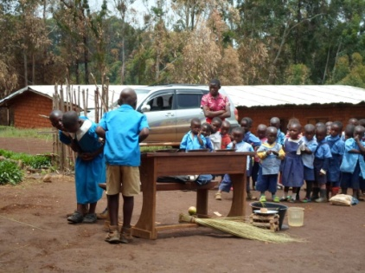Pictures:

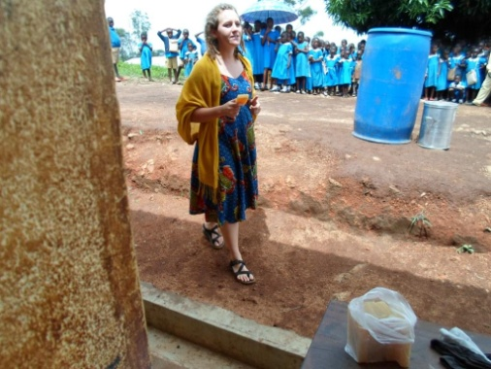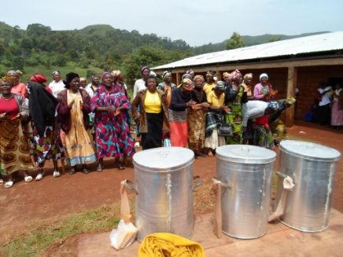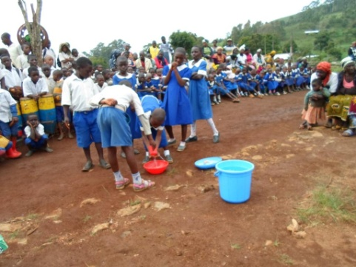

3

2

1

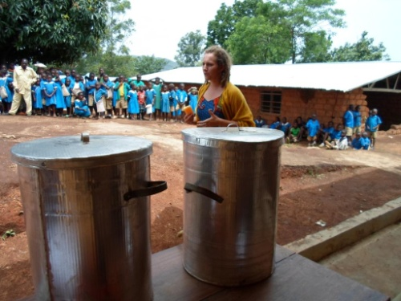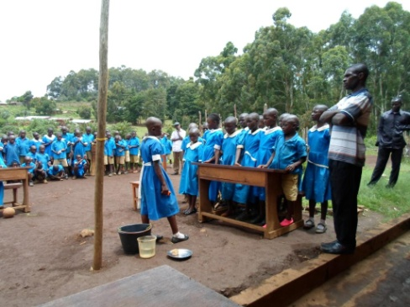

4

5

6

1-*Health Scouts of PS Dzeng performing a sketch on the importance and steps in washing hands*

2-*Parents in GS Mbirboh dancing and rejoicing about the water tanks donated to their school for hand washing. It’s fun to work with these communities.*

3-*Health Scouts in GS Vekovi performing a sketch on how we can get sick if we do not wash our hands before eating.*

4- *Still in GS Vekovi, Health Scouts perform a sketch on how to teach basic hygiene and sanitation in the class room.*

5-*Shannon Clawson presenting hand washing tanks and sensitizing the community of GS Lassin*

6- *Water barrel and soap donation to GS Lassin.*

**Appreciation:**

Thank you all for your continued support for the continuity of this project. We keep striving to be always result driven. Our communities speak well about us and listen to what we tell them. We are confident that we will do more with your support and that of our beneficiaries.

Compiled By:

 Mark Chaffee N

Program Manager

Knowledge for Children Cameroon