KNOWLEDGE FOR CHILDREN (NGO)
MOTTO: ASSURING A BETTER LIFE
P.O. BOX 100, KUMBO, BUI REG.NO E26/PS/118/206
TELEPHONE: (237)75285448/77642630/77622330
E-MAIL: cameroon@knowledgeforchildren.org
WEBSITE: www.knowledgeforchildren.org
28th August 2013

KNOWLEDGE FOR CHILDREN REPORT ON HEALTH EDUCATION IN 40 PRIMARY SCHOOLS.

Introduction:

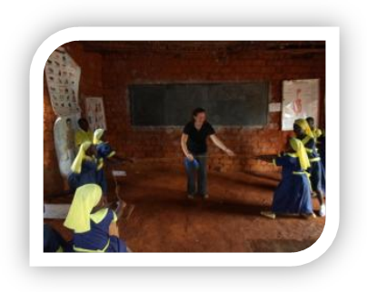
Since submission of the last report, Knowledge for Children has continued with the motto:”Good Health for Quality Education” to continue to support our newly-installed clubs and strengthen our first 20 clubs. We did this by visiting all 40 Health Clubs for a working session. This allowed teachers to observe interactive learning in the classroom, as well as discuss individual concerns with the Health Team. As a result of the need for a Community Coordinator identified in our last series of workshops, we also held a series of four workshops to train and formally install a Community Health Club Coordinator for each school in our Health Program. Lastly, we identified graduated Health Scouts in three communities to participate in a Alumni Network Youth Camp.

Project Continuity:

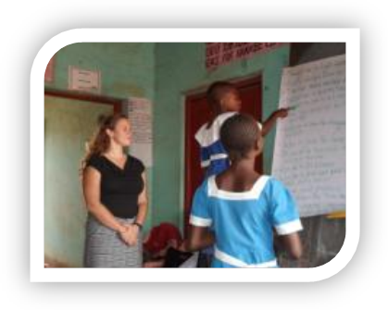
Following the workshops that instructed club coordinators on the proper usage of Health Club materials, the Health Team set out to visit all 40 Health Clubs during April and May. The team was able to visit all 40 schools and introduce new games and demonstrate the interactive teaching methods discussed during the workshops. The team introduced a health-themed “Tug of War” game as well as the “Lions and Elephants” game that teaches students about how HIV affects the immune system. We were also able to lead a discussion with each school based on the HIV/AIDS action reader “I still want to play”. This reader teaches children how to support their friends that have parents with HIV.

During the school visits, we were also able to meet with school club coordinators and counsel them on how to address specific problems they were experiencing in their club. Finally, we were able to meet the Community Health Club Coordinators that were selected by the school to ensure the continuity of the Health Program, as discussed during the workshops held in March. We were able to explain the purpose of the Community Health Club Coordinators and invite them to a workshop/training that was scheduled in July.

The KforC Health Team was then able to conduct a series of workshops to introduce the new Community Health Club Coordinators to the Health Program and train them on how to support and manage their local Health Club. Workshop participants defined the roles and responsibilities of Community Coordinators, learned interactive teaching methods, reviewed the qualities necessary for a good facilitator, and brainstormed ways to involve the community in Health Club Activities.

Lastly, the Health Team was able to meet with three of four secondary schools to begin initiation of the Alumni Network. The team established relationships with the Head Masters of the secondary schools and identified the former Health Scouts within these schools. This list of graduated Health Scouts will be used to create invitations for our Alumni Network Youth Camp.

Follow Ups:

The Health Team now needs to plan and implement two Youth Camps for the official initiation of the Alumni Network. The camps will be held to train graduated Health Scouts on leadership and mentoring skills, decision-making, HIV/AIDS education and prevention, and club management. The camps are currently scheduled for November and will be held in Kumbo Zone as a pilot program. Following the success of these camps, we hope to expand the program to all 40 schools through partnership with the Community Health Club Coordinators.

Conclusion:

We hope to create a healthy environment by working with our youths for better healthy practices. The saying here goes “A Healthy Mind Can Only Be in a Healthy Body”

Appreciation:
We will endlessly continue to extend our heart felt gratitude to all those who have and are still giving their financial and moral support to help us bring more healthy habits to primary school children so as to create an HIV Free Generation in the North West Region of Cameroon. Please tell us what you think, any advice or suggestions are welcome!

Compiled By:

Losha Mark Chaffee N

Program Officer

KforC Cameroon,

Good Health For Quality Education

