**KNOWLEDGE FOR CHILDREN (NGO)**

MOTTO: *ASSURING A BETTER LIFE* REG. NO. E26/PS/118/206

HEADQUARTERS: Kikoo House, Squares - Mbveh road, Kumbo

P.O. Box 100, Kumbo, Bui Division, North West Region

TELEPHONE: (237) 75285448 / 94479325 / 33481393

E-MAIL: knowledgeforchildren@gmail.com WEBSITE: www.knowledgeforchildren.org

17th February 2015

**January 2015 Global Giving Report**

**Introduction:**

After the installations of the new health clubs in September and October of 2014 the health project took a break to evaluate the workshops that we organized in October. We realized that the workshops were very necessary as the coordinators shared best practices among themselves. We also discussed the challenges they are facing and are now focusing on designing solutions to these challenges.

**World Aids Day:**

During the month of November the health team was preparing for world Aids Day. We had a series of planning meetings with other partners like Banso Baptist Hospital (BBH), Rural Development Foundation (RDF) and Shisong Hospital. The two hospitals provided personnel and resources for Voluntary Counseling and Testing.RDF and Knowledge for Children provided two thousand condoms that were distributed during the celebration of World Aids Day on the 1st of December 2015.

We started this day with a parade that brought together a lot of people some of who made up a convoy that escorted us to the market.

The Venue of the Celebration for 2014 was Mbve Market which is the biggest market in Kumbo. Plus the 1st of December coincided with the big market day which brings a lot of people from surrounding villages. With this opportunity we were able to reach out to so many people in one place.

Knowledge for Children invited 50 Health Scouts from 5 clubs who first went round the market to distribute flyers about HIV and Aids then they later presented drama and songs educating the population about HIV and Aids.

Our counseling and testing team was implacable and was able to test 304 people in one day. Everybody who got test was given condoms to take home.

**Conclusion:**

Last year was a very productive year for the Knowledge for Children Health Program, we were able to graduate 17 health clubs that are now self sustainable. And we were able to add 10 new clubs to the program. The Health program continues to grow in strength and quality with more communities getting involved. Our objective is to bring more healthy practices to many more children in rural communities.

We can only achieve this with your support. We continue to be grateful to all those who have and are still contributing either morally or financially to the growth and success of this project. God Bless.

**Picture Gallery:**

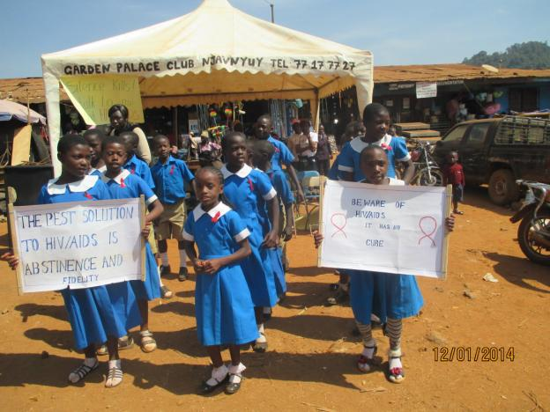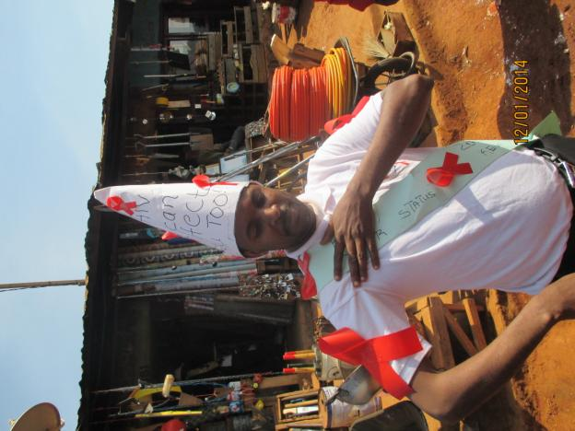

Health Scouts Singing

Mr. AIDS

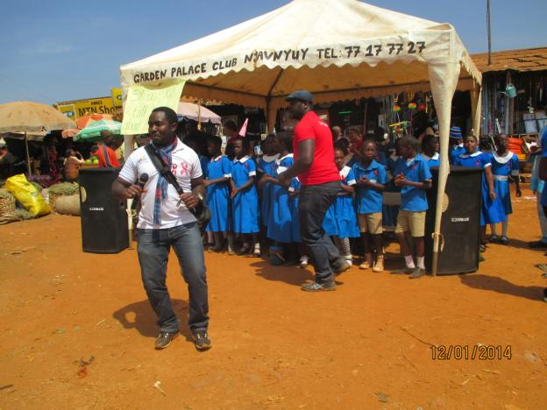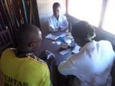

Know Your Satus

HIV and AIDS Dance

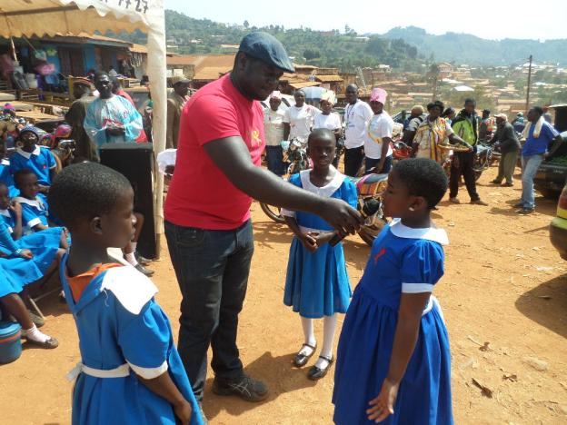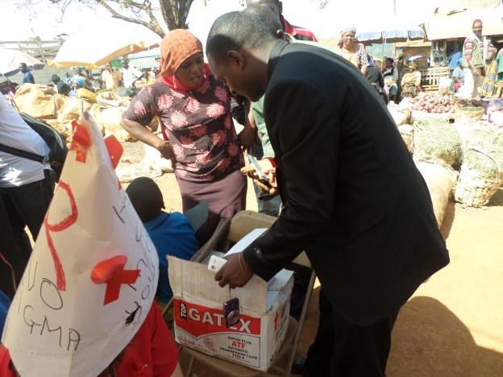

The Drama

Use a Condom

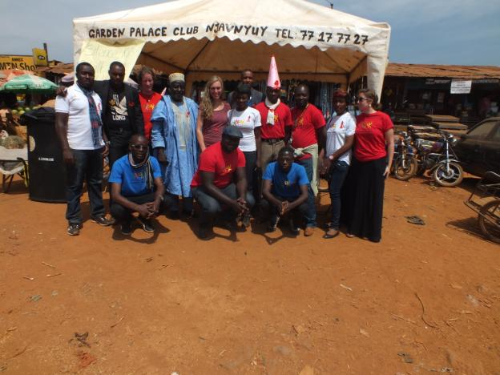

The Team

Compiled By:

Losha Mark Chaffee N

Program Manager

Knowledge for Children Cameroon.

Mark.kforc@gmail.com