Title: Proving Basic Needs and to Education of refugee children, unaccompanied miners and orphans in Kampala.

Summary of the proposal

This is meant to help refugee children in all their various categories in Kampala Uganda to have a shelter, food, medical care and access the Universal Primary Education (UPE). We teach them English and other different subjects and pay school fees to refugee children and other marginalized children in Kampala in order to prepare them to integrate formal education sector and being able to be familiar with the Uganda Education System.

Identification of these children:

Refugee children in Uganda are from various back ground such as unaccompanied minors, orphans, vulnerable children from poor family, those with single parent who were born out of rape and those who have been of human trafficking.

INTRODUCTION

Refugee children from different countries like D R Congo, Rwanda, Burundi, Sudan, Eritrea, Ethiopia and many other countries and marginalized children like unaccompanied minors, orphans and street children are increasing in number in communities here in Kampala. Today there is no specific program aiming at taking care of them especially to access the government program called “free education”.

PROBLEM ANALYSIS

The Uganda government initiated the Universal Primary Education for all, a program which is officially called to be free to all children in the country in all government schools in one hand. On the other hand the government of Uganda requests parents of children to make a contribution of 20$ per term (3 months) for each child who is at school. Many parents have failed to rise up this money especially for someone who has more than six children and do not have a clear source of income; this is the case of refugee parents in general. Because of this reality, many children from poor families in the local communities and those who are unaccompanied do not go to school.

On the other hand refugee children and other migrant children are more and more vulnerable because of their status, some have been victims of human trafficking and when they reach here in Kampala, they have no one to take care of them. As consequence they have been for many times victims of the unlawful arrest, sexual abuse, defilement, forced labor, accused of many crimes in the city, and being subjected to all forms of violence. Beyond that they have no where to stay, nothing to eat, and do not go school.

Their fate is determined on the streets of Kampala where they are founds as small gangsters and in the community where they are always called thieves commonly known in Luganda (local language) as “Bayayi”. It may be true of false that these children are directly or indirectly involves in different crimes in the city because they do not have anyone to care for them. At the end, they are arrested, sentenced and sent to prisons for many years. In many cases they are even accused of crimes which they have not done because they the easiest to be accused and to arrest without any resistance or defense.

For other refugee children things are quiet different, many come from countries where English is not spoken when they want to enroll for education here the first requirement is the capacity to speak, understand, write and read English and make them familiar of the Uganda Education system especially revising for them all the different subjects and clarify some differences between the teaching, the subjects and methodologies between their countries of origin and the host country. Other refugee children do not have access to education because their parents are really poor and cannot be able to provide their children with exercises books and do not have the 20$ mentioned above and this is the majority of refugee children in Kampala.

It has been seen that when a refugee want to integrate to the education here he or she is put in a lower level. For example someone who has been in level 6 in his or her country of origin is put in level 2 here in Uganda. Many refugee children and their parents consider this as wastage of time; they end up by dropping out from school and end up being victims of different crimes such as sexual exploitation of young girls and prostitution. For young boys it is more being manipulated and being used in different crimes such thief and other forms of drogue abuse.

All these children whether refugees of local do not have any perspective of the future and are more a source of instability for the community in the future if not looked after, much resources are wasted to arrest and punish them rather than educating them. For this we came up with this program to occupy and take care for all these children who are not going to school.

We have noticed the problem of attitudes of some parents who have a negative perception of the Uganda Education system and think that refugees are just for short term situation. They don’t encourage their children to go to school as they say that their children will study when they are resettled to the third country or when they go back to their countries of origin, but the reality is that these two options take long and many children are growing up and feel ashamed to be in a lower class.

ATTEMPT FOR SOLUTION

After analyzing the problem affecting refugee children in Kampala PPDR initiated a school and caring programs for them. We have registered 230 children into two classes and so far 86 have already started classes every day at our offices. We take care of them every day from 9am to 12pm and they are taught English and other subjects like French, Kiswahili, physical education and music. We are looking forward to develop a curriculum suitable to their level and age. These lessons are just a gesture to prepare them for real formal education program and those who have finished the program in our classes will be encouraged to join the formal education system when they have now the capacity to adapt. PPDR has looked for shelter for those who have no where to stay, we take to hospital those who are sick, we provide special shelter to those who are sexually abused and help them with food.

Goals and Objectives

- To encourage refugee and forsaken children to go to school by offering the basic tools
- To offer clear information to refugees about the Uganda Education System
- To contribute to the development of refugee and forsaken children and make them dream for a better future in life
- To change the attitude of the authorities and make them understand than one among the best ways of protecting refugees’ and forsaken children is to educate them.
- To provide an environment which allows these children to develop in all aspects of life.

Clientele
Our main clients are children refugees, children from migrant families in Uganda and the marginalized children in the hosting community who cannot go to school such as street children, orphans, unaccompanied minors, children mothers who have been sexually abused and are chassed out from school and any child who will be identified as vulnerable. Today very few refugee children access the education; it is even difficult to estimate the statistic because this program does not exist for them. There are just some few children who are going to school after a help from some churches or from people of good will. But the majority are just at home, their exact number is unknown up to now because there has not been any research aiming at identifying them but it is true that many families have more than 5 children. What we know is that they are 28,000 refugees in Kampala and 350, 000 refugees in Uganda and the majorities of these people are children.

Methodology

- Enrollment

There is ongoing information sessions about the necessity to send children to school at our office and more campaigns will be done by PPDR members where they will be visiting place to place where refugees are living in Kampala. Still all religious leaders and refugee community leaders will be involved in this sensitization by doing it hand in hand with them. More information sessions will be organized in all places mostly visited by refugees and announcements will be made in public places. In this program refugee children newly arrived will be also targeted and encouraged to attend classes and in this we shall collaborate with the police that handles new arrivals.

- Who will teach these children?

Teachers are PPDR members who are taking care of these children and any other person who may be interested to offer services to them such as volunteers and interns. Teachers are volunteers who are giving out their little efforts for the better life of these children.

- Where the teaching will take place

The teaching is taking place at the office of PPDR in Kampala and other designated areas in Kampala as PPDR may see it necessary.

- How will the teaching be monitored?

The Education and Training Department at PPDR will collaborate with the ministry of Education and sport to ensure that the education offered to these students is accurate and do confirm to the Uganda Education System standards. These children will be evaluated by the Ministry of Education after an exam, those who will successively pass it, will be allocated in their different respective classes which they were in there countries of origin.

- Organizational arrangements for the program

This children education program will be coordinated by the head of Education and Training Department at PPDR in close consultation with the coordination team of PPDR and the committee of the parents of these children.

Logistic arrangements which are need

Two classes
Two teachers and a cleaner
One computer, one printer and one photocopier
Variety of books and exercise books
Chalks, pens and pencils
Ream of papers and Black Boards
Plastic chairs and files
Food, bed rooms, stencils and cooker

- Staff and Administration

The program will be coordinated by the head of Education and Training Department at PPDR and will be assisted by two teachers and one person for logistics.

- Available resources
One class which is now divided into two, two teacher and the head of Education and Training Department, three black boards, 25 benches, 15 books, One computer, chalks and 86 children.

BUDGET

Ref | Budget line item | Unit | Quantity | Unit cost in USA $ | Budget amount in $ | Year budget in $
1 | Staff Allowances
a. | The project coordinator | Month | 12 | 400 | 4,800 | 4,800
b | (2) teachers | Month | 12 | 700 | 8,400 | 8,400
c. | Logistician | Month | 12 | 100 | 1,200 | 1,200
2 | Subtotal staff Allowances |  |  |  |  | 14, 400
2 | Office, classes and materials
a. | One office and two classes | Month | 12 | 350 | 4,200 | 4,200
b. | Variety of books and exercise books |  |  |  |  | 300
c. | 50 Reams of Papers |  |  | 8 | 400 | 400
d. | 2 Black Boards |  |  | 50x2 | 100 | 100
e. | 20 boxes of chalks |  |  | 3x20 | 60 | 60
f. | 250 Plastic chairs |  |  | 8x250 | 2000 | 2000
g. | 2 Office tables |  |  | 100x2 | 200 | 200
h. | 4 office chairs |  |  | 50x4 | 200 | 200
i. | One photocopier |  |  |  | 700 | 700
j. | Phone and airtime |  |  |  | 600 | 600
k. | First Aid Clinic |  |  |  | 300 | 300
l. | Break first |  |  |  | 1,000 | 1,000
Total |  |  |  |  |  | 10, 060
3 | Sleeping rooms/ Shelter
a | Sleeping room |  | 6 | 100 X6 | 600 | 7,200
b. | Food |  |  |  | 300 | 3,600
c. | Others (Clothes, stencil, medical care |  |  |  |  | 10,000
Total |  |  |  |  |  | 20,800
3. | Total General |  |  |  |  | 45,260

PPDR Education Department FAL quarterly report from December 2010 to March 2011

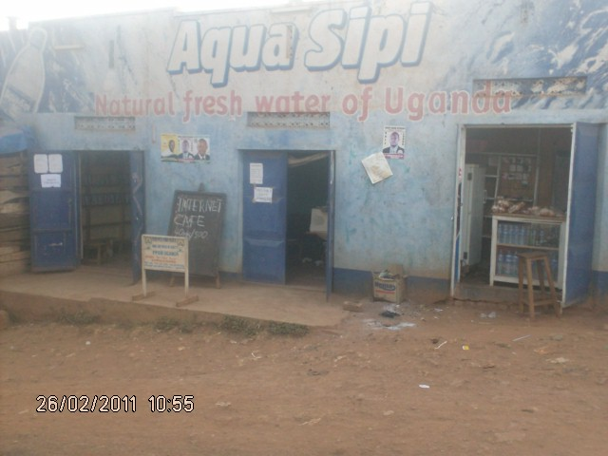
PPDR main office at Social Center Kisenyi

- Introduction

Uganda has more than 350,000 refugees from different countries; more than 28,000 refugees are living in Kampala the capital city. Having observed that these refugees face the first hardship to communicate and others to real cope up with the realities of life in the new country of asylum, it was then requested that learning English is the very first step to follow and the ability to freely express for some is part of the solutions to their problems and others need to learn skills and identify their profession.

To day they are only less than 1,000 refugees who have access to FAL/ English program and this because of some limitations in centers operating these programmes.

This time there are refugees themselves under PPDR who are active in offering services to others and one among them is Bashizi Mulumeweka Gilbert who is a instructor for FAL/ English program at PPDR.
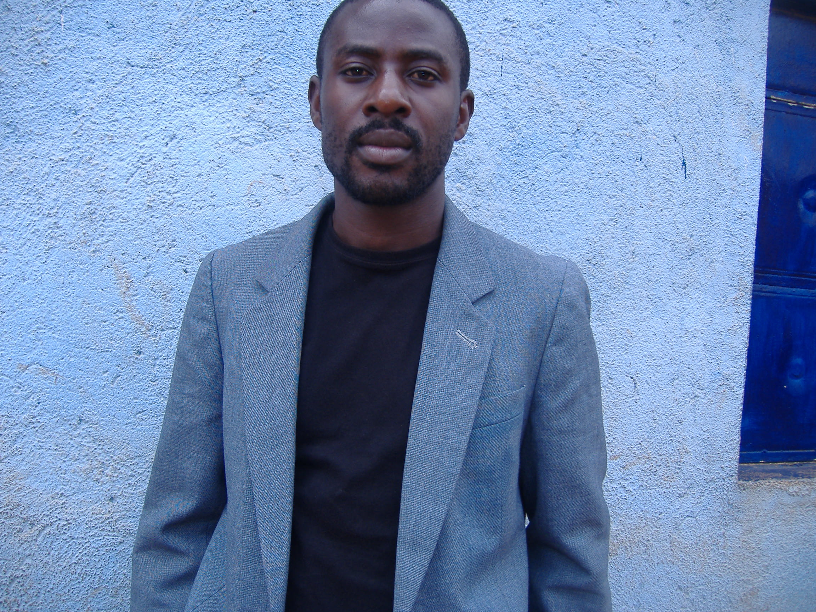
Gilbert Bashizi Teacher at PPDR

Gilbert is a refugee from D R Congo, a teacher by profession and now holding a Bachelor in Theology. He is well known by his students as Pastor Gilbert. He teaches a class of adults’ people four days per week. He said that it is the grace of God that he is able to offer services to his fellow refugees despite all the hardship and challenges and his happiness is to see people progressing.

The organization People for Peace and Defense of Rights is an independent organization which is more centered in the promotion of human right through different activities such as the education. The majority of her members come from different countries where English is not commonly spoken.
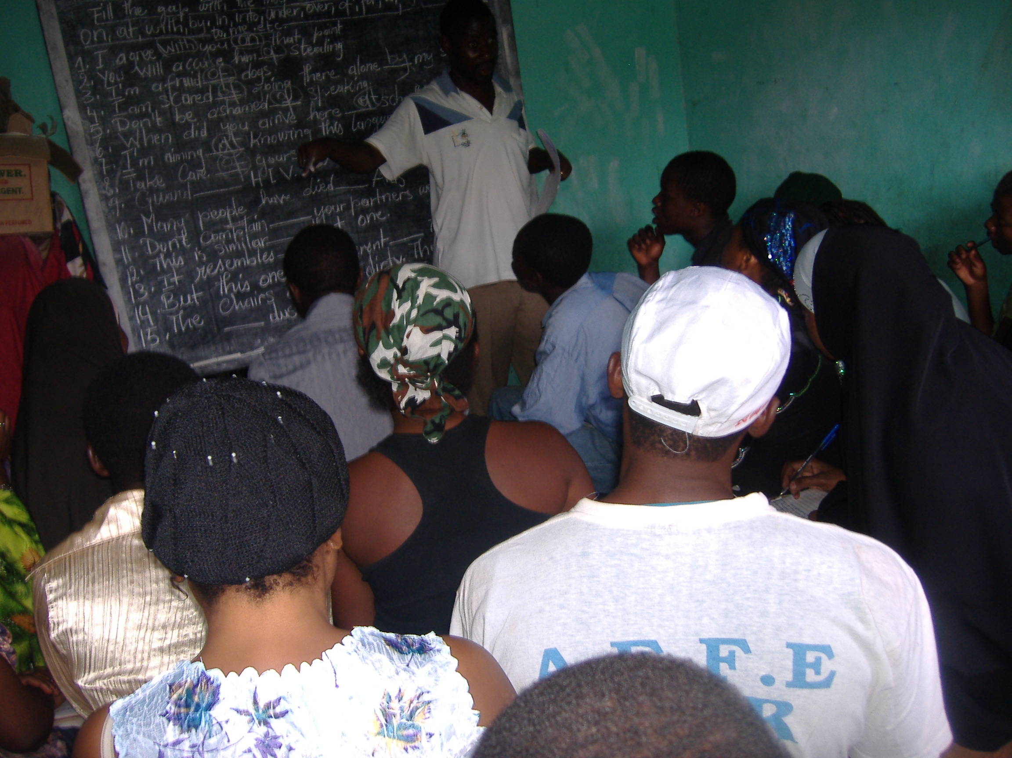
Adults Refugees in Class at PPDR

This constitutes a barrier in communication between service providers and refugees. As a tentative option to solve this problem the Education department at PPDR puts in place this activity of education department.

On the other hand, refugee children are facing different problems to access the Education system in Uganda because some cannot speak English as consequences they are demoted to low levels, others do not have money to pay and are just at home and other have never been to school.

The main objective of PPDR education program is to teach English to Refugees who may be interested. The object is to solve illiteracy and communication problems and the service providers and at the end to make refugees functional in the society.

Project overview

The project started in December 2009; classes are haled at PPDR centre offices. We are having one class which is allocated at PPDR offices.

We registered pupils as follows

Under Children program

Male: 35
Female: 42
Total: 77
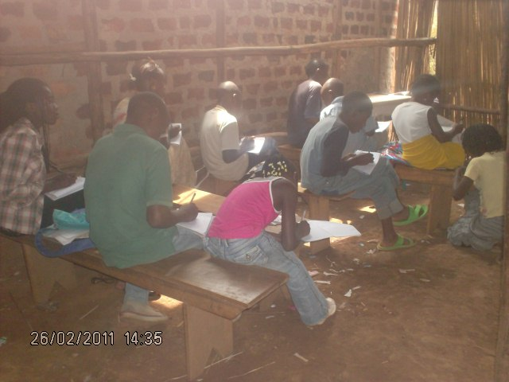
Refugee Children and unaccompanied minors in class at PPDR

These were only pupils who registered as new and who are currently learning at PPDR. However many are still coming and we keep on advising them to wait for the nest term because of the logistic problems.

Instructor
NIWAMANYA ONEX
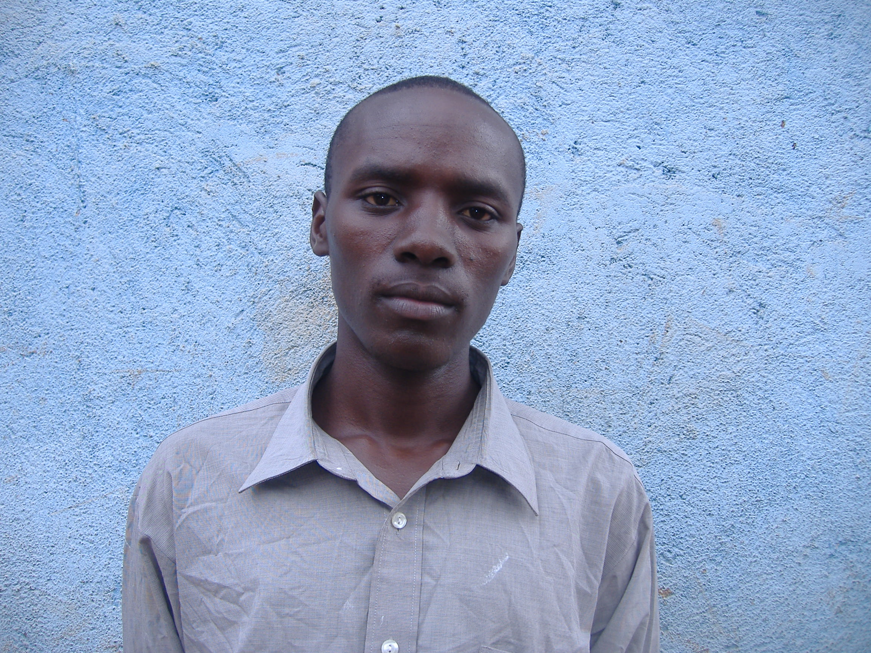
Onex is a Ugandan, member of PPDR who is in charge of the children education in the organization.

These children are taught English and other subjects such as Geography and history among others.

Under Functional Adults Literacy (FAL)

In Functional Adults Literacy we registered total number 69 students and they are divided into two classes, 40 are in level one and 29 are in level two. Level one and level two.
Male: 32
Female: 37

Instructors are Gilbert Bashizi in level one and Kulihoshi Musikami in level two

Many are still coming and want to learn but we have limited spaces and other logistics in place to accommodate many students. These are so far new students who have been recently registered and who are waiting for the new term.

Level | Male | Female | Number of students
 | 34 | 29 | 63

These adults are learning a range of different topics a side with English main human rights, peace and economical activities.

Registration procedures

In order to place pupils in any level, the registration process is for the first term required each prospective pupil to write an intake assessment.

Class time table

We have one class session which starts at 09.00am and ends at 12.00pm every Monday, Tuesday, Thursday, and Friday for young children.

In the after noon the same days we have level one in the same class and on Wednesday from 4 – 6 pm, Friday 2 – 4 pm and Saturday 9 – 11 am level Two.

Achievements
The number of students has increased; the department has one teacher for each program. We received scholastic materials from the Finish Refugee Council which also has manifested interest in the English For Adults program. The department has done every thing possible to maintain the program. The program has helped many refugees to get busy and therefore forget their hard experience they went through and to reduce their trauma.

Training of One instructor by FRC and attending one workshop.

Determination of instructors to offer a service to their fellow refugees at the cost of self sacrifice.

PPDR Computer Training

This helps many refugees to acquire a skill when they have finished with the English lesson and after this they easily integrate in the local community. This also helps them to get employment and solve many other social problems.
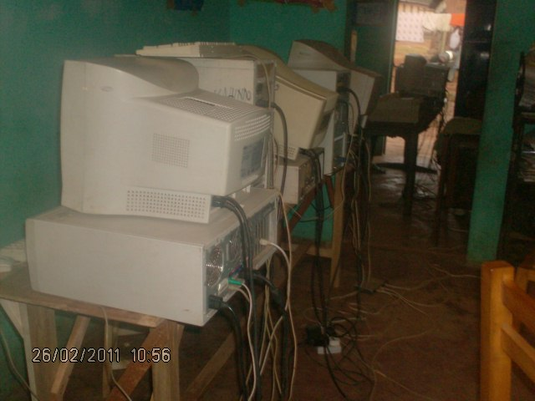
PPDR Computer Training Center

Challenges

Challenge in the literacy English class include late coming and absenteeism, high drop out rate, students joining in mid-term , poverty problems slow learners, and lack of support from the government, Non Governmental Organizations and community.

- Language problem is still another challenge where by in some cases pupils want to understand things in their local languages and this becomes a challenge since they are learners from different nationalities.

- Students present different interests so it has been hard to get a homogeneous class.
- Lack of classrooms, chairs, tables, pens and books (Grammar and story books and other books in different subjects).

- Lack of fund for the program, the program is funded through the contribution of PPDR members.

- Few instructors and little allowances given to them.

