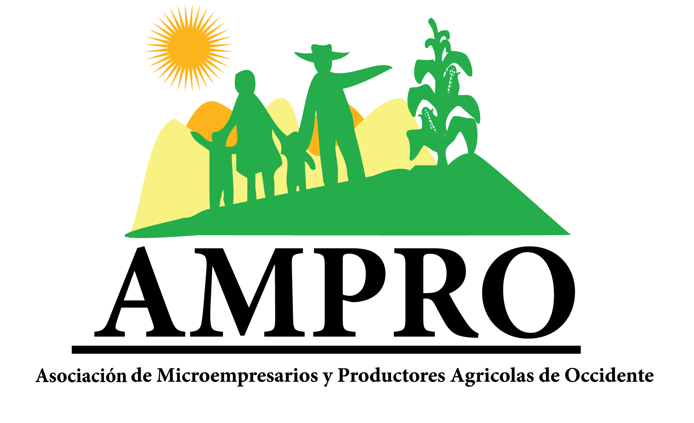
Project:
Scholarships and Training for AMPRO Youths

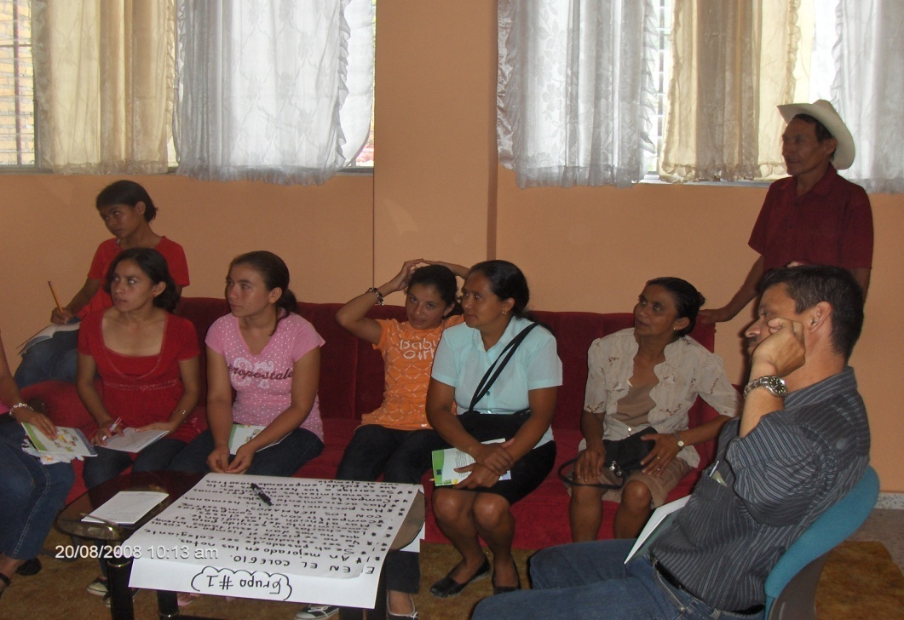
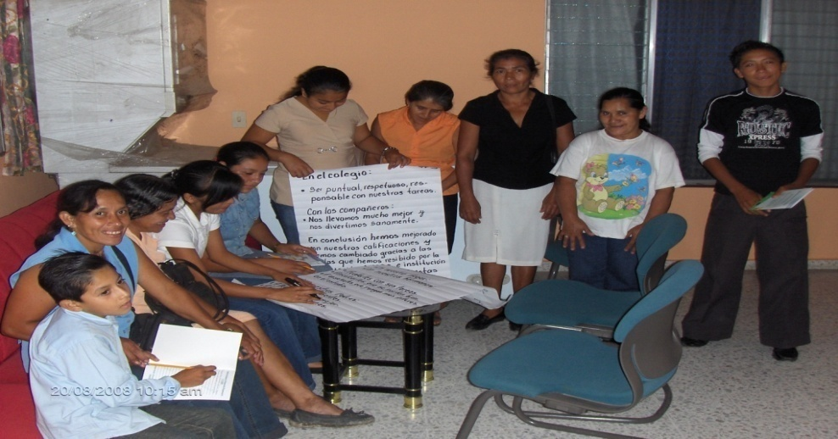

PROJECT PRESENTED BY AMPRO TO PRIVATE DONORS FOR PARTIAL FINANCING
2011

AMPRO 2011. Santa Rosa De Copan, Honduras.
SUMMARY
AMPRO respectfully requests a total amount of $6811.29 dollars from private donors through globalgiving.org. The money will be used to finance scholarships for high school students (4,200 dollars) and workshops for counselling and training the same students (2,611.29 dollars).

I INTRODUCTION
Studying in Honduras is far from easy, especially in western Honduras and even more so for people living in the countryside. Since 80% of the rural families live below the poverty line, lots of children and/or adolescents have to forgo schooling in order to help their parents with household tasks and on the fields, growing basic crops or coffee to contribute to the family income. Those children that manage to study often receive a low-quality formation because of lack of motivated teachers, strikes regularly causing classes to be suspended in government schools, and poor school infrastructure lacking in basic necessities such as books and services. Moreover, many do not attend school because of a lack of resources, lack of motivation, or lack of labour options. More than 40% of the Honduran population is younger than 18 and most of them end up as unschooled labourers because they do not finish their studies or follow a short formation.

In the light of these problems (not assisting school), and knowing that all the member families of AMPRO (Asociación de Microempresarios y Productores del Occidente de Honduras) consider the formation of their children very important, Pilarh (an Honduran NGO) and AMPRO, with logistical help of the Belgian NGO Trias, have started to grant scholarships of 330 Lempira/month (17 $/month) to the sons and daughters of the poorest members of AMPRO, who are willing to study. These scholarships were funded with own resources and with the help of GKM (a Belgian organisation), assigning a total of 30 scholarships during the years 2005-2006, and 60 during the years 2007-2008-2009-2010 support by the Belgian Cooperation. The youths get a scholarship in order to begin and finish high school or technical school (age 12-18).

The scholarship program is already having a positive impact, because more than 90% of the youths receiving a scholarship is continuing with his or her high school studies. Thanks to the AMPRO scholarship program, two of the beneficiaries have obtained scholarships for advanced studies abroad: one from the US Peace Corps, for studying in the USA, and one from a university in Peru. They intent to return and help with the development of AMPRO, and to generate new ideas for local projects.

For 2011, with the help of foreign organisations Trias NGO, GKM-BRS Foundation and the Belgian Cooperation, AMPRO, and Pilarh aim to add the number of scholarships to 90, which will help to contribute even more to the professional development of poor rural youths and to create a skilled labour force. However, the financial resources of AMPRO and Pilarh are insufficient and searching alternative sources of financing for the scholarship program is needed in order to support more youths with both a scholarship and constant counselling, training and coaching in order to achieve the aim of the project.

II JUSTIFICATION.
For the Honduran families, and especially so for the ones involved with Pilarh and AMPRO, the formation of their children is very important. Unfortunately, the governments’ lack of interest in supporting the rural population results in less than 30% of the rural youths obtaining a diploma. Moreover, the poverty in which most rural families live does not allow them to offer a formation to all of their children.

The attendance of children and youths at secondary school is very low, which is worrying because of the high percentage of unemployment or underemployment in the rural areas and the high percentage (>40%) of the population under 18. With the awarding of scholarships AMPRO is contributing to the formation of young professionals (skilled labour force) who will be able to take a competitive position in the labour market and to create local business initiatives, generating local work opportunities. Besides, with this scholarship program we hope to encourage young people to contribute to their villages and their organisation AMPRO. They will be more committed to AMPRO, community, and country, and have the skills to support and lead the future development of the region and AMPRO. We will avoid young people to get involved with youth gangs or to migrate to the large cities in search for jobs. Their entrepreneur mentality will be strengthened, so the young professionals themselves will start up productive enterprises.

According to the testimonies of parents and the children, receiving a scholarship has caused a remarkable change in their lives because without it they would most likely be working in the fields instead of attending school, thus continuing the poverty cycle.

Also, this project corresponds to the strategic guidelines of “help and support for youths” within AMPRO’s work frame, named Young Entrepreneurs Program (Programa de Gestión y Apoyo a Jóvenes), and also within the strategy of local economic development, in cooperation with the NGO Trias.
The Belgian organisation GKM, after observing the great effort made by AMPRO, has approved supporting this action for at least another 2 years and even increase the number of scholarships until 90 but the organisation has to be able to pay at least 50% of the total cost and AMPRO has not the economical means to do that.

III GENERAL INFORMATION ABOUT AMPRO Y PILARH
AMPRO: Association of Small Entrepreneurs and Farmers of Western Honduras.
AMPRO is a non-profit development association, constituted by small and medium farmers and entrepreneurs in Western Honduras, with the main objective of improving the living standards of its members. In order to achieve that, the organisation represents and defends the rights and interests of its members, mediates development projects, and carries out lobby work.
AMPRO consists of 5 branches, more than a hundred groups distributed over Western Honduras, making a total of 1600 members. Each branch counts with its own board of directors. The highest level of the organisation is the general assembly, followed by the central board of directors. AMPRO also counts with a basic technical team consisting of an administrator/accountant and a counsellor.
VISION
By 2015 AMPRO should be organised, responsible, and solidary; with a main executive office holding its own infrastructure; generating benefits for farmers, entrepreneurs, and civic society; with opportunities for our children to work, and as an association to be recognised nationally and internationally.

MISSION
To be a union association of farmers and small entrepreneurs of western Honduras that contributes to improving the living standard of its members through the mediation of commercial and social projects through lobby work.

AREA OF INFLUENCE
Western Honduras
- Copán
- Ocotepeque
- Lempira
- Santa Bárbara

PROGRAMS
AMPRO handles the following programs:
- Approaching governments and private and public institutions.
- Production and marketing (basic crops, coffee, handicrafts, etcetera).
- Supporting youths (scholarships, entrepreneurship, forming youth networks, workshops, training, etc).

ALLIES
In order to achieve its mission, AMPRO has made alliances with several local institutions, the most important ones being:
Adelsar (Agencia de Desarrollo Estratégico Local: agency for local strategic development, a Honduran governmental institute), Asonog (Asociación de organismos no gubernamentales: Asociation of NGO’s), Trias NGO (Belgian Organisation), Caritas International (NGO), Centro de la Mujer Copaneca (Copans’ Women Centre).

PILARH: Projects and Initiatives for the Self-development of Honduras.
Pilarh, which mainly delivers services to producers and entrepreneurs, is a non-profit development institution, established with the goal of supporting small and medium farmers and entrepreneurs in western Honduras. Improving their living conditions and impulsing the economic development of their communities, thus achieving a sustainable progress. In order to achieve this, Pilarh offers the farmers and entrepreneurs counselling on issues such as integral development in entrepreneurship, marketing, technical support, formation of entrepreneurs, impulsing associatively in branch-related networks (to motivate the producers and small businesses to work together according to their trade branch, improving quality and quantity of their products, in order to obtain better prices for their commodities), and approaching local governments.
VISION
To be an innovative, competitive, and sustainable institute, with a high capacity for mediation, that contributes to the self-development of the target population.
MISSION
We are a private, non-profit development institute, offering quality services in technical support, training, and consultancy, directed towards promoting the social and entrepreneurial self-development of the low-income population, acting ethically and transparently.
AREA OF INFLUENCE
Western Honduras
- Copán
- Ocotepeque
- Lempira
- Santa Bárbara

PROGRAMS
Pilarh handles the following programs:
- Centre of Support to Entrepreneurial Development Centro (CADE).
- Social and local economic development program (PSDEL).

IV GOALS OF THE PROJECT
1.- Main goal
To contribute to the schooling/ professional formation of AMPRO youths, both girls and boys, so they achieve a professional career and contribute to the development of AMPRO and its communities (creation of micro-enterprises/low scale business)
2.- Specific goals.
a) To promote and foster entrepreneurship (management skills and decision making) in the AMPRO youths who receive scholarships so in the future they can lead the organisation and provide local labour opportunities.
b) To raise awareness about the importance of a professional formation with the youths receiving a scholarship.
3.- Expected results
a) 90 youths receiving a scholarship participate actively in the events organised by AMPRO and in their villages.
b) 90 youths redact a plan of insertion with their village corresponding to their studies or profession (social service).
c) Redaction of one plan of support for AMPRO per youth corresponding to their studies or profession and in accordance with the programs handled by the organisation(AMPRO wants to promote the youth participation actively inside the organisation and also outside like participating in activities carry out by the local government).
d) 95% of the youths receiving a scholarship obtain a diploma (corresponding to their schooling level 12-18 age) that allows them access to, and a competitive position in, the labour market, or to design their own enterprise.

V PROJECT IMPLEMENTATION.
The project will be implemented in the year 2011 and will hopefully continue during the following years until at least 2015. AMPRO, together with Pilarh, will be responsible for implementing the project with an emphasis on gender issues. Before the implementation of the project, other AMPRO stakeholders will be familiarised with it.
The training approach ensures the implementation of the concept “learning while doing” with space for feedback and evaluation of each workshop, as well as the empowerment of the youths concerning the project and AMPRO. During the whole process emphasis will be put on the importance of education for youths, promoting entrepreneurship and the importance of being organised.
The initial training of the youths receiving scholarships will be imparted by means of workshops throughout the year during the holiday periods to avoid youths missing school.

Within the project, the following training workshops will be held:
a) General knowledge of AMPRO.
b) Knowledge of the scholarship regulations and the rules for obtaining and keeping scholarships.
c) Leadership, motivation, and values.
d) Insertion of the youths in the activities and programs of AMPRO of their villages/groups.
e) Entrepreneurial orientation
f) Labour orientation
g) Organisation in networks
Workshops a, b, d and g will be handled by AMPRO with support from Pilarh. The other modules would be imparted by the allies of AMPRO, possibly Adelsar, Centro de la Mujer Copaneca, or another institution.
These workshops will allow the youths to self-evaluate their skills, abilities, and opportunities, in order to help them get inserted in the labour market and to generate general knowledge about starting up productive enterprises (self mediation). Moreover, it will allow them to get to know the internal processes of AMPRO.
The workshops will be held in Santa Rosa de Copán, unless it becomes necessary for logistical reasons to change the location, after consulting AMPRO/Pilarh.

VI SELECTION PROCEDURE
In principle all sons and daughters of AMPRO members have the option to apply for a scholarship. However, during the selection process the rules of the AMPRO scholarship project will be applied with an emphasis on gender and according to the scholarship regulations.
For the selection of scholarship applicants, the following procedure will be followed:
1. Promotion of the scholarship project in the divisions and groups of AMPRO, and selection of potential candidates for a scholarship (comply with the regulations of the scholarship program).
2. Application of a test to candidates to determine their general knowledge and suitability.
3. Selection of 90 candidates for scholarships by a commission of AMPRO and Pilarh according with the scholarship regulations. The main criteria to select candidates are the following: a) The candidate should be a son/daughter of a member; b) should demonstrate that she/he really needs a scholarship; c) children of single mothers should be given preference; d) the member should participate actively within the organisation; and e) the beneficiaries should be committed to participate in activities and events that AMPRO carry out to strengthen the students and to obtain good notes and f) To have a minimum notes of 7.5 out of 10.
4. Candidates sign a commitment with AMPRO and their groups/villages (social service).
5. Following-up of selected candidates through the implementation of the project (workshops) and by AMPRO and Pilarh themselves.

VII BUDGET.
We consider increasing the number of scholarships from 60 to 90 in the future implementation of the project. The number of scholarship will initially increase proportionally to the scholarships received previously, for instance, if a division received 6 scholarships in the past, it would receive 12 in the future. However, the exact numbers will be determined during the promotion and selection procedure.
At present, each scholarship consists of 330 lempiras a month ($ 17.55), making a total of 3300 lempiras a year ($ 175.5), since the school year consists of 10 months of classes. We represent the costs for the previous year (2010) or year zero in Table 1.
Cuadro 1. Currents costs for 60 scholarships during one year (in dollars).
NIÑAS
DIVISION | GIRLS | BOYS | TOTAL | Scholarship  /youth | Total cost  /month | Total cost 2010
LOS PINOS | 10 | 6 | 16 | 17.5 | 280 | 2,800
LA CANTEADA | 3 | 1 | 4 | 17.5 | 70 | 700
EL PUENTE | 5 | 5 | 10 | 17.5 | 175 | 1,750
ERAPUCA | 12 | 5 | 17 | 17.5 | 297.5 | 2,975
PUCA | 9 | 4 | 13 | 17.5 | 227.5 | 2,275
GRAND TOTAL |  |  | 60 |  | 1,050 | 10,500

As can be seen in Table 1, AMPRO awards 60 scholarships for a total value of $ 10,500.00 per year, This does not include the costs for holding the workshops.
If we increase the scholarship project to a total of 90 scholarships a year, the cost will change from $ 10,500.00 a year to $ 15,750.00 a year, as can be seen in Table 2.
Table 2. Projected costs for 90 scholarships for year 1 of the project (dollars).
DIVISION | GIRLS |  | BOYS |  | TOTAL |  | Scholarship  /youth | Total cost  /month | Total cost 2011
LOS PINOS |  | 15 |  | 9 |  | 24 | 17.5 | 420 | 4,200
LA CANTEADA |  | 5 |  | 2 |  | 7 | 17.5 | 122.5 | 1,225
EL PUENTE |  | 9 |  | 7 |  | 16 | 17.5 | 280 | 2,800
ERAPUCA |  | 16 |  | 6 |  | 22 | 17.5 | 385 | 3,850
PUCA |  | 15 |  | 6 |  | 21 | 17.5 | 367.5 | 3,675
GRAND TOTAL |  |  |  |  |  | 90 |  | 1,575 | 15,750

On the other hand, there are also costs involved with the organisation of the workshops and the fees for professional trainers. We include in this calculation the costs for the selection of scholarship candidates and the carrying out of the project. We repeat that it’s essential not only to grant scholarships but also to ensure the professional development of the youths receiving scholarships.
According to Tables 3 and 4, the costs for implementing the scholarship project amount to more than $ 7,826.48 doll for one year (2010). Transportation costs for AMPRO personnel or the partners (Pilarh, Adelsar, etc) are not included.
Table 3.- Personnel costs for holding the workshops in 2010 (30 students, in dollars).
N. | Concept | Cost
1 | Professional trainer fees  $ 212.7/workshop * 4 workshops (each during 2 days) | 851.40
2 | Transport for trainers and supervision | 175.50
3 | Meals trainers ($ 4.25 /meal *2 meals *3 trainers * 8 days)  Note: only meals for the external trainers are considered | 573.84
4 | Work books (30 books * $ 5.31/book) | 159.30
 | Total | $1760.04

Table 4.- Transport and alimentation costs for the beneficiaries of the workshops in 2011 (30, in dollars)
N. | Concept | Cost
1 | Light meals during the workshops (2 meals/day * 0 participants * $1.5/meal * 8 days) | $720.00
2 | Breakfast ($ 4/breakfast * 30 breakfasts/day * 8 days) | 960.00
3 | Transport ($ 212/workshop * 7 workshops) | 1,484.00
4 | Hotel costs | 1,063.00
 | Total | $4227.00

VIII FINANCING NEEDS
1. Scholarship costs.
At present, both AMPRO and Pilarh finance part of the costs of scholarships, workshops, and transportation, with the help from the Belgian government (DGOS) through the Belgian NGO GKM, as can be seen in Table 5.
Table 5.- Current contributions (2010) to the scholarship costs (in dollars).
APORTES ACTUALES PARA PAGO DE BECAS POR AÑO
(10,500.0 dollars)
INSTITUTE | Contribution
PILARH | 25% | $2,625.00
AMPRO | 25% | $2,625.00
GKM Belgium | 50% | $5,250.00
GRAND TOTAL | 100% | $10,500.00

According to the project planning, in order to grant a scholarship to 90 youths, $ 15,750 per year is needed for scholarships alone as can be seen in Table 6. As can be observed, for the scholarships alone we count with a deficit of $ 6276.00 in order to execute the project as planned. In order to abridge the deficit, AMPRO and Pilarh solicit the help from private donors through globalgiving.org.
Table 6.- Estimated contributions from year 1 of the project (2011, in dollars).
APORTACIONES EN EL PROYECTO
(15,750.00 dollars)
INSTITUTE
PILARH | 15% | $2,625.00
AMPRO | 15% | $2,625.00
Bélgica GKM | 25% | $3,688.00
Donations from private donors | 45% | $6,812.00
GRAND TOTAL | 100% | $15,750.00

2. Workshop costs.
The costs for holding the workshops from 2011 onwards are estimated in Tables 7 and 8.
Table 7.- Personnel costs for holding the workshops in 2011 (90 students, in dollars).
N. | Concept | Cost
1 | Professional trainer fees  $ 212.76/workshop * 12 workshops. | 1914.89
2 | Transport for trainers and supervision | 320
3 | Meals trainers ($ 4.25 /meal * 2 meals *3 trainers * 24 days)  Note: only meals for the external trainers are considered | 1721.52
4 | Work books (90 books* $ 5/book) | 450.00
 | Total | $4,406.41

Table 8.- Transport and alimentation costs for the beneficiaries of the workshops in 2011 (60, in dollars)
N. | Concept | Cost
1 | Light meals during the workshops (2 meals/day * 30 participants * $1.5/meal * 24 days) | 2,160.00
2 | Breakfast ($ 4/breakfast * 30 breakfasts/day * 24 days) | 2,880.00
3 | Transport ($ 212/workshop * 12 workshops) | 1,484.00
4 | Hotel costs | 2,126.00
 | Total | $8,650.00

The costs calculated in Tables 7 and 8 (costs for the workshops, not including the scholarships themselves) will be partly financed by AMPRO and Pilarh. However, AMPRO and Pilarh do not dispose of the resources to finance the total costs and currently they are looking for extra sources of support both within and outside of Honduras.
As can be seen in Table 9, AMPRO and Pilarh only have the means for financing halve of the workshop costs (6,921.9 dollars). GKM Belgium is already committed to contribute a further 10% of the costs. The missing 40% is being petitioned from private donations through globalgiving.org (20%) and other donors (20%).

Table 9. Contributions per institute in order to finance the costs of the planned workshops (2011, in dollars).
Workshop costs for 90 students
INSTITUTION | Contribution
PILARH | 25% | 3,264.11
AMPRO | 25% | 3,264.11
GKM Belgium | 10% | 1,305.54
Private donations through globalgiving.org | 20% | 2,611.29
Other donors | 20% | 2,611.29
GRAND TOTAL | 100% | 13,056.44

NOTE: we wish to make clear that the costs calculated above only cover one year of the scholarship project, so we need to dispose of this amount each year anew in order to form the young professionals needed by the country and AMPRO. We estimate that the costs may increase with 5 to 10% during the coming years (2012-2015).

IX RISKS
From the beginning of the project, we have encountered no difficulties that interrupt the processes of youth training. However, we do emphasise that in order to reach our goals, political stability in the country is needed, especially in the western region of Honduras. If not, strikes among the teaching personnel result in classes being suspended, to the detriment of the youths receiving scholarships.

