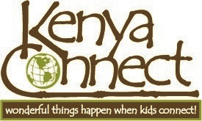

Who is Kenya Connect? Kenya Connect is a grassroots NGO creating significant, lasting changes toward peaceful, productive globalization. The experiences we provide children in Kenya, and their partners around the world, inspire them to fulfill their potential as “world citizens” –--to value work, to celebrate diversity, and to grow into adults for whom acts of generosity and the spirit of sharing are a way of life.

What has Kenya Connect Accomplished? Kenya Connect began nine years ago when ethnomusicologist and Maryland Teaching Artist Tim Gregory set up a pen pal and school sponsorship program in partnership with a Kenyan associate, James Musyoka. Since then, over 100 schools across 26 states have been engaged in Kenya Connect’s outreach as well as schools in Canada, China, France, Korea, New Zealand and the United Kingdom. Connecting schoolchildren across the globe inspires cross-cultural exchange and global awareness, and has fostered service-learning projects that improve the lives of all involved. Student-generated fundraisers from Read-a-Thons to Walk-A-Thons have provided for the installation of 45 water tanks designed to collect and store rainwater. Children at Kenya Connect’s 46 enrolled schools in Wamunyu, Kenya no longer have to miss instruction and walk long distances to haul water, and schools remain open during their frequent droughts. Partner schools and communities from the developed world have also provided new desks, fences and sporting equipment. Hundreds of needy students have been given gifts of school supplies, books and new uniforms (made by local women with small tailoring businesses) and special needs children have been provided with vocational equipment and wheel chairs. An income-generating chicken coop project and two solar-powered learning resource centers have also been constructed.



How has Kenya Connect Impacted the Schools?
Since Kenya Connect began partnering schools, headmasters in Wamunyu have reported a significant increase in attendance (especially in schools provided with water tanks), higher academic achievement in students, and a stronger sense of community. In addition, during the famine of 2009, Kenya Connect and its donors provided food for students at the schools so that children would not go hungry and their studies would not be interrupted. Pen Pal letters go both ways (over 65,000 to date), and so do the benefits to children who make connections with a friend and a culture on the other side of the world. English lessons in writing, grammar, and vocabulary development are enriched by the exchange of communication. Students experience real world lessons in social studies, geography, and science as they learn about their pen pals and the world in which they live. This rich cultural exchange of ideas and questions increases global awareness and understanding, with far reaching consequences for a more peaceful, just world.

Why a Green Learning Resource Center?
Kenya Connect is committed to the ongoing improvement of the educational infrastructure in Wamunyu, a semi-arid, rural area located in the Eastern province of Kenya. The populace is largely dependent on agriculture with little economic production, resulting in high poverty levels. While Kenya Connect had a profound impact on many local schools, the area still lacks an essential community oriented educational center. A Green Learning Resource Center will provide the much needed space for professional development training for teachers, adult literacy programs, a library and media resource center, tutoring, and safe recreation. Public and other school institutions can utilize the materials for individual use, collaborative planning, study, or research purposes. Hundreds of primary and secondary schools with thousands of students would benefit from the establishment of a community resource center. Many children in this area who do not have the opportunity to go to formal schools will benefit greatly from this facility. The green Learning Resource Center will be equipped with information and technology facilities, including internet and email access, providing research and improving communication capabilities across the local community. In addition, leading edge “green” technology, including solar power and Earthship water technologies, will be featured, providing a working model for self-sustaining development across Kenya.

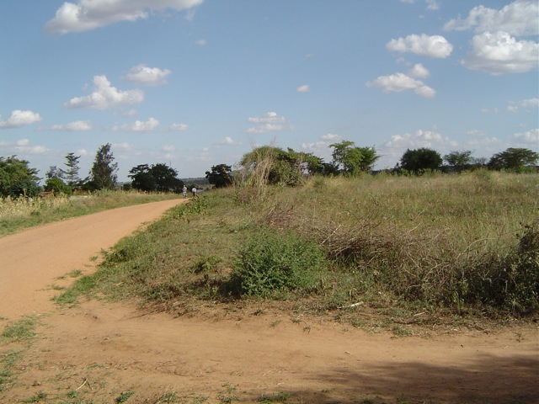

Site of the Kenya Connect Learning Resource Center
Wamunyu, Kenya

For more information on Kenya Connect visit www.kenyaconnect.org or contact Tim Gregory, kenyaconnect@comcast.net

