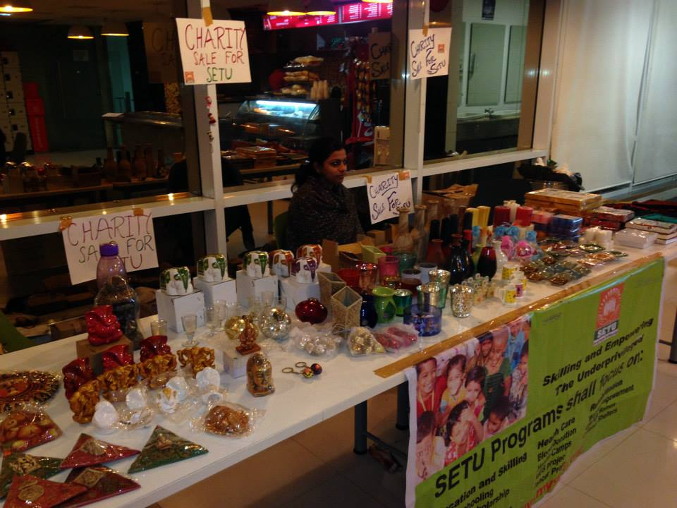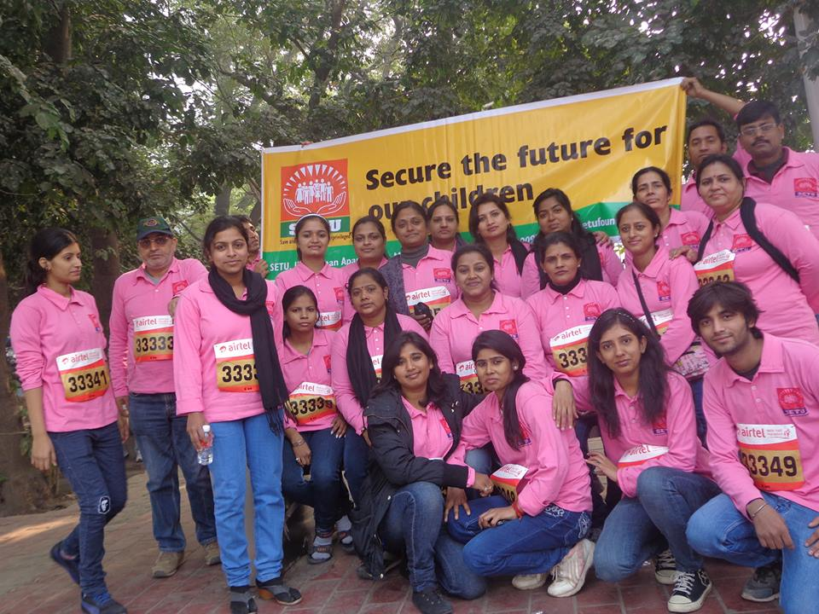

Sale for fund raising at DELL

SETU Staff at Marathon organised by Airtel.