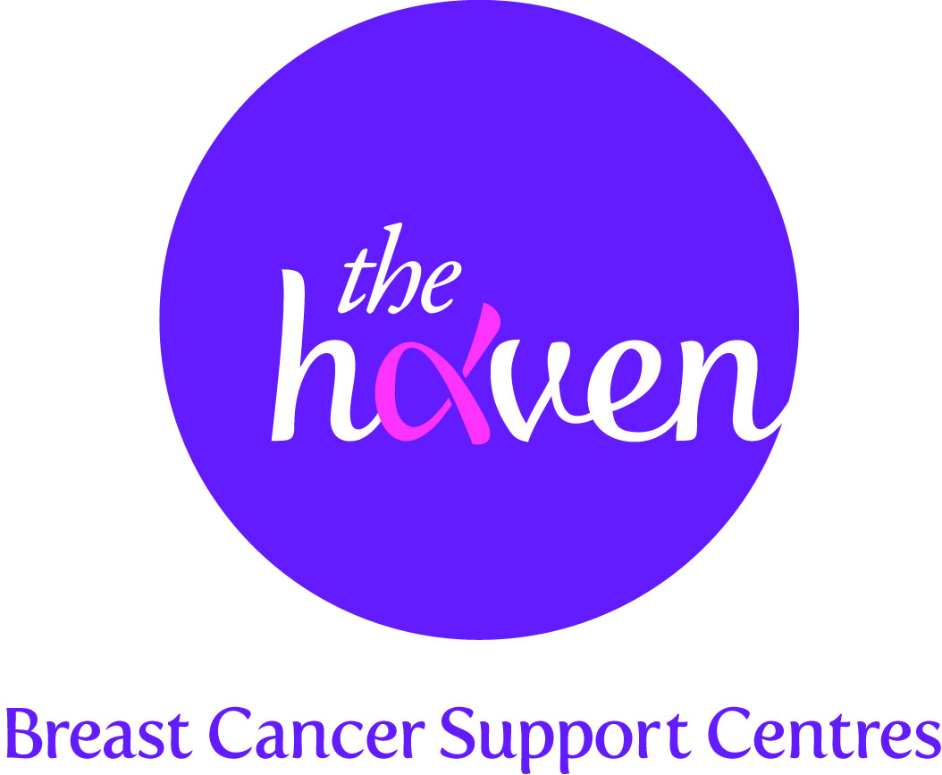
The Haven: Breast Cancer Support Centres

An update on recent activities, September 2013

- We are getting closer to opening our fourth centre
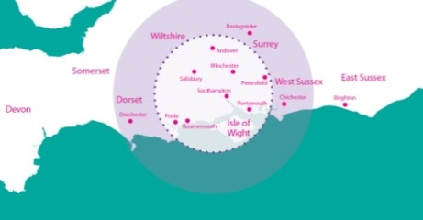
In April we announced our plans to open a new Haven centre in the Wessex region of England. This area, which encompasses Hampshire, parts of Berkshire, Dorset and Sussex, has one of the highest numbers of breast cancer diagnoses in the UK. There is currently very little support available in Wessex to help people face the challenges of this dreadful disease so there is a clear need for our unique support programme. We need £2.5m to reach our goal of opening a fourth Haven and we are delighted to report that we have already raised well over £550,000. It is hoped that the new centre will open towards the end of 2014.

- Business-men reach the summit of one of Europe’s highest peaks
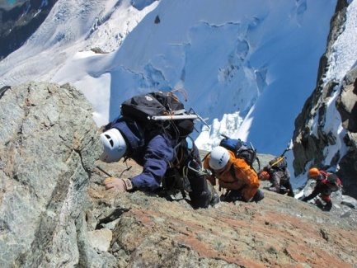
A lawyer, a banker, a consultant, two property experts, a financier and an IT specialist with a combined age of 350, have successfully climbed to the summit of the notorious Matterhorn in aid of The Haven in Wessex Appeal. Arguably one of the most challenging peaks in the region, the 4,478metre exposed ascent features a twelve hour rock climb and is notorious for claiming more lives per year than any other rock face in the Alps. The group had previously had very little mountaineering experience but trained hard as part of their preparations for the climb. They all made it to the top and managed to raise an incredible £155,000 towards the Appeal.

- Helping cancer patients know their employment rights
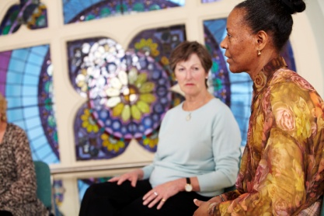
Getting a cancer diagnosis can have a huge financial impact as people face lengthy treatment programmes and debilitating side effects causing them to take extensive sick leave. The London Haven has introduced a new seminar designed to give patients confidence and reassurance by helping them work out their rights and protections. This includes advice and guidance on: entitlement to sick pay and annual leave, time off for medical appointments, changes to working conditions and rights to privacy and confidentiality.
.
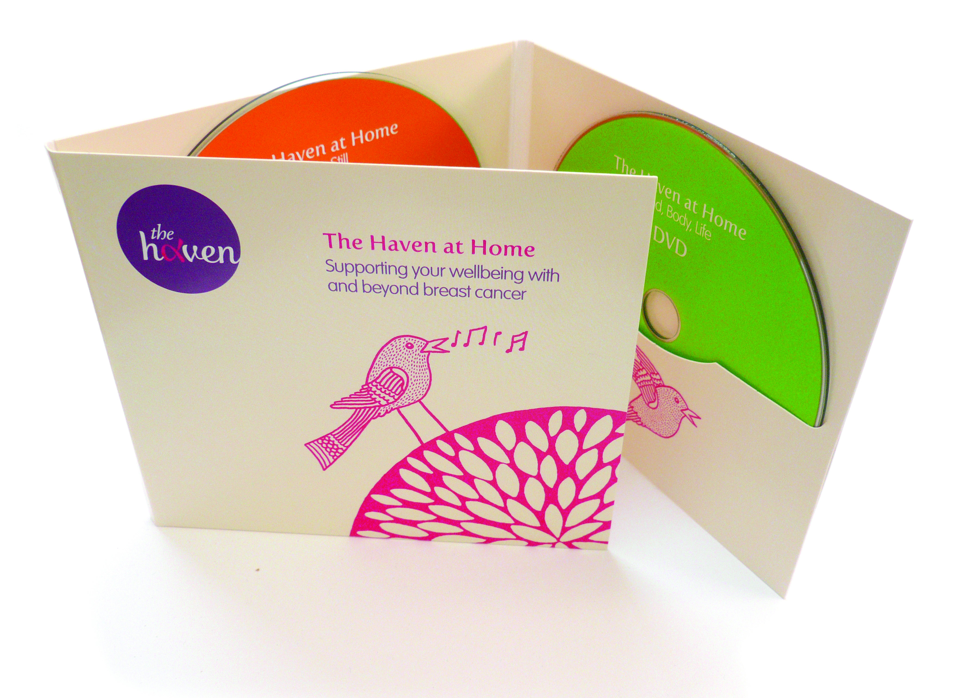
- A short film about The Haven
A short film about how The Haven has helped three women recover from breast cancer was made in time to be launched at the charity’s annual signature event, Blush Cabaret in April. The film tells the women’s individual stories about the impact of having a breast cancer diagnosis but also how The Haven has given them a more positive outlook through its programme of therapies and support classes. The film can be viewed here.

- A Visitor’s story, Maggie
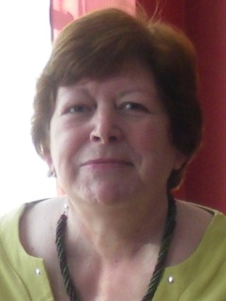
“I had an almost inevitable feeling about my diagnosis. I’d found a small and very painful lump which stopped me sleeping in my favourite position and I just knew it was cancer. I was in the middle of a really a really terrible family crisis and I just thought “Yes of course it’s cancer - just one more awful thing to deal with,” though in a strange way it did make me focus more on myself instead of the family problem.

I was dealing with a lot of emotional pain that had nothing to do with the cancer and I also have had ME for about seven years, so was feeling pretty stressed. I knew that stress would lower my ability to cope with treatment and recovery and with so much going on, I knew that I needed some strong emotional support.

I was seeing an NHS nutritionist who recommended The Haven. She said, “They have the fullest information for dealing with all areas of breast cancer care,” so the day after my first radiotherapy session I phoned and spoke to the Haven Programme Manager. At my first appointment we discussed what was available. I wanted to have aromatherapy which had been helping with my ME symptoms for a while and also nutritional advice. I also needed help with my emotional upset and stress.

The individual counselling sessions really helped to get to the roots of my emotional problems and have given me effective techniques for dealing with strong negative feelings and stress. Group sessions such as Emotional Freedom Technique and Mindfulness taught me how to quiet my mind when things are stressful. I feel more secure in my ability to choose the right nutrition to keep me healthy and the aromatherapy sessions were blissful and calming.

All the advice I was given helped greatly and it was all given with calm reassurance and empathy. The Haven is aptly named. It has been my lifeline for almost a year now and I know will continue to be there for me.”

