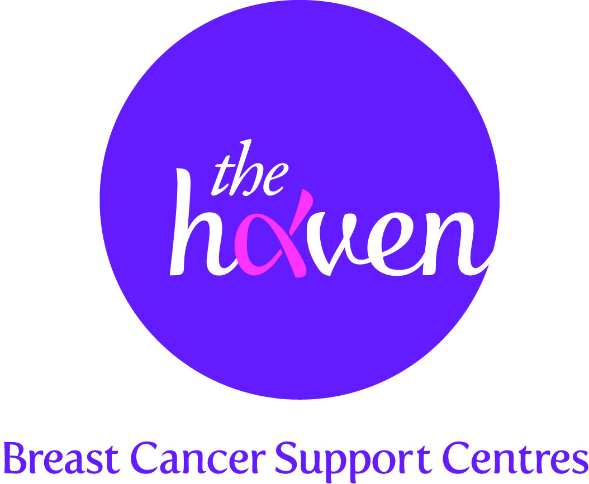
The Haven: Breast Cancer Support Centres

An update on recent activities, October 2014

- Breast Cancer Awareness Month
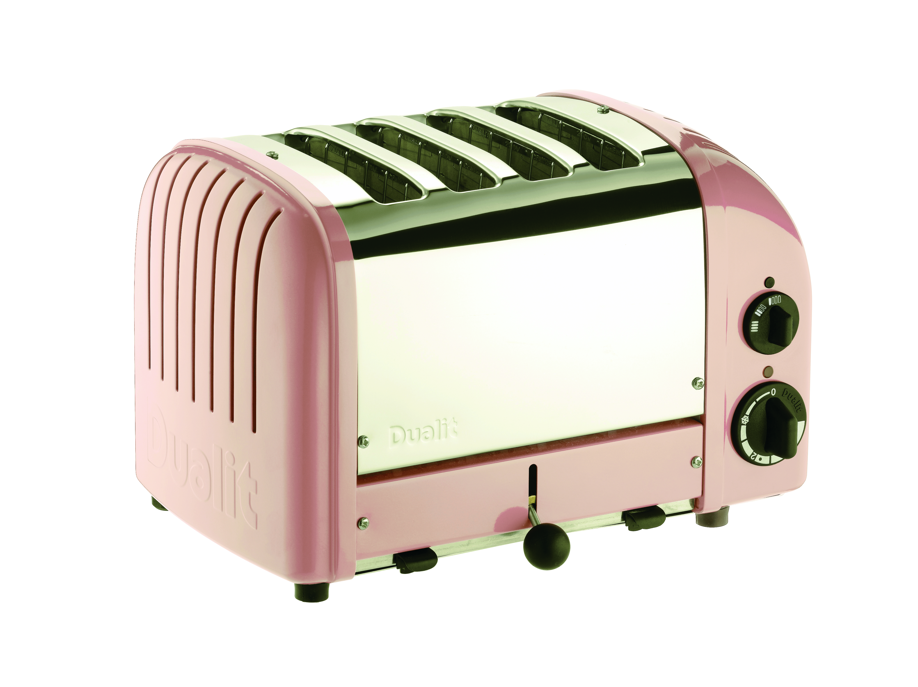
October marks Breast Cancer Awareness Month which is global campaign to raise awareness of breast cancer research and support. The Haven has more awareness and fundraising activities than ever throughout the month and there are so many ways people can get involved. We are delighted to be supported by several high street brands who are all donating a percentage from sales of special ‘pink’ products in October. These include a gorgeous collection of pink boots and slippers by UGG Australia and a special edition pale pink toaster by Dualit. See here all the products helping us this month.

- A new Haven for North and East London
With a new Haven poised to open in Hampshire next summer we are very excited to report that plans are in place to open a new Haven which will serve both North and East London. A £5m capital appeal has just been launched and will be led by breast cancer fundraising charity, Future Dreams, who has already raised well over £1.5m for research in to secondary breast cancer. We are expecting to achieve our target within five years.

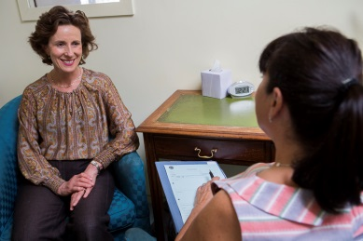
- Piloting a new Haven service delivery
The Haven currently runs its breast cancer support services from centres which are not located within hospitals. Many patients seek relief away from medical environments. However, we are always looking to innovate and experiment with new ways of providing services to as many people as possible. For the first time, The Haven will be running a pilot from next summer which will be a satellite service accessed from a new breast unit within a National Trust hospital. We will be providing a range of support and therapies on the busy clinic days at the unit.
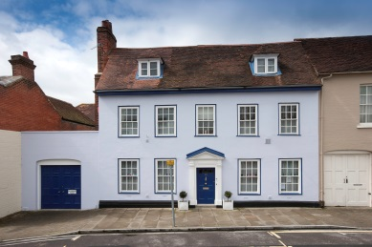
- The Haven in Wessex Appeal
We will soon be starting renovations on the stunning Grade II listed building which will be new Haven centre in Hampshire. We are delighted to have the support of top UK furniture brands, John Lewis and Furniture Village, who are donating lots of lovely products including a stunning new kitchen.

- The Haven at the Chelsea Flower Show
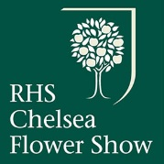
The Chelsea Flower Show is a great British institution and a very popular event for the Queen and the public at large. Next year, we are thrilled to be exhibiting a garden at the Show for the first time. We are honoured to have a Chelsea stalwart designer, with nine Gold Medals to her name already, creating an artisan garden that will encapsulate the essence of a Haven. A place of safety, tranquillity and beauty. The garden will then be transported to our new Haven in Hampshire where our Visitors will be able to enjoy it. We’re hopeful that, in the fiercely competitive environment that personifies Chelsea that we will be bag a Gold Medal. Watch this space.

- A Visitor’s story, Georgina
I was a project manager in the building trade for 20 years. It is a very high-pressured, male environment and on top of that I was still coping with the fall-out from my mother’s death from cancer.
Then I was diagnosed with breast cancer. The consultant said he didn’t know how far it had spread so they wanted me in the next day for surgery.

Everyone reacts differently to terrible news but I remember splitting into 2. One part of me left the planet and the other half went totally into practical mode. I detached myself emotionally from it – this thing was just not happening to me and I had to block it out. I told the consultant that I couldn’t go in for surgery immediately as I had 3 projects on the go with 26 men working for me and I had 3 days to sort out the work and back up. I was back working within 8 days and I worked the whole way through my radiotherapy. I very rarely even mentioned my illness to anyone. It was as if it hadn’t happened.

My world imploded 4 years later. I had come back from overseas and work dried up and so I floated for 6 months. There were days when I couldn’t even get out of bed. I was heading for a deep depression but didn’t even realise it at the time. I had buried my illness so deeply that it had started to affect my whole life – mentally, emotionally and physically. I was discovering that you just can’t bury a traumatic event like this without it having some kind of effect later down the line. Luckily for me a friend reminded me about The Haven and suggested I try Mindfulness.
I went along and something in me just clicked the minute I walked through the door. Throughout my illness I had been alone. I retreated into myself and wouldn’t let anyone near me. What I loved the most about The Haven was that I could just come in and sit and be. I didn’t feel bad about myself, I didn’t feel a failure. I could be honest and didn’t feel I was being judged. Here were people I could talk to about my feelings – something I had never done before as all my energies had been spent on just keeping it all together.

Because of coming here you could say that cancer saved my life. It forced me to stop the destructive life I was living. It took me 4 years to get to the stage of coming because I had been in denial for so long. They have helped me with my mental outlook. I had faced my own mortality and the fear that goes with it. It’s so difficult to talk about deep emotional and personal fears and this is where The Haven and its wide range of treatments and complementary therapies, was able to help me to start sorting things out for myself. The therapists are so friendly, professional and understand how the mind and body work together in people with breast cancer.
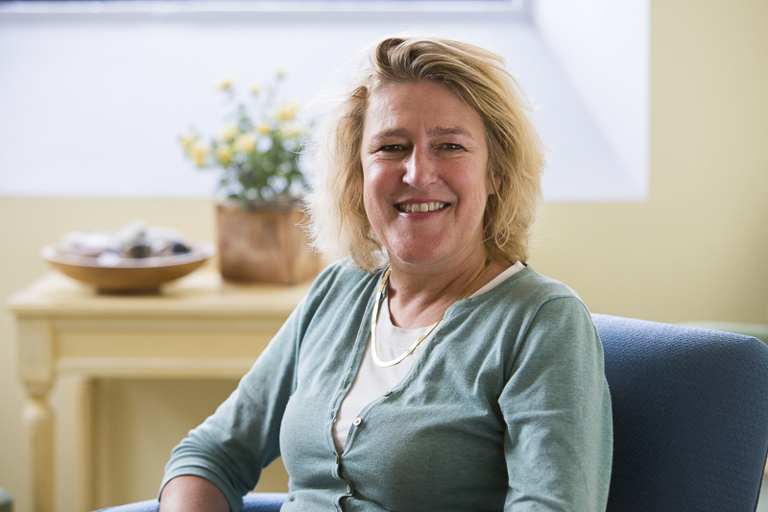
The Haven has had a life-changing effect on me. It has helped me to get out of the working trap and indirectly has given me the mental strength to sell my house, move out of London and start a new life in the country. I could not have done it without the support of the people here.

I felt I had lost control of everything but now I am taking care of myself, paying attention to my diet, exercising every day, something I hadn’t done for years and I’ve learnt that I mustn’t isolate myself. Every time I come here I leave with a smile on my face and lighter of heart.

