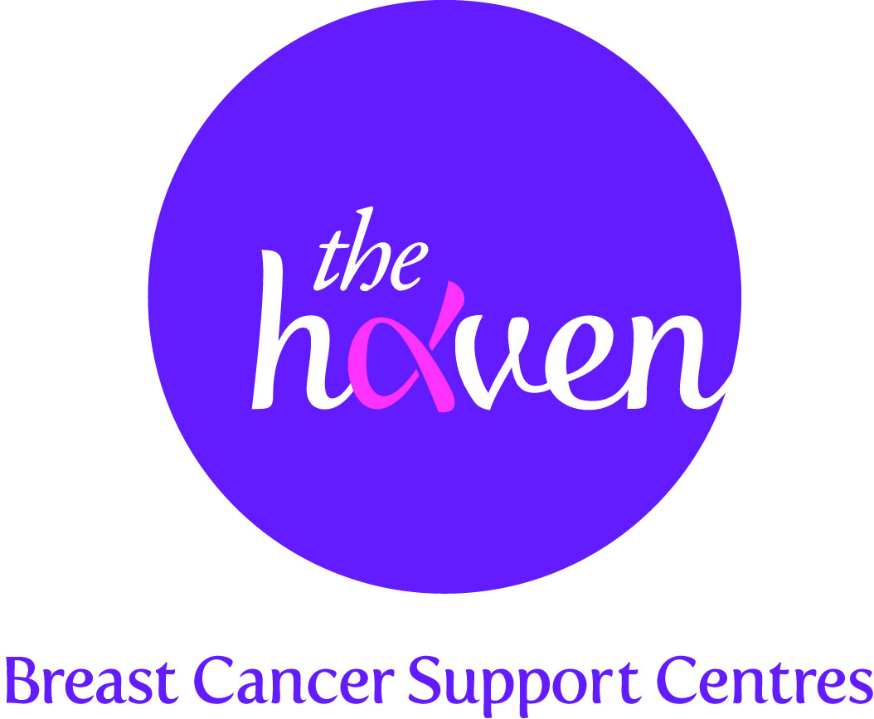
The Haven: Breast Cancer Support Centres

An update on recent activities, March 2012

One in eight women in the UK will be diagnosed with breast cancer at some point in her life. Our free programme of care can make such a difference to our Visitors’ health and wellbeing, and we are extremely grateful to all our supporters for helping us to care for women and their families affected by breast cancer.

- More free therapy sessions for our Visitors: We now provide ten free sessions of one-to-one treatment as part of our Haven programme. Our sincere thanks to Walk the Walk whose funding has made this possible. Team Haven is also gearing up for London’s MoonWalk in May.

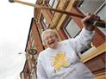
- London 2012: The Haven’s torchbearer, Moira Starkey

Our 84 year old fundraiser has been selected as an Olympic torchbearer due to her tireless fundraising. Moira, who uses two walking sticks, completed a full 26 mile marathon by taking 1,876 laps of her village hall over three months. Moira is preparing for her Olympic glory by walking another marathon.

- Partnership with Macmillan Cancer Support: We are delighted that Macmillan Cancer Support has awarded us funding for two new posts to be based at our Haven in London. This partnership will ensure that that people affected by cancer will have access to a wider range of support and services.

- Mindfulness-based stress reduction (MBSR) for women with breast cancer

The largest and most rigorous study of its kind investigating the impact of Mindfulness Based Stress Reduction (MBSR) on women with breast cancer has been published online by the prestigious Journal of Clinical Oncology. MBSR is a way of learning to relate directly to whatever is happening in life, and consciously and systematically working with stress, pain, illness and life’s challenges and demands.

Led by Dr Caroline Hoffman, The Haven’s Clinical and Research Director, the study results show statistically significant improvements in mood, anxiety, depression, anger, vigour, fatigue and confusion for women in the MBSR group compared to women in the control group, which indicates that MBSR could help thousands of women with breast cancer.
Visitor Lisa Hamilton Jones says: “For the first time in months I felt that a veil had lifted and that I was really living again. By the end of the course I had regained my positive attitude to life, I could cope with the stress I was under – I could control my anger, and although I still felt desperately upset at times, I could handle it. The eight weeks spent on the MBSR course were totally life-changing.”
- Visit by HRH The Countess of Wessex to our Haven in Yorkshire

It was our team in Yorkshire’s very great pleasure to welcome HRH The Countess of Wessex, The Haven’s Patron, to our beautiful Haven in Leeds city centre. The Countess took a tour of the building and spent time meeting and speaking to Visitors. The Countess said: “I’m completely and utterly devoted to The Haven. Thank you for everything you’re doing. Please keep doing it, because it is hugely appreciated.”

