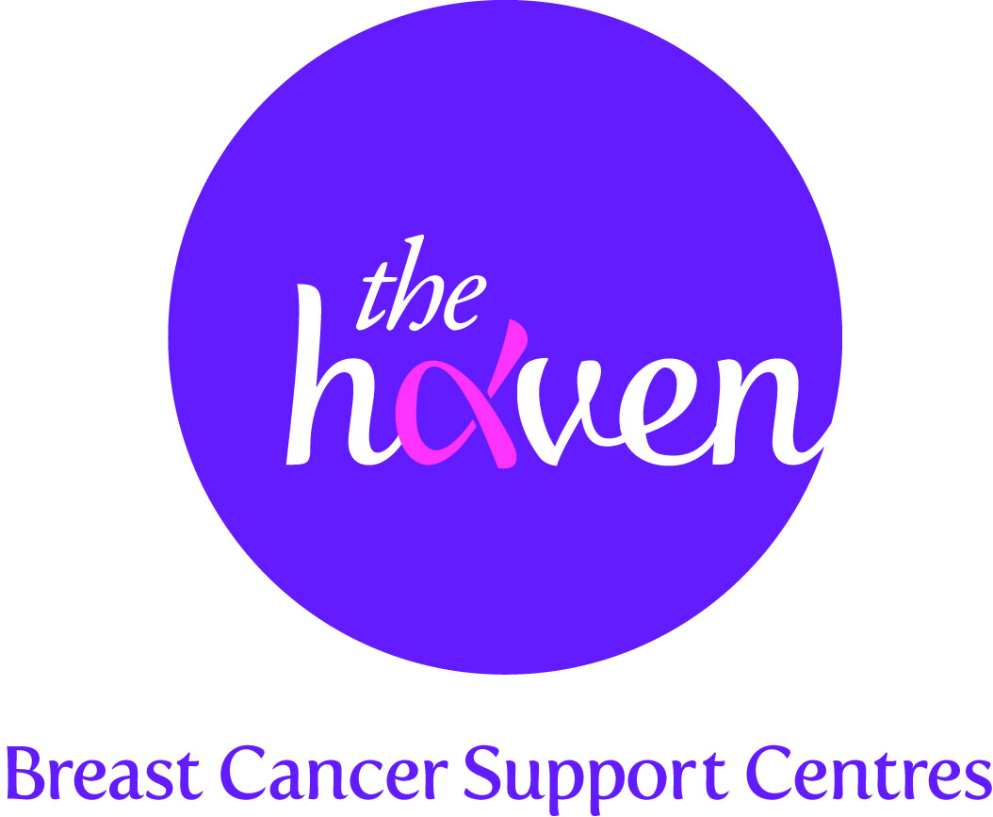
The Haven: Breast Cancer Support Centres

An update on recent activities, March 2014

- Major boost for the Haven in Wessex Appeal

We were delighted to announce at the end of February that we have purchased a beautiful period property in the picturesque village of Titchfield in Hampshire, which will eventually become our fourth Haven centre. With Wessex having one of the highest rates of breast cancer in the UK, the new centre will provide vital one-to-one support for the nearly 3,000 breast cancer patients in the region. Clare Morgan who visited the London Haven welcomed this news:
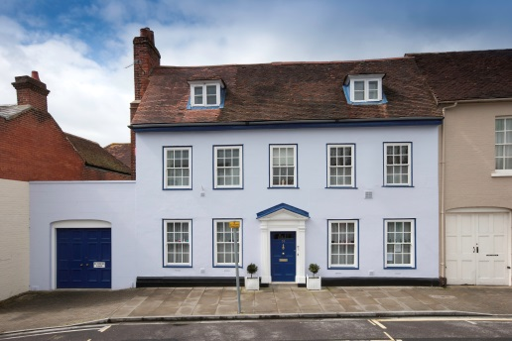
“The Haven was essential for me as it provided a safe tranquil environment, particularly after finishing treatment, where everyone understood exactly what you were going through. No one should have to travel far when they feel ill, let alone travelling into London from as far as Portsmouth during chemotherapy. The breast cancer patients of Wessex really need this essential one-to-one support centre closer to home.”
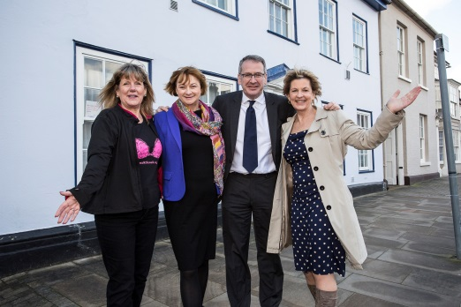
To cover the costs of purchasing, refurbishing, and converting the building into a Haven, as well as providing initial running costs for the first two years, the Haven in Wessex team has to hit the fundraising target of £2.5m. So far over £800,000 has been raised through a series of events, challenges, grants from trusts and foundations, and major donations. We hope to be able to open the new Haven in April 2015.

- The Haven in your kitchen
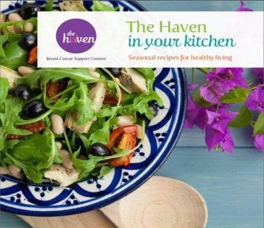
In January we launched a much awaited book, The Haven in your kitchen Seasonal recipes for healthy living. This new publication is a companion to The Haven’s Guide to Healthy Eating which we published in 2013. This latest Haven publication aims to educate and inspire breast cancer patients and their families to use food to develop a healthier lifestyle. We have received excellent feedback from Haven visitors and non-visitors alike who have all been amazed at how tasty healthy food can be. The new book has over 60 recipes based on the four seasons and packed full of beautiful photographs. The book is available from our website at a suggested donation of £10 ($16.50)

- An evening with Martin Clunes
Martin Clunes, the British actor best known for playing the title role in the hit comedy TV series Doc Martin, got behind The Haven in a fundraising event this month. The actor took part in an intimate, but frank, interview about his life and career in front of an audience of his fans and Haven supporters. An audience member asked Clunes “I’m sorry but I’ve been asked by one of your fans in America – what do you smell like?” The surprised star replied: “Nivea with a bit of Matey bubble bath at the weekends”. It was a terrific and fun evening and the charity hopes to raise thousands of pounds through an online auction which includes a walk-on part in the next series of Doc Martin.

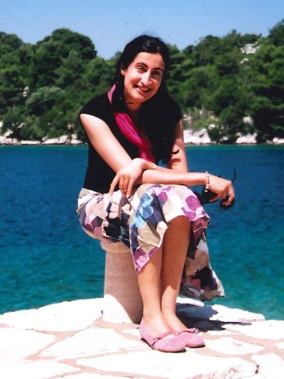

- A Visitor’s story, Mausumi, 44
I qualified as a doctor in 2005 and moved up to Yorkshire to work in Leeds and be nearer my parents. I was diagnosed in summer 2013. After a five hour appointment at the breast clinic I was told I had grade four breast cancer and that I was likely to need a mastectomy and chemotherapy. One of the problems of being a doctor yourself is that people assume you understand exactly what is going on and that you can take news about yourself as a medical professional rather than as a human being, which you can’t. It was a horrible experience and I was on my own which made it even worse. Fortunately, I did see the breast care nurse afterwards who was incredibly kind and supportive.

My first reaction was shock, and the initial fear that it was terminal. I wasn’t that familiar with breast cancer terminology and to me hearing “grade four breast cancer” was very scary. My second thought was more positive – I had no regrets. I had followed my passion for travel and had seen the world. As the news sank in, I started to worry about telling my family and friends. We had had a particularly tough year, losing a friend to lung cancer, and my father being diagnosed with prostate cancer. I wasn’t sure how they would take yet more bad news. The hardest person I had to tell was my Dad. I had to wait until after the Wimbledon semi-final so I didn’t ruin it for him, but when I told him, he was in tears. Nothing prepares you for having to break the news to everyone else. It’s awful and I found myself having to stay positive and console the person I had just broken the news to. I was surprisingly calm but also in a bit of a daze.

I had initially heard about the Haven at a doctor’s education evening and was so impressed that I took some information back to my medical colleagues, so when I was diagnosed I immediately got in touch. I needed something to get me through the treatment and help with the anxiety I was feeling.

I went to an introduction day where I found out about everything the Haven had to offer and it was good to meet other women there. I then had an initial consultation with Debbie. It was so helpful being able to talk things through with her and together we decided on my programme of support. I saw the nutritionist, and the medical herbalist who gave me some herbal medicine to help me get through my first few sessions of chemo. She was so kind and gave me great hope. I also had Reiki, which was amazing and deeply relaxing. I have also tried lots of the different groups and classes, including tai chi, yoga, belly dancing, a mindfulness course and the sing therapy group. It’s great to be able to come here. It provides a structure to my life at the moment and it is such a supportive environment to come in to. It feels like family, and it means so much to find that there are people who really care about you, and want to help you in whatever way they can.

You are treated very much as an individual at The Haven and the support is very flexible when your situation changes. I had a particularly difficult time between my fourth and fifth chemo session, when I was told that the cancer could have re-appeared. I became very anxious as the potential reality of my situation started to sink in. I saw Debbie again who saw that I needed some help with dealing with anxiety and preparing for the future. I went to a meditation group that very afternoon, and immediately felt much better. Thankfully there was no reoccurrence.

I’ve now finished treatment and am excited about the future. I want to work more closely with breast cancer patients, and get involved in using mindfulness when dealing with pain and illness. I can’t sing The Haven’s praises enough. You just enter this amazing, nurturing environment and feel supported. You can turn up looking however you like and there is no judgement, just complete empathy. It really has changed my life. Thank you so much.

