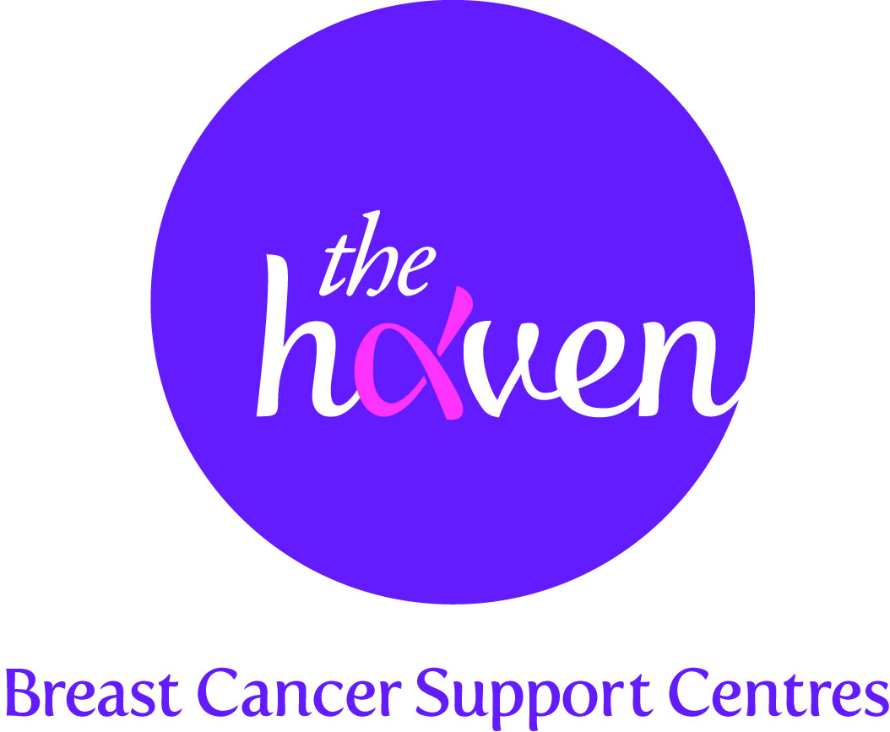
The Haven: Breast Cancer Support Centres

An update on recent activities, March 2013

- Helping more people through the trauma of breast cancer
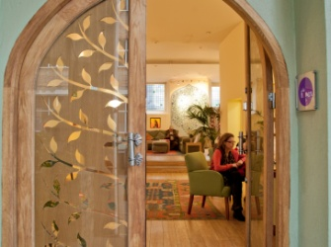
The Haven has seen well over 200 new Visitors across its centres since January. Breast cancer diagnosis has unfortunately risen in the UK over recent years. While it is great news that people are surviving longer with better treatments and earlier diagnoses, it does mean that there are more and more breast cancer patients out there that need our in-depth and personalised support. We are now embarking on an expansion programme so we can help more people and have already started raising funds for a new centre in the South of England. Watch this space.

- Surgery Monday, catwalk Sunday!
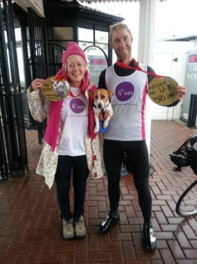
Our Yorkshire Haven organised an amazing fundraising event in early March which involved 18 of its Visitors as models for a fashion show at a top hotel in Leeds. The Blossom event celebrates breast cancer recovery and underlines how our help can get women back on track and re-build their self-confidence. Marie Phillips who has had a bilateral mastectomy bravely offered to model some swimwear and lingerie. She then discovered that the final part of her reconstructive surgery was due literally days before the show. She still went ahead and strutted her stuff on the catwalk! We salute you Marie.

- Mothering Bunday – making buns to raise funds
The people of Hereford will be going baking crazy for Mother’s Day in the UK which is on 10 March. To coincide with this day when we celebrate and reflect on motherhood, our Hereford Haven is encouraging people to get baking buns and other tasty treats to raise funds for The Haven under the campaign banner Mothering Bunday. The idea has already captured the imagination of the local population with an ever growing social media presence. Please like them on Facebook

- Helping breast cancer patients with their weight

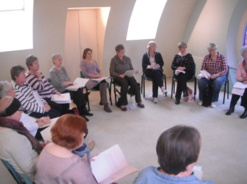
The Haven in London introduced a new class after Christmas due to a growing need. One of the side effects of breast cancer treatment is weight gain and once that treatment is over people find it hard to shed those pounds. Our nutritional therapist introduced a new weight management class in January taking place weekly, offering helpful tips, tailored advice and recipes. It has proved to be very popular with our Visitors who are now well on their way to achieving a healthier weight.

- A Visitor’s story, Hannah Rains, 26, London

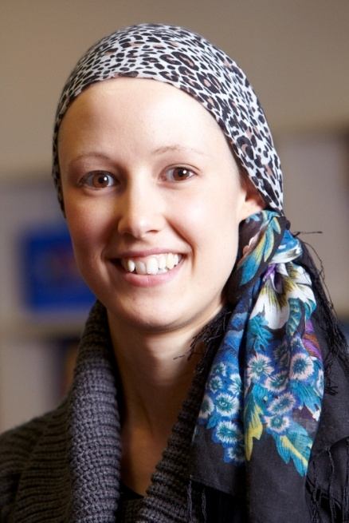
I was originally misdiagnosed at 22 years old, so I had been living with a cancerous tumour inside me for nearly two years. Knowing only a little about cancer and its progression I was sure that it would have spread to other areas of my body but tests and scans later showed that fortunately this was not the case, although it had spread to my lymph nodes.

All of my initial concerns and worries were surrounding my late diagnosis. Once I had CT, bone and MRI scans that showed the cancer had remained local, I began to focus on the surgery and treatment ahead. I decided to move back to my hometown of Leeds for my treatment which meant moving away from my boyfriend of six years who was studying for a degree at the time. Emotionally I started to struggle and physically I was suffering from fatigue, difficulty sleeping and anxiety.

I went to The Haven in Leeds who put together a programme of support for me. It included Shiatsu massage and reflexology which both helped hugely with the physical symptoms and helped me to relax. Just getting out of the house and having somewhere to go at a time when I was at risk of infection was good for me. The Younger Women’s support group was really helpful and beneficial. Although I was still quite a bit younger than the other Visitors, it was so good to meet other people in a similar situation, who understood what I was dealing with. We always stayed after the group to enjoy a healthy lunch at The Haven and continue our chat. I’m still good friends with some of the women I met there.

I am now living back in Newcastle and have returned to work as a Physiotherapist and finished my course of herceptin in June 2012. I recently passed the one year mark of taking tamoxifen – only four to go! The Haven is a wonderful, relaxing and welcoming place to go at any point before or after treatment. Everybody that I met was so friendly and supportive and I can’t thank them enough for helping me through the toughest part of my life.

