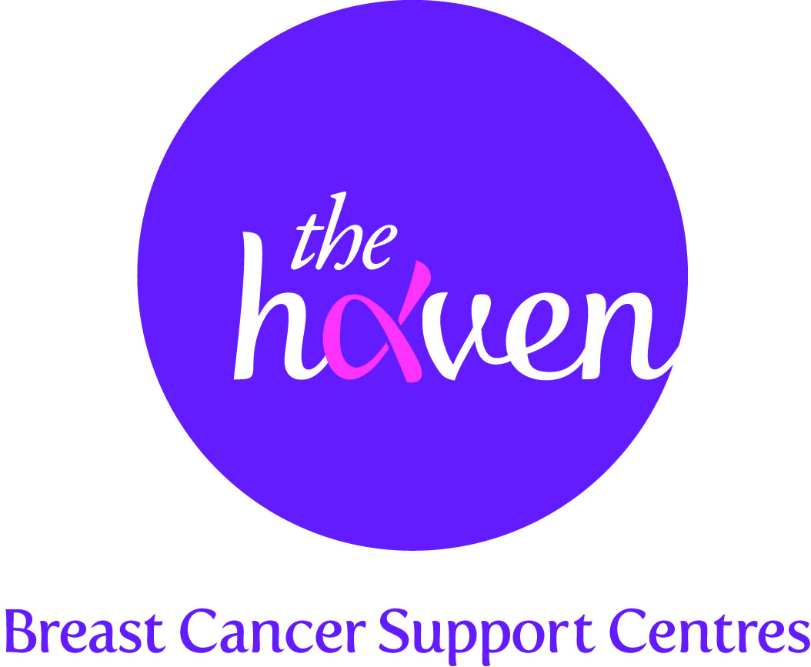
The Haven: Breast Cancer Support Centres

An update on recent activities, June 2013

- The Haven has now helped over 10,000 people with breast cancer
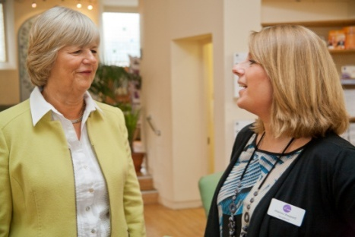
In April we recorded our 10,000th Visitor at The Haven since the charity established in 2000. Our celebrity ambassador Kimberley Walsh, said: “I experienced at first-hand just how vital The Haven’s support was when they were able to help a dear friend of mine. I am glad to say that my friend is now cancer-free and is living a full and active life. More and more people need to know about this amazing charity which offers such an important life-line to people who need emotional and physical help at such a traumatic time of their lives.”

- Fight cancer by getting fit
There is growing evidence from research studies suggesting that physical activity can reduce the impact of cancer symptoms, the side-effects from treatment and in many cases reduce the risk of cancer returning, improving long-term survival. UK charity Macmillan Cancer Care recently published a report which underlines the importance of physical exercise. In response to this The Haven has introduced a new class at its London centre which is a gentle introduction to getting fit and keeping fit through a combination of cardio-vascular exercise and strength training.

- Why The Haven is needed
We know that a growing need exists across the UK for the specialised help we give; sadly, the rate of incidences of breast cancer is increasing. Statistics released earlier this year showed that in 2010 almost 50,000 women were diagnosed with invasive breast cancer, which equates to 136 women per day. Recent figures have also shown that the number of younger women diagnosed with breast cancer now totals more than 10,000 a year, an unprecedented development. While many women with breast cancer now have a more positive prognosis than ever before, we must be sure that each and every one gets the support she needs so that both she and her family can cope with the tremendous impact of this disease.

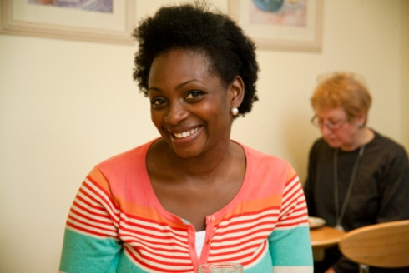
- New Haven services reach more people with cancer
Our new partnership with Macmillan Cancer Support has proved very popular in meeting the needs not only of our Visitors but also of patients with any type of cancer. Macmillan have provided a substantial grant towards two new posts in our Haven in London: an Information and Support Manager, to liaise with medical and community networks, to increase healthcare and patient awareness of our free services; and a Welfare Benefits and Money Management Adviser, to provide information and advice for Visitors and others with cancer on issues such as entitlement to state benefits and welfare provision. To date these new posts have supported 246 different Visitors by providing specialist advice services. Having to cope with breast cancer and all that comes with it is hard enough for anyone, but for those who are struggling on a very limited income it can seem overwhelming. This new service provision can make all the difference.
- Comedy helps raise funds for The Haven
An evening of comedy and cabaret raised a massive £80,000 ($121,556) for The Haven. The charity's signature event, Blush Cabaret, now in its tenth year took place at the intimate Cafe de Paris in the heart of London's West End. After a three-course dinner and live auction, well known comedians and cabaret artists performed for free.

- A Visitor’s story, Pat Williams, Hereford
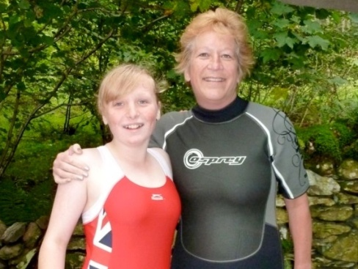
When I felt a small lump in my right breast the size of a pea I didn’t react too quickly because I couldn’t always feel it. With the benefit of hindsight I wish I had. When the hospital confirmed that it was cancerous, panic set in. I just couldn’t believe it was happening to me. I always felt well and was never ill. I remember going to bed that night and crying to my husband Pete that I didn’t want to die and leave him and my daughter, Victoria who was just eleven. Later, Pete emailed our friends but I just felt numb and I couldn’t talk to anyone.

Our main concern was for Victoria. Should we tell her, how would she react? We decided to tell her and answered all her questions as honestly as we could but without scaring her. She asked if I was going to die and if she would catch it - to which of course our answers were ‘no’.

When I spoke to my breast care nurse and doctor I started to feel a bit better but my first set-back came when I went in for a mastectomy and they found that the cancer had spread to my liver and spleen. As the realisation that I had secondary cancer dawned, I once again felt scared and numb. We decided not to tell Victoria about this latest blow.

During six months of chemo I felt very ill. I suffered with sickness, mouth thrush, constipation and diarrhoea. I felt spaced out and had no sense of taste. I was so tired that I needed an hour’s sleep most afternoons just to get me through the day. I felt desperate, depressed and couldn’t look at anything positively. Despite my supportive family and friends I felt very alone and my outlook on life was very bleak. I was emotional all the time and just couldn’t talk to anyone about it. One Sunday, having dinner at a friend’s, Pete read an article about The Haven in the Worcester County Magazine. The next day he phoned up and booked me in and I’ve never looked back.

At the introduction day I just cried for most of the day. I could barely talk to anyone but one conversation I do remember was with Jan, the breast care nurse who said: “Try to look at having chemo differently. It may not have got rid of the cancer as you were hoping, but it has stopped it from spreading.” Such a simple line but true. It turned my life around and I started to think about things more positively from that point on.

After the introduction day I was given my free programme of therapies at The Haven. Acupuncture helped with nerve problems in my hands and also arthritis in my knees for which my knee surgery had been put on hold. Acupuncture kept the swelling down and with an aid of a stick, I am still mobile. I saw the nutritional therapist who helped me to change my diet by reducing my dairy and sugar intake and the medical herbalist suggested milk thistle which helps the liver to function. I have also had reflexology and shiatsu, Tai Chi and counselling, which has been invaluable.

More setbacks came when cancer spread to my pelvis then lungs and more recently my bowel. We decided to tell Victoria and she is coping very well. Once a month I come to the secondary breast cancer support group. It is totally invaluable and helps tremendously. The ladies who attend this group are amazing and give me hope. They are so supportive and fun to be with. They listen, advise and encourage and are a total life-line – one that I wouldn’t have without The Haven.
Three years on, I feel optimistic about the future. My lung cancer has cleared, my pelvic cancer is reducing and my liver and spleen are stable. I’m a naturally positive person but I still have off days and get scared - I don’t think that ever goes away. I make the most of every minute of being with Pete and Victoria, and if an opportunity comes our way, we take it. I have had the most amazing support. My family and friends are so strong and supportive and the people at The Haven are wonderful too – really encouraging and no matter how you feel they can empathise. They help get me through each day.

