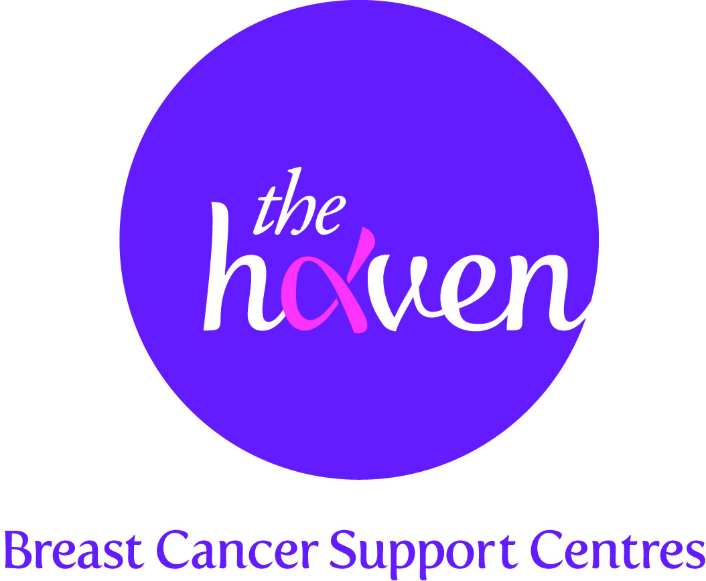
The Haven: Breast Cancer Support Centres

An update on recent activities, January 2014

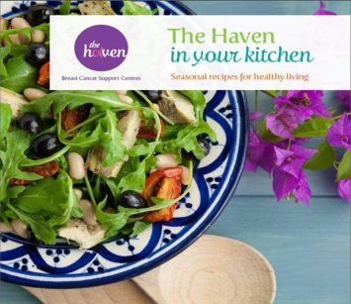
- The Haven in your kitchen
Later this month we will be publishing a much awaited book, The Haven in your kitchen Seasonal recipes for healthy living. This new publication is a companion to The Haven’s Guide to Healthy Eating which we published in 2013. It is our hope that both these books will help educate and inspire breast cancer patients to use food to develop a healthier lifestyle. The charity’s nutritional therapists have chosen healthy recipes that have been particularly popular with our Visitors for people to try at home. The new book, which will have over 60 recipes based on the four seasons and packed full of beautiful photographs, will be available to order from our website from the end of January.

- Opening up our service to help more people
From February, the London Haven will be trialling a new service which will enable more people to access our programme. Up until now our service has only been available during office hours, Monday to Friday, but thanks to funding from a trust we will now be able to open one evening a week, offering help to those patients that are unable to access our service during working hours. The trial will run until the end of July and if we see a good take-up of the evening opening we will aim to roll this out across all our Havens.
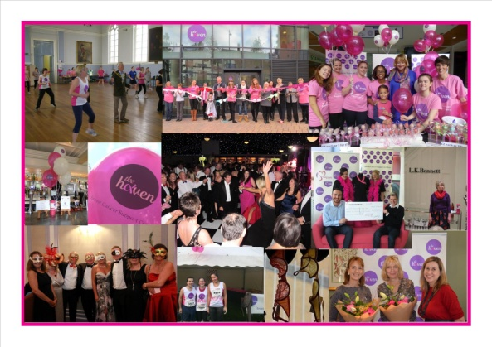

- Breast Cancer Awareness Month boosts awareness and funding
Throughout October The Haven ran a series of awareness and fundraising events under the campaign banner Breast Cancer Awareness Month. Each Haven had a packed programme of activity involving the local community, our Visitors and our corporate supporters to help boost awareness of our unique support service and raise vital funds for the charity. We were delighted to have raised nearly £170,000 during the month from this activity.

- The Haven in Wessex Appeal
The appeal finished 2013 on a high with a stunning carol concert held in the prestigious and historic chapel at Winchester College. The beautiful candle-lit service included readings from several celebrities including Julian Fellowes, the creator of the hit TV series Downton Abbey. So far the Appeal has raised £800,000 which has made a substantial dent in the £2.5 million target to open a new centre in Wessex.

- A Visitor’s story, CJ
I was pretty proactive with screening because my maternal aunt had breast cancer, but when I asked my radiographer “what do you think” and his sharp intake of breath confirmed the worst, I was totally unprepared for the complete shock I felt. Our adopted boys were then 8 and 11 and my first thought was that I didn’t want to die and abandon the boys – they had already had the upheaval of adoption in their young lives – I couldn’t do it to them again.
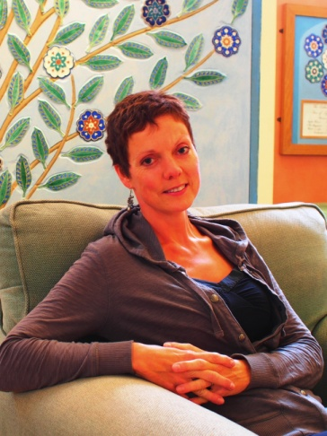
Following the initial shock and fear I became strangely calm. I didn’t want the boys to suspect that anything was at all wrong. They needed stability in their lives so until we knew what we were dealing with, I wanted to keep things as normal as possible for them. I got on with telling my close friends and waiting for my treatment. I had a lumpectomy, six cycles of chemotherapy and radiotherapy. The cumulative effect of all this made me feel awful. Chemo leaves you very vulnerable to any infections and although I looked after myself and stayed away from lots of people, I just could not miss my sons’ Christmas concerts, so I took the risk and sure enough I caught a cold which put me in hospital for five days.
I picked up a leaflet about The Haven at hospital when I was first diagnosed. I was keen to try anything that might help, so I came in and met the nurse specialist who discussed what support might be most beneficial for me. I spoke to the nutritional therapist who analysed my diet and suggested practical ways that I could improve it; maintain a good weight and even out the peaks and dips in my energy levels. I also had acupuncture which helped to increase my white blood cell count so that I could stay on schedule with my chemotherapy appointments. Keeping to schedule was really important to us as a family because changes to the plan were very unsettling for the boys. I also knew that I needed some help in managing stress on a long term basis and this is where mindfulness based stress reduction (MBSR) really helped. I went to a class and could see how it would be really useful so I signed up for the Haven course to learn more and I can now practice it at home and it has become a part of my life.

Coming to The Haven has been very good for me. Even just coming in for lunch, to read some books and have a chat with some of the other women going through the same thing is very restorative. You don’t have to explain your situation to everyone – they all just understand.

