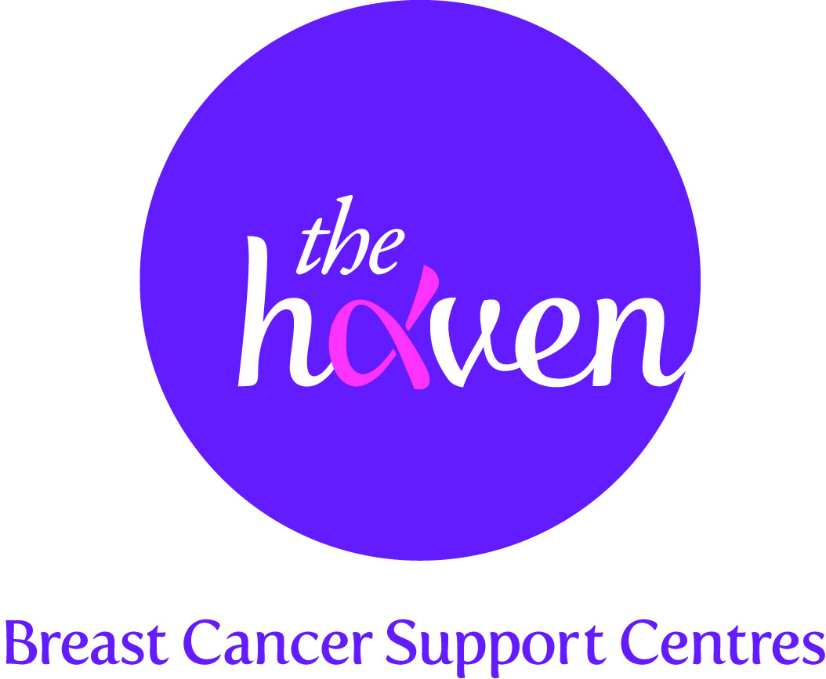
The Haven: Breast Cancer Support Centres

An update on recent activities, February 2015
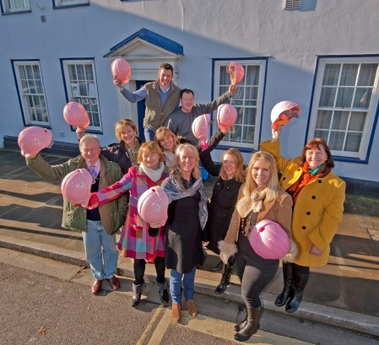
- Hats off to the new Haven!
In January, a team of builders, donning pink hard hats, started the renovations for the new Haven centre on England’s South Coast otherwise known as ‘Wessex’. The work to the beautiful 18th century building will take around six months to complete and we look to open this new breast cancer support centre in October 2015. Once open the centre will be able to cater for breast cancer patients located around the cities of Southampton and Portsmouth and beyond.

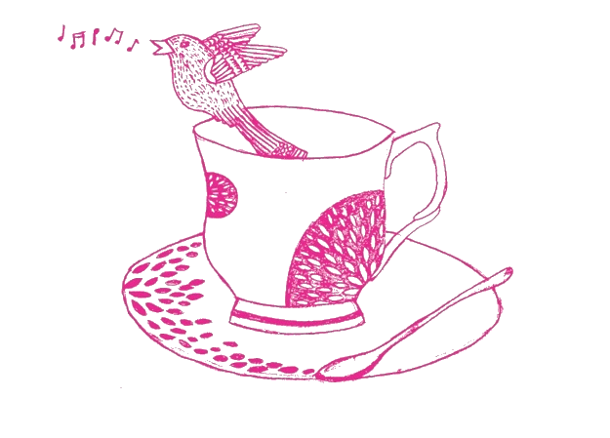
- Tea party craze raising money for new Wessex Haven
Teams of supporters across the South of England have been raising several thousands of pounds for the new Haven centre by organising tea parties. Dubbed the Million Pound Tea Party, hundreds of people from all walks of life have been getting out their best china, baking cakes and inviting their friends for tea, fundraising for the appeal in the process. We are hoping to raise around £50, 000 from this campaign.

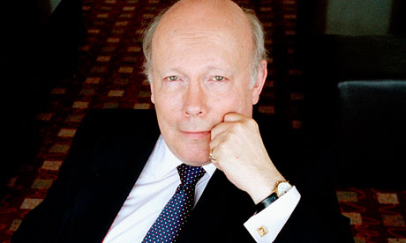
- All you want to know about Downton Abbey
Lord Fellowes, the creator of the globally popular period drama, Downton Abbey, will be hosting an exclusive lunch for supporters of the Wessex Haven appeal next month. The lunch and a talk will be themed around the TV series and guests will also have the opportunity to ask questions about Lord Fellowes’ life in film and television. Any money raised from ticket sales and an auction will go towards the new Wessex Haven appeal.

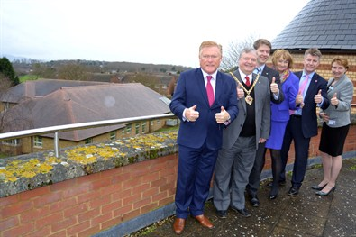
- Testing a new service model
It has just been announced that we will be working in partnership with an NHS (National Health Service) hospital in the city of Worcester to test a new Haven service model. For the first time, we will be offering a satellite service from the premises of a brand new, state of the art breast unit in the grounds of the hospital. All Haven services have been available from our stand alone centres since we established in 2000. Having high quality clinical and holistic care under one roof will be the first of its kind in England and if the model is successful we could be looking at replicating the service at other NHS sites across the country.

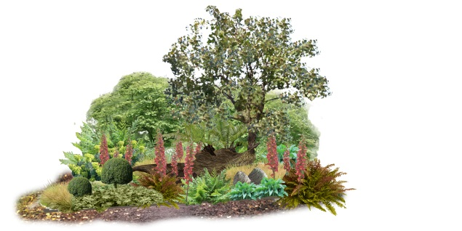
- Making a garden into a ‘haven’
Plans are coming on well for the charity’s garden – Breast Cancer Haven – for the highly popular British institution, the Royal Horticultural Society’s annual Chelsea Flower Show. The designers, Sarah Eberle and Tom Hare, now have a clear vision of the artisan garden will look. It will attempt to catch the essence of a Haven centre where people feel safe, relaxed and inspired. The show will run from 19 – 23 May and The Haven will hope to scoop one of the coveted awards.

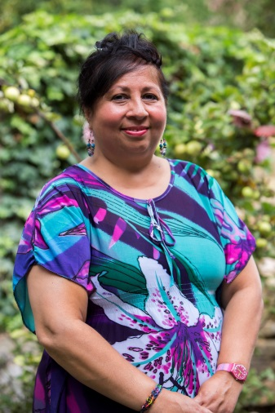
- A Visitor’s story, Kalpana

“If it hadn’t been for The Haven, I couldn’t have retained my fighting spirit or sanity”
I have worked in many roles from hotel receptionist to sales and market research and in 2008 I was working for TFL when I went for my NHS breast screening. They discovered I had a lump in my left breast which after further investigation was diagnosed as a stage 2, grade 3 tumour. When discussing my treatment plan with the consultant, we agreed that I would have a lumpectomy and radiotherapy but I felt I couldn’t go down the chemotherapy route as I thought it would be too much to cope with, whilst caring part-time for my unwell and disabled Mum.

I was preparing to get back to work in September 2013 when I was called back for a routine check-up. It was Breast Cancer Awareness Month and a Breast Care Specialist nurse noticed swelling on my neck. I had just thought it was excess fat but the nurse was not happy and organised a biopsy for the next day. After further scans the news was not good, the cancer had returned and now I had metastases in my lung, liver, skull, right shoulder, and left leg and at the base of my spine.

A support nurse at St. Thomas’ Dimbleby Cancer Care asked me if I had tried The Haven. So I investigated and immediately found The Haven an uplifting environment and the sessions go hand in hand with my medical treatment. I have found the acupuncture and reflexology sessions have really helped and the meditation workshop was particularly useful. I like the way The Haven gives you the opportunity to meet other people including therapists, staff and visitors.

At the moment I feel in limbo as I have consented to an 18 week trial of chemotherapy, to keep my tumours in my liver under control. I don’t know how long I have left but I don’t feel hopeless about the future, the Herceptin I am taking has shrunk my tumours and given me time to regroup. I am very grateful for The Haven, it is such a welcoming environment and they have time for you, which they often don’t have at hospitals. I appreciate the way in which The Haven recognises the benefits of the integrative approach and through their sessions like meditation and yoga, aim to support your body and mind together.

After the shock of cancer returning, it was comforting to come here. It’s a sanctuary for me where I can meet others going through the same thing. If it hadn’t been for The Haven, I don’t think I would have retained my fighting spirit or sanity.

