Jaia’s Story

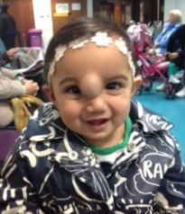
My name is Jaia, I am now 11 months old. On Friday 20th December 2013 Professor Iain Hutchinson carried out surgery to remove a haemangioma on the bridge of my nose.
When I was around 6 weeks old I have had many appointments with local hospitals and a specialist surgeon who dismissed any further investigation or treatment, advising that I should be monitored till the age of 10 even though my vision was being affected, my facial features started to become disfigured and it was radiating a lot of heat.
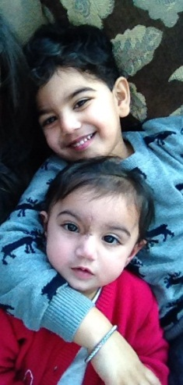
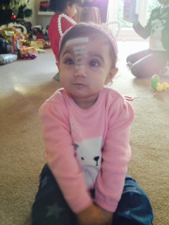
My Mummy’s friend from work suggested that we contact Saving Faces which we did. Professor Hutchinson met with us and diagnosed the tumour as a haemangioma , although the tumour was benign a MRI scan was needed to investigate further and this was arranged at a local hospital.
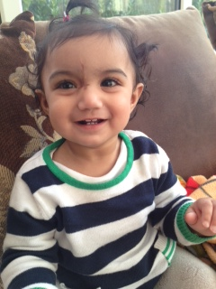
Following the results of the MRI scan Professor Hutchinson advised the best route of action was for surgery, which after a lot of heartache for my Mummy and Daddy it was decided this was the best thing to do.
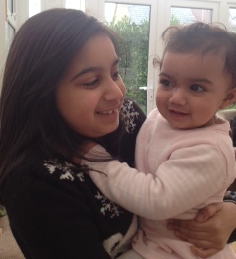
My operation was carried out successfully at St Bartholomew Hospital and after a big kiss from The Professor, I was up and about a few hours later and back home the following evening in time for my 1st Christmas.
Look at me now! My scar is healing fantastically and my facial features are back to normal. I am enjoying a full life and I am having lots of fun with my family especially my older sister Jasmine and brother Jayden.
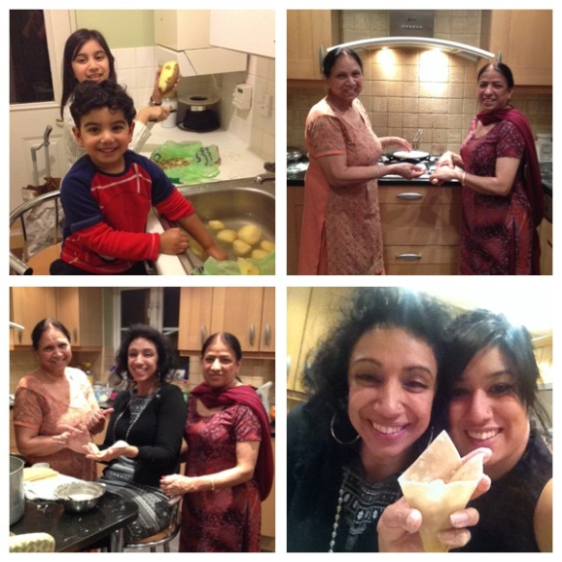
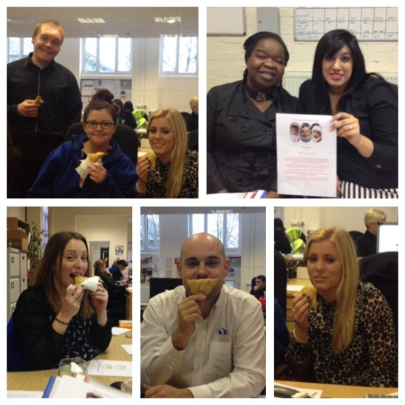
We are now fundraising to raise money for this fantastic charity and help support Professor Iain Hutchinson and his team carry on his amazing work, without him I don’t know where I would be today. My family have got together, they have been making samosa’s and cakes to raise money, we have raised over £1000 so far! In June this year, my Mummy, Daddy, Aunt, Uncle and Friends will be participating in The 5k Colour run for Saving Faces in London.

