PROJECT TITLE: EDUCATE 200 WAR AND HIV/AIDS ORPHANED UGANDAN GIRLS
PROJECT WEBSITE: http://www.globalgiving.org/projects/aids-education-uganda/
LOCATION: LIRA DISTRICT, NORTHERN UGANDA
REPORT PERIOD: QUARTERLY REPORT FOR MONTHS JULY, AUGUST AND SEPTEMBER 2013.
COMPILED BY SUSAN EJANG – PROGRAM ASSISTANT LIRA

INTRODUCTION
Platform for labour Action is supporting 27 girls with school lunch, scholastic materials and physiological support in all aspects of their lives, this with support from Global Giving. The beneficiaries go to government owned schools whose funding for school fees mainly comes from the Ugandan government, the schools that the girls go include: Elia Olet primary school, Lira Modern primary school, Lira police primary school, Lira primary school, Ojwina primary school, Starch Factory primary school, Lango Quran primary school, King James primary school, Railways primary school, Adyel primary school, Canon Lawrence primary school, Lira Parents’ primary school and Sir Samuel Joe nursery and primary school and secondary schools of Dara Christian high school, Savior secondary school and St Mary’s girls secondary school Aboke.
This project has made a difference in the lives of so many girls in northern Uganda with access to education that has in turn built their self-esteem through their continuous counseling from Platform for Labour Action.
In this quarter of July, August and September 2013, there were various activities that were carried out in the project as noted below.
MONITORING VISITS
10 monitoring visits were made to PLA beneficiaries, the School visited were inclusive of Sir Samuel Nursery and primary school, Railways primary school, Lango Quran primary school, Lira police primary school, Saviors senior secondary primary, Adyel primary school, Lira modern primary school, Lira police primary school, Lira primary school and Starch Factory Primary school.
The purpose for these visits was to ensure that the beneficiaries’ problems affecting their performances are discussed and forwarded to PLA office for solution.
During the visits, the beneficiaries were talked to on a one on one basis while sharing their experience about life at and out of school and how they felt since PLA started supporting them.
COUNSELING

All the beneficiaries that were talked to got counseling from the organization, some of the beneficiaries were able to share personal issues while the majority had mainly challenges at school psychological support was therefore provided to those children who seem to decline in performance to help them realize the importance of education and thus improve on their performances.

The teachers were too involved in the discussion to work together with PLA staff to ensure the improvement of the beneficiaries in both school and class work. The beneficiaries in schools also discussed their performances and came to better conclusion that they will seek help from their teachers and hold group discussions to help improve on their performances.

AMODO SANDRA’ STORY

14 years old Sandra never got to know her parents and is currently being supported by Mrs. Betty Etuku who stays with her in Ojwina division. Mrs Betty took on the responsibility of taking care of Sandra after her grandmother Awili Angellina passed on in 2008.

Sandra has no knowledge about her parents’ as they all died when she really a young girl, even her grandmother who could have shared this with her unfortunately passed away without letting her know about her late parents

“My grandmother never talked a lot about my parents to me expect, that they died HIV/AIDS,” sadly mentions Sandra.

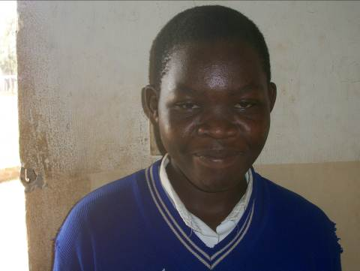
Above is a face picture of PLA beneficiary Sandra Amodo

According to Sandra, she has only known her late grandmother for the most part of her years as she lost both her parent to HIV/AIDS when she was hardly a year old.
“My grandmother was the only person that I ever knew,” responded Sandra.

In the care of Etuku Wilson, Sandra has been given a room in which she can sleep in outside the main house. According to Sandra, Uncle Wilson treats her like his own daughter though due to limitation of money, he is unable to afford her education.

“I am given food while at home though at times when uncle’s wife is around, she gives me a lot of work that makes me sleep late at night without revising my books,” explained Sandra.

With support from Platform for Labour Action, Sandra is now a candidate at Lira primary school and she will be seating her primary leaving examinations this November 2013.

From PLA Sandra is being supported with scholastic materials, school lunch and counseling, these have helped her concentrate in her studies with hope of becoming a better person in future.

“I want to become a doctor,” Sandra continued to mention that with the support she is currently getting from PLA, she hopes to study hard so that she is able to attain her dream of becoming a doctor.

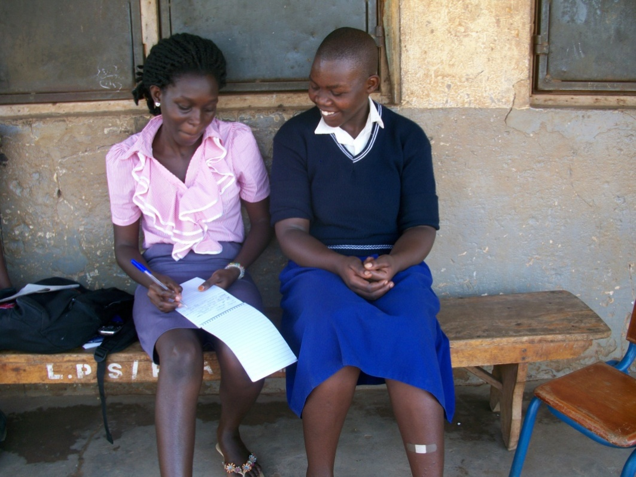
Picture showing PLA beneficiary Amodo Sandra as she discusses some of her future dreams with PLA Student intern Adul Christine during the school monitoring visit at Lira Primary School

“I love studying because I believe that, that is where my better future will lie,’ mentioned Sandra.

“My best subjects are science and English,” mentioned Sandra. In both subject, Sandra was able to score above the average mark of 50%

To PLA and the donors, Sandra is grateful for the continuous support, “you know, my caretaker doesn’t pay for my fees so I am happy that the donors have taken care of that other problem that I was facing, I am now permanently in school because of the donors and Platform for Labour Action,” happily mentioned Sandra

APILI ESTHER’S STORY

13 years old Esther is born into a family of 6 children in which she is the second born. Her father passed in 2002 during the LRA war and her mother Helen also passed on due to HIV/AIDS in 2005.
They were left in their village in Ogur with relatives who cared less about them.

Fortunately for Esther her paternal aunt Rose Alipu, visited the village and asked for her together with her two sisters (Peace and Margret) to come live with her in Lira town.

When they reached at her home, it was a happy family. They stayed for a short while and her aunt later lost her husband to HIV/AIDS. This worsened the situation as all the burden of care was left to her aunt. They had come 3 of them from the village, her aunt has 4 children together with 4 other children of her other paternal aunt who had died. This totaled to about 11 children all under her aunt’s care, who was currently a house wife.

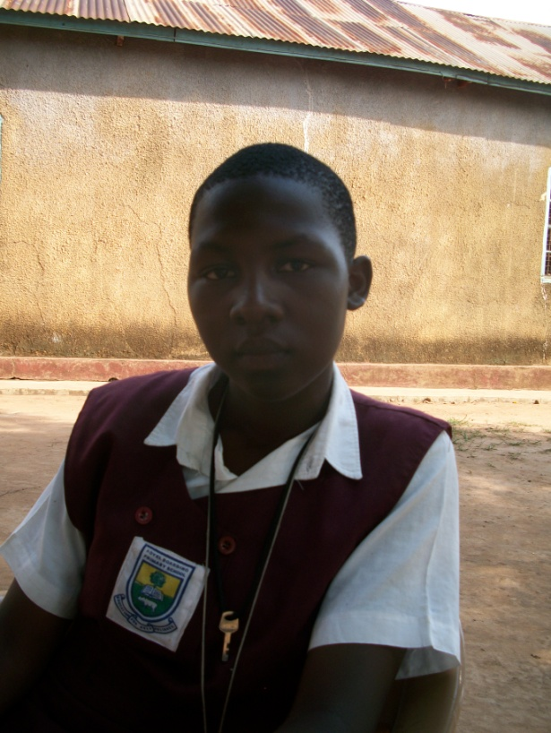
Picture showing Apili Esther in primary six of Adyel Primary School

Her aunt though struggled hard to see that all of them were in school and from primary one to three, she was in Lira Primary School under her aunt’s sponsorship.

“I was widowed and from then life became hard since I was only a house wife with no education though support all the children under my care I wash clothes in the neighborhood, narrates Esther aunty.

Esther is now in Adyel Primary School in primary six with support from PLA that she got through her aunt.

Esther loves English so much because it has helped her improve both her spoken and written English. She can now also easily express herself openly to her teachers as well as other people.
She scored 66% in English in the mid- term examinations.

“I want to become, so that I can help the sick people return to a happier and healthier living”, says Esther.
She was therefore advised to aim higher in life and also read hard so as to reach her goals.

During play time, Esther likes to play hand ball and net ball for leisure, and every Wednesday, she goes for fellowship at the Anglican Church near the school for worship and preaching which keeps her going.
According to Esther the worship and preaching inspires and encourages her to perceive through life troubles.

“When am at home, i helpmy aunt with the cooking, washing utensils and clothes, and bathing the young ones among others, its not too much work for me,” mentions Esther.
After a week’s holiday in Lira town, she usually goes back to the village in Ogur to find things to do to help her make money. She at times digs in the garden, planting maize, beans, which she sells to help raise money to cater for clothes and personal things like pads.

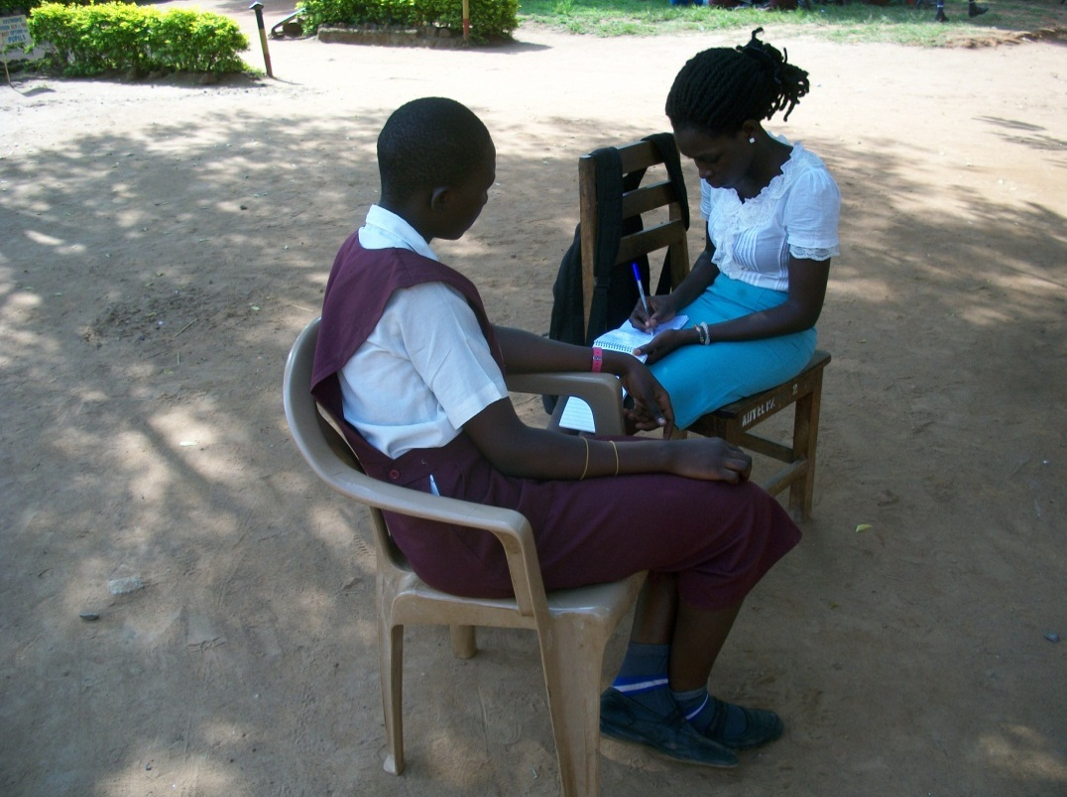
Above is a picture of PLA beneficiary Apili Esther as she shared her story with Adul Christine PLA student - intern at Adyel Primary School during the school monitoring visit

To Esther PLA and support from the donors has given her a step closer to her dream to that she remains grateful.
“Am so happy and thankful to PLA for their great support throughout this time” says Esther.

AMONG EMILY’S STORY
12 years old Emily is one of PLA beneficiaries who is in Primary Five at Adyel Primary School.
She was born to the late Opitru Jasper and the late Janet Apilli.
“My parents died in my village in Apalla, they had gone to visit my grandmother who was sick at time., That’s where they got attacked from by the rebels. They were then killed and I was left with my older brother who is 15 years old and also taken care of by Uncle Tonny,” Emily narrated
Emily is currently staying with her Uncle Ogwal Tonny in Kakoge A in Lira district.
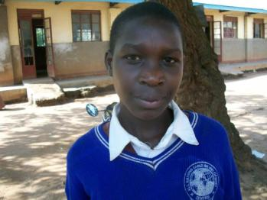
Face photo of Among Emily.
Ogwal Tonny works as a taxi conductorin Lira town and with a number of 15 people to look after in the same home stead, it becomes hard for him to pay fees because of this she sought the help from well-wishers.
Emily says she is happy when PLA started paying their lunch at school. This is because they are feeling better at school since hunger is one of the factors that was affecting the performances of all pupils in school including Emily herself.
“I am now feeling relieved because those days I used to travel back home looking for food of which this made me tired” Emily narrated.
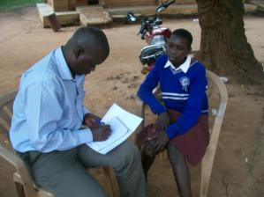
Picture showing PLA student Intern Abila Humphrey with PLA beneficiary in a blue sweater Among Emily a primary Five pupil at Adyel Boarding Primary School during the school monitoring visit.
Emily’ performance in school is still poor but with more effort Emily she promises to improve on her performance. Her dream is to become a doctor.
“I want to become a doctor that’s why I love science though I didn’t peform so well in it. I will improve in it because I want to be able to heal people when I become a doctor,” mentioned Emilly.

She is very happy and very appreciative to PLA and she said if possible PLA should also do the same to other War and HIV/AIDS Orphaned Ugandan girls outside.
“Thanks to PLA for what they are doing and May the good Lord bless the work of their hands,” says Emily.

AKULLO ELIZABETH’STORY
14 years old Elizabeth lost both her parents to war and since then is in the care of her aunt Atim Dorrine.
Elizabeth was introduced to the organization by PLA trained peer educators in ojwina division in Lira district. Since 2012 Elizabeth has gained support from PLA varying from scholastic materials, counseling to school lunch. With all that, Elizabeth cannot ask for more.
“Am very happy with the support from PLA, I didn’t know I would even make it to primary seven,” narrates Elizabeth
Elizabeth is a primary seven candidate who will be seating her primary leaving examination this November, according to Elizabeth, she promises not to disappoint her donors.
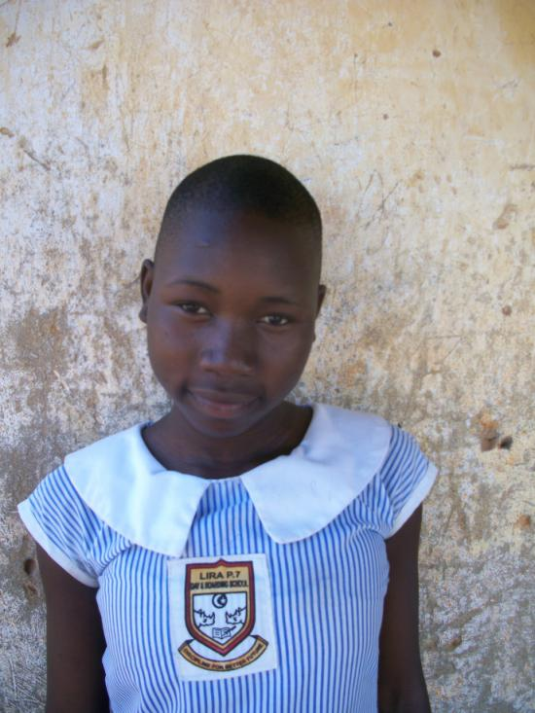
Face picture showing Akullo Elizabeth
Elizabeth’s best done subjects are English and Social Studies. Much as her performance in other subjects is good, Elizabeth has a big problem in mathematics. she scored 20% in the Pre Mocks examination and this is not good.
With consultation from her maths teacher Elizabeth hopes to catch up before her final examinations.
“I am working on performing better by reading my books , I now go to school very early in the morning to attend the morning preps that the boarding pupils get, said if I want to go to university. I am doing this by always coming for preps at school every evening”
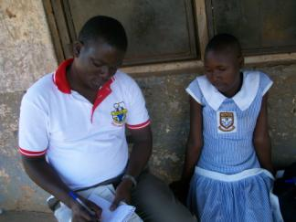
Hamphrey PLA Intern as he writes down Elizabeth’s case story
“At home, I lack paraffin to read my books since I stay in a house that is not electrified” she continued.
This will affect her performance because the only ample time she has is only during day time of which this will be lesson time at school. This is limiting Elizabeth’s dream of being a nurse.
Elizabeth received 1.5litres of paraffin from PLA program Assistant so that she is able to use it in lighting as she read her books while at home.
Elizabeth continues to be grateful for the love and support that she has received from the donors and platform for labour action.
CONCLUSION
To the donors and the organization the beneficiaries remain grateful for the support that they receive. To most of them they now can concentrate in the books and working hard to perform as hunger at school was already taken care of by the donors.
In the next quarter 6 of the beneficiaries are to seat the final primary leaving examinations in the different schools, with prayers, guidance, support from the organization and hard work from the beneficiaries themselves, they hope to perform better.
We will continue to support the beneficiaries, monitor their activities both in school and at home.

