PROJECT TITLE: EDUCATE 200 WAR AND HIV/AIDS ORPHANED UGANDAN GIRLS
PROJECT WEBSITE: http://www.globalgiving.org/projects/aids-education-uganda/
LOCATION: LIRA DISTRICT, NORTHERN UGANDA
REPORT PERIOD: QUARTERLY REPORT FOR MONTHS OCTOBER, NOVEMBER AND DECEMBER 2013.
COMPILED BY SUSAN EJANG – PROGRAM ASSISTANT LIRA

INTRODUCTION
Educate 200 war and HIV/AIDS orphaned Ugandan girls is a project that started in lira district as a result of the 21 years war by LRA rebels. After the war, the girl children’ education in the schools was ignored and most of the orphaned children were engaged in child labor, because of this many girls in the region were not educated and the ones that had the means were unable to concentrate in school without the scholastic materials and food.
Lira district is no longer affected by war and the communities are in rehabilitation but there is need to better the future through education of the girl child.
This project is currently supporting a number of 26 beneficiaries. The girls are supported with scholastic materials, lunch fees and counseling and they are in the schools including; Lira primary school, Lira Police primary school, , Adyel Primary school, Lira Modern primary school, Elia Olet Primary school, Saviour Secondary school, Railways Primary school, King James Primary school, , St Mary’s college Aboke. Lira parents primary school, Lango Quran Primary school, Sir Samuel Joe Nursery and Primary School, and Starch Factory Primary School.
This project continues to make a big difference in the lives of the girls that are getting the support and this has eased their access to education that has in turn built their self-esteem through their continuous counseling from Platform for Labour Action.
In this quarter, October, November and December 2013 there were various activities that were carried out in the project as noted below.
MONITORING VISITS
14 monitoring visits were made in this quarter both in school and the different homes that beneficiaries leave in.
20 girls were reached during the school visits well as 7 girls were reached during the home visits made.

During the school visits the beneficiaries were encouraged to perform better and read hard for their end of year/promotional examinations.
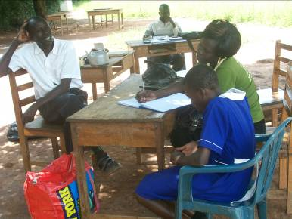
Above is a picture showing PLA staff (in green T shirt) during the school monitoring visit at Lira parents’ primary school.

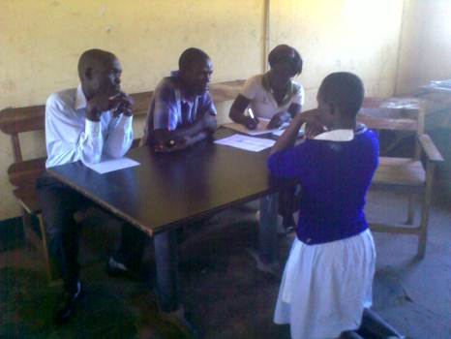
Above is a picture showing PLA beneficiary Amodo Sandra (blue sweater) as she listens to the advice from her class teachers during the school monitoring visit by PLA staff Susan Ejang at Lira primary school.

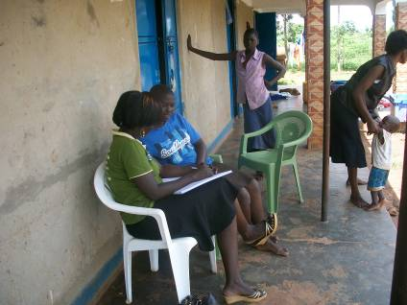
Above is a picture showing PLA program Assistant Susan Ejang during the home visit to one of PLA beneficiaries Apolot Mercy in Anai parish Lira district

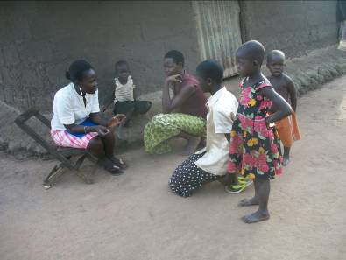
Above is a picture showing PLA staff during the home visit in a place called Boroboro in Lira distri
HOLIDAY EVENT/PLAY DAY
At the beginning of every holiday, PLA staffs take off time to meet with the beneficiaries to share information and play the different games that the girls come back with from their different school.
Other issues such as their end of year performance are discussed and their expectations as well as future aspirations are laid out and expressed for guidance.
This year the Objective of the holiday event was based on the following;
- To find solutions for the problems that the beneficiaries face especially in their schools and home.
- To create an environment where the beneficiaries are free to share their experiences
- Interact with fellow beneficiaries

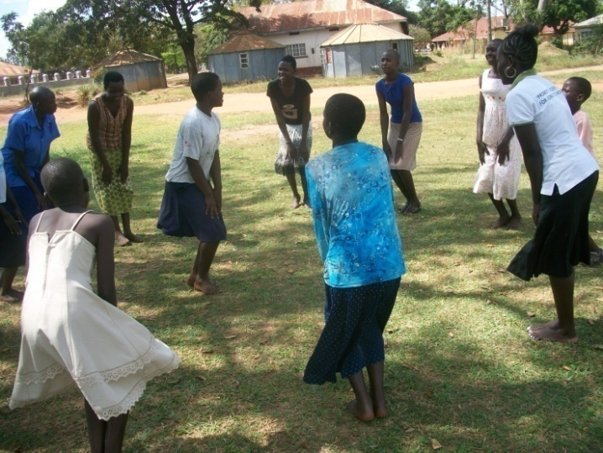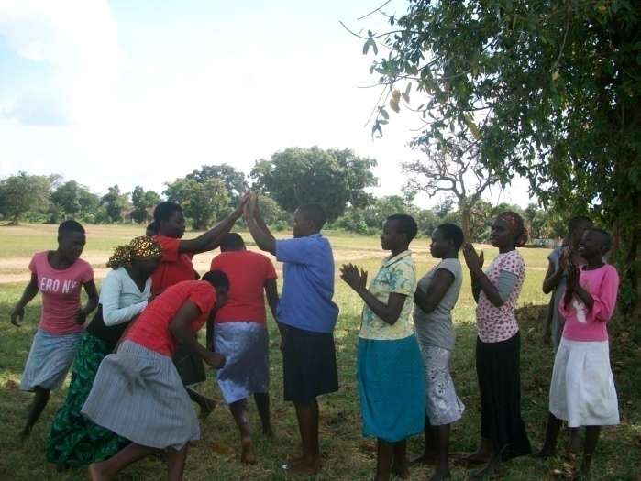
Above is a picture showing the PLA beneficiaries during the play day with PLA program Assistant Susan Ejang

Among other things the beneficiaries were able to receive clothes, sanitary pads, deodorants and shoes, to some of the beneficiaries like Awino Cinderella, this was a motivation for her good performance in school
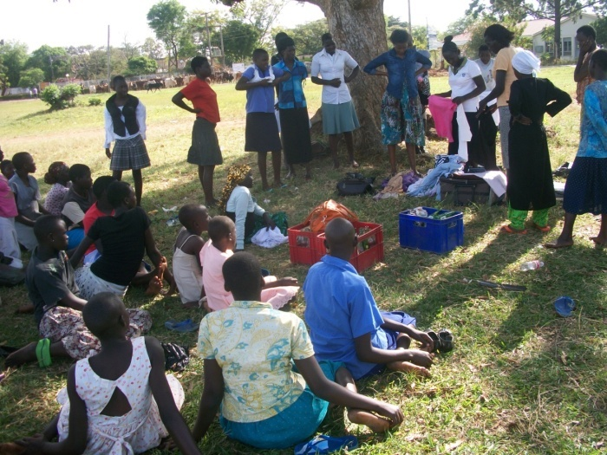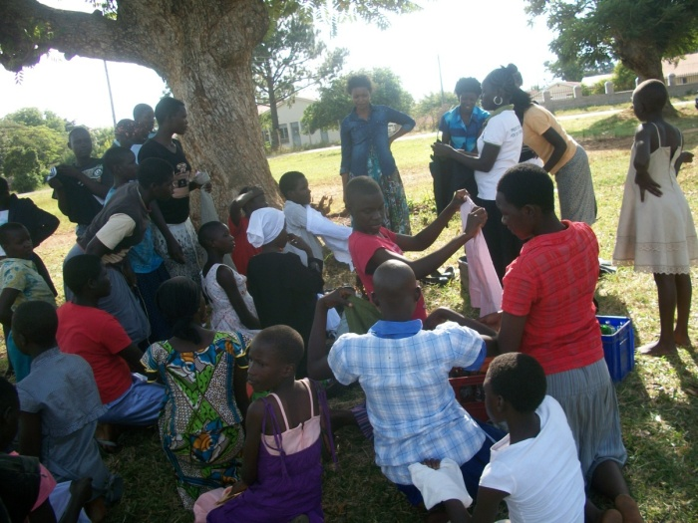
Above is a picture showing PLA beneficiaries as they receive clothes and sanitary pads from PLA staff during the “Holiday event”

COUNSELING

During the school and home monitoring visits the beneficiaries are listened to, talked to and also counseled. During the visits, the beneficiaries are able to share personal issues.
While in school the beneficiaries are supported on how to perform better and also guided, the school teachers have been involved in the discussion to work together with PLA staff to ensure the improvement of the beneficiaries in both school and class work.

During the quarter the program Assistant was able to talk to one beneficiary Zaitun Acan at PLA Lira Field office.
Zaitun is one of PLA beneficiaries who has benefited from the project since last year 2012, she sat her primary leaving examinations but due to continuous illness as a result of her HIV/AIDS status, she was unable to perform to her expectation.
At the beginning of this year, Zaitun again fell sick being unable to continue with school and up to date, she is still recovering.

She shared her dreams and future plans with the desire to continue with her studies and hopes to repeat primary seven so that she is able to perform better in her primary leaving examinations next year in 2014.
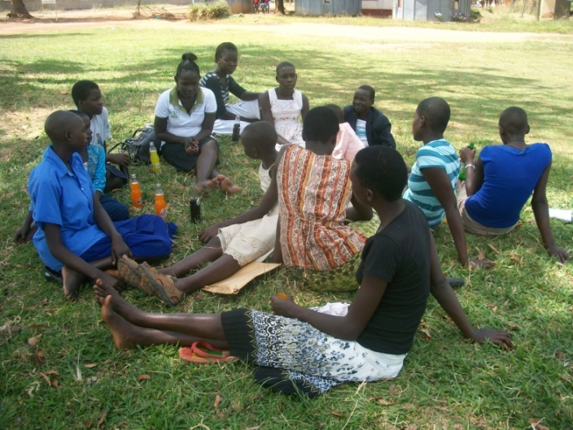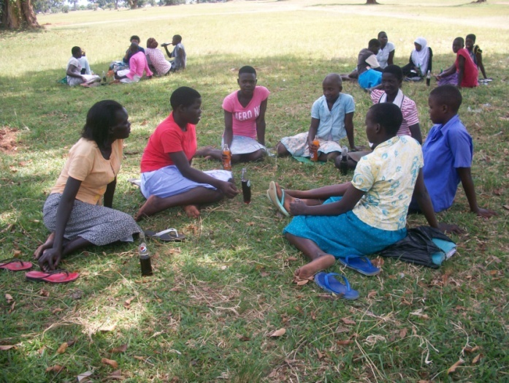Above is a picture showing the beneficiaries during the group counseling with PLA staff in Lira district Northern Uganda

CAREER GUIDANCE IN SCHOOLS AND PLA BENEFICARIES

During the quarter we were able to reach 2 schools of Adyel primary school and Sir Samuel Joe Nursery and primary schools with different messages, the pupils and our beneficiaries of the mentioned school were reached also other topics on children’s rights, how to choose a career and the need to work hard to attain ones dream.

Continuous career guidance was rendered to PLA beneficiaries during the holidays where after 7 beneficiaries choose that they would want to become lawyers, other beneficiaries choose to become nurses, doctors, accountants, teachers etc. The different career options were availed to children and the duties required under each were discussed to enable the beneficiaries have options when picking a future prospect.

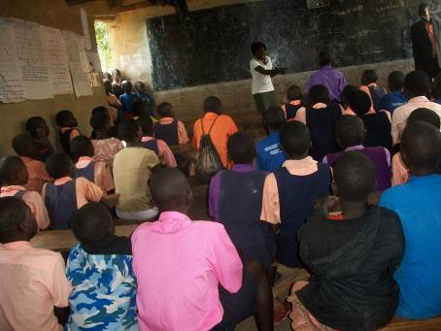
Above is a picture showing PLA staff sensitizing the pupils of Sir Samuel Joe Nursery and primary school on their rights and responsibilities
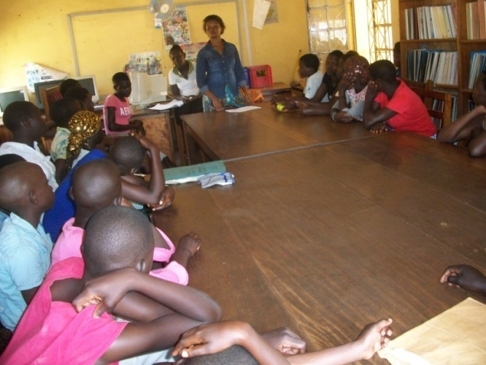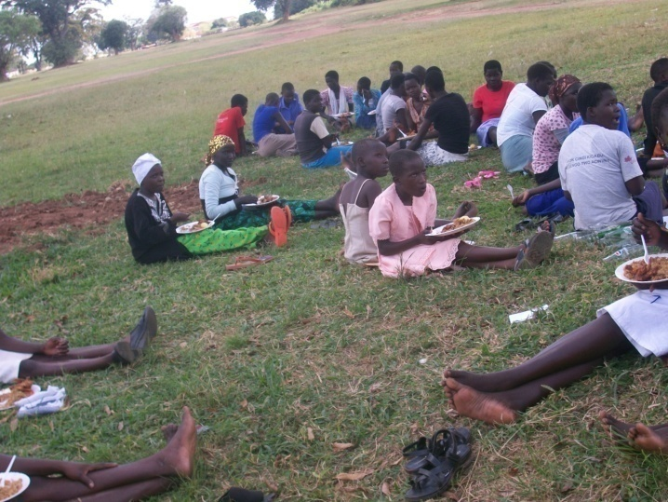
On the left is a picture showing PLA legal Assistant Joanitah Amumpire as she provides career guidance to PLA beneficiaries and on the rights is a picture showing the beneficiaries during a lunch break in Lira district.

PRIMARY LEAVING PUPILS

8 girls this year did their primary leaving examinations.
Primary leaving examinations were this year done on 4th and 5th November 2013, the girls who finished their Primary seven examinations included; Awor Asha, Apolot Mercy, Akoli Frida, Aceng Dorcus, Apio Holga, Epilla Farida, Amodo Sandra and Akullu Elizabeth all from 5 different primary schools within Lira.

PLA program Assistant was able to attend two (2 )different dedication prayers in the schools of Lira Police primary school and Lira primary school on behalf of the beneficiaries parents, the dedications prayers were encourage the beneficiaries and strengthen them during their examinations

Platform for labour action was also able to send success cards to the beneficiaries, the cards contained words of encouragements, to this the beneficiaries were excited and honored to receive the cards, “I am very happy to get this success card, it’s the only one that I have received compared to my friends”, mentioned Aceng Dorcus

BENEFICIARY’S STORIES
STORY OF ASHA AWOR

15 Years old Asha sat her end of primary school examinations this November on the dates 4th to 5th at Lira police primary school with support from Platform for Labour Action.

Asha is one of the girls who were identified last year 2012 by Platform for Labour Action as vulnerable orphaned girls affected by HIV/AIDS.

Asha scored 71 in integrated science, 65 in social studies, 40 in math’s and 79 in English in her Pre Primary Leaving Examinations.

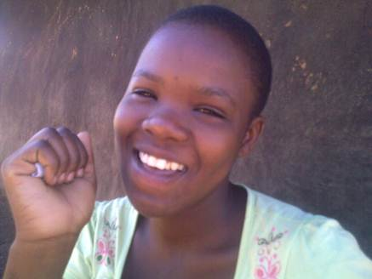
Above is a face picture of PLA beneficiary Awor Asha

Asha lost both her parents to HIV/AIDS and she is now under the care of her also infected uncle Ebong who stays in Adyel division.

Asha’s Uncle has been the provider in this family of 4 who also include Asha brother and 7 years old sister.

During the visit at Asha's home, she explained that she is now the one taking care of the home considering that her uncle is still in mulago hospital in his tenth month away from home suffering from HIV/AIDS.

“My uncle is still at the hospital and from the time that he left home, I have-not seen him, I hope to go there in my primary seven vacation with help of our neighbors,” says Asha.

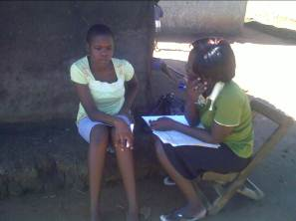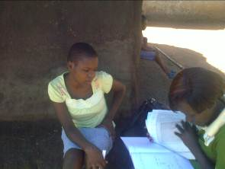
Above is a picture showing the program Assistant as she talks and looks through Asha Awor’s examination results during the home visit in Adyel division Lira district

Despite of the numerous problems Asha faces at homes in terms of food for her and her siblings, she is interested in continuing with school and her dream is to become a lawyer.

I love reading books and because of that I want to become a lawyer and also get respect from people, excitedly mentions Asha.

In our search for Asha’s relatives, we were able to get a well wisher who has promised to support the family with food for the time being as they search for stability

To Asha, she is grateful that despite all the hardships, she is able to go to school where she also gets lunch.

NEBILA KADIJA’S STORY

12-year old Nebila is a Mukiga (by tribe) born to the late Abdu Mubrak and Nima Sauda. She is currently under the care of 43-year old Rehema, her paternal aunt.
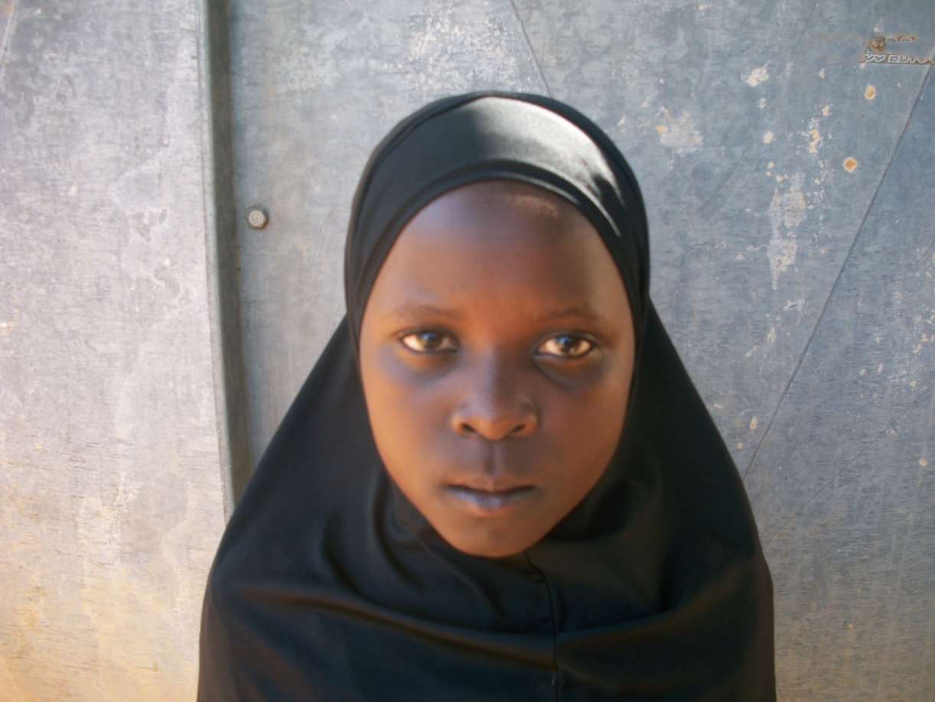
Above is a face picture of Nebila Kadija

Since 1999, Nebila’family has been living in Lira district though in 2007 and 2009, Nebila lost her parents to HIV/AIDS, “after my parents died, my aunt took over taking care of me and her other children,” mentioned Nebila.
Nebila’s rural home is in a place called Kazinga near Kololo primary school in Kanugu district
Nebilla has grown up in a Muslim community because of that, Nebila loves to pray and to learn Arabic, this holiday Nebila plans to continue going to the mosque to learn more Arabic,” It has become easy for me to read and write in Arabic, I can communicate to my friends at the mosque”, said Kadija.
With her continuous dream to become a nurse, she scored 81% in mathematics and 61% in her English Subjects, Nebilla managed to get a promotion to the next class and with continuous hard work she plans on seating her Primary Leaving Examination
To Nebila, she is grateful for the donors and PLA’s support to her education and further mentioned that she is lucky to have been selected by PLA among the many vulnerable girls in Lira

CONCLUSION
As the year comes to an end the beneficiaries successfully completed this year with support from the donors that ensured the lunch at school, continuous counseling through the school and home monitoring visits was availed to them.
To the donors were remain grateful for the support that they have rendered to the girls and together with the beneficiaries we pray that the support to the girls continues so that they can become better citizen with better futures attained through stable childhoods and education.

