PHOTO GALLERY
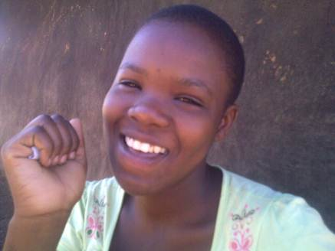
Above is a face picture of PLA beneficiary Awor Asha

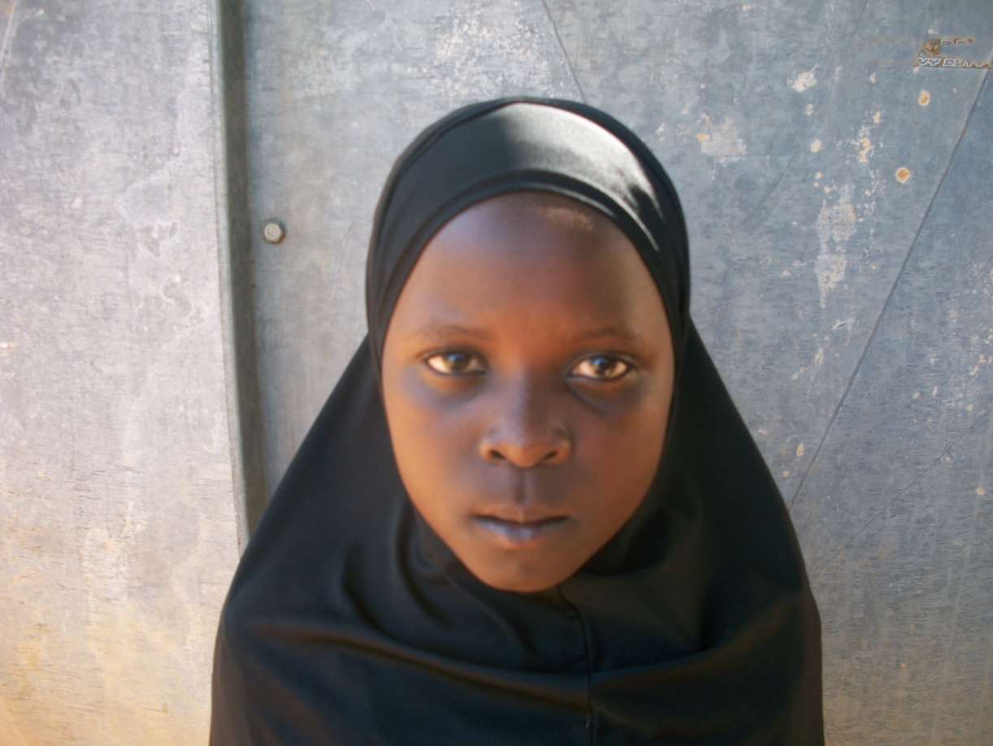
Above is a face picture of Nebila Kadija

