PROJECT TITLE: EDUCATE 200 WAR AND HIV/AIDS ORPHANED UGANDAN GIRLS
PROJECT WEBSITE: http://www.globalgiving.org/projects/aids-education-uganda/

LOCATION: LIRA DISTRICT, NORTHERN UGANDA
REPORT PERIOD: QUARTERLY REPORT FOR MONTHS JANUARY, FEBRUARY AND MARCH 2013.

COMPILED BY SUSAN EJANG – PROGRAM ASSISTANT LIRA

INTRODUCTION

With support from Global Giving, Platform for labour Action is currently supporting 37 girls with school lunch, scholastic materials and physiological support in all aspects of their lives. The girls go to government owned schools including: Lira primary school, Lira Modern primary school, Lira police primary school, Elia Olet primary school, Ojwina primary school, Starch Factory primary school, Lango Quran primary school, King James primary school, Railways primary school, Adyel primary school, Canon Lawrence primary school, Lira Parents’ primary school and Sir Samuel Joe nursery and primary school and secondary schools of Dara christian high school, Sarvior secondary school and St mary’s girls secondary school Aboke.

“Educate 200 War and HIV/AIDS Orphaned Ugandan Girls” is a project that has given hope to 37 for a better future through education, despite the hardships endured due to the absence of their biological parents who they lost either to HIV/AIDS or during the 21 years long LRA rebel war.
Below is a detailed account of these project activities carried out in the months January, February and March 2013.

SCHOOL LUNCH PAYMENT

As the school term began on 4th February 2013, payments for the beneficaries were prepared amounting to (Two million seven hundred seventy seven thousand and eight hundred shilling) Ugx. 2,777,800 and equivalent of USD 1,200

The payment was for the whole year 2013, which means that our beneficiaries are guaranteed of school lunch for the rest of the year and can therefore concentrate at school as they will have no worries of hunger.
The girls have been very appericative of this step by PLA saying that they will not be sent away from school this year and therefore, will do their best to study hard.

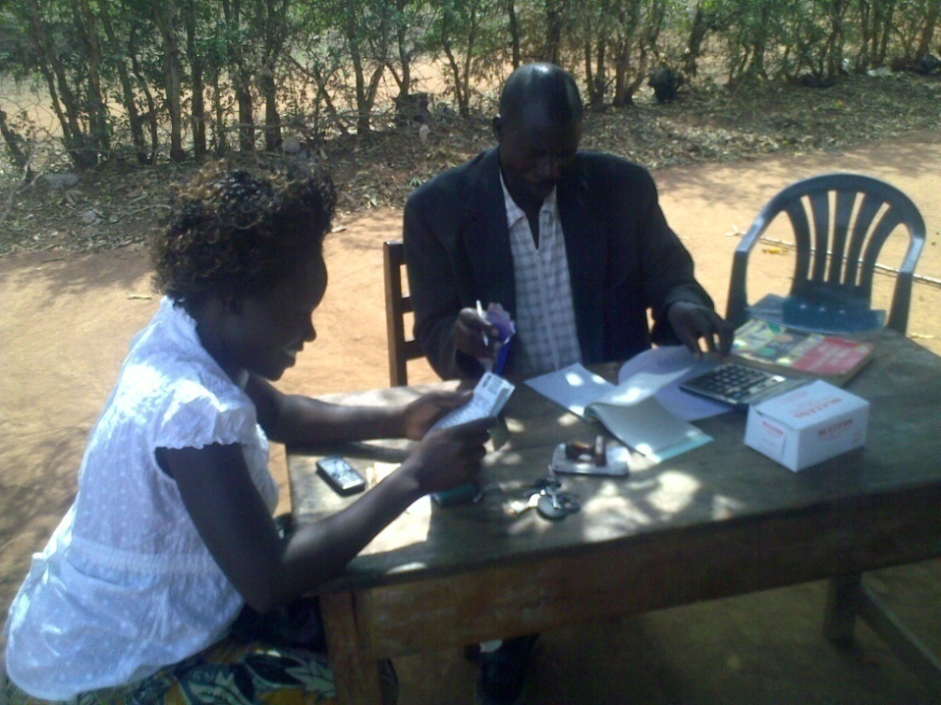
Above is a photo showing PLA program assistant as she speaks to the headmaster Lira parent’s primary school about the girls’ school lunch fees for the year 2013

SCHOOL MONITORING VISITS

12 school visits were made to the schools including: Lira Primary school, Lira Modern Primary school, Sir Samuel Joe nursery, Lira Police primary school, Lira parents’ primary school, Lango Quran Primary school, Elia Olet primary school, Starch Factory primary school, Adyel primary school, Railways primary school, Dara Christian high school and Sarvior secondary school.

During these visits, PLA Program Assistant discussed the beneficiaries’ welfare with the teachers and requested them to support and guide the girls while they are in school.
The visits to the schools were made to ensure that the beneficiaries get psychological/ support from the organisation.

The girls also shared with PLA Program Assistant some of the activities that they were engaged in during the holidays, such as visiting their relatives in the villages, helping their guardians in the gardens and doing household chores.

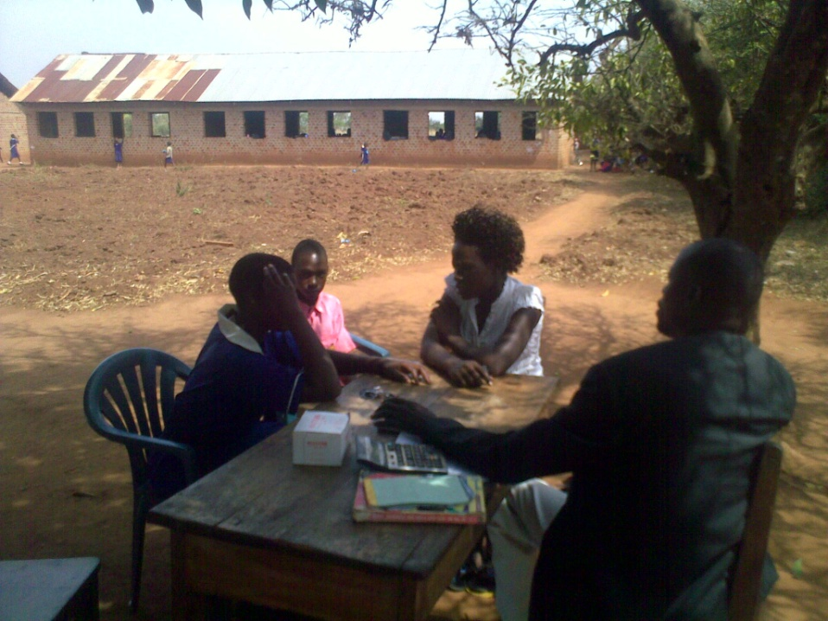
Above is a picture showing PLA program Assistant as she listened to one of the beneficaries Mercy during the school monitoring visit at Lira parents’ primary school

HOMES MONITORING VISITS

7 home visits were to made 6 beneficaries with Awor faith receiving 2 visits and the rest of the girls that is Cinderella, Harriet, Dorcus, Monica and fridah received 1 home visit each; the girls were doing fine with their guardians support.

Each of the girls had a story to share especially the girls who had the long school holiday. For girls like Cinderella and Faith, they were spent in their hoildays in their father’s villages helping out in the gardens and visiting relatives.
For girls like Harriet, Dorcus, Monica and fridah, they spent their vacation here in Lira town helping their guardians with home chores.

HARRIET’S STORY

17 years old Harriet was born to Alferd and the late Mary, she is currently under the care of Awnca.

She never got to meet her mother as she was told that she died after giving birth to her, her father died when she was only 3 years of HIV/AIDS though Harriet was tested and found negative.

During the hoildays, Harriet spent most of her time helping out her guradian in her business and home chores.

Since I was free and didn’t have books to revise, I helped out my aunty to make local brew, with some of the money got from the business, my aunty gave me to buy some of the things that I needed like sanitary pads for my hygienic use,” explained Harriet.

During the visit, PLA program Assistant also discussed with Harriet her thought of joining secondary school.
She was very postive and mentioned that, she had all intensions of joining secondary school with the support of her gurdian and PLA, I have a dream of becoming a nurse and I can only join that after studying sciences in secondary school, mentioned Harriet.

Harriet received 20 aggregates with 3 in English, 5 in Science, 5 in Social Studies and 7 in mathematics from her Primary Leaving Examinations results and she has now been admitted in senior 0ne at Iceme girl’s secondary school

To the donors Harriet appreciate the continous support and thanked PLA for choosing her out of the many girls in Lira to support in education

PRIMARY SEVEN RESULTS

This year we got very good results from the girls who sat for the Primary Leaving Examinations in 2012. The girls had reservations about their performance, however they managed to get first and second grade. This enables them to join secondary education.
The results of the girls were also follows;

      - Awio Cinderalla got 7aggregates
      - Akot Rebbeca got 10 ggregates
      - Awor Faith got 14 aggregates
      - Amuge Sitina got 16 aggregates
      - Atai Sandra got 20 aggregates
      - Odyek Rachael got 20 aggregates
      - Ocida Harriet got 20 aggregates
      - Acio Lonna got 21 aggregates

HOSPITAL VISITS

4 hospital visits were this quarter made to Acan Zaitun one of PLA beneficaries who was admitted at Lira Referral Hospital, the visits were meant to encourage and strengthen her as her healith condition was not good.

Acan underwent different kinds of treatment from the hospital untill she was discharged after improving.

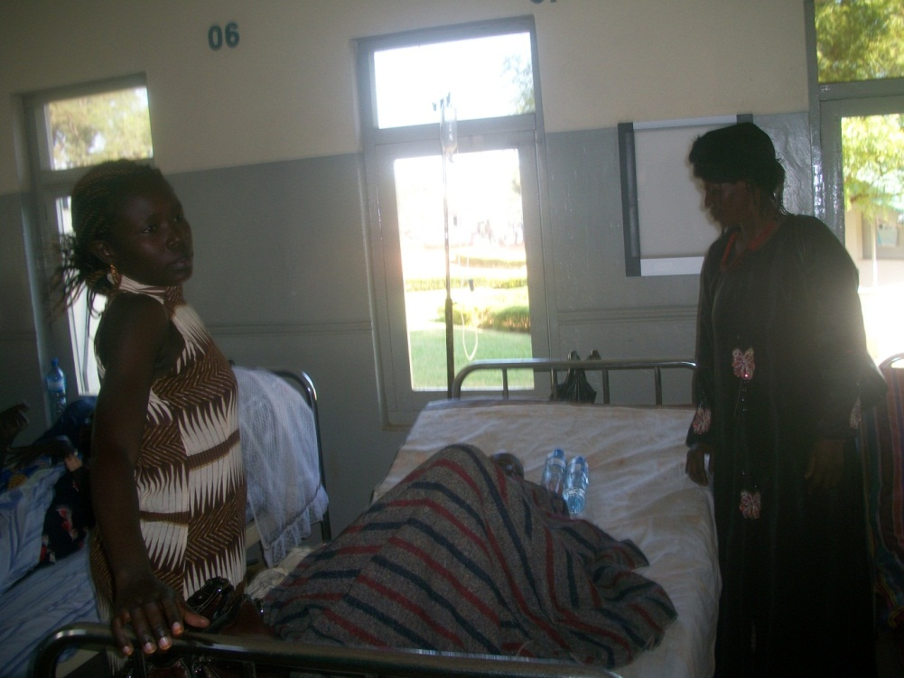
Above is a picture showing Program assistant Lira standing near Acan bed at Lira Referral hospital during the monitoring visits

15 years old Zaitun was among the girls waiting from her PLE results when she fell sick and was first admitted at Lira modern clinic.

In 2003, Zaitun lost both her parents Hussein and Viola Akullu to HIV/AIDS and after a blood test, she was found to have the same disease.

Continuous visits were made to the hospital to monitor Acan’s condition with hope for improvement. She was later discharged from the hospital after 5 weeks of treatment. She is currently under home care where continuous monitoring will be made by PLA to ensure that her health is improved so that she can resume school.

COUNSELLING

During the quarter, PLA Program Assistant Lira Susan Ejang counseled 23 girls, during the sessions; the girls shared their life experiences and dreams. Some of the girls were also able to share their end of year results and beginning of term results.

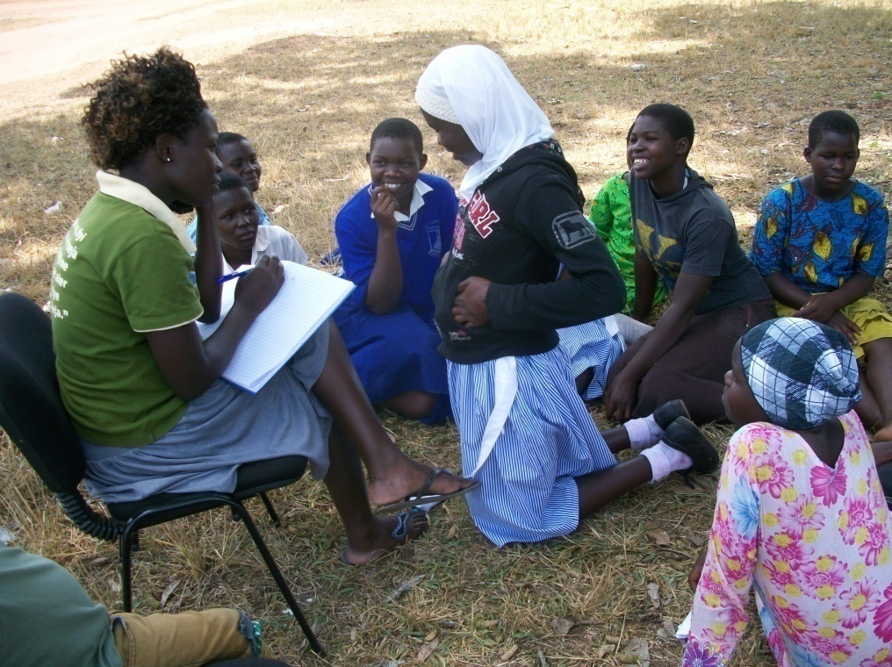
Above is a photo showing PLA program Assistant during a group counselling session

During the sessions the girls were also able to share their fears to which they were assured that if they studied hard, their future will be bright.

BENEFICIARIES’ STORIES

AWIO CINDERELLA’S STORY

12 years old Cinderella was born on 21st/March/2000 to the late Anthony Okello and the late Mary Okello and was nicknamed Agirli (meaning a girl) by her parents.

Cinderella is currently under the care of her maternal Uncle Odur Richard who is also married and works as a welder at corner Kamdini in Adyel division in Lira district.

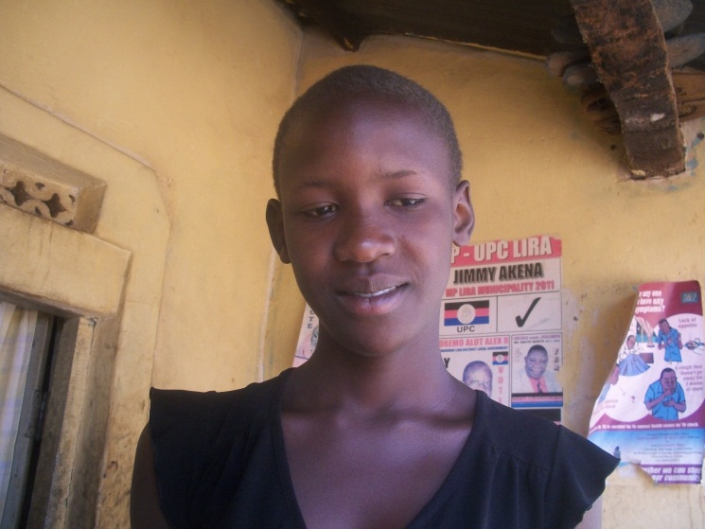
Above is a face picture of PLA beneficary Cinderella Awio

Cinderella was identified as one of the war affected girls in Lira district by PLA, “I was not sure of making it to PLE because life both at home and school were both hard, “narrated Cinderella

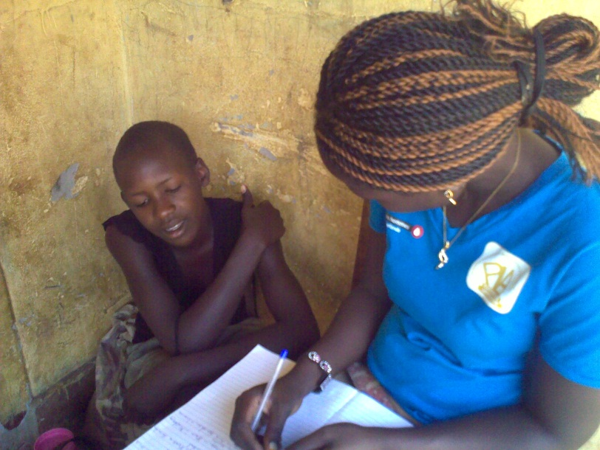
Picture showing PLA Program Assistant as she talked to Cinderella during the Home monitoring visit at her home in Teso bar A Parish in Adyel division.

Cinderella’ performance in school was average due to lack of concentration in class while her teachers taught, “I am so happy for what PLA did for me while I was at school, my school lunch was paid and I was given all the scholastic materials i needed for class and my final examinations, they also encouraged me to study and read hard”, Cinderella explained.

Cinderella was able to score 7 aggregates from Adyel primary school and now her dream has changed to become a doctor because she wants to study science subjects.

She has now joined one of the best government schools in the region called Mary’s girl’s secondary school in Aboke. She passed the entrance examinations and her school term and secondry life has also begun.

“According to Cinderella, she is not sure whether she will be able to finalise her education in this great school since her guardian is not able to cater for her school fees, ‘I wish and pray that the donors will support me too in secondary school because I have all hopes of attaining my dreams if am supported,” Cinderalla narrated.

Cinderalla will need support of scholatic materials and a total amount of Six hundred thousand shillings (Ugx. 600,000) each year for continue with her secondary education at St Marys secondary school Aboke.

AKOLI FARIDAH’S STORY

14 years old Faridah is currently in (P.7) primary seven at Lira primary school.
She is born to the late Ayugi Matatu and the late Yusin Okello and currently under the care of her 22 years old aunt Atim shamim.

Faridah’s father died when she could hardly speak and her mother later died in 2008, they all died as a result of HIV/AIDS though Fardia has tested Negative of the same disease.

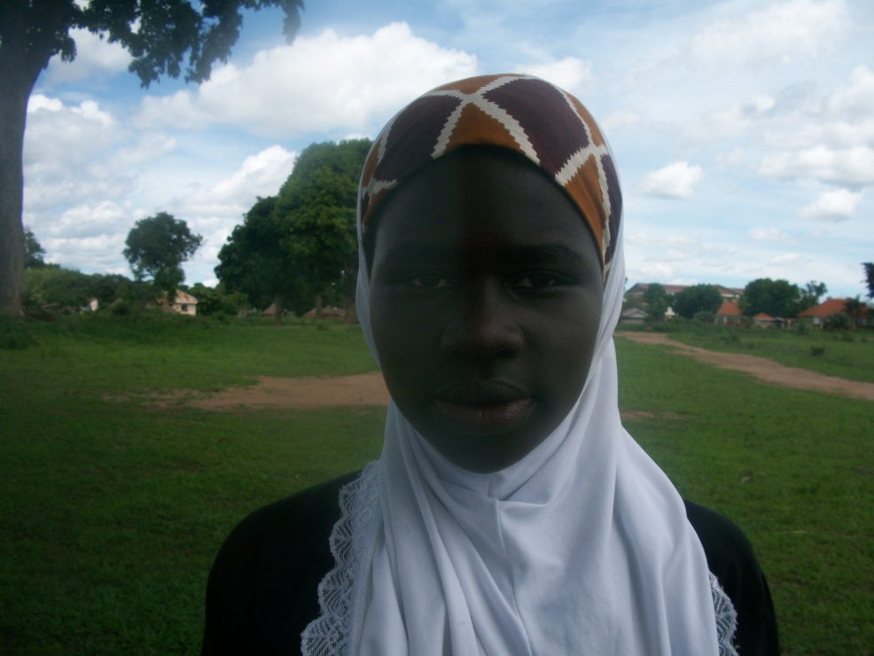
Above photo is a face picture of Faridah

Faridah’s best subjects are English and Science she was able to perform well in the said subjects; she got 76 in English and 69 in Science. Her dream is to become a nurse and she hopes to work hard towards achieving her dream.

During the hoildays, Faridah was helping her guradian to serve food at a local resturant on Juba road in Lira town. “The money helps us to get food and clothings as well as other things that are needed at home,” mentioned Faridah.

“The advantage here is that when it`s school time, I allow Fardiah to go so that she can study hard and become a better person in future,” mentioned Shamim, Faridah’s gurdian.
“Its quiet a big family,” added on Shamim
“Am so happy for what PLA is doing for me, because I wouldnt be in school if it wasn’t for them. At the time PLA found me, it was a school day and I was here at the resturant serving food, am so glad that I can now be like other children who are going to school, may God bless the hands that support me,” concluded Faridah.

AKELLO SUSAN’S STORY

15 years old Susan is one of the girls who were idenified by PLA in the year 2012. She is born to the late Akullu Rose and the Otyama Alfred and currently in the care of her guardian Akullo Silvia in a village called Starch factory in Adyel division Lira Municipality.

Irrespective of the house chores that she has carry out both in the morning and eveing, susan is interested in education and because of that, her school teachers have agreed to give her extra lessons so that she doesn’t lag behind in her class.

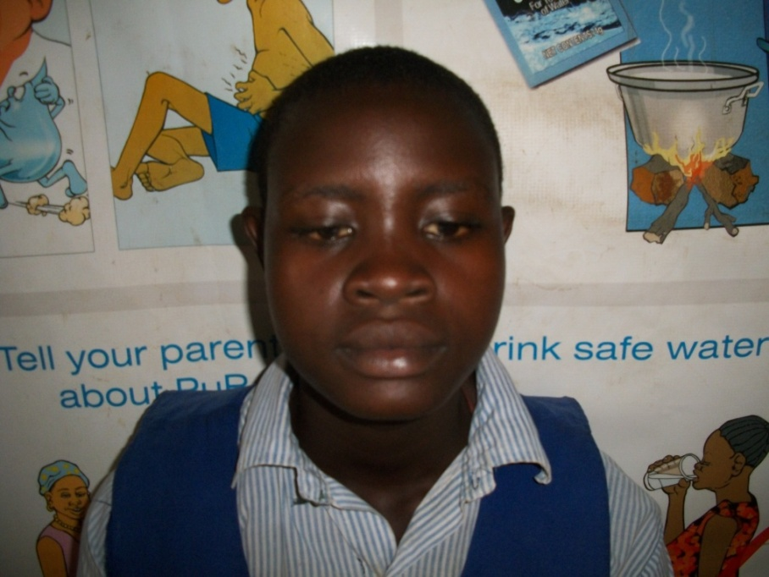
Above is a photo PLA beneficiary Susan Akello

Being an orphaned child has not hindered Susan’s interest in school this year as she has greatly improved in her participation in class and school.

In the last visit Susan’s gurdian had agreed to give enough time to Susan to read her books and associate with her friends, in the recent follow up, Susan has been given the time to carry associate with friends and revise her books.

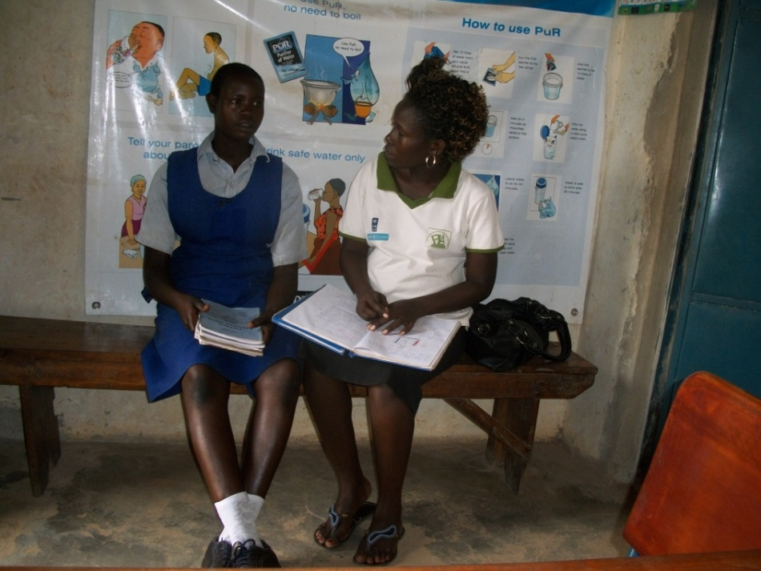
Above is a photo showing PLA Program Assistant during the monitoring visit at Starch Factory primary school

Susan’s dream is to become a nurse, “I want to study nursing here in Lira comprehensive school of nurse to make a difference in people’s lives in the hospitals, that way they will gain hope of life” explained Susan.

Susan is an athlete at school and also loves playing games such as netball; this is one of the co-cirrulum activities that she undertakes when out of class.

Susan continues to be grateful for the support that PLA renders her from providing scholastic materials, providing school lunch to psychological support.

PLA will continue to monitor Susan performance both at school and at home as well as continue to talk to her guardian to treat her better. The school teachers have agreed to give Susan extra class exercises for her to improve in class work.

AWOR FAITH’ STORY

16 years old Faith Awor this year received great news of joining secondary school which is a step ahead in attaining her dream of becoming an accountant like her late father.

Faith has been supported by the project since 2008 and according to her guardian Grace, who says that PLA`s support to Faith has greatly helped them especially when it came to psychological support and school lunches.

“Faith is infected with HIV and because of that, she continuously needs people who can encourage her like PLA does, “mentioned Grace

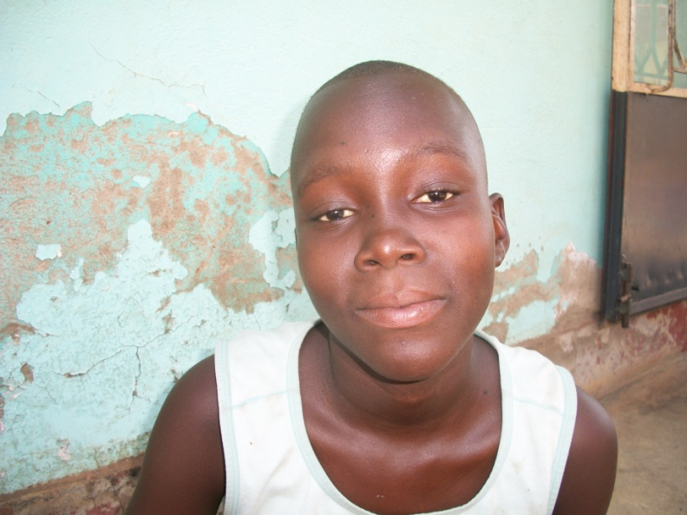
Above is a photo of Faith Awor

This year faith chose to join Dara Christian high school in Lira, for her continous studies in secondary education.

“’I hope to perform better in this stage of my education because I still want to become an accountant like my father, he encourged me to study hard when he was alive,” sadly remembered Faith

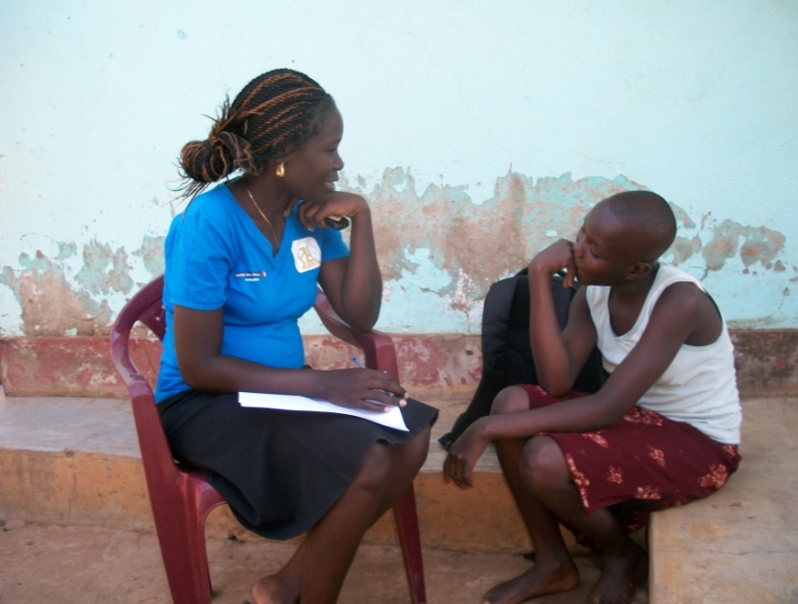
Above is a photo showing PLA program Assistant as she encouraged to Faith to concentrate on her education during the home visit.

To PLA faith regards the organisation as her family, “I am so grateful for the support that the organisation has given to me from primary level to now,” expressed Faith

Faith is going to continue getting all the necessary support from PLA ranging from psycological support to scholatic materials and any other support in her education that PLA can provide.

“I am so grateful that the donors take off some of their time and money to take care of people like me, may the Lord bless you,” expressed Faith.

AMODO SANDRA

14 years old Sandra has only known her late grandmother for the most part of her years as she lost both her parent to HIV/AIDS when she was hardly a year old.
Her grandmother Angella Awili died in the year 2010 and was left home alone.

“My grandmother was the only person that I ever knew, she lost my mother to HIV/AIDS and most of her other children and property to the war. She never talked about her past because it hurt her so much,’ sadly remembered Sandra.

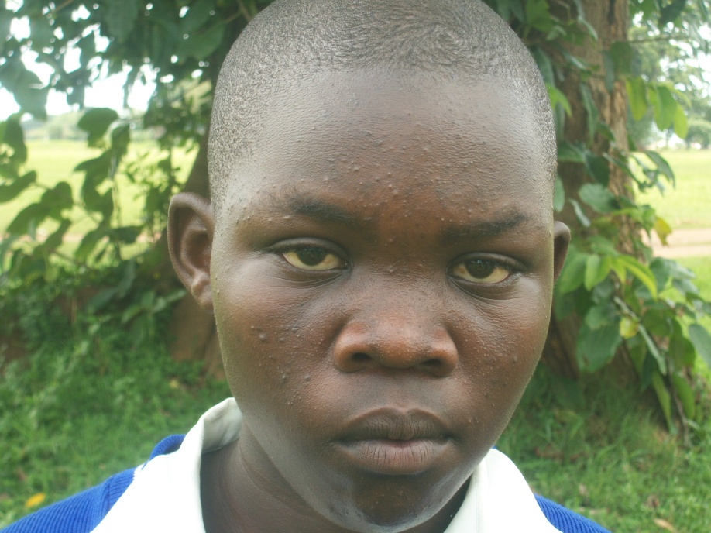
Above photo showing a face picture of PLA beneficary Sandra Amodo

Sandra is currently under the care of Etuku Wilson who has given her a one room house
“He now treats me like one of his children, but of course I can’t get the same treatment as his own children,” mentioned Sandra

“I love studying because I believe that, that is where my better future will lie,’ mentioned Sandra. Sandra is studying at Lira primary school

“I love science a lot and I believe that I can make it in becoming a doctor, Sandra continued to mention that with the support she is currently getting from PLA, “I hope to study hard so that I don’t disappoint my self and the people supporting me,” she concluded.

“Uncle Wilson has given me a room to stay in until i find where to go, but there is nowhere to go so I guess I will be staying here until I start working,” mentioned Sandra.

To PLA and the donors, Sandra is gratefull for the continous support, “you know, my caretaker doesn’t pay for my fees so I am happy that the donors have taken care of that other problem that I was facing, I am now permanently in school because of the donors and Platform for labour Action,” happily mentioned Sandra

CONCLUSION

Thet year 2013 started with great news with the beneficaries performance being encourging with the best student getting a first grade with 7 aggregates (1 in English, 2 in Science, 2 in Social Studies and 2 in Mathematics ) to join secondary school. The girls have been appreciative of the support of PLA and the donors in both their education and life out of school.

With 11 beneficaries joining secondary, there are limitations especailly in terms of fees and the increase in the cost of goods in the country, because of this, some of the girls will find it hard to join secondary since their guradians are unable to afford the costs.

This year PLA will continue to support the beneficiaries with scholastic materials, school lunch, and counseling. A number of other activities such as school and home monitoring visits will carried out in addition to organsing play days during the hoildays for the girls to have the opportunity of sharing their talents and hobbies with PLA and fellow beneficaries.

