PROJECT TITLE: EDUCATE 200 WAR AND HIV/AIDS ORPHANED UGANDAN GIRLS
PROJECT WEBSITE: http://www.globalgiving.org/projects/aids-education-uganda/

LOCATION: LIRA DISTRICT, NORTHERN UGANDA
REPORT PERIOD: QUARTERLY REPORT FOR MONTHS JANUARY, FEBRUARY AND MARCH 2014.

COMPILED BY SUSAN EJANG – PROGRAM ASSISTANT LIRA

INTRODUCTION

Platform for Labour action with support from Global Giving is currently supporting 26 girls with school lunch, scholastic materials and physiological support in all aspects of their lives. The girls go to government owed schools of Lira primary school, Lira Modern primary school, Lira police primary school, Elia Olet primary school, Starch Factory primary school, Lango Quran primary school, King James primary school, Railways primary school, Adyel primary school, Canon Lawrence primary school, Lira Parents’ primary school and Sir Samuel Joe nursery and primary school.

“Educate 200 War and HIV/AIDS Orphaned Ugandan Girls” is a project that has given hope and a better future through education to more than 100 beneficiaries in northern Uganda, despite the hardships endured due to the absence of their biological parents who they lost either to HIV/AIDS or the 21 years long LRA rebel war.
Below is a detailed account of these project activities carried out in the months January, February and March 2014.

SCHOOL MONITORING VISITS

9 school visits were made to the schools of: Lira Modern Primary school, Sir Samuel Joe nursery, Lira parents’ primary school, Lango Quran Primary school and Adyel primary school, Railways primary school,

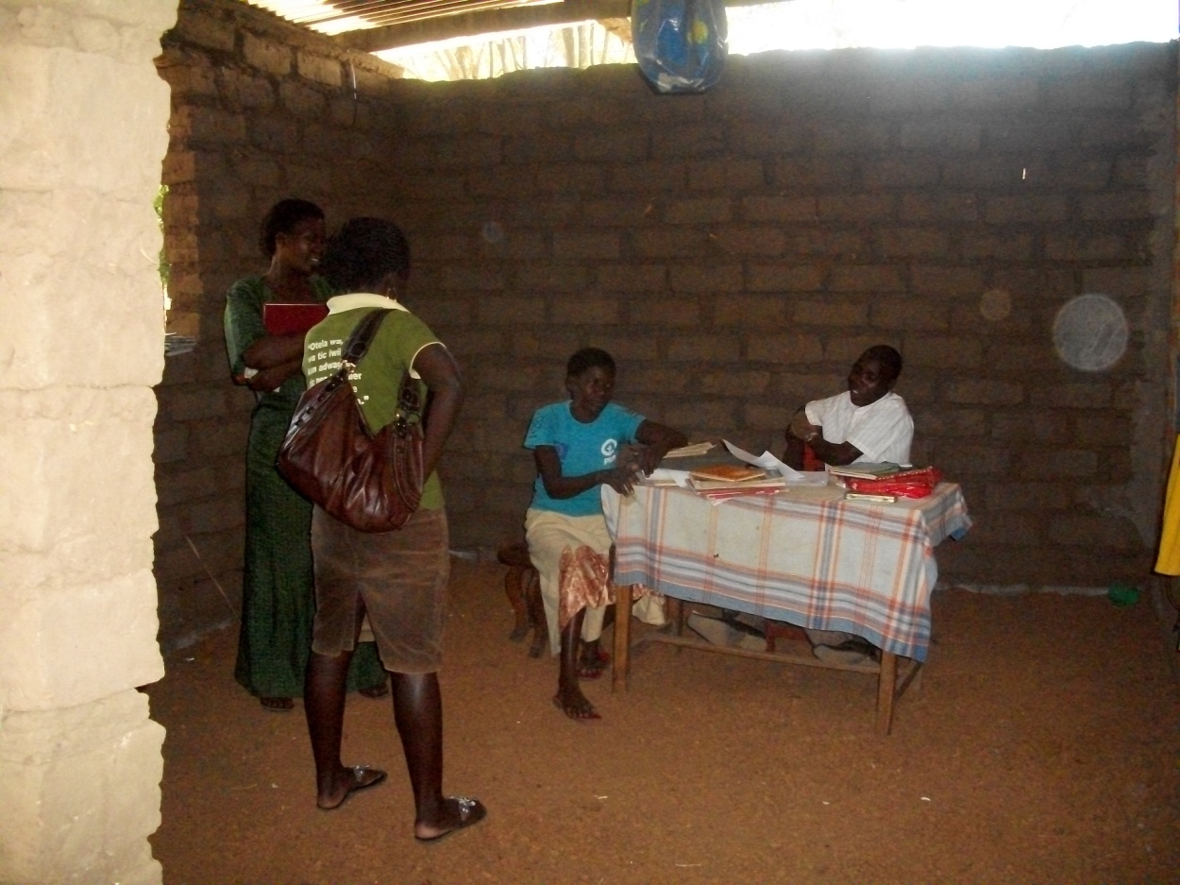
Above is a picture showing PLA staff Susan Ejang in green t-shirt as she talked to some of the teachers at Sir Samuel Joe nursery and primary school in lira district

The visits were made to ensure that they had all resumed with their studies in their respective schools. During the visits, PLA staff advised the beneficiaries to study and work hard to become better citizens as well as have a better life in future.

During the visit, the girls also shared with PLA staff some of the activities that they were engaged in during the holidays. Most of the girls were as a norm in their villages visiting their grandparents as well as other relatives; other beneficiaries were also engaged in farming despite the dry season.

PRIMARY SEVEN RESULTS

This quarter we were able to receive primary leaving examination results of the 8 girls that sat their examinations last on 4th and 5th November 2013, the girls were inclusive of Awor Asha, Apolot Mercy, Akoli Frida, Aceng Dorcus, Apio Holga, Epilla Farida, Amodo Sandra and Akullu Elizabeth all belonging 5 different primary schools within Lira.

Though there was fear and tension from the girls on how good their performance would be, the girls managed to maintain first and second grades which means that the girls are ready to join another level; of school (secondary education).
Some of the results of the girls were also follows;

- Awor Asha 14 Aggregates
- Epila Faridah 24 Aggregates
- Akullo Elizabeth 24 Aggregates
- Amodo Sandra 22 Aggregates
- Apolot Mercy 20 Aggregates
- Akoli Frida 18 Aggregates
- Aceng Dorcus 28 Aggregates
- Apio Holga 19 Aggregates

COUNSELING

19 PLA beneficiaries were this quarter counseled and talked to by PLA staff and especially PLA program Assistant who pays them visits both at school and at home.
As the year began some of the beneficiaries had problems related to their guardians as some of the girls were to be taken as baby sitters while 2 of the girls were being forced into marriage at an early age. With intervention from PLA the girls are back to school with willingness to study hard.

PLA is to continue talking to both the guardians and the girls with more emphasis on the need for the girls’ education.

BENEFICIARIES’ STORIES

APILI ESTHER STORY

13 years old Esther is born into a family of 6 children in which she is the second born. Her father passed in 2002 during the LRA war and her mother Helen also passed on from the HIV/AIDS virus in 2005.
Together with her brothers’ and sisters, they were left in their village in Ogur with relatives who cared less about them.

This year Esther is one of the beneficiaries who seating her primary leaving examinations, and this is thanks to her aunt Rose Alipu who at the time visited the village and asked for her together with her two sisters (Peace and Margret) to live with her in Lira town

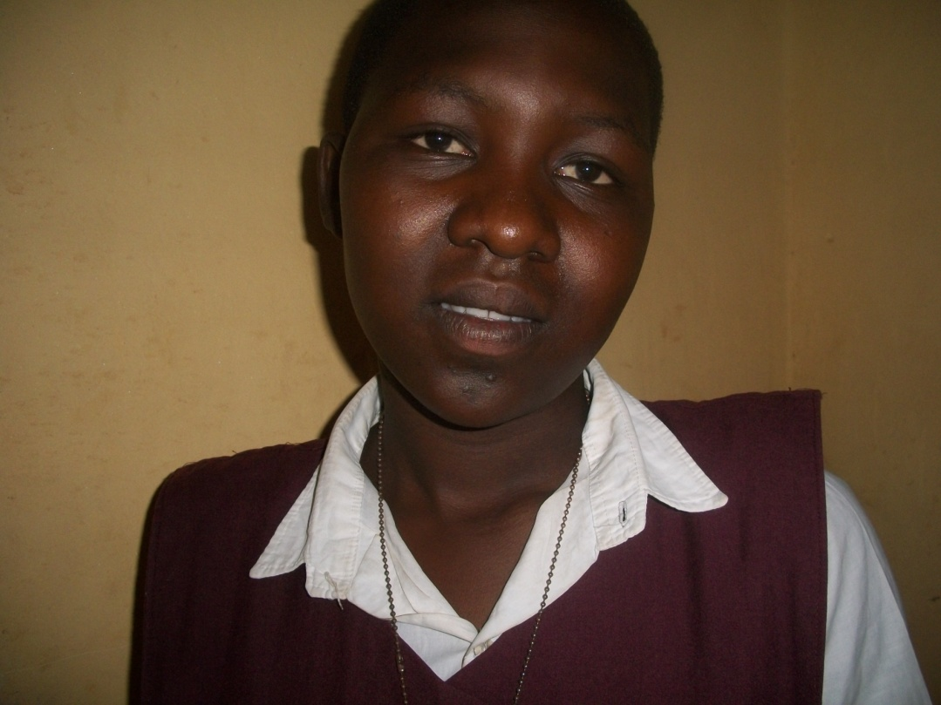
Above is a face picture of PLA beneficiary Esther Apili

When they reached at her home, it was a happy family. They stayed for a short while and her aunt later lost her husband to HIV/AIDS. This worsened the situation as all the burden of care was left to her aunt. They had come 3 of them from the village, her aunt has 4 children together with 4 other children of her other paternal aunt who had died. This totaled to about 11 children all under her aunt’s care, who was currently a house wife.

Her aunt though struggled hard to see that all of them were in school and from primary one to three, she was in Lira Primary School under her aunt’s sponsorship.

“I was widowed and from then life became hard since I was only a house wife with no education though support all the children under my care I wash clothes in the neighborhood, narrates Esther aunty.

Despite this hardship, Esther’s love for education has never stopped and she wants to be a better person who will give back to the community.

“I want to become, so that I can help the sick people return to a happier and healthier living”, says Esther.

During play time, Esther likes to play hand ball and net ball for leisure, and every Wednesday, she goes for fellowship at the Anglican Church near the school for worship and soul searching According to Esther the worship and preaching inspires and encourages her to perceive through life troubles.

“When am at home, I help my aunt with the cooking, washing utensils and clothes, and bathing the young ones among others, it’s not too much work for me,” mentions Esther.

After a week’s holiday in Lira town, she usually goes back to the village in Ogur to find things to do to help her make money. She at times digs in the garden, planting maize, beans, which she sells to help raise money to cater for clothes and personal things like pads.

Esther does appreciate the donors for the support that they give her To Esther PLA and support from the donors has given her a step closer to her dream to that she remains grateful.
“Am so happy and thankful to PLA for their great support throughout this time” says Esther.

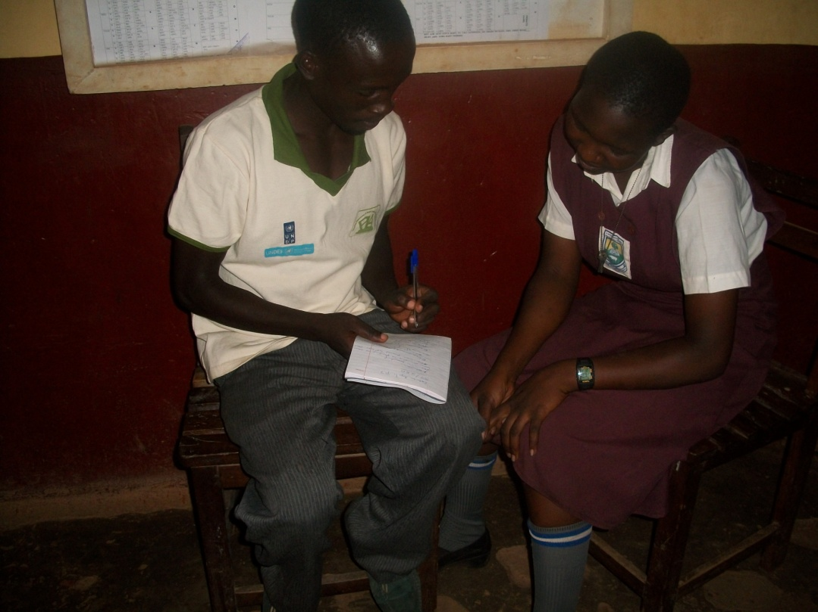
Above is a picture showing PLA Samuel Odong as he records some of the challenges that PLA beneficiary Esther (in school uniform) faces in school

Esther requests that if it’s possible, she is given support to join boarding section, that way she will have a fair competition with other children from well to do families.

ACHOLA SUMAYA’S STORY

13 years old Sumaya was born to the late Obugo Saidi and the late Kole Jamila. She is now in the care of her 33-years old paternal aunt, Birungi Asuma who is staying at Alito camp in Ojwina division in Lira district, near Adyel primary school.

This year Sumaya will also seat her primary leaving examinations and with her past performance in class that is no doubt that she will not pass. During her promotional examinations, Sumaya managed to score 42nd position out of 285 pupils of her class.

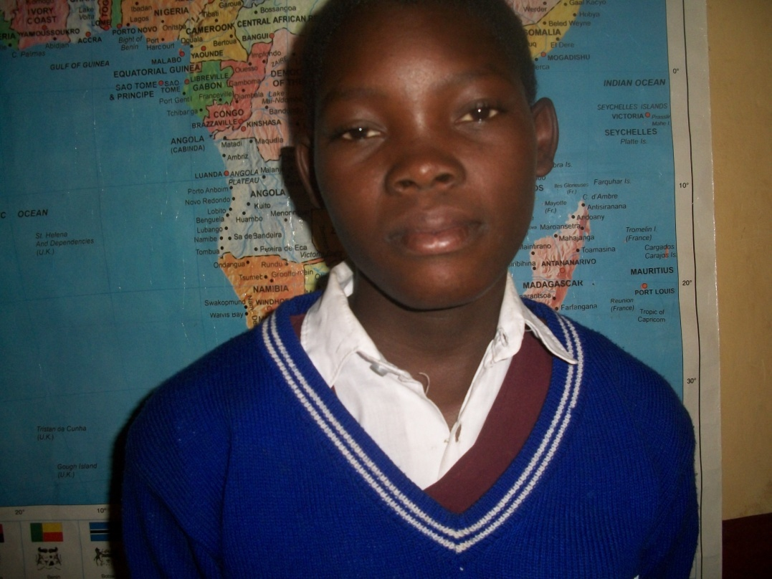
Above is a face picture of PLA beneficiary Achola Sumaya

Sumaya’s aunt Birungi was widowed 3 years back but still stays at her husband’s former employer’s home.

“My husband was a house help and so he was given this grass hatched house to stay in and when he died of HIV/AIDS, we encouraged not to leave the house,” mentioned Birungi

“All together I have 4 children to look after yet all I do is wash people’s clothes in the neighborhood, my wish is for the donors and Platform for labour action to continue to support Sumaya and also chose at least more two of the children, because despite my luck of money, I want the future to become brighter for these children than mine my has been,” explained Birungi

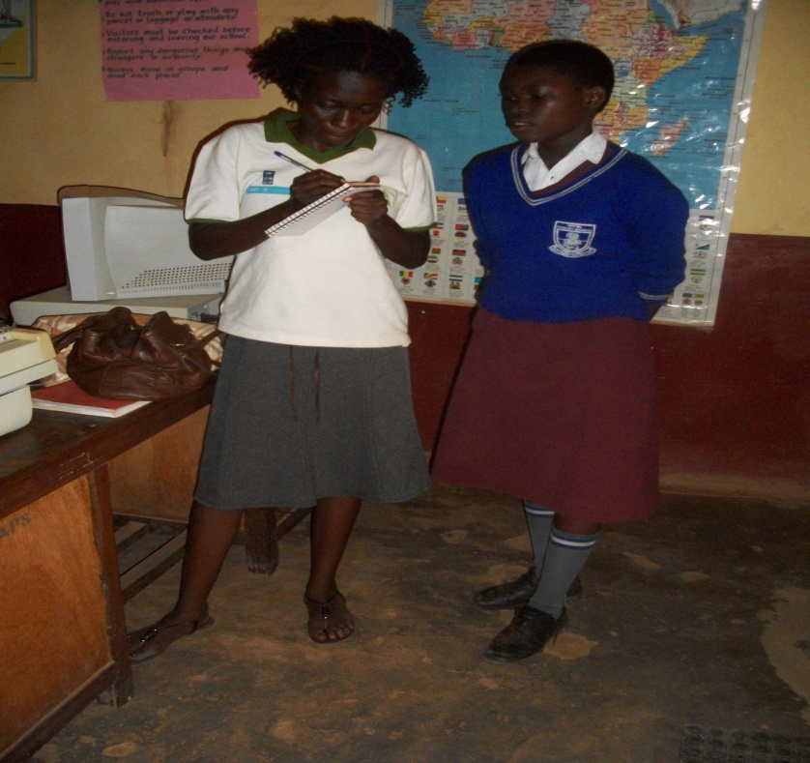
Above is a picture showing PLA staff Lorna Odong as she interviews PLA beneficiary Achola Sumaya during the school monitoring visit in Adyel primary school in Lira district

Sumaya’s dream is to become a nurse.

Like all the other beneficiaries, Sumaya continues to pray that she is supported till she attains her dream of a nurse, “Am grateful for the support that the donors through PLA has provided to me and I pray that their support to me will not only stop at primary seven but this will continue till I complete my education, I promise to perform better so that I don’t disappoint not only myself but PLA too,” mentioned Sumaya.

EJANG FIBBY’ STORY

13-year old Fibby was born to the late Akullu Harriet and the late Odong Benson, and she is currently under the care of her aunt Akullu Lilly.

Fibby’s father died in 2000 and her mother in 2001 as a result of HIV/AIDS.

“My 35-year old aunty Lilly is on medication and in a very critical condition, she hardly stays for 2 weeks without becoming sick. This scares me a lot as I know that she will die anytime soon.” Fibby sadly explained

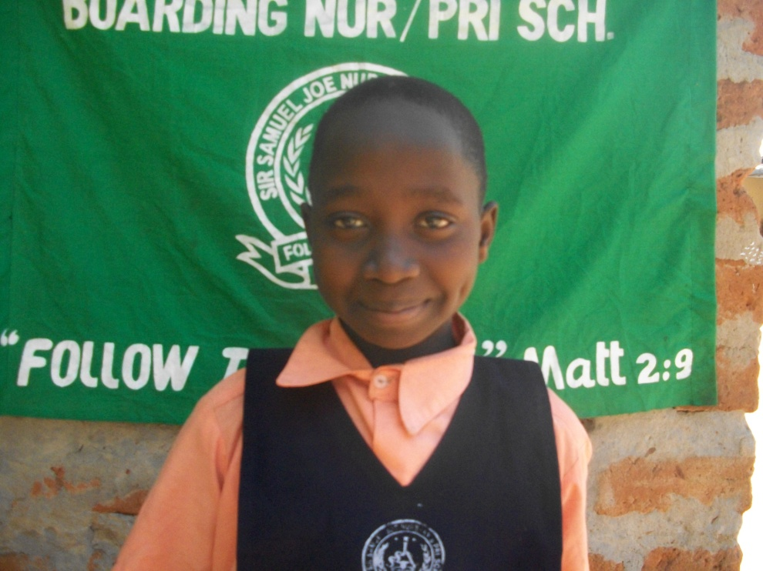
Above is a face picture of PLA beneficiary Ejang Fibby

Fibby is now in primary 7 at sir Samuel Joe primary school in Boroboro,
Fibby’s best subject remains to be math and this is especially shown in the time that she spends practicing it on a regular basis as mentioned by her school math teacher, Miriam Okello.

“I would like to become a teacher after completion of my education,” mentioned Fibby.

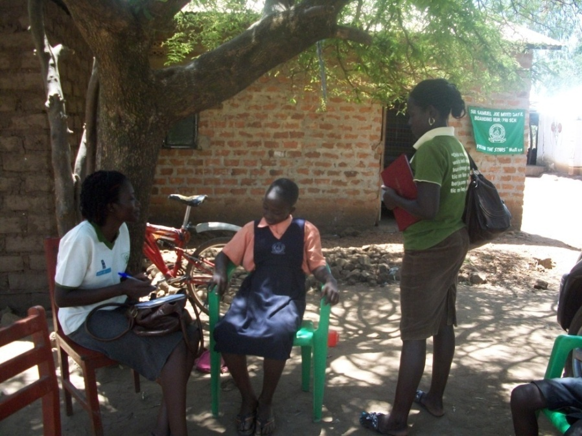
Above is a picture showing PLA staff Lorna Odong and Susan Ejang both in t-shirts as they talk to PLA beneficiary Fibby during the school monitoring visit in Sir Samuel Joe Nursery and primary school.

“The condition at home is not good at all especially now that all the eyes are on me, we survive on greens like dodo and hardly change the diet,” sadly narrated Fibby .

With Fibby’s aunt sick, as the elder person at home, she has to look after the young ones. “On a regular basis, I always move with my aunt to the main referral hospital to pick for my young sister and aunt medication each other time it’s done,” mentioned Fibby.

Fibby and her 3 siblings stay in a semi permanent house that leaks., the house is in a bad condition and in the last visit, the local leader of the area had collected 120,000 Uganda shillings that would support in constructing for the family a grass thatched house.

ATOKA NANCY’S STORY

13-year old Nancy is born to the late Abura Emmanuel and Ayo Molly. She is under the care of her 35-year old disabled paternal uncle, Abura Thomas.

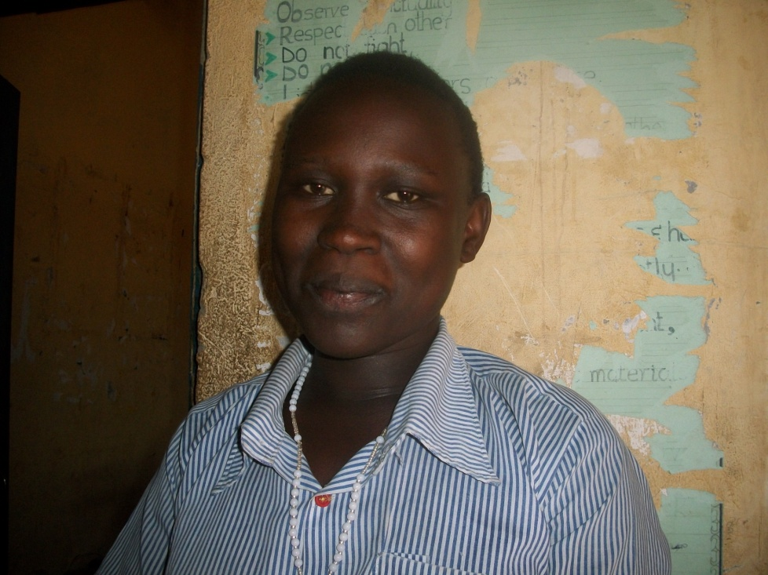
Above is a face picture of PLA beneficiary Nancy Atoka

This year Nancy is in primary six at Railways primary school in Lira.

Despite her bad performance in the past, Nancy managed to score 38 out of 80 pupils in her class, this lead her to get the promotion to the next class in primary six.

“I don’t want to disappoint anyone, therefore am going to read so hard and consult with the teachers whenever I can,” promised Nancy.
In explaining why her performance has been bad in the past, Nancy mentioned that at home she has a lot of work to take care of before and after school and because of this, its had for her revise her books.

“By the time I get to read my books out of class and school, am already tried and very sleepy, this made it hard for me to perform better, but now due to the advise that I have been getting from PLA and my teachers, I can always utilize the free time here at school to read my books,” mentioned Nancy.

The lunch that Nancy receives from the school has also boosted her performance unlike before when she would become very lazy at school in especially after hours because she would be very hungry to concentrate in class.

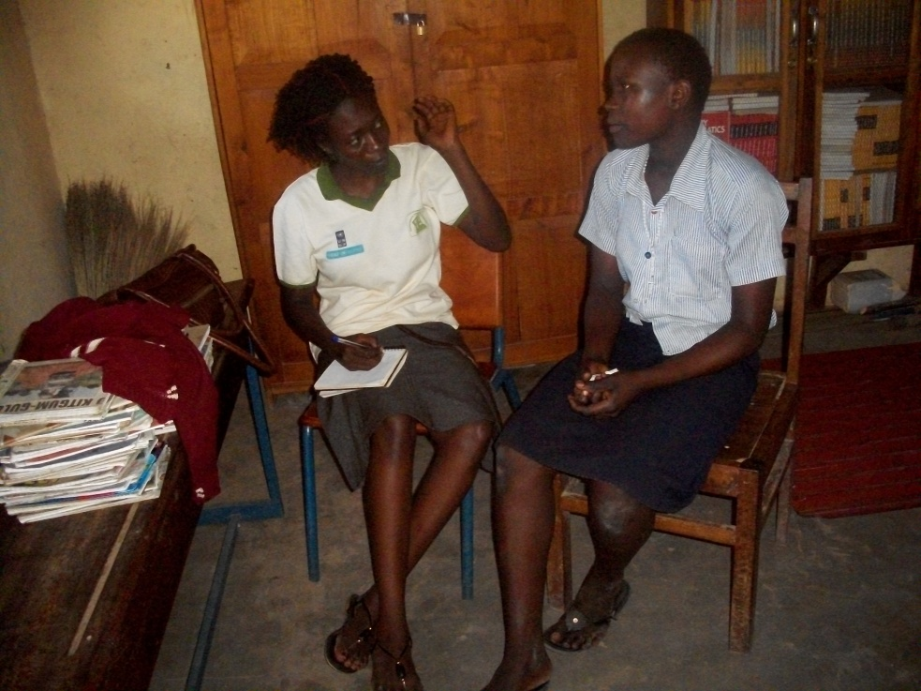
Above is a picture showing PLA staff Lorna Amollo as she talks to PLA beneficiary Nancy during the school visit at Railways primary school in Lira district

Nancy is very grateful that PLA choose her out of the many girls that cant afford to be in school anymore, “I continue to pray that God will bless the people that send support for me to be in school” conclude Nancy.

ENANG MORINE’ STORY

13-year old Morine was born to the late Okello Alfredand the late Amony Collin and she is now in care of her 37-year old paternal aunt Atyang Anna.

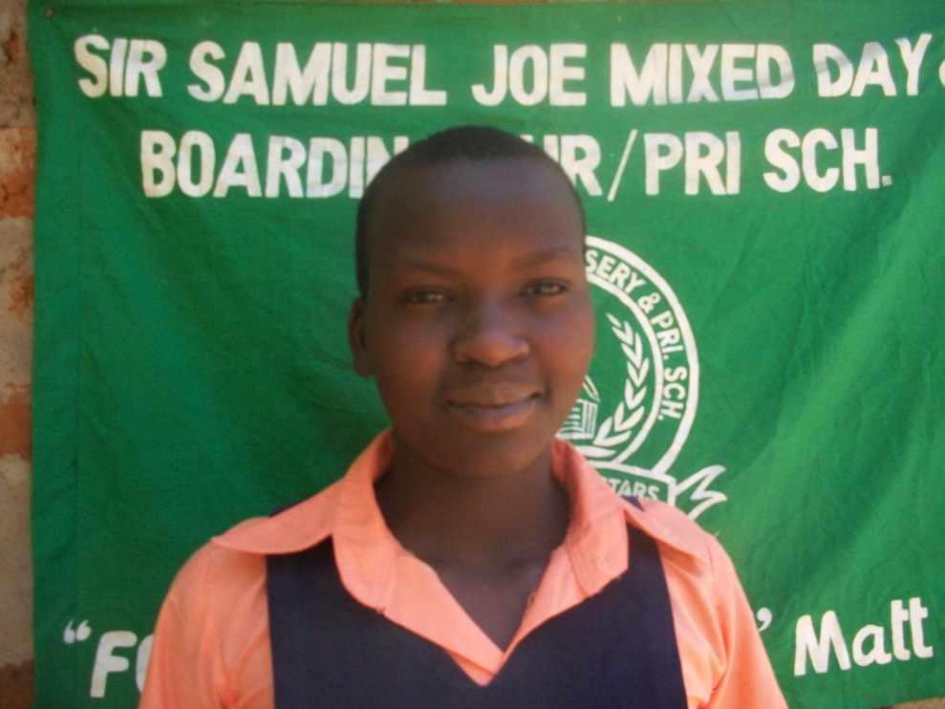
Above is a face picture of PLA beneficiary Enang Morine

Morine is the head prefect at her school in Sir Samuel Joe nursery and primary school, this position was given to her due to the discipline, and her performance in school and especially the leadership skills that she portrayed.

During her free time Morine loves to do a lot of things which are inclusive of time spent in church.
“I love playing hand ball and singing, I also teach Sunday school children at our church in Ogena Christian church,” happily narrated Morine

Morine currently in primary seven at Sir Samuel Joe nursery and primary school.
“I was the 1st out of 64 pupils in my class and though math is my best subject I don’t understand it from the school where I am but when my friends show me how a calculation is done,” said Morine

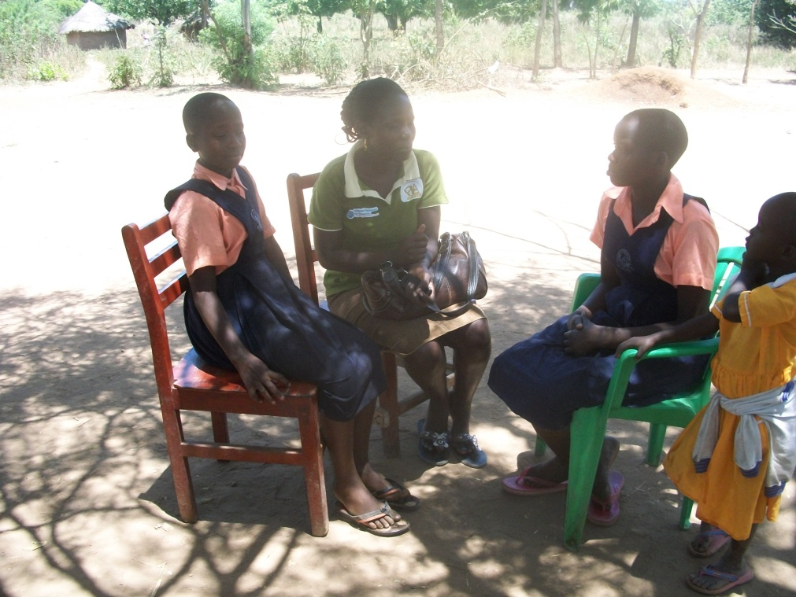
Above is a picture showing PLA staff Susan Ejang as she talks to PLA beneficiaries Morine and Fibby during the school monitoring visit at Sir Samuel Joe Nursery and primary school in Lira district.

Morine parents were both killed by the rebels in 2000, “after their death, my grandfather tried to cater for me but he became helpless until aunt Anna took me up but she can also hardly help. It is the church that provides for us but it’s also fading away,” sadly mentioned Morine.

Morine has 2 siblings but currently she doesn’t know where they are and who is supporting them, she continues to be grateful to PLA for the support that they have renderer her in the past years of her school, which was since her primary 5.

“I promise to perform better now that I will seat my Primary Leaving examinations this year”. Mentioned Morine.

CONCLUSION

Despite the challenges faced by the beneficiaries due to increase in the costs of living, they have still managed to start school with interest to work hard.
This year the beneficiaries will need school lunch, scholastic materials and continuous counseling. 7 girls this year will also seat their primary leaving examinations and their schools demand they join the boarding sections so that they are able to benefit from the extra lessons.

PLA and the beneficiaries remain grateful to the support that is received through global giving; this support has given hope to a better future to many girls in the region.

