PROJECT TITLE: EDUCATE 200 WAR AND HIV/AIDS ORPHANED UGANDAN GIRLS
PROJECT WEBSITE: http://www.globalgiving.org/projects/aids-education-uganda
LOCATION: LIRA DISTRICT NORTHERN UGANDA
REPORT PERIOD: JULY-SEPTEMBER
Compiled By Susan Ejang -Platform for Labour Action Lira Field Officer

INTRODUCTION
There are currently 31 children who are benefiting from the project. Out of these 31 eight(8) are in secondary school, one(1) in vocational and 22 are in primary schools in Lira district. The schools that the children go to include Almond college, Saviors secondary school, Bulluge secondary school, Railways primary school, Erute primary school, Ireda primary school, Lira primary school, Elia Olet primary school, V.H public school, Lango Quran primary school, Alini secondary school, Wiobyek primary school, Akia primary school and St Augustine vocational lira
Though Lira has been recovering from the war that lasted for 21 years, there are still pressing issues such of access to services such as as education and health, which need to be addressed.
ACTIVITIES UNDERTAKEN
During the quarter (July, August and September) we made four ( 4) Home visits, seven (7)school visits and provided counseling support to 28 children.
Home Visits
In the previous activities such as holiday events that are carried out each holiday break, the guardians of the beneficiaries have been involved in supporting the children in both their schools activities and personal lives this has given the children confidence. In home visits the guardians are too talked to monitor how the beneficiaries improvement both at home and at school.
The children who were visited at home were excited and happy to receive PLA. Below is therefore the stories of some of the children that were talked to.
AGUTI DORINE
14 years old Dorine will write Uganda Primary School Leaving Examinations in November this year. If she performs well she will continue to secondary school and continue to aspire for her dream of becoming a Finance Minister in the Uganda Government.
“During the holidays, I was going to school because as primary seven candidates we had to finalize the primary School syllabus”, said Dorine.
“I was also able to attend a one week youth camp that was supported by our church, the theme for the camp was taken from the book of Jeremiah 8:4-8 which says, if someone falls doesn’t he/she rise up again.” Excitedly mentioned Dorine
In her mid term examinations, Dorine was able to score 24 aggregates in division two and mathematics was her best subject where she scored distinction 2. She still has to improve in social studies that she scored pass 9 and she was in the 13th postion out of 67 pupils, rthis is an average performance for Dorine. .
“Math is one of my best subjects and I always try to calculate some numbers before I sleep, the other subjects were so hard though I do revise them,” said Dorine.
In her primary seven mock examinations, Dorine kept her promise of performing better and she was able to score 16 aggregates. She was able to score credit 4 in mathematics, credit 5 in social studies, credit 3 in science and credit 4 in English, she was therefore in the 11th position out of 657 pupils in her class. Dorine is capable of performing better than this as been a constant been reminder.
Doreen’s performance in class has improved very much as a result of counseling which began last year. PLA field officer was able to talk to Dorine’s guardian who used to make her do a lot of work. Now it is different. She says that now my guardian listens to me. For example, Dorine had a fear that she was infected with HIV/AIDS, since her mother died , and thus, wanted to get tested. Her Aunty Esther took her to a hospital where she turned out to be HIV negative.

Dorine in now in a boarding section, this to thanks to the school’s contribution, her guardian and PLA support. This will make her concentrate more since she will have enough time to read her books with the help of the teachers at the school, this has also further boosted her confidence of performing better.

“I am already preparing for my primary leaving examinations that will be written in November, and I promise not to let Platform for Labour Action (PLA) and the donors down, since I have come from not having food to now having a better meal at school and proper treatment ever since PLA started supporting me ” Dorine happily says.

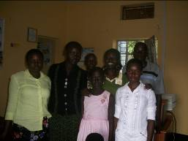
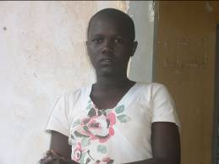

On the left is the face picture of Aguti Dorine of Aduku Road Primary school and right is the group picture taken of some of the beneficiaries Ajok Oliver, Atai Sandra, Aguti Dorine, Okello Emmanuel, Patricia and Dorine,s sister Anna with the Field Officer Susan Ejang at PLA Office lira.
At home Dorine didn’t ever have a say and had to work hard to earn food, but with continuous counseling she says, “I am relieved and whenever am saddened, I remember the words that a better life is ahead of me since PLA is on my side,” emotionally mentioned Dorine.
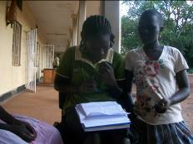
Picture showing PLA field officer Susan Ejang as she looked through Aguti Dorine’s mock results outside PLA lira office

ACEN JENNIFER
16 years old Jenifer is now in senior one at Almond College.
Jenifer has got a twin sister Apio Susan who is also a PLA beneficiary
“During the holidays, I helped my mother who is a farmer to weed the sweet potatoes and cassava,” said Jenifer
Jenifer’s mother Margret was a camp a leader at Ambalal camp during the insurgence that was in lira district.
The war took away her husband and 2 children and left them too homeless.
Even in my village in Apalla, I don’t have a house to call my own mentioned Margret. Margret has got great responsibility of all the 8 children and one granddaughter.
The community in Ambalal was able to give her a garden that she proudly gets food fro for her house hold, though the house whish now shelters them was temporally given to them by the Local council leader of Ambalal.
“We depend on the foods that our mother grows for food and clothing’s,” mentioned Jenifer

Jenifer is one of the beneficiaries is was very much affected by the war and hence lost her father who was the break winner

Jenifer has six sisters and one brother, “my sister Harriet is working as a sectary in lira and helps the family at times, she is also married with one child,” mentioned Jenifer.

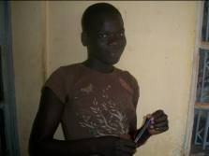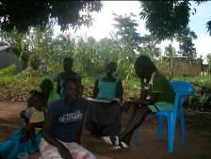
On the left is the face picture of Acen Jenifer and on the right is group picture of some of Jenifer’s family members taken during the home visit at Jenifer’s home

Acen Jenifer‘s position in class was 19 out of 170 students. “I still hope to perform better than this”, mentioned Jenifer.
Jenifer is trying to adjust from having to study four subjects in primary to 12 subjects in secondary school.
Jenifer’s performance in her subjects in second term were as follows chemistry 71, fine art 65,physics 66, history 65, physical education 62, agriculture 64, Entrepreneurship 50, biology 30, mathematics 53, geography 57, English 55, CRE 62.
“My future dream is to become a doctor, I want to be able to save lives that’s why am also going to try my best in performing better in biology”, said Jenifer
“Before PLA, I used to work in restaurants washing dishes and serving food to customers so that I could pay for my fees but now with scholastic materials and school lunch being provided, I feel life is fair to me,” mentioned Jenifer.
AKOT REBECCA
Rebecca is 12 years old and is in Priimary Six at V.H Public School Lira. At the beginning of this year Rebecca had to repeat primary six because of her poor performance in examinations.
Both the teachers and PLA field officer agreed it was for her own good to repeat primary six so that she is able to pefrform better and attain good grades whish would get her to a first class secondary school, this was during counseling and when a school visit was made to V.H public school, the teachers were in support of the adfvise.
Rebecca is one of the beneficiaries that PLA has been supporting with lunch, scholastic materials and counseling
In first term, Rebecca scored 79 in her best subject English, followed by 69 in science; she was therefore able to take the 18th position out of 222 pupils in her class.
At the end of second term, Rebecca’s position was not so good because she scored only 64 in English and 61 in science and was therefore the 32nd out of 219 pupils in her p.6 class.
“I didn’t perform to my best because I became sick and stayed home for more than 2 weeks,” mentioned Rebecca.

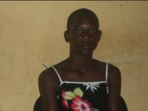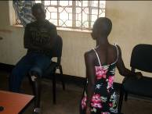
On the left is the face picture of Akot Rebecca and on the right is the picture showing PLA beneficiary Odong Samuel s.6 Kira College Butiki also an orphan formerly in the camp as he advised PLA beneficiary Rebecca V.H public school on the tactics of performing better in class.

“Mary Atam, Rebecca’s guardian said, “I have tried to provide her with all that she needs, but you know there is always little available though I want her to concentrate on her studies and become a better person than I am.” Mary sells food stuff at Lira market

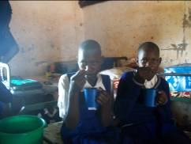
Picture showing Akot Rebecca with her friend Elisabeth as they took porridge at break time in their dormitory at V.H public school

“I thank Platform for Labour Action for the continuous support that they have been giving me, my life is different now and I have hopes of becoming a doctor now,” mentioned Rebecca.
With the counseling that Rebecca has got from PLA she has now learnt to take care of herself hygienically and is able to concentrate more in class.
AWOR FAITH’ STORY
Awor Faith is 12 years old currently in primary six at V.H Public school Lira together with other PLA beneficiaries Akot Rebecca and Akullu Daphine.

Faith is living with her mother, Grace in Adyel division; she lost her father in 2007. Both Faith and her mother are HIV positive. Faith tries her best to properly feed her daughter due to her health condition. Faith has been counseled about her condition by both PLA and her teachers at school. “Faith is HIV/AIDS positive and needs all the support that she can get especially at school, at home and from PLA,” mentioned her math teacher Acan Betty. “Faith is currently on treatment as she properly takes her medication and the food provided in school helps her a lot in these. Also, I have a garden of greens and this is always on her dish”, says her mother Grace.

Faith has two other siblings with one in secondary and the other in primary four. They are supported by other organizations such as Victory Outreach Uganda.

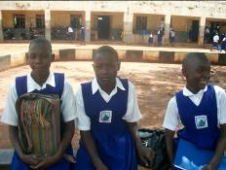
Picture taken of PLA beneficiaries Akot Rebecca, Akullu Daphne and Awor faith during the school monitoring visit at V.H Public school

During the holidays I played a lot with my friends, revised my books and also helped my mother in the gardens, mentioned Faith.
During the home visit by the field officer Susan Ejang, Faith was out in the gardens uprooting beans with her friend Edith.

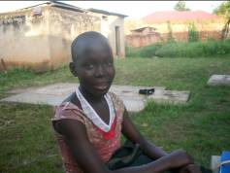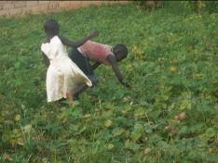
On the left is the face picture of faith at home and on the right is the picture taken while faith was up rooting beans with her neighbor friend Edith.

In first term Faith was 190th out of 222 pupils in her class, in second term faith improved when she became 143rd out of 219 pupils in her class.

“My best subject is English I only got 60/100 but I hope to perform much better in the end of years examinations,” said Faith.

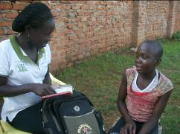
Picture showing PLA field officer Susan Ejang as she held a conversation with PLA beneficiary Awor Faith while seeing some of the scholastic materials that were given to the beneficiaries in first term

SCHOOL VISITS
There were a number of 7 school monitoring visits to the schools of Aduku road primary school, V.H Public school, Lango Quran primary school, Erute primary school, Elia Olet primary school and Akia primary school.
The school monitoring visits are meant to check on the beneficiaries’ performance in class and school.
This is also gives the organization the chance to meet the beneficiaries teachers since in most cases they are the ones that see theses while at school and have one or two things to mention about their performances. The school teachers also play big roles in shaping the benficaries better future especially when they get to know that they are vulnerable like our children are.
During the school visits the beneficiaries are monitored to see if they are getting school lunch and if they are properly using their scholastic materials as this is given to them once in a year.

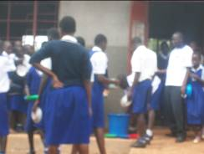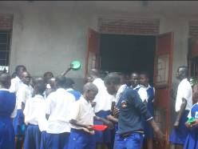
Above is a picture of the school children at V.H Public school as they got their lunch. This is the same school that beneficiaries Akot Rebecca, Akullu Daphne and Awor Faith go to.

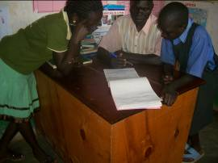

Picture showing the field officer as she viewed Aduk Morine’s performance report for second term with the deputy head teacher Awio Francis at Lango Quran Primary school
12 Year old Aduk morine was 17th out of 62 pupils in her p.5 class, compared to first term where Morine was 14th out of 61 pupils. “I have been on and off school because many times and sent away for fees,” explained Morine

ACIO LONNA
Acio Lonna is 12 years old currently in primary six and PLA has been supporting her with scholastic materials, lunch as well as counseling that has kept her strong. Lonna is under the care of her grandmother Caroline Okello of Obori village. Acio Lonna comes from a very big family who has to work hard to have supper at home; “at times she does not even come to school due to a lot of work that she has to carry out in the garden”, added Mrs. Ayo
“We are 9 at home with both sisters and brothers that our Grandmother has to take care of. I have 3 sisters and 5 brothers, one of my sister’s, Janet, is selling in the market and the rest of us try to help grandmother with her garden” , says Lonna.

During the visit we were not able to talk to her since she was in a career guidance session in her class.

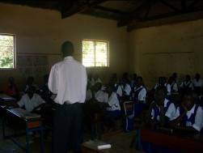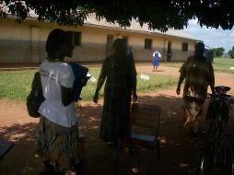
On the left is the picture of Acio Lonna’ class as career guidance session went on. The right is the picture of the field officer as she met with the senior woman teacher and the head teacher of Akia primary school

“We really appreciate the work that PLA is doing to help these children, though we would appreciate even more if you would identify more children especially from this school,” mentioned the head teacher Mrs. Ayo

Akia primary school was a camp during the insurgency which therefore makes it a place of so many helpless children.

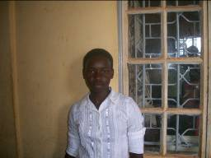
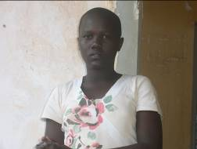
On the left is the face picture of Aguti Dorine of Aduku road primary school P.7 and on the right is the picture of Atai Sandra of Lira Primary school P.7

15 years old Sandra’s dream is to become a doctor, “I want to be able to treat people, my father was shot and no one was able to treat him because there was no doctor, I want to save lives,” continued Sandra.

As a result of PLA intervention, Sandra now enjoys staying at home because she is not over worked like before.

Sandra’s performance declined this term as she was able to score 31 aggregates in her mocks examination. “The examinations were so hard for me, though I intend to pass my primary leaving examinations with flying colors,” said Sandra

When asked what she was going to do about her performance, Sandra said, she would revise her already done mock papers with her class mates and class teachers in case of anything she does not understand.

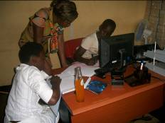
Picture showing PLA staff youth community coordinator as she guided the two PLA primary seven candidate beneficiaries atai Sandra and Aguti Dorine on their future dreams

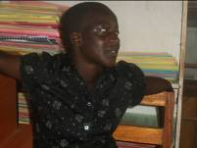
Face picture of PLA Senior four beneficiaries Akello Margret of Okwang secondary school

During the holidays, Margret kept on revising her books in preparation for her final examinations

“Platform for Labour Action has totally changed my life, until this year I never thought that I would ever seat senior four,” happily mentions Margret.

Akello Margret is one of PLA beneficiaries who was faced by the war and therefore had to stay in the Ireda camp after they had lost everything including her father.

Margret’s mother with no stable job, has to look after 4 children but gives a lot of support to her children in terms of letting them revise their books

On top of the support that PLA has been giving Margret that is scholastic materials, school lunch and counseling, Okwang Secondary school has also continued to give her a bursary of 30,000 Uganda shillings (USD 12) for her class performance and involvement in school sports every school term.

“Margret wants to become an engineer in the future, I am trying to perform to my best in my science subjects so that am able to attain my dream,” said Margret.

“During my vacation I intend to help my mother at the produce line to sell food stuff, so that my three siblings can have a better life,” mentioned Margret.

OBSERVATIONS
The continuous counseling that has been provided to the girls has led to improvement of their performance and has echoed in some of their stories above. For those who did not improve, they are motivated to work hard and hope to improve in the following term. Currently we have five (5 ) girls due to write their end of Primary Leaving Examinations (PLE) They are motivated to work hard so that they can perform better and with the help of free meals and scholastic materials that have been provided by Platform for Labour Action, they have the chance to do so.
CHALLENGES
Sanitary towels for the girls still remain a challenge, as this is not provided for in the project.
CONCLUSION
A number of 28 beneficiaries were talked to this quarter on both their academic performance and personal life, the girls have acquired confidence and are able to participate in other school activities such as the child rights clubs which was not the situation before. Child rights club was one of the clubs that was founded by the benficaries in a holiday event that was held for trhem to get to know each other and to freely communicate to PLA staff as well as as district officials like the police officer in charge of child family and protection unit. The beneficiaries have now gone ahead to sensitise other children in their schools like Eila Olet primeay school.In this quarter, many of the beneficiaries’ performances have improved. Acen Jenifer, senior one, and Aguti Dorine, primary seven are two examples.

