ASHA STORY

15 Years old Asha is now in primary seven at Lira police primary school with support from PLA. She is one of the girls who were identified last year 2012 by PLA as vulnerable orphaned girls affected by HIV/AIDS.

Asha faces many problems at home, but she is still interested in education and she performances well in class, she managed to score 77 in English subject. “Currently the major problem that I am facing is lack of food at home since my uncle Ebong has now been hospitalized for 2 months and one week, its hard for me and my younger brother to get food even the neighbors are now tired of us sadly narrated Asha”.

Above is the face picture of PLA beneficiary Asha
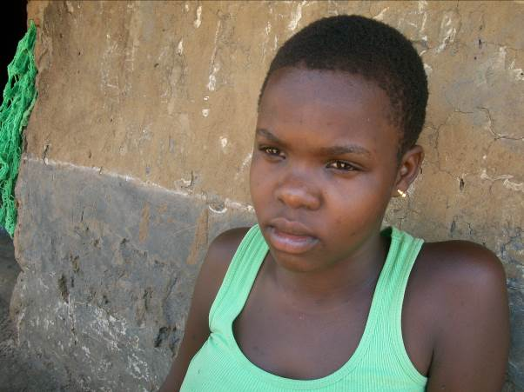
Asha lost both her parents to HIV/AIDS and she is now under the care of her also infected uncle Ebong who stays in Adyel division.

At home Asha has to move in the neighbor to pick leftover food for the rest of her family including her uncle.

During the visit at Asha's home, she explained that she is now the one taking care of the home since her uncle is still at the hospital.
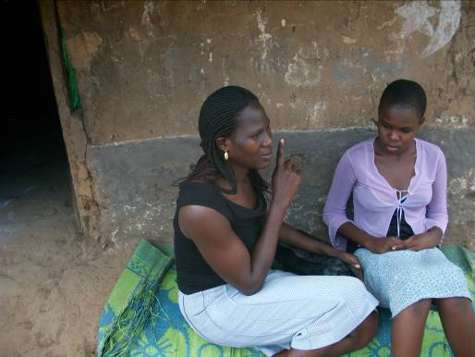
Above is a picture showing PLA student intern Jacky Onek as she talks to Awor Asha a PLA beneficiary during a home visit.

“I dont know how what I will do this school term, since my uncle doesn't seem to get better,” sadly mentioned Asha

We have started searching for other relatives Asha could have through the area local councils hopefully they will be talked to start taking the responsibility of the Asha and her brother upbringing.
To Asha, she is grateful that despite all the hardships, she is able to go to school where she also receives lunch.
“At school everything is fine since I get to have my lunch and happily study, and so gratefully to PLA for this and I hope they never stop helping me even after I have finished my primary seven,” explained Asha.

To Asha, she is grateful that despite all the hardships, she is able to go to school where she also receives lunch.

