END OF YEAR MEETING – PAMDU GIRLS CLUB
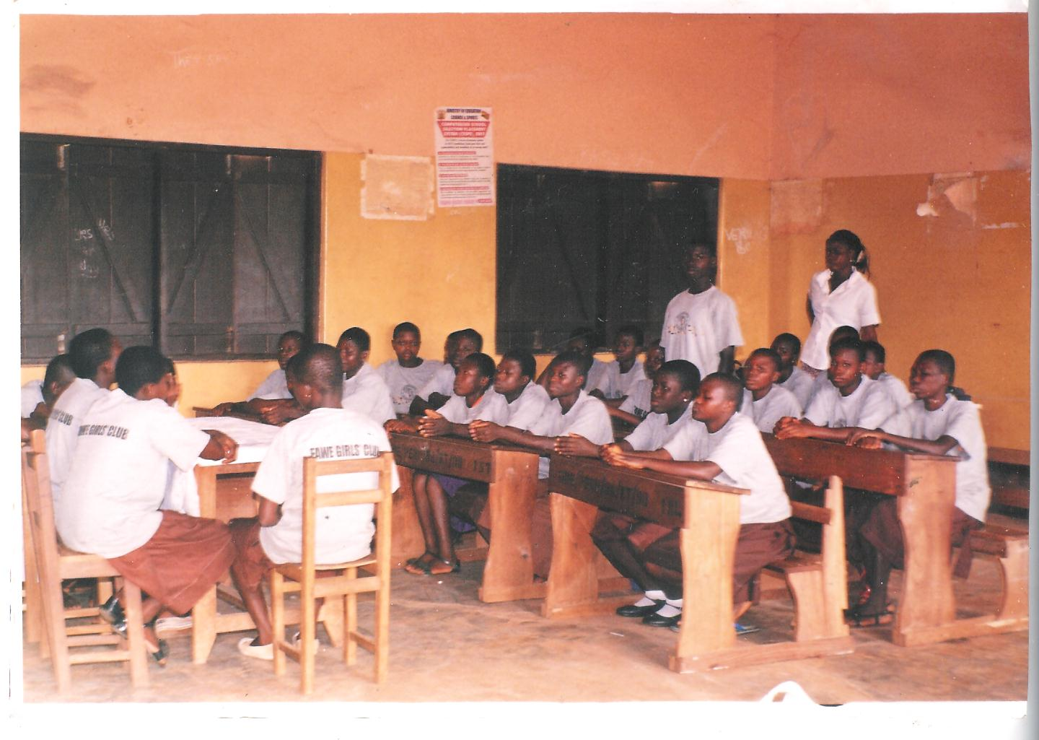
PANDU Girls Club

