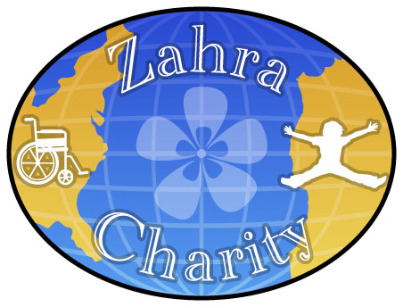

The Zahra Charity Strategic Plan: 2010
I. Executive Summary
The Zahra Charity (ZC) is an American 501©(3) non-profit dedicated to building and managing the first specialized neuro-rehabilitation facility in Morocco: The Moulay Ali Institute for Rehabilitation (MAIR). Indeed, several patient populations with neurological conditions do not have access to neuro-rehabilitation. Among them are: children and adults with pre- and post-birth neurological disabilities (genetic or birth-induced, respectively), patients with traumatic brain injuries (TBI), spinal cord injuries (SCI) and stroke induced neurological conditions.
ZC will reach out to generous and conscientious people/entities to assemble the resources necessary for making the MAIR facility become a reality: ZC will solicit and collect the needed funds and medical equipment throughout the United States and elsewhere.
In addition, ZC will:
- Sponsor neuro-rehabilitation training of Moroccan medical staff (future MAIR employees) in the United States.
- Organize a volunteer program of U.S. medical staff in Morocco, to help implement our proven neuro-rehabilitation protocols at MAIR. These efforts will target young practitioners, who will benefit from opportunities to develop additional medical skills and also acquire important global and cultural experiences.
The board of ZC Charity features our Co-founder, Dr. Jonathan Fellus. He is a world known expert in cutting-edge, comprehensive neuro-rehabilitation (see bio), and our chief medical officer. Since 1999, Dr. Fellus has been the director of the Traumatic Brain Injuries Clinic at The Kessler Institute for Rehabilitation (KIR), in New Jersey.
Our other Co-founder is Dr. Mohammed Sbia, who is originally from Morocco. He is also our chief executive officer. His doctorate degree is in brain research, with a specialty in neurotransmission, neuro-pharmacology and brain plasticity.

The Zahra Charity has organized its objectives into short and long term goals, as listed below:

Short-term goals (Years: 2010-2013): ZC will launch the first phase of MAIR, scheduled for Fall of 2011. This facility will be hosted in a leased, pre-existing building. Its startup/operating budget will be $75,000. The patient capacity will be 10 per day. This low patient capacity is intended to allow for slow but careful implementation of our neuro-rehabilitation protocols. Dr. Fellus and Dr. Sbia will coordinate this process and make sure that MAIR patients will get the best care possible.

Long-term goals (Year 2013 and beyond): By the end of Year 2013, ZC expects to generate positive cash flow and as such will mark the building and opening of permanent and self-sustaining MAIR in Marrakech City, Morocco. Startup/Operating Budget of $500,000. At the start, this first of its kind medical facility will have a daily outpatient capacity of 50 (minimum).

