April 15th, 2011 By Joe Fitzgibbon
After 13 Years With MPU, Norman Stands Ready for New Challenge

Four-Legged Member of Mounted Patrol Unit Retires, Lands New Job as Therapy Horse
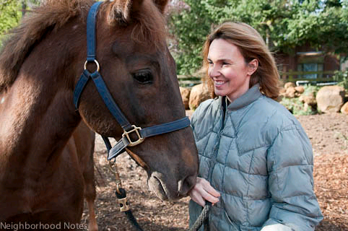
Nicole Budden of Happy Trails Riding Center. And Norman, of course.
When Norman, the senior four-legged member of the Portland Police Mounted Patrol, was approaching retirement age this spring, trainer Jennifer Mack knew where to call: Happy Trails Riding Center in West Linn.
For the past five years, the center has provided horse therapy for children and adults with physical and emotional disabilities. The gentle up-and-down movements of a horse’s back replicates the human gait and can strengthen and invigorate muscle tissue that has softened or atrophied from disease or little use.
“We’re not only seeing physical benefits but lots of self-confidence as our kids and adults spend more time on the horses,” says Nicole Budden, founder and director of Happy Trails.
Norman should fit right in, says Mack.
“He’s smart, is really good with people and used to lots of attention,” she says. “Best of all, Norman has a strong work ethic and once he learns what they need from him, he’ll do great.”
Budden has taken the gelding into her care for a month-long trial and training period. Once the equine masters the daily routine—including gentle games and rides around the three-acre ranch—and settles into his new digs, he’ll begin working with the dozens of disabled who come from as far as Salem for therapy.
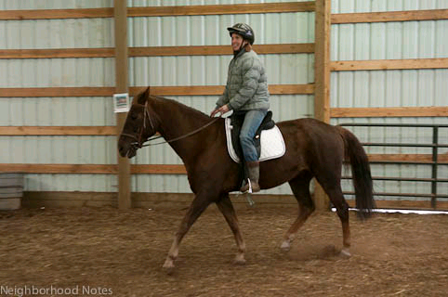
Budden working with Norman at Happy Trails Riding Center.
For the mostly novice riders, it’s not unusual to see them burst out with excited laughs or gasps once they are lifted into the saddle and handed the reins of one of the 1,000-pound animals.
“They immediately feel a sense of freedom and power,” Budden says. “It’s thrilling to watch.”
Happy Trails Riding Center is a member of the non-profit organization North American Riding for the Handicapped Association and relies on dozens of volunteers and donations to pay for the upkeep of its five horses, stalls, exercise arena, food and medical care.
Budden, who grew up around horses in California, started the program five years ago as a way to deal with the grief following the death of her disabled daughter, Hanna.
“I wanted to reach out to children, and this was so natural for me,” she says.
Budden has since expanded the center’s clients to include adults with disabilities.
Morgan horses, like Norman, are intelligent and have an easy-going temperament, Mack says. The 20-year-old, chestnut-colored horse should respond well to a rider who is nervous or off balance, she says.
In fact, after more than thirteen years of controlling crowds, dealing with troublemakers and posing for thousands of photos and strokes, Norman stands ready for his new challenge.
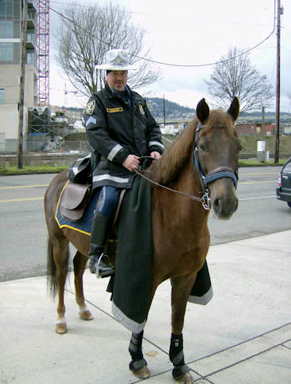
Norman on duty with Sergeant Ossenkop. Photo: Portland Mounted Patrol
As with any aging animal, the former cop mount has a few ailments, including pre-Cushing’s Disease—a digestive ailment that can shorten the animal’s life without proper diet. But, Mack says, the horse should live a strong, vital life for another ten years or more.
Mack knows that she’ll miss Norman’s daily antics but she’s pleased that he will continue to serve the public and have the companionship of other horses.
“He’s playful and a bit of a jokester, and I’ll definitely miss him,” she says. “Horses can get depressed if they are left by themselves, and I’m happy that Norman will have a new herd and new friends.”
Most of the $5,000 cost to train and care for the animal over the next year will be paid for by a grant from The Safeway Foundation, says Budden.
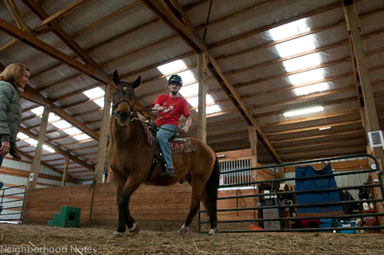
Happy Trails client Adam Tardy gets a riding lesson. After a little more training, Norman will participate in these riding lessons, too.
The public is invited to celebrate Norman’s formal introduction with carrot cake and refreshments on Saturday, May 14, from 10 a.m. to 11:30 a.m. at 20560 Fernview Road.
Lessons at Happy Trails run about $30 for 30 minutes and $45 for 45 minutes.
If you would want more information about horse therapy or you’d like to volunteer at the center, call 503.675.3005.

