[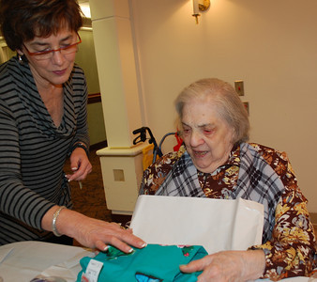](http://cedarvillage.smugmug.com/2012Events/Chanukah-Party/i-Gx6jQGk)