Project Title: Boost Income of Foster Parents & Orphaned Teens in Sri Lanka

Organization: Children’s Emergency Relief International

Project Need and Beneficiaries

Note: Due to space limitations on the GlobalGiving website, we are providing this description of CERI’s activities in Sri Lanka in addition to the information supplied on our GlobalGiving project page.
Launched in 2004 at the request of the Sri Lankan government, CERI’s foster care program has helped 180 orphans, who lost their parents in the civil war and the 2004 tsunami, to find nurturing foster families or be reunited with their relatives. CERI caseworkers maintain frequent contact with the children and their new parents, tracking students’ progress at school, assisting with homework, basic medical care, and life skills training, as well as organizing educational after-school activities.
In addition, CERI/Sri Lanka’s revolving loan program has helped increase the earnings of low-income foster families. With CERI’s support, parents established a modest community fund that several families tapped into to launch the now thriving fishing, farming, tailoring, and poultry-raising businesses, to name just a few. The program requires that the principal plus interest be repaid after a 3-month grace period.
This project will support income-generating activities for 18 foster parents and 14 young adults graduating from CERI’s foster care program in Eastern Sri Lanka that’s been ravaged by the protracted civil war, and in Southern Sri Lanka hit by the destructive tsunami. Doing so will enable more foster families to achieve financial stability, while also creating new jobs for other members of these communities.
Some of the business ventures this project will support include a dairy business; a mill to grind chili and rice; an internet café/printing shop; a seamstress shop; a mobile food sale; a goat farm; and a piggery, among others.

CERI Contact:
Marianna Gurtovnik, Contract Administrator
CERI-USA Office
1406 Stonehollow Drive, Suite 500 | Kingwood, Texas 77339
office 281-360-3702| fax 281-360-2587 | website www.cerikids.org
cell 281-462-0214

Read our success story on page 2

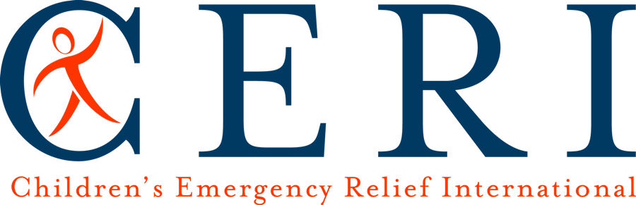

CERI HELPS A SRI LANKAN POTTERY MAKER PROSPER

Mrs. M. Shanthakumary, 50, lives in Eravur, in eastern Sri Lanka. Her husband is an unskilled, low-paid laborer. In addition to two school-age children of their own, the couple has adopted a nine-year-old Hindu girl.

A seasoned pottery maker, Mrs. Shanthakumary is a regular attendee and a secretary of Women’s Small Group (WSG), an indigenous network of small business owners established by CERI’s foster care program in eastern and southern parts of Sri Lanka. CERI has noticed Mrs. Shanthakumary’s hard work and awarded her a loan in the amount of 10,000 Sri Lankan Rupees ($88) to jumpstart her pottery business.

Prior to receiving the loan, Mrs. Shanthakumary struggled to earn enough money to purchase clay. Her retail sales to neighbors generated only insignificant income, and a large portion of the family’s revenue had to be spent on the children’s education.

After obtaining a loan from the WSG, Mrs. Shanthakumary bought clay and molded a large number of pots, which she personally transported to, and sold at, a famous nine-day Temple Festival.

“I’m very happy that I was able to earn a substantial profit in my pottery business in the summer of 2010. I spent nearly 20,000 Sri Lankan Rupees ($178 – editor’s note) and gained an income of 40,000 Rupees from this effort. Now I am making a profit of about 20,000 Rupees per month.

I’m also saving a portion of my profit to build a house. I’m anxious to obtain a larger loan to expand my business and to build a storage room for my materials. In pottery business, we need just a small amount of capital, mainly for clay, so it’s possible to get a sizeable return from a small investment. I thank CERI for providing me with a loan and for helping to improve my family’s life conditions,” Mrs. Shanthakumary said with a big smile on her face.

