Student Profile

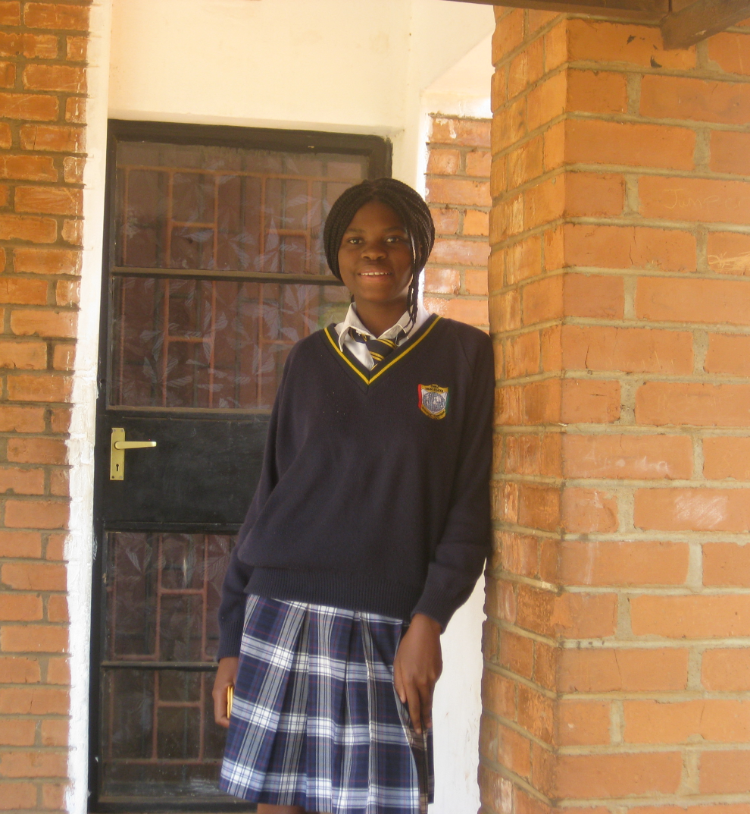
Name: Margaret Ngoma

Gender: Female
Date of birth: 13th February 1996
Place of birth: Lusaka, Zambia

Mother: Daka Atiness
Profession: Unemployed

Primary School: Chibelo Basic School

Secondary School: Chalo Trust School

2011 Grade Level: Grade 9

Family Background:

Margaret lives with her mother (Mrs. Atness - her maiden name) in Kalikiliki. She is 51 years of age and only completed her education through grade 6. Her father passed away in 2003. They live in a three room home which floods during the rainy season. Margaret is one of six children: the first and second children are married and do not live at home, the 3rd born brother lives at home and is a security guard to support his mother (although he is currently not working). He earns about 350-400,000/month, although the work is not consistent. Mamuna, the 4th born son, graduated from grade 12 in 2007 and does “casual work.” The 5th child also finished school and is unemployed. Margaret is the 6th born and youngest. Luckily, Margaret’s mother is now renting out part of their home, which has added a bit to the family’s income. Mrs. Atiness says that some of the improvements they have made to the rental rooms are due to the money they have saved by not paying for Margaret’s education.

Student’s Educational Background:

Primary - Chibelo Basic School

Margaret attended Chibelo from 1st to 7th grade where she really liked her teachers because they encouraged her to succeed. English and Social Studies were her favorite subjects. She placed number one in her class in seventh grade. She excelled especially in English and Mathematics.

At Chalo Trust Secondary

Grade 8

Margaret got off to an exceptional start to her secondary school career. She remained at the top spot in her class for the entire year, earning 8 A’s during term three and 541 out of 600 points in her final exams. These were some of the best results the school has seen to date. “Margaret is a brilliant student as can be reflected from her performance. Her results are splendid,” her teachers raved. Margaret hopes to keep improving, especially in Mathematics. A highlight from this year came at the Chalo Trust Talent Show, where Margaret appeared as a model in front of the entire school. She also modeled at the yearly Traditional and Prize-giving Day in October, where she won awards for Best in Civics, Best in Religious Education, and Best Overall in her class. Margaret made her friends and family proud, and she is sure to continue excelling during grade 9.

Grade 9

It has been another spectacular year for Margaret. She has demonstrated her commitment to her academics and her natural brilliance. In Term 1 she earned 8 A’s, an impressive feat, and came 2nd in her class. Term 2 was equally remarkable; she earned 7 A’s and maintained her 2nd position. Even during the holidays she is committed to revising her work and improving her performance; she spent time over the August break doing tuitions at DK. She has impressed all of her teachers and plans to finish the year strong with high marks on her National Exam.

Margaret’s Interests:

Margaret’s hobbies include reading and singing. She also participates in netball where she is a defender. She also participates in private tutoring after school. She has also been a member of the club Family Health Trust (FHT) since 2003 where she learns about HIV prevention during weekly meetings. An important lesson the organization has taught her is not to succumb to group influences. Since being in grade 8, Margaret has also taken up an interest in modeling.

Career Interest:

Margaret aspires to be a doctor. “I will educate the community concerning health matters and teaching the youth to abstain from drugs and sex before marriage. I will also teach the community about the dangers of sexually transmitted infection and how they can avoid it. I will also empower youths to resist peer pressure so that they can be good citizens of this country.

Teacher’s Comments:

“Her academic prowess is shown by the grades she obtained in nine subjects. She has maintained 1st position since Term 1. This is no mean achievement. Her behavior is exemplary. She relates well with students and teachers. We wish her all the best next academic year.”

Margaret’s Thoughts:

“My name is Margaret Ngoma and I am aged 13. I started primary school at Chibelo Primary School. I am the last born from my family of six, with three brothers and two sisters. I like singing in the church choir where we congregate and helping my friends in need.

I was not able to go to school because of school fees, but with the introduction of free education by the government, I am able so I really thank the Zambian government for that. When I started schooling, we did not have enough teacher, but now we have enough teachers and they are helping us academically. I had a problem of thinking where I could get my school support when I go to grade eight. But now I am happy Kucetekela Foundation which is willing to help those in need.

I feel encouraged by the Kucetekela Foundation and I know that I will go far with my education since Kucetekela is ready to better myself and my family at large. “

