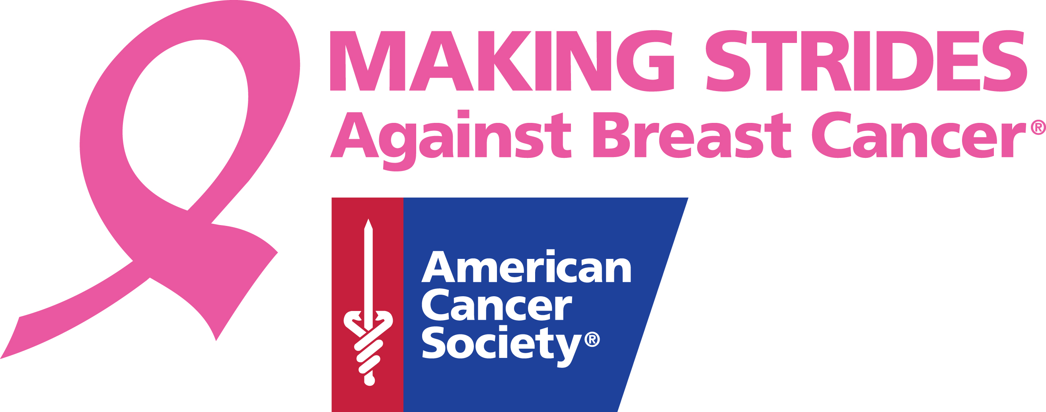

MAKING STRIDES AGAINST BREAST CANCER

Making Strides Against Breast Cancer is the American Cancer Society's premier event to raise awareness and funds to fight breast cancer. But it’s more than just the name of a walk – it describes the amazing progress we’re making together to defeat this disease. Since 1993, 3.5 million walkers have raised more than $230 million through Making Strides. In 2010 alone, over 450,000 walkers across the country collected more than $40 million to help fight breast cancer.
Making Strides is your opportunity to honor breast cancer survivors, educate women about breast cancer prevention and early detection, and raise funds and awareness to help achieve a day when no one will have to hear the words “You have breast cancer.” The majority of Making Strides events take place during Breast Cancer Awareness Month in October. They are typically five kilometers (3.1 miles) or five miles in length.
The American Cancer Society has a presence in more than 3,400 communities across the country and is the only organization available 24 hours a day, seven days a week to help people touched by cancer. Breast cancer is the number one reason people call the Society. When you support Making Strides, you are helping the Society seek better ways to prevent, detect, and treat breast cancer, as well as provide help and hope to people facing the disease.
Sign up online for Making Strides and enjoy a day of exercise, camaraderie, entertainment, food, and most importantly, a chance to honor someone you love who's been affected by this disease. Together, we will make strides toward a future where breast cancer will no longer threaten those we love!

