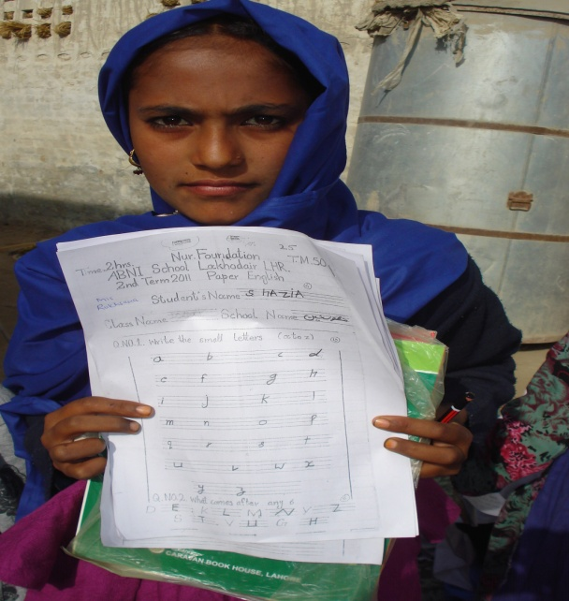

**Student proudly displaying her test results**

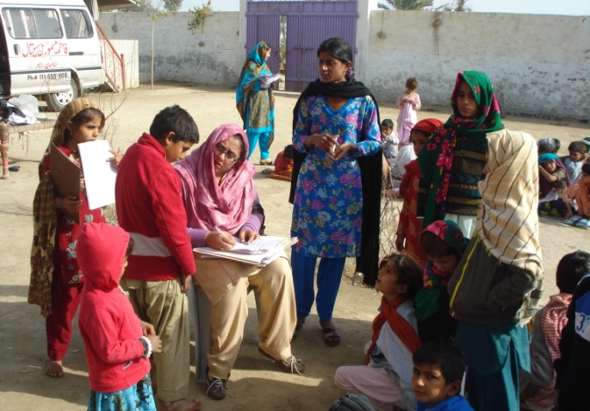

**Teacher giving individual attention to her students**