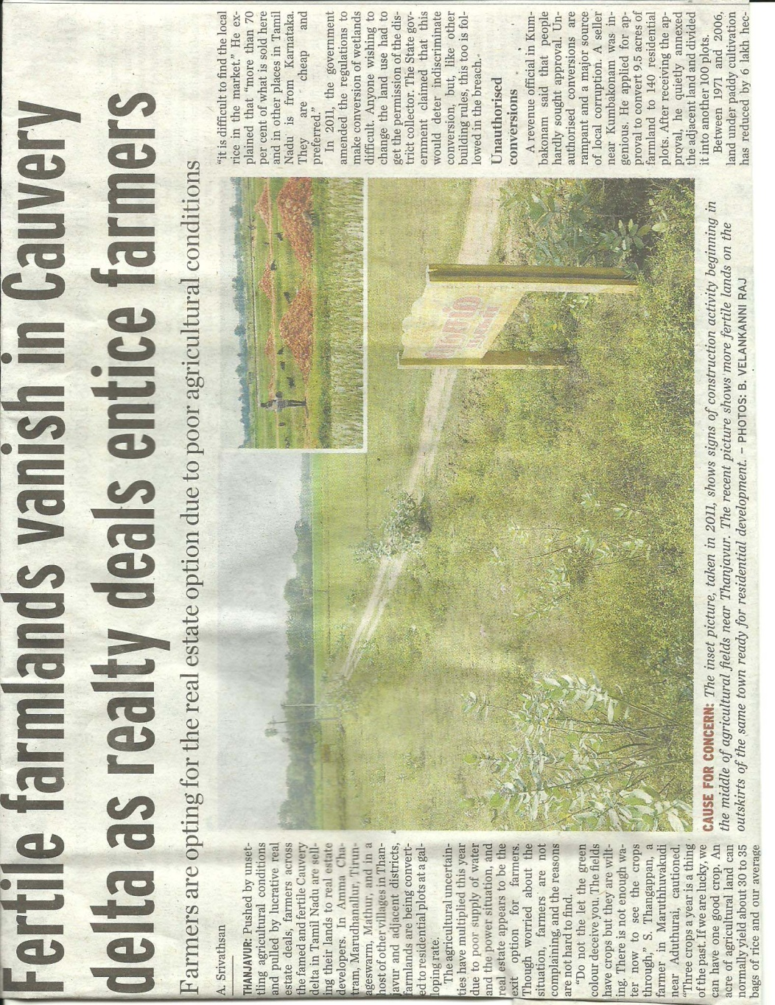
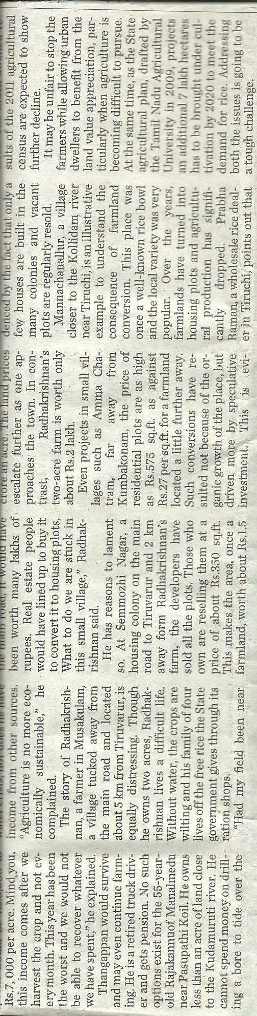

Chilli FFS farmers and resource Chilli FFS farmers’ discussion with
persons in the field resource persons after field visit

