Stories For Hope-Rwanda

B.P. 4557
District of Gasabo, Remera
Patricia Pasick, Ph.D
Executive Director

Contact Information:
ppasick@gmail.com
734-678-5512 (US)
011-250-785559866 (RW)

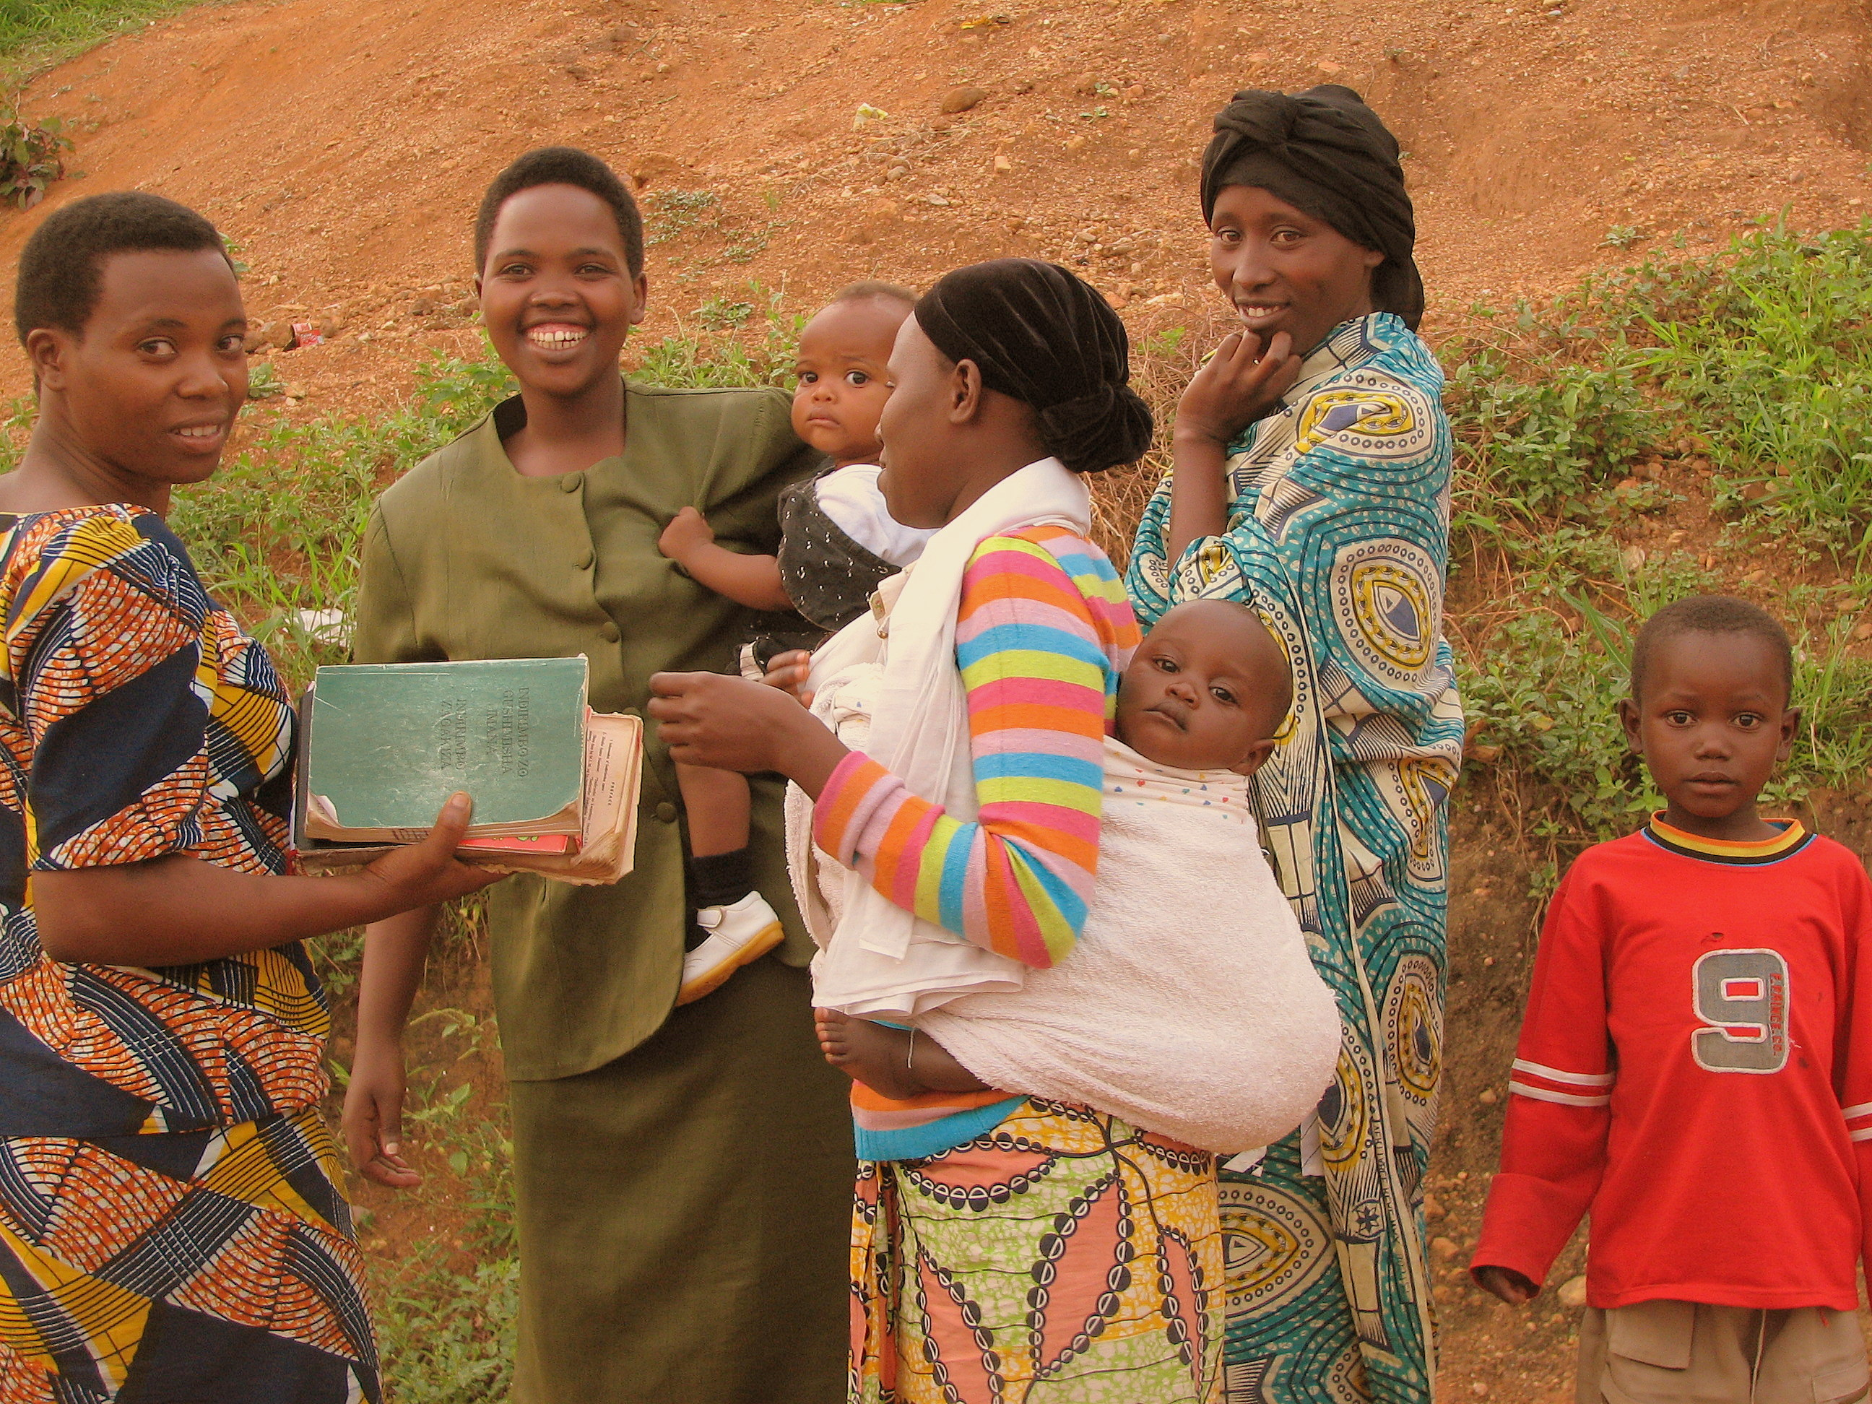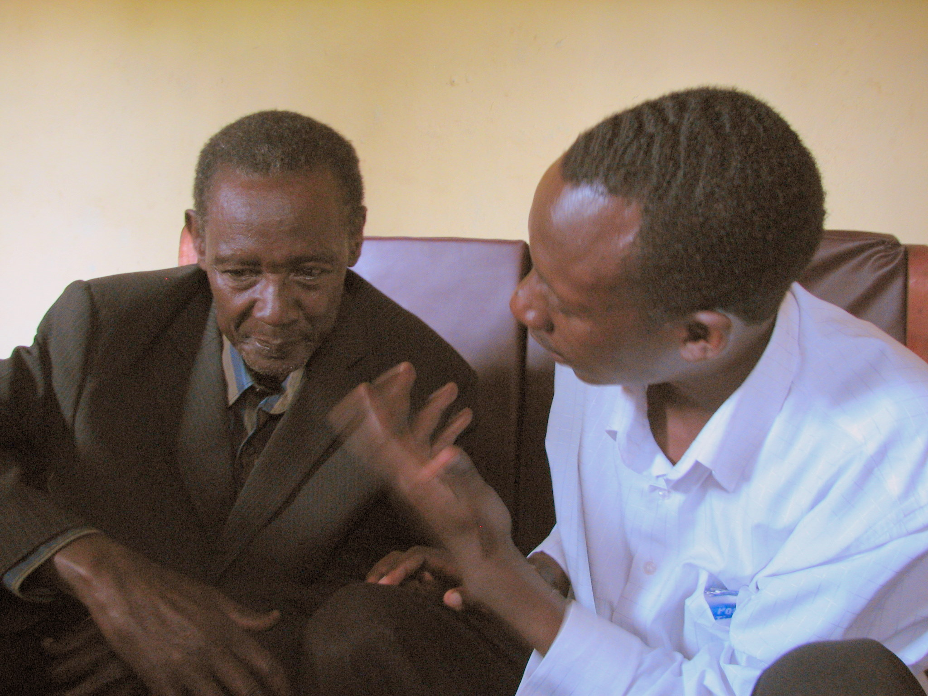

Elders:

”Help your children to know more about the lives of their ancestors: their everyday lives and dreams, their positive qualities and achievements, their culture, and what they hoped for the future generation.

A person is more than how he or she suffered, or made others to suffer. Surely, there is more to a person than that.

If the only thing young people knows about their victim relativse is that the person died unfairly and horribly, that’s their only legacy, and where their minds will go in the still moments of the day and night.

If the only thing young people know about perpetrating relatives is that these people killed or helped kill, that’s their only legacy, and where their minds will go as they walk –or hide--among their fellow citizens.

Remember: an unknown, not a known history, tends to repeat itself.”

---from the planned orientation session for elders

Stories For Hope – Rwanda
A Project with the Ministry of Sports and Culture, The Republic of Rwanda

SUMMARY Stories For Hope – Rwanda , is a 2009-2011 project to assist Rwanda in building a positive legacy for the next generation, the first to be born after the 1994 genocide. Trained facilitators guide conversations between young people (ages 14-24) and elders. Using digital media (CD and Web-based), family and cultural stories are recorded for each participant, and archived for the nation, as part of its intangible heritage.

RATIONALE
Healing: Knowing the life stories about deceased or incarcerated family members, provides an important opportunity for young people to make good choices, recover from trauma and loss, and helps heal feelings of both shame and anger. Providing a positive legacy for the next generation also helps heal elder survivors as well.
Violence-prevention: The death of over one million, and the absence of family and cultural stories, leaves the next generation more vulnerable to outside influences, and feelings of revenge. This holds true for young people who are survivors, and those who have family members in prison.
Cultural Archive: Stories For Hope – Rwanda hopes to begin, or add to, a growing archive of oral histories and traditions which celebrate positive pre-colonial indigenous cultural practices in Rwanda and the histories of individuals, families, and villages before, during, and after the genocide.

MODEL
The model for Stories For Hope – Rwanda derives in part from “StoryCorps,” in the US, which has recorded 10,000 conversations since 2003 for the Library of Congress. A similar family story project is being created in Cambodia for children of victims in the Khmer-Rouge massacres.

BUDGET
Donations and grants are being solicited in the US to meet a 2010 $170,500 budget.

IMPACT
The target is 300 stories within three years. Using national radio to broadcast selected stories into the rural districts, is being explored. CD, film and book projects will extend the project as well.

CURRENT FUNDING
The Ministry of Sports and Culture signed an MoU in 2009, and provided start-up funds. We report to Executive Secretary Jean de Dieu Mucyo, from the National Commission to Fight Against Genocide.

CAPACITY-AND COMMUNITY-BUILDING
A story-telling unit will be built in the capital and one rural district, within the first year. Community leaders, including those from youth and elder sectors will play important roles. Local Rwandese staff will be hired. Facilitators will be trained in narrative psychology techniques, a healing tool for use with survivors. By Year Three, the project hopes to leave behind the capacity for districts to set up their own storytelling centers, equipped with stationary and/or hand-held recorders
STAFFING

Patricia Pasick, Ph.D., a psychologist and author from Ann Arbor Michigan, leads the project. She is a University of Michigan and Harvard-trained psychologist with 25 years experience in narrative and family psychology, trauma work, teaching, and training. Dr. Pasick worked in Rwanda 2006-2007. She consulted to a leadership training program, developed projects in several schools, and has compiled a collection of stories from Rwanda’s top 100 government leaders.

Lydia Taima Muganyika, B.A. is in-country manager. She is also a Youth Coordinator for Never Again Rwanda, our local partner.

Albert Nzamukwereka, B.A.is a Rwandan trainer.

Benon Kalisa, is in-country translator, and Senior Trainer

Tambo Nelson is a media manager, in charge of audio recordings

Martin is a recent secondary school graduate, and an assistant.

Louise Akaliza is a student at the Kigali Institute of Science and Technology, and an assistant.

Valgas Gahizi is a group coordinator for Never Again Rwanda, and a coordinator for SFH.

Eli Sam Ntibanyendera is a media manger, in charge of audio recordings in Gicumbi.

Theophile Rutayisire is psychologist living and working in Rwanda.

Emmanuel Ndenghayo, B.A. is the director of the Sociotherapy program, in Gicumbi, Byumba, and our local partner.

Emile Babu is a US-based Rwandan transcriber

Leah Brunt is a student at the University of Michigan, and an assistant.

Erica Rouleau is a student at the University of Michigan, and an assistant.

Daniel Littlewood is the project’s film and audio editor.

Jane Hassinger, D.S.W. is a consultant from the University of Michigan, with Africa experience

David Wallace, Ph.D. is an archives consultation from the University of Michigan.

Lynn Malinoff, Ed.D. is a consultant from Eastern Michigan University, and is a researcher for the Institute of Children, Families, and Communities.

Donna Freund-Ross, M.S.W. is a social work consultant working in the field of loss and trauma.

Stakeholders

US Stakeholders

- Robert and Patricia Pasick

- Re-Cellular, Inc. Ann Arbor, Michigan

- Institute for Children, Families, and Communities, Eastern Michigan University

- Africa Studies Center, The University of Michigan
Rwanda Stakeholders

Confirmed stakeholders-Rwanda

- Ministry of Sports and Culture
- The National Archives of Rwanda
- District of Gasabo

- The National Commission To Fight Against Genocide

- Community-based Sociotherapy (Byumba, Emmanuel Ngenahayo)

- NURC (National Unity and Reconciliation Commission)

- Neveragainrwanda, a Rwanda-based NGO

- Inteko izirikana

What is Stories For Hope—Rwanda?

- Stories For Hope-Rwanda is a US non-profit corporation in the State of Michigan, registered in June 2008.
- The Republic of Rwanda issued us International Non-Governmental Organization (INGO) status, effective December 1, 2008, and renewed that status in April, 2009, and June 2010.
- We expect to have tax-exempt status in US in 2010
- In the US. a Board of Directors and Advisory Committee search has been created

MISSION STATEMENT

- The primary mission of Stories For Hope-Rwanda is charitable, to provide psychological assistance to youth whose families were ruptured in the 1994 genocide, by re-starting intergenerational storytelling, and providing technical assistance to help build capacity for the country to sustain this time-honored cultural practice.

The purpose is to re-build a positive legacy for the newest generation of young leaders, who may inherit a negative post-genocide legacy defined by intergenerational trauma and loss, feelings of anger and revenge, and conspiracies of silence which breed depression and anxiety.

- A second mission is to assist Rwanda in building an archive of oral histories which capture the essence of Rwandan values and culture.

- A third mission is train facilitators in techniques of narrative psychology, which emphasize strength-building, positive cognitions, meaning-making, and stories.

OBJECTIVES

- To train a cadre of storytelling facilitators from both the adult, and youth sectors.
- To enlist young people in recruiting their elders to tell stories they deem important to the next generation
- To enlist widows and elders to tell stories to orphaned youth.
- To collect and record 300 stories, and make them available to families and the nation on digital media.
- To provide therapeutic support as needed to participants, and create a de-briefing procedure for staff and participants
- To broadcast selected stories on Radio Rwanda, for wider distribution to rural districts.

Goals and Timelines: 2008-2011

2008 GOALS (ALL COMPLETED)

- To establish a relationship with the co-sponsor, MINESPOC, the Ministry of Sports and Culture, Republic of Rwanda
- To draft and sign an MoU with MINESPOC
- To register as an international NGO with the Ministry of Local Government.

2009 GOALS

January-May (ALL COMPLETED)

- To conduct focus groups of elders, for feedback about the project (e.g. Inteko izirikana)
- To develop possible sites for storytelling
- To begin recruiting bookkeeper, adult facilitators, and translator.
- To continue fund-raising , in US and Europe
- To apply for University action-research grants
- To obtain start-up funds from MINESPOC
- To obtain 501 (c) (3) tax-exempt status for US donors
- To refine US team consisting of Board of Directors (5), and Advisory Committee members (6).
- To refine and revise the marketing and interview processes, through US trials
- To build a website and online repository for stories.
- To conduct the pilot project
- To build a Rwandan national steering committee
- To increase the number of stakeholders in Rwanda and US
- To screen, interview, select, and train facilitators
- To market the project in Rwanda through the media
- To select storytelling sites and set up permanent location in Kigali.
- To evaluate and summarize the project for Ministry, all stakeholders and donors
- To begin facilitator selection

Second page

(GOALS AND TIMELINES 2008-2010, con’t.)

June-December

- To implement Stories For Hope in August and October (ONLY AUGUST)
- To institute Most Significant Change evaluation at each point. (COMPLETED)
- To catalog and upload stories to the website. (COMPLETED)
- To broadcast selected stories on Radio Rwanda (NOT COMPLETED)
- To raise funds for 2010. (PARTIALLY COMPLETED)

GOALS 2010

- To continue evaluating project
- To bring Ministry officials and trainers to US for a workshop
- To collect 100 stories February, and April, July, and October
- To visit provinces, and target storytelling in major towns.
- To obtain funding for 2011, in US and Rwanda.

GOALS 2011

- To revise and scale Stories For Hope to operate outside of Kigali
- To implement and evaluate the project in major towns and districts
- To conduct TOT (Training of Trainers) workshops
- To collect 100 stories April, July, and October
- To write a manual for use with other post-conflict, post-genocide nations and regions
- To translate some of the stories for a book

Who is Patricia Pasick?

As a clinical psychologist, my specialty is families, and young adult development. With a focus on untold stories, I attend to the unspoken, unnoticed, or unheralded narratives of peoples' lives. “Family” has been my career focus for 30 years as a practitioner, trainer, and author.

After obtaining graduate degrees from Harvard and the University of Michigan, I have worked in Ann Arbor, Michigan, and Santa Barbara California. In academia and post-graduate positions, I have taught and published in academia, lecture frequently, and supervise and train therapists in narrative psychology.

In 2006, I closed my clinical practice to focus full-time on writing and international work. A long career has meant many experiences:

- Co-Director, Narrative Family Therapy, Ann Arbor Center For the Family, 1996-2003
- Member of numerous professional organizations, including the American Academy of Family Therapists, and the American Psychologist Association.
- Faculty in Psychology, Fielding Institute, Doctoral Program in Clinical Psychology, 1995-1999
- Over 30 years experience as a psychologist, therapist, writer, teacher, and consultant
- Authored articles for professional journals and books, including a book about youth ages 14-24 that is
highly rated by parents, schools, colleges and universities. (Almost Grown,W.W. Norton, 1998)
- Collaborated with a Rwandan professional to write part of his memoir, to be published in September, 2010 (For Gloria)
- Working on a book of personal stories from 25 government officials in Rwanda (The Origins of Individual Leadership in Rwanda)

About Rwanda

In 1994 Rwanda endured an unprecedented death toll of close to one million people (Tutsis and moderate Hutus) and hundreds of thousands of widows, orphans and disabled people. Within three months, the civil war and the genocide totally devastated the country: almost half the population fled Rwanda in order to re-establish themselves, 80 percent of domestic animals were killed, planting material was lost, and economic infrastructure was largely destroyed. Large numbers of professionals, including doctors and teachers fled or were killed. In one decade, all human development indicators collapsed. The prevalence of absolute poverty mounted from around 50 percent in the mid-eighties to over 80 percent in 1994.

More than 100,000 children live in child-headed households

Indirectly, the genocide severely affected production capacities: elimination of qualified staff that still affects all professional organizations in the country; around one third of all rural households female- or orphan-headed; more than 100,000 prisoners in detention; and a stark rise in HIV-AIDS prevalence as a result of widespread rape.

This is the context that the new Government of National Unity, formed according to the Arusha Accord, had to face for national reconstruction and reconciliation through an intense period lasting from mid-1994 through to 1997. In 1997 the government turned its attention away from recovery and started a macroeconomic stabilization program and implemented significant structural measures, particularly to prioritize and control spending.

Between 1998 and 2001, the legal framework was put in place for decentralized governance. In 2003 the new Constitution was adopted and general elections were held, which were overwhelmingly won by the Rwanda Patriotic Front (RPF).

Reconstruction and reconciliation; governance and capacity; regional peace and stability; and language are the four issues that summarize the political, social and economic context defined by the aftermath of the 1994 genocide in Rwanda.

Already existing structural constraints of a landlocked country, a low natural resource base, high transport costs, limited land availability and a high population growth rate were intensified by the devastation caused by the genocide. Overpopulation in the North, poverty in the South and problems related to the functioning of Gacaca jurisdictions (a court system based on community justice) actively fuel social tension. Despite these impediments, Rwanda has achieved impressive progress and has put in place crucial policies for growth. There has been some diversification of exports and privatization is being pursued energetically. The Government and the President of the Republic have a legitimate power base with widespread popular support and the anti-segregation (‘Barwanda’) policy is generally applauded.

Rwanda today struggles to heal and rebuild, but shows signs of rapid development. Rwandans continue to grapple with the legacy of almost 60 years of intermittent war.
How did Stories For Hope – Rwanda come to be born?
On Day Two of a leadership development program for the government of Rwanda, a Secretary-General in one of the ministries told the group a story about how he came to be a leader. It was a story no one had ever heard him tell.
Racing across the border from the Congo to search for his family, days after Rwanda's 90-day genocide was halted; he found his way to his home village. There, over several horror-ridden, excruciating weeks, he organized the exhumation and proper re-burial of tens of thousands of slaughtered people lying in shallow, mass graves, including his own parents and brother.
He went on to found an organization to help thousands of orphans and widows and directed his career toward serving the next generation. He is now a high government official, the father of three children, and possessed of a determination to help his country.
He posed some questions to me, as a psychologist in the US.
- What will happen when the next generation of young men and women came of age?
- What should the next generation, born after 1994, know about what happened to their relatives?
- Would depression and despair overtake them, and an anger-drenched desire for revenge?
- With Rwanda committed to unity and reconciliation, what should be done about the children of perpetrators in jail or coming to trial?
After three trips to Rwanda, more conversations with the Secretary General, and a meeting with the President, I decided to use my skills as a psychologist to address these concerns. Over the next months, I stewed over his questions. The death of over one million people in the genocide didn't have to mean the disappearance of their life stories. How could they be brought forward by survivors, and told to others?
I immersed myself in relevant psychologies. I flew to New York to meet with Yael Danieli, the psychiatrist who first wrote about children of Holocaust survivors, and about the need to break conspiracies of silence that grew around traumatized parents. She became a therapist for many of their children in New York City. Her advice was to develop an intervention for the next generation. But Rwanda could scarce develop a therapist corps to help millions of young people. Also therapy is not culturally acceptable in Africa.
And then one day, on National Public Radio (NPR), I heard someone tell a life story through StoryCorps. StoryCorps is the largest oral history project of its kind, using mobile and fixed storytelling 'booths' with facilitators to encourage elders to tell the next generation important stories of their lives. If you've ever heard the stories, they are all moving and emblematic of the human spirit and its capacity for creating good out of adversity. As an archive of the US Library of Congress (30,000 stories so far), StoryCorps is a growing portrait of who we really are as Americans.
I knew this format was the right fit. As the wife and mother of Jews, I was by deep association, very much aware of the power of Holocaust stories to assert the triumph of the human dignity and spirit over the human capacity for evil. I designed a project to train Rwandans to collect the life stories of the elder survivors, plus their positive pre-genocide memories about those who perished. In telling and recording the stories, they help heal the wounds of so many lost young people. The stories also create a national 'We Shall Remember' archive for the nation, particularly for the young people cut-off from the positive legacies of their families and villages
Why We Need Your Help

Stories For Hope – Rwanda is a project within the non-profit sector. The Republic of Rwanda funded the pilot portion of the project. Other funds come entirely from private, foundation, and corporate donors. We have added several stakeholders in Rwanda, and have developing several funding sources in the US: the University of Michigan, and Psychology Beyond Borders.

Time is of the essence. The goal is to launch the project as the first post-genocidal generation comes of age. Already, genocidal ideologies have cropped up in secondary schools, and the nation is hurrying to help educate these young people about the sources of the Rwandan genocide, and debunk the many myths about how it was perpetuated. The coming generation of leaders has experienced massive loss of family and of positive role models, and continues to need support, especially as they come of age.

Rwanda is making remarkable progress as a nation, from a ground zero of near total destruction. In less than ten years time, with good governance, it rebuilt itself at all levels. As a sub-Saharan nation, surrounded by warring countries, it has been peaceful, with no outbreaks of ethnic violence since 1996. Initiatives around GNP, unity and reconciliation, gender equality, democratic processes, employment, health, training and education, and infrastructure have been very successful. Rwanda’s goal by 2010 is to be more self-sustaining, and to serve as a resource and example to the rest of Africa.

Still, it remains one of the poorest nations on earth, and has one of the densest populations in the world.

By collecting 300 stories, we hope:

- To support the continued healing of the current generation of survivors.

Telling stories is therapeutic. Techniques can be easily taught to trainers, who will teach non-professional facilitators. Community-based mental health is essential in a country without many professionals. Therapeutic storytelling provides another opportunity for people to continue recovering from trauma and loss, and other consequences of the genocide, including the imprisonment of family members.

- To promote the health and safety of the next generation

The absence of positive family stories leaves the young women and men of the next generation more vulnerable to outside influences, unsure of themselves, and subject to more anxiety and depression. The second-generation often suffers more after-effects than their survivors elders. Young relatives of participants often convert guilt into blaming the vicitms. They all need adult and family support in order to make their passageway to adulthood more secure and safe.

- To provide an ever-expanding archive for the nation’s history, another way to honor its losses and gains.

The many genocide memorials scattered among the cities and villages of Rwanda are a tribute to family members lost in 1994. This project has the capacity to archive what has not been lost, the many positive stories still alive within families once torn apart by the struggles. Orphans particularly benefit from stories about their relatives and home villages.

Research Basis for the Project

The rationale for this project is research-based. It is informed by recent work in narrative social change, PTSD recovery, and peace and reconciliation techniques.

PROBLEM: Genocide may produce some major emotional difficulties for some in the subsequent generations:

- Depression, the result of being raised by parents depleted by poverty, depression, PTSD, rape, disease by rape, imprisonment, or from being orphaned.

- Irrational anxieties, the result of unnamed fears of future genocides, being abandoned, or a
return to extreme poverty.

- Suppressed anger and rage, the result of living in a post-genocidal society with feelings of anger at those who killed others, or who accuse others of killing. Blaming the victim is a common response to guilt about coming from a perpetrator family.

- Shame/Blame, the result of being born into a perpetrator family, and then blaming the victims as an after effect of feeling shame or guilt.

- Guilt, the result of either surviving the genocide, or having a family member who perpetrated.

- Developmental delay, from fewer adult role models, and from fears of re-enacting the pathways of their ancestors. PTSD symptomology interrupts work and schooling.

SOLUTIONS:

- Healing is advanced when people hear or tell personal stories, including those which emphasize the positive qualities of their relatives, the cultures they were raised in, and the fullness of their ancestors’ lives.

- Having a purpose for telling a story, for example, for the health and survival of the next generation, helps the re-telling of the painful stories

- Young people grow stronger from hearing the stories of their elders; it widens their choices, helps them with the identity formation process, and de-mystifies the past.

- Sharing positive as well as traumatic memories of victims and perpetrators is a way of defeating violence in the future.

Story-telling Procedures

- Who: Any adult or young adult in Rwanda. Emphasis is on emerging young leaders. The project is not just for those who suffered at the hands of perpetrators, but includes survivors of perpetrators who may be jailed. Young people who wish to participate are asked to bring to the session an elder they know and respect (parent, relative, mentor, teacher, community leader). Participants are recruited from within trusted institutions: schools, churches, or clubs. Ethnicity is not a selection factor. However, the project strives to operate in areas known to have sustained the greatest losses during the genocide, and war.

- What: Any stories that people believe are important for the next generation to hear and remember, may be told. Instructions to elders are to tell stories that are “true, positive, and intended to be helpful.”

- How:

- All the stories will be recorded as digital audio tiles. CDs are made for each participant.
- All the stories told in private, in a safe, soundproof space.
- The storytelling process will be a dialogue. The storyteller will be guided to tell important stories from his/her life. The listener will ask questions from his or her own curiosity, and be guided by questions provided by the project.
- Facilitators will listen, be sure each person has a chance to speak, encourage the description of particular strengths in individuals and families, and encourage the description of strengths that lay in the culture.
- Facilitators are trained to watch for opportunities for ‘double-sided’ stories, stories of strengths and resources in the face of loss and violence.
- Following the conversation, young people and elders are debriefed using an interview process, and paper-and-pencil tool, to determine if any re-traumatization has occurred, and to elicit helpful ideas for the intervention.

4 With whom:

- Within the talking space will be one trained facilitator, who will also run the sound equipment.
- Facilitators will speak Kinyarwanda and/or French and English. Other staff will remain outside the talking space, and help participants at the beginning and end of the interviews.

- Where: The project takes place anywhere in Rwanda where we are asked to record.

Web-site

http://www.storiesforhope.org

Stories for Hope Rwanda, in addition to being an intervention for the sake of the next generation, seeks to build an archive for ordinary Rwandans to archive their family stories, and draw upon the stories of their countrypersons, for hope and inspiration.

The University of Michigan, within the School of Information, has built a Web-site for this purposes, and will host the site, at least until 2015.

For participants who give permission, their actual audio recording of their conversation, plus the English translation of the story, is archived on the Web-site. For many, this includes photos of the pair of participants who made the recording.

Archive

Our goal is add to the archive of stories which arose from the 1994 genocide, by contributing recordings of dialogues between youth and elder. Some pertain directly to the genocide; others are about the struggle to defeat poverty, illness, conflicts among people, lack of education, and the effects of being a refugee.

In June, 2010 we made contact with the director of Rwanda’s National Archive. The Archive is now holding 100 CDs of recorded dialogues, a collection which await more careful cataloguing on the next field trip
Examples from pilot interviews
- A young 14 year-old orphan girl, whose father died in the 1994 genocide right before she was born, listened while her mother told her stories of her father, and his gentle ways with their older children, for example, how he would play hand games with them. This helped the girl form positive images of her father, not just images of his murder and death.

This same mother also told stories of how her own mother raised her, the values she imparted about caring for others and working hard. The orphan girl later commented after the interview that “now I know why my mother is like she is.” The girl now can see a legacy of caring that extended as far back as her grandmother.

- A young man, aged 19, is in a family that returned from Uganda, in 1995. His mother answered his questions about his father, who survived as a refugee, but who has remained silent about relatives killed in the genocide. The mother was able to give important details about how his father managed to discover and re-bury his relatives’ remains, as they re-entered Rwanda. The young man had never heard this story. “Now I know why Dad is so quiet, and sad at times.” Before the story, he had assumed his father chose to be distant from the family.

- Another young man, aged 18, whose father died of illness when he was 8, listened while his uncle, his father’s brother, told him about his father’s many small business ventures when the father was about 18. This was startling news, and helped the young man understand why he also felt drawn to starting businesses, and after the story, felt more determined to do so.
Sneak Preview

Scene: A small booth especially designed to be soundproof, equipped with a small wooden table and 2-3 chairs, and two microphones. An adult, about 55, enters with a woman, about 30, and her son, aged 14. A community worker, speaking in the family’s native tongue, stands as they enter. In the corner of the small booth is recording equipment and a chair for the worker. The worker closes the door, and they all sit.

Worker: “Welcome, Innocent. Please come in and be comfortable. (Introductions) We are trained workers who are very honored and happy to see that you are interested in telling important stories about your family.

I see you have brought your daughter and grandson, who are interested in knowing more about their ancestors. We know many have died, and we are very sorry and sorrowful for that. Yet positive stories can never die. They help the new generation to grow healthily.

You know many of their stories of the past, including your own. . You know the special stories your deceased parents and relatives would have wanted to tell their children and grandchildren. And you have said you will answer any questions the younger families’ members have.

The stories we shall hear belong to you and your family, Innocent, and only those people whom you choose to know the stories. We will not share them with anyone without your permission. Please consider the age of the young people who are here, and tell your story accordingly.

We are here to listen with our hearts and minds, and help you tell some of those stories. We will be here as guides, not censors, or passing judgment. Some of the stories may be sorrowful, but many are not. For example, the stories may tell of the special gifts and talents and successes of your parents and relatives, of their lives before the genocides and conflicts began.

Be assured that this is a private and safe space. Do you want to begin, or would you rather have your family begin by asking questions? Or we can begin with our own questions.”

The interview begins, first with Innocent speaking with his daughter. He wants to tell her a story about his parents, how they came to live in Ruhango, their dreams, and their struggles. The daughter, Nadia, has a question about an aunt who died in 1959, and he tells about her life, and where she is buried.

Then Innocent speaks to his grandson, who lost his father in the genocide. He tells the boy about his father, what this father was like as a child, and what he thought the father would be wishing for the child, had he lived. The boy is silent, but listens intently. His mother becomes tearful, and the worker moves her chair closer, as they listen together.

The interview continues about 45 minutes. Photos are taken, and printed. The family is asked for permission to place their stories in an online library, and they sign appropriate forms. Next is de-briefing, and assembling small frames for the photos, as keepsakes.

Worker: Thank you, everyone, for coming. Please stay a bit longer and speak with me about the experience of this storytelling session. It is natural to have emotions while listening to, or telling stories about your family. Here is a CD of your story. You can listen to it, in private, or at the Internet café. Since you agreed, your story will be online in several weeks. The Web address is on the CD sleeve. You can ask to have it removed at any time, by contacting us.
Prompts

This is a guided story-telling process that has a purpose beyond catharsis and information. While the counselors will create a lot of time and space for the stories to emerge, the point is to guide the storyteller to emphasize the full life and positive qualities of the people who are now gone or incarcerated, and emphasize the future for the next generations.

- Prompts for the younger listeners. “You might ask:”
  - What should I know about the values of our family?
  - How did you survive, so as to continue our family, and be able to tell me these stories?
  - What do you want me to remember about our beloved family members who died in the genocide?
  - What story do you want me to especially remember about our family victim’s life, before the genocide?
  - What do you hope for me?
  - What are some things we can do in the next generation to promote peace, reconciliation, and unity?
  - What story from your own life do you want me to know about?

- Prompts for the older storytellers. “You might tell us”
  - What was a typical day in your life, as a child?
  - Tell us about your village?
  - What was the best moment of your life; the worst?
  - How would you like to be remembered?
  - What qualities do you possess that have enabled you to go on with your life?
  - What are some ways you stand up against these effects which seek to defeat you?
  - What qualities of our family continue to survive, and thrive?
  - What does that say, for the kind of family we are?

Ethical Issues

- Stories For Hope Rwanda is open to all volunteer participants living in Rwanda, ages 18 and older, without regard to former ethnic identities.

- Participants will be asked for their names, birthdates, and addresses, including email addresses.

- Each participant will be asked to sign a consent form giving permission for the interview to be witnessed, and audio-taped. A second sent form will ask for permission to 1/use the interview on the project’s Web-site; and 2/include the interview in a national archive.

- On the Web-site and in the national archive, participants may ask to be identified by a first name only, or be anonymous.

- Every interview will be conducted in a secure, soundproof facility.

- Every interview will be held confidential by Stories For Hope staff. That said, some of the permissioned stories which are potentially inspiring to the population may become radio pieces, newspaper accounts, or included in a book to be distributed to the population with names removed if requested.

- Each participant will receive a CD, tape, or transcript of their interview, and a CD player.

- Recorded audios will be kept in on two hard-drives, and one hard-copy. These will be protected from theft.

- Participants will be encouraged to have their photos taken, after the interview. Photos for each participant will be instantly printed, and framed before departure.

- Participants may ask that an interview be stopped, and the audio deleted at any point in the interview process.

- It is expected that many of the interviews will provoke emotion among the listeners and storytellers. It will be explained to participants that this is both normal, and allowable. Facilitators will be trained to help people through anything emotionally distressing.

Afterwards, all participants will be offered a debriefing after the interview, to handle questions, concerns, and upsetting feelings, and discuss the process. A photo session at the end of the intervention appears to be restorative, and positive.

Operating in Rwanda: Challenges and Solutions

LANGUAGE BARRIERS:

The primary languages in Rwanda are French, and Kinyarwanda, a version of Bantu. The target generation, ages 16-30, speaks basic English learned in primary and secondary schools. Their older family members may not speak English.

We are aiming for US staff that speak French, and for Rwandese staff who speak all three languages. Storytelling, and recordings, will be in native languages, and the facilitator will understand what is spoken.

UNITY AND RECONCILIATION ISSUES:

Divisionism: Rwanda’s plan is to minimize ethnic identities and accentuate one identity: being Rwandan. That said, the country is comprised of approximately 85% formerly Hutu, and 15% formerly Tutsi. Espousing genocide ideology is a crime in Rwanda. Because it still appears, especially in remote districts, care will be taken to handle any storytelling that promotes division and revenge. Facilitators are trained to dissuade such talk, and stop the interview if necessary. Two senior facilitators listen to all interviews at the end of each day to vet for possible divisionism. No story with this feature will be posted on the Web-site.

Truth-telling: Focus groups have suggested that elders have some workshop preparation before they participate in the project. The workshop will encourage elders to speak both comfortably and honestly to young people. We will attempt to sooth their fears by showing video examples of storytelling before the actual session. That said, we will not vet stories for ‘truthfulness’ within individual stories.

HEALTH AND SAFETY:

Rwanda is a country where petty crime and violence is very minimal, even in Kigali, the capital city. Money will be kept in local banks, in a bank account.

In the districts, we will travel with a driver who will also act as bodyguard over equipment and staff.

It is expected that some of the stories told will be about the horrors of the genocide. Debriefing for participants is part of the process, and proper referrals if necessary. Additionally, the project will ensure regular de-briefing time for US and Rwandan staff around issues of secondary traumatization (see Ethical Issues)

POWER:

All sound equipment for the project will be able to run on batteries, as well as local electricity. In Kigali, where Internet access is available, stories will be uploaded onto our Web-site.

Appendix

REFERENCES

Bagilishya, D. (2000, September). Mourning and recovery from trauma: In Rwanda, tears flow within. Transcultural Psychiatry.
Bayer, C. P.,Klasen, F., & Adam, H. (2007). Association of trauma and PTSD symptoms with openness to reconciliation and feelings of revenge among former Ugandan and Congolese child soldiers. Journal of the American Medical Association, 298, 555-559.
Davies, R. (2005). The ‘most significant change’ (MSC) technique: A guide to its use. Davies and Dart.
Denborough, D. (2008). Collective narrative practice: Responding to individuals, groups, and communities who have experienced trauma. Adelaide, South Australia: Dulwich Centre Publications.
Denborough, D., Freedman, J, and White, C. (2008). Strengthening resistance: The use of narrative practices in working with genocide survivors. Adelaide, South Australia: Dulwich Centre Foundation.
Diamond, R., & Becker, M. (1999). The Wisconsin quality of life index: A multidimensional model for measuring quality of life. Journal of Clinical Psychiatry, 60(3), 29-31.
Dyregrov., A., Gupta, L., Gjestad, R., & Mukanoheli, E. (2000). Trauma exposure and psychologist reactions to genocide among Rwandan children. Journal of Traumatic Stress, 13(1).
Dyregrov, A., Kuterovac, G., & Barath, A. (1996). Factor analysis of the impact of event scale with children in war. Scandananvian Journal of Psychology, 37, 339-350.
Hamama-Raz Y., Solomon, Z., Choen, A., & Laufer, A. (2008). PTSD symptoms, forgiveness, and revenge among Israeli, Palestinian, and Jewish adolescents. Journal of Traumatic Stress, 21(6), 521-529.
Herman, J. (1992). Trauma and recovery: The aftermath of violence-- from domestic abuse to political terror. New York: Basic Books.
Hollway, W. (2000). Doing qualitative research differently: Free association, narrative, and the interview method. Thousand Oaks: Sage Publications.
Horowitz, M., Wilner, N., & Alvarez, W. (1979). Impact of event scale: A measure of subjective stress. Psychosomatic Medicine, 41, 209-218.
Jenkins, A. (1990). Invitations to responsibility: The therapeutic engagement of men who are violent and abusive. Adelaide, South Australia: Dulwich Centre Publications.
Monk, G., Winslade, J., Crocket, K., & Epston, D. (1997). Narrative therapy in practice: The archaeology of hope. New York: Jossey- Bass.
Neuner, F., Schauer, M., Klaschik, D., Karunakara, U., & Elbert, T. (2004). A comparison of narrative exposure therapy, supportive counseling, and psychoeducation for treating posttraumatic stress disorder in an African refugee settlement. Journal of Consulting and Clinical Psychology, 72, 579-587.
O’Kearney, R. & Perrott, K. (2006). Trauma narratives in posttraumatic stress disorder: A review. Journal of Traumatic Stress, 19(1), 81-93.
Onyut, L., Neuner, F., Schauer, E., Ertl, V., Odenwald, M., Schauer, M., & Elbert, T. (2005). Narrative exposure therapy as a treatment for child war soldiers with posttraumatic stress disorder: Two case reports and a pilot study in an African refugee settlement. BioMed Central Psychiatry, 5(7), from http://www.biomedcentral.com/1471-244X/5/7
Rasmussen, A., Smith, H., & Keller, A. (2007). Factor structure of PTSD symptoms among west and central African refugees. Journal of Traumatic Stress, 20(3), 271-280.
Schaal, S. & Elbert, T. (2006) Ten years after the genocide: Trauma confrontation and posttraumatic stress in Rwandan adolescents. Journal of Traumatic Stress, 19(1), 95-105.
Ungar, M., Brown, M., Liebenberg, L., Othman, R., Kwong, W., Armstrong, M., & Gilgun, J. (2007). Unique pathways to resilience across cultures. Adolescence, 42(166), 287-310.

Ungar, M., & Teram, E. (2005). Qualitative resilience research: Contributions and risks. In M. Ungar (ed.), Handbook for working with children and youth: Pathways to Resilience across cultures and contexts (pp.149-164). Thousand Oaks, CA: Sage Publications.
Van Ijzendoorn, M., Bakermans-Kranenburg, M., & Sagi-Schwartz, A. (2003). Are children of Holocaust survivors less well-adpted? A meta-analytic investigation of secondary traumatization. Journal of Traumatic Stress, 16(5).
Weine, S., & Laub, D. (1995). Narrative constructions of historical realities in testimony with Bosnian survivors of ‘ethnic cleansing’. The American Journal of Psychiatry, 58, 246-260.
White, M. (2005). Workshop notes. Retrieved April 30, 2009, from http://www.dulwichcentre.com.au
White, M., & Epston, D. (1990). Narrative means to therapeutic ends. New York: W.W. Norton.
Yael, Danieli. (1998). International handbook of multigenerational legacies of trauma. New York: Plenum Press.
Yuen, A., & White, C. (2007). Conversations about gender, culture, violence & narrative practice. Adelaide, South Australia: Dulwich Centre Publications.

