2016
Society for Poor People Development

(SPPD)

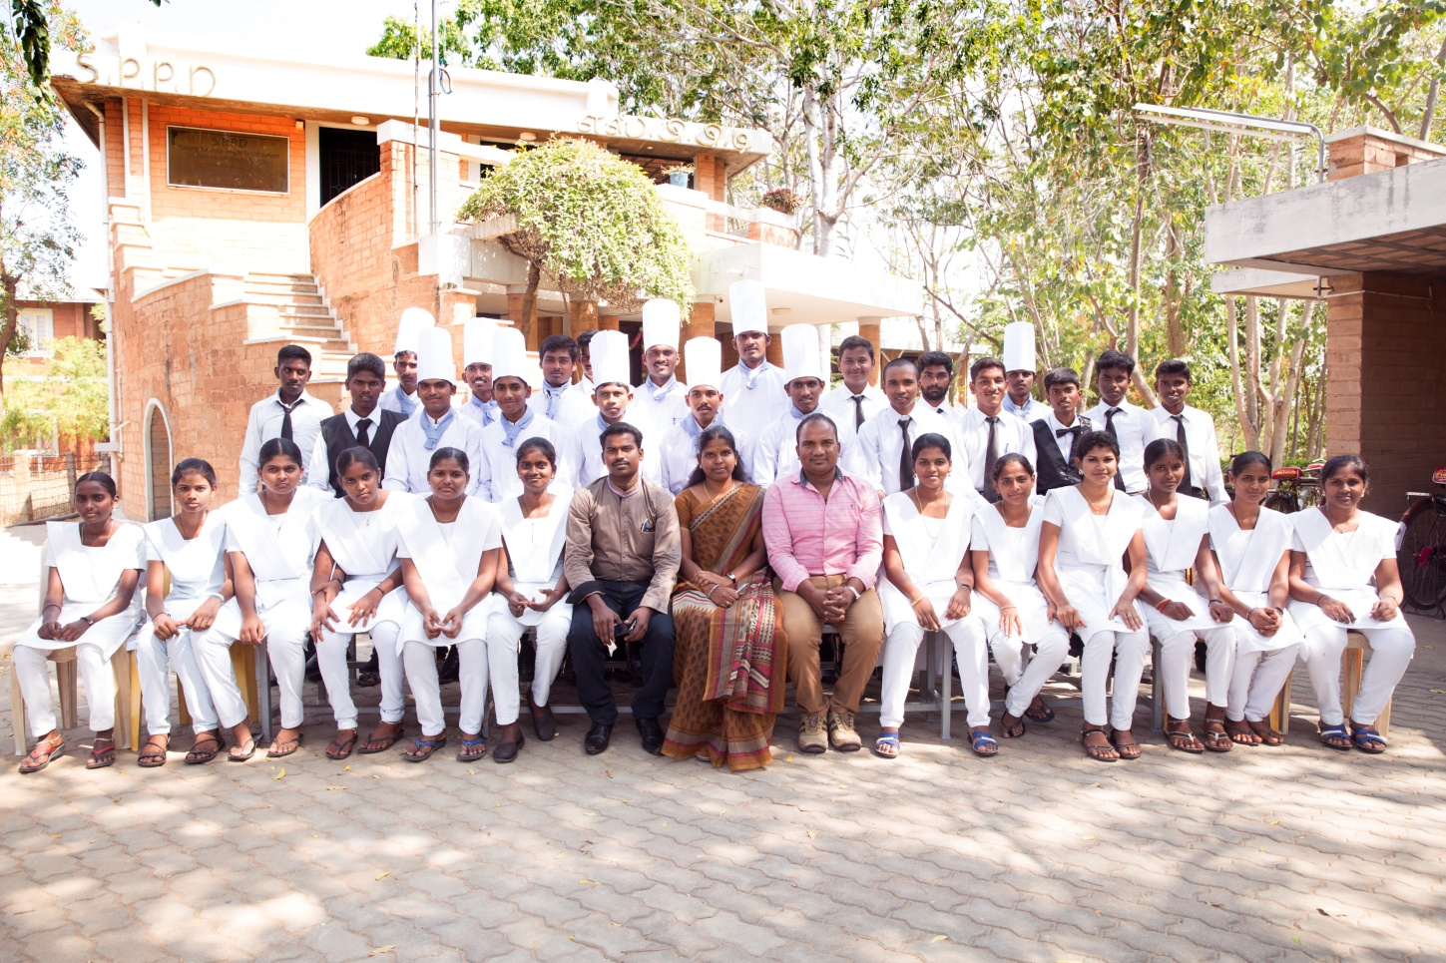

[BRINGING LIVELIHOOD TO 1,200 POOR RURAL YOUTH OF WOMEN HEADED FAMILY IN TAMIL NADU]
Imparting vocational skill training in the field of Hospitality, Health Care and Fashion technology to the poor rural youth, many of whom who have dropped out of formal schooling.

Project support
We cannot wait to share these good news and support that has poured in the last three years in supporting the 204 poor rural youth. Thanks to our 200 donors who have helped us in achieving our mission - supporting poor, less educated youth with vocational skill training. The commencement of vocational skill training programmes have transformed and empowered the poor youth to become productive recruits.
We propose to extend the present project by empowering 1200 rural youth with skill training as there is a growing demand for vocational skill among the youth community of our project area. Besides demand for skilled workers is already acute and will become even more intense as the industrial sector becomes the dominant provider of employment.

SPPD Introduction:

Since 1995, SPPD has come a long way in bringing transition among the targeted community – children & youth, women and farmers.

More than 294 children who are orphans, abandoned, who belong to aged parents, parents infected with HIV-AIDS, have passed out from our Children’s Home, are now the FIRST in their families who can read and write. The functioning of 25 Evening Study Centres have catered to the needs of 9243 children till date offering them free tuitions, educational materials and nutritional supplement. Bursary support & educational support to 972 students have helped them continue their schooling without any difficulty.

204 youth have been skilled in nursing and catering, 70% who are now at job placements in approx. 25 hotels / 18 hospitals, earning a decent livelihood of INR 7,500/- to INR 9,000/- per month. Vocational & entrepreneurial training in tailoring to 620 women help them increase their household income. Financial schemes provided to 5135 women Self Help Groups members have transferred the real economic power in the hands of women and has considerably reduced their dependence. This has helped in building self-confidence, self esteem and self worth.

Summary :
The project empowers 1200 rural youth with skill training in Hospitality, Health , Fashion designing & Beauty Care (boys & girls of age group 14 to 21) many of whom have dropped out of formal schooling, discriminatory values in society and lack of education mainly from women headed families, which will result in gainful employment.

Demand for the project:
The areas of intervention of this project are framed out in the dry belts of Central Tamilnadu (Karur, Perambalur, Dindigul & Trichy Districts). These areas receive an average rainfall consequently driving the farmers to practice unproductive dry land farming leaving them in constant poverty. The monsoons are not very generous to the farmers, worsening the situation. This has led to temporary migration of the heads of families to nearby towns, in search of a decent livelihood leaving behind women to take up the entire responsibility.
People living in these areas are in a condition of poverty & mostly women-headed because of the underlying reasons.
The majority of families have an average of three to four per household and they struggle to survive by doing odd jobs. By the time their children reach high school, parents cannot afford to keep them in school. This is more phenomenal in girl children who stay back to take care of sick parents or siblings and boys to do some sort of work to financially aid the family. Poor living conditions and desperate search of a livelihood, compel girls from such families to move under contracted life into textile industry which contributes towards the country’s economy. The situation of girls after they come out of these factories is very pathetic. Acute health problems like skin disease, respiratory problems, asthma, infertility problems of women make them even more vulnerable. They are crucially deprived of the chance for a proper education while the cycle of poverty continues & more vulnerable to dropping out & require bursary/financial support to continue the education for bright future.
Another big issue in these areas is the influence of alcoholism. It increases family problems; separation and broken family lead to children being abandoned and psychologically affected. Most of the male community have drinking problems; lose all their income on alcohol consumption and consequently fail to financially support their families, leaving women to take up the responsibility.
For the children from these poor families who succeed to be in school, continuing with the education is still a big challenge this is because many of them drop out (stop) due to other reasons such as family needs. There are many factors that may cause dropout of students in an early age. They constitute financial problems in large, dysfunctional and poor families who have problems in providing adequate clothing for all their children. In many families elder siblings have left school early to supplement the family’s financial needs as well as to take care of their younger siblings’ education. Also problems like divorce, alcoholism and domestic violence often presage school dropouts.
In certain cases, where there is the possibility of continuing education, youth who are normally influenced by featured films (movie) illustrating the luxury life of a graduate in arts and science, pursue these long term courses. They are often deprived of various learning and income-earning opportunities that could help in improving their social status and living conditions. Vocational skill training will be an effective way to help empower such marginalized populations.
Supporting for a quality vocational and entrepreneurial skills training programme to poor youth will greatly help to reduce on the unemployment problem, enable self-reliance among the disadvantaged communities, help to curb down the vicious and intergenerational cycle of poverty among children that tend flow from one generation to another.
As well as working along with the mission of India, the overall objective of NSDC (National Skill Development Cooperation) of India, is to create training capacity in the country, support scalability and sustainability of private enterprise, create a market ecosystem for skill development and meet the targets set out by the Government. NSDC mandate was to train 150 million people by 2022.
SPPD has worked to catalyze the vocational training sector in the dry belts of Trichy District over a decade. In this phase, with ample experience in the relative field, we believe that extending our support to 1200 rural poor youth will accomplish the facing demand for skill programmes as there is an emerging need for skilled youth in the field of hospitality, fashion designing and beauty care.
The project supports:
- Support a youth with study materials – 15 USD
- Will provide a set of uniform for a youth – 20 USD
- Will provide lunch & bus pass for a youth – 40 USD
- Will provide basic furniture for a centre (students table and chair) – 80 USD
- Support a youth to get training in Computer and English for two months – 100 USD
- Will provide two training computer for a training centre – 200 USD
- Will provide a youth for a year with course fee, uniform , study materials and bus pass – 250 USD
AIM
- Emphasize the importance of vocational skill training among the women-headed families (widows, destitute, women with disabilities, women whose husbands having drinking problems, living with HIV/AIDS and other health hazards) and children of these women through orientation and awareness programme.
- Skill training will be imparted in Hospitality, Fashion designing and Health & Beauty Care to 1200 youth in the respective trades. Students will be provided with their regular course material together with supplementary activities like special English coaching class, computer class, personality development, etc.
- The youth on completion of the skill training will be placed with job in respect to the course pursued.

IMPACT
- 4794 women will have a widened vision about the significance of vocational skill programme. They act as stimulators to drive their children’s aim into the vocational field of employment.
- 100 volunteers will have a thorough knowledge on the project’s perception and admissions will be guaranteed through their effort.
- 1200 youth will be skilled at the end of the project period holding a dignified position, good personality development, versatility and become financial supplements to the family.
- The constant orientation to the community, volunteer support, the end-result of trained students will support the continuity of the center even after the project period.

Activities
1. Emphasize importance of skill training
- To help broaden the vision of the local community on the importance of vocational skill training, awareness-raising programmes through our available various sources - 384 women Self Help Groups (SHGs) with 4794 members, Evening Study Centers, existing youth clubs will be made use of by means of one-to-one, one-to-group counseling, issuing of pamphlets, notices, conducting door-to-door canvassing & advertising through local T.V channels.
- External sources like youth clubs, celebrity fan clubs, farmers clubs, etc. will be contacted and orientation programmes will be organized to intensify the significance on skill training.
- 50 volunteers in each block will be oriented on importance of vocational skill training who consecutively will scale up activities of the project in the respective blocks.
- Establishing a network with Government Institutions working with similar objectives will help us to sustain the project in the long run.

2. Skill training
  - Enrollment: With support of awareness programme made to the community, the students who are dropped out of formal schooling, discriminatory values in society and lack of education of women headed families will be enrolled.
  - Courses Period: The courses runs through a duration of 6 months in the following trades Hospitality, Fashion designing and Health Care & Beauty.
  - Enrollment: Each year a batch of 400 students will be enrolled under the above mentioned trades totaling to 1200 at the end of three years.
  - Extracurricular activities: Besides their regular calendar of activities, students are also made to focus their interest on personality development, special English coaching, computer classes, etc.
  - Certificate: On successful completion of the training the candidate will be awarded with recognized certificates.
3. Ensured job placement
  - As we have good experience in providing skill training in various trades existing in other project areas for a decade, we have developed excellent rapport & good reputation with the industries for placement. The successful youth will be job placed in various industries depending on their trade.
  - Regular access with the youth under placement will be monitored to recognize the student’s attitude at the work place, ensure the placement environment has a philosophy of care and appropriate guideline will be provided.
  - With the skill training imparted and job placement, they can come out of poverty and have a secured life. The standard of living of the skilled youth will stand as a witness for the success of skill programmes amongst the inhabitants in their locality.

