Name of Organization : Masvingo Community Based HIV/AIDS and Vulnerable Children Organization MACOBAO

Province : Masvingo

Country : Zimbabwe

Address : 47-49 Hofmeyer Street , Masvingo, Zimbabwe

Email : macobao@gmail.com

Phone : +263 712 589 379

Project Director : Timothy Manyemba

REPORTING DATE : 9 JUNE 2010

ORGANISATIONAL PROFILE
Masvingo Community Based HIV/AIDS and Vulnerable Children Organization (MACOBAO) is a Private Voluntary Organization (PVO 15/2007) and Firelight grantee partner since 2008. MACOBAO’s governance structure consists of 7 executive members who are elected at the Annual General Meeting. MACOBAO’s vision is an improved care for the infected and affected by HIV and AIDS. The organization’s mission is to influence behavior change through health education and promotion, support and care for orphans and vulnerable children. The intervention seek for improved programming at local and community level , appropriate HIV and AIDS education and more and better designed services including those that address the needs of orphans and vulnerable children in their families .

The organization started operations with its main focus on strengthening initiatives for the prevention of HIV infections , mitigating the impact of AIDS and reducing communities’ vulnerability to HIV and AIDS and others who are vulnerable because of poverty, gender inequality , discrimination or social marginalization and to strengthen coping mechanisms and develop community capacity for AIDS affected families and lastly to promote community empowerment and ownership through community mobilization and wider participation. MACOBAO has been involved in care and support of orphans and vulnerable children for the past 3 years and has develop best practice especially in the Community based orphan care program whose thrust is to support community initiatives without undermining community coping mechanisms .

Over the 3 years of good and strong partnership with Firelight Foundation, MACOBAO’s capacity has evolved resulting in strategic planning to better guide institutional decision making, ability to counsel and nurture local communities in the planning, development, implementation, monitoring and evaluation of their activities, participatory development methodologies, community outreach and standing. The organization helped its staff to strengthen their technical, operational capacity to execute stated objectives, as indicated by clear and understood vision, with mission statement consistent with the organization’s portfolio, clear and consistent personnel systems with effective financial management, including compliance with generally acceptable accounting and auditing standards.

Summary
A major problem noted that does not fall into a single Program Domain is that there is an increase in the number of children living in difficult circumstances. Their problems are compounded by:

- Lack of economic security, which leads to dropping out of school (through lack of tuition fees) and poor health (through inability to pay for treatment);

- Abuse (through inadequate awareness of children’s rights on the part of both children and adults)

- The HIV/AIDS epidemic leading to an increase in the number of orphans.

Increasing levels of poverty and destitution.
Poverty is due to a number of factors such as low agricultural production, limited opportunities for income generation/enhancement, unemployment which is estimated to be at 80%, inflation, increasing breakdown of family and community structures etc. The implementation of Economic Structural Adjustment Programs has contributed heavily to the increasing poverty and destitution. The Economic Structural Adjustment Programs have resulted in many people losing their jobs both in the private and public sectors. Through the Food Security and Poverty Alleviation (FS&PA) program, MACOBAO improved agricultural production, increased opportunities for income generation/enhancement as well as strengthen family and community structures to deal with increasing poverty and destitution.
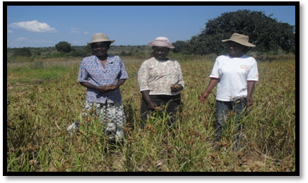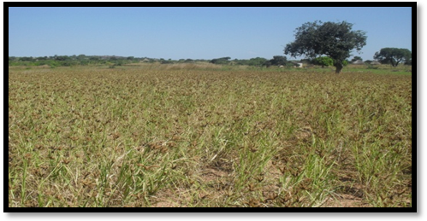
MACOBAO Volunteer with caregivers harvesting the small grains

MACOBAO assisted communities and caregivers of OVC to grow small grains. Small grains did well because they can cope well with low or limited rainfall. OVC will benefit from the food security programs and Rapoko mealie meal is good for PLIWHAS.

Increasing number of unproductive school leavers, graduates and out of school youth.
There is an increasing number of children leaving school and failing to find formal employment or to engage in productive self-help activities. The current curriculum does not give them enough life skills to start their own income generating activities for self-reliance. Access to vocational training is very limited in the rural areas as most training institutions are based in the urban areas with little or no resources to capacitate these children. 25% - 35% of the children leaving primary school do not proceed or have no access to secondary school. During the period 2008-2009 the completion rate at secondary level was 85%. Dropouts at secondary school have been as a result of inability to pay school fees, gender stereotyping and other socio-economic factors that prevent parents from sending their children to secondary school. Through the Childhood and Youth Development (C&YD) program, MACOBAO is implementing activities that will try to create a conducive learning environment for the children to realize their full potential and become useful members of their communities. In addition, activities implemented under the Childhood and Youth Development program, seeks to impart life skills and knowledge for self-reliance among children and youths in their families.

Nutrition Gardens
500 OVC are benefiting well from the project through adequate nutrition and disposable cash from the sale of surplus. Communities managed to raise funds amounting USD 750.00 and have managed to assist 5 bereaved families through procurement of coffins and food for the mourners. Some of the funds were used to access vulnerable children to health services, a component that didn’t have a budget allocation from Firelight Foundation. Through community engagement and participation, 20 vulnerable children were accessed to health services through payment of hospital fees and procurement of drugs at public and Mission Hospitals considering that their fees and charges are affordable.
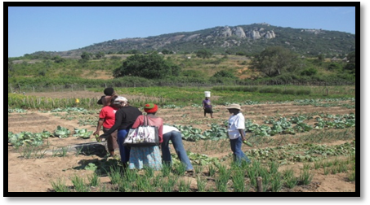
Caregivers harvesting, ready to send cabbages, tomatoes, cucumbers and fresh beans for market at the local market.

Educational Support
MACOBAO volunteers assisted vulnerable children in their families with homework and followed up on their performance through home visits support. Children under the school fees program received support and are attending school well. Children are generally enjoying school since all the required learning aids have been supplied timeously.

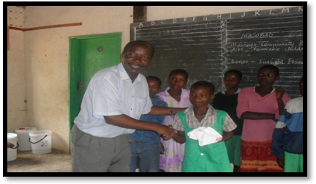
A School Headmaster at Barahanga Primary School congratulating one of the OVC for good behavior and performance. The Child is benefiting from the School fees program funded by Firelight Foundation implemented by MACOBAO in Masvingo District, Masvingo Province in Zimbabwe.

