Project Plan
For 6,000 Nadi filter units for Flood Affected families of Sindh
The project will be implemented within 2-3 Years time period

More than 6,000 Nadi filter units will be installed in camps or families living in flood water to make them possible to drink safe and clean drinking water & about 72,000 people will be benefited through this innovative safe drinking water solution. Through this project more than 72,000 households will have opportunity to drink safe and clean drinking water and save their women and children from water borne diseases and infections.

The project is highly sustainable and once 6,000 families will get Nadi filter units & in future will be able to keep maintain household level technology through their own health
S. No | Activity | Detail Expenses / | Total in US $
1. | Survey and provision of Aquatabs to the flood affected families in areas of Thatta, Sukkur and Nawabshah | US $ 3,000 | 3,000
2. | Distribution of Mosquito nets to 6,,000 flood affected families | Lump sum | 5,000
3. | Material for Distribution and installations (Hammer small. Nails 10, net 5 sets, scale 5, sand 5 mounds, balty 5 for water etc | Lump sum | 6,000
4. | Health awareness meetings and seminars at group level to promote health and hygiene for 120 groups | Lump sum | 6,000
5. | 6,000 Nadi filter units for the 6,000 flood affected families | US 20 * 6,000 Nadi filter units | 120,000
6. | Transportation Loading & unloading through 200 trucks  US $ 150*200 trucks | US $ 150*200 trucks | 30,000
7. | Travel of resource persons & food & accommodations | -Taxi charges:  - Food & Honorarium  US $ 5,000 | 5,000
Total TOT Nadi filter training expenses in US $ |  |  | 175,000/=
Funding Requested from GLOBAL GIVING |  |  | 123,500
AHD & Community Contribution will be |  |  | 51,500

Problem of the Flood affected area communities:
Floods Dirty and poor hygiene conditions  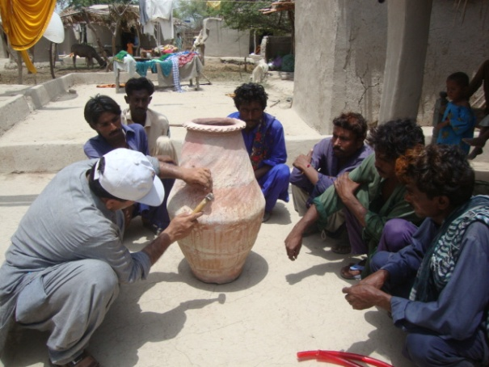  Trainings on Nadi filter by AHD staff 2014 | Un safe drinking water  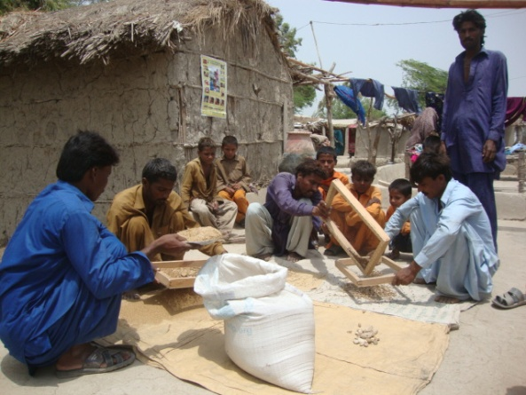  Sand sewing and washing Nov 2015
Flooded water enter in houses  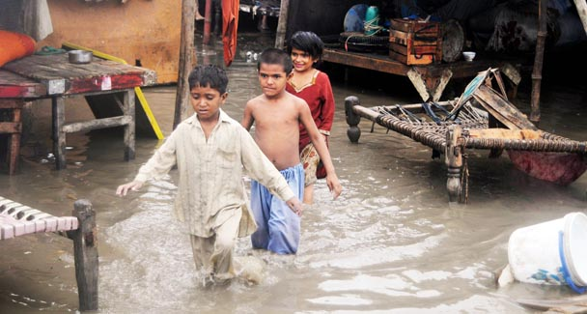 | Floods damages their houses, cloths etc  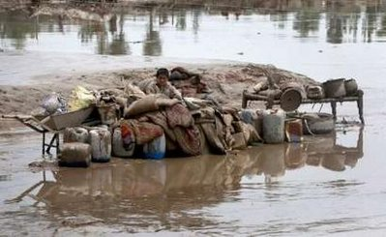
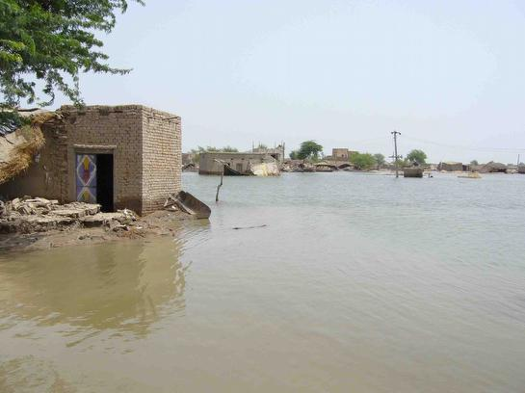  Unlimited flood water | 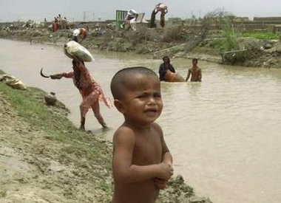  Families shifted to safer place, on the links of canals

Solution will be provided through this project:

Safe drinking Nadi filter  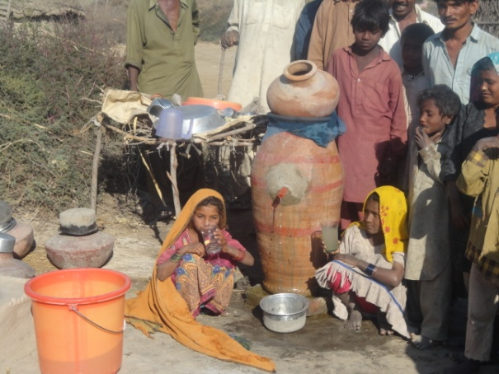 | Nadi filter water unit at household level  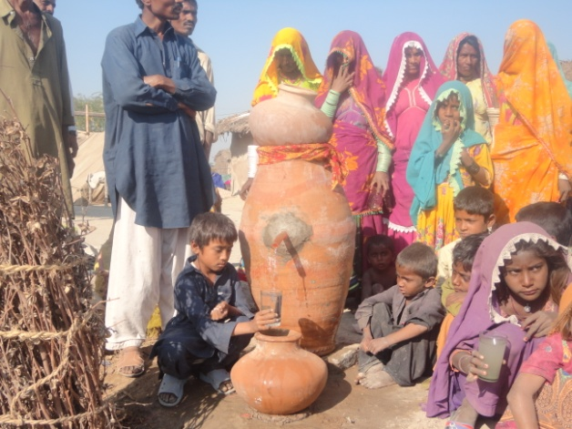
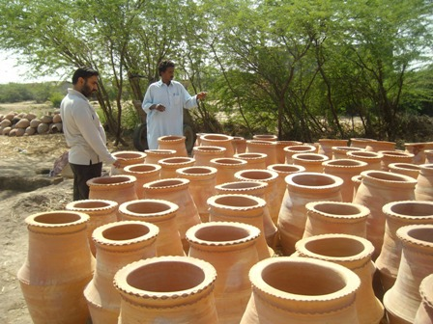  A household level Nadi filter, cheap and innovative | 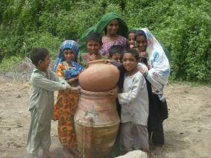  A group of children happy to see the house hold filter

Project plan prepared by:

A. Khurshid Bhatti Miss. Anita Ishaq
President / CEO Project Co-leader &
Association for Humanitarian Development Women program coordinator
House #. 39/b, Block-B Unit. No. 2, info@ahdpak.org
Latifabad Hyderabad Sindh
Ph: +92-22-3860880
Email: ahdpak@gmail.com
www.ahdpak.org

For Direct & Online donations please see below:
Bank Account details:
Association for Humanitarian Development;
Account Number: 0059-0102-1502057; Soneri Bank Latifabad Branch,
Plot No. 3/H, Ghauri Dream City, Latifabad Hyderabad.
Pakistan Swift Code: SONEPKKAHYD
If needs more clarification please write info@ahdpak.orgor can call at
Ph: 022-2860880

