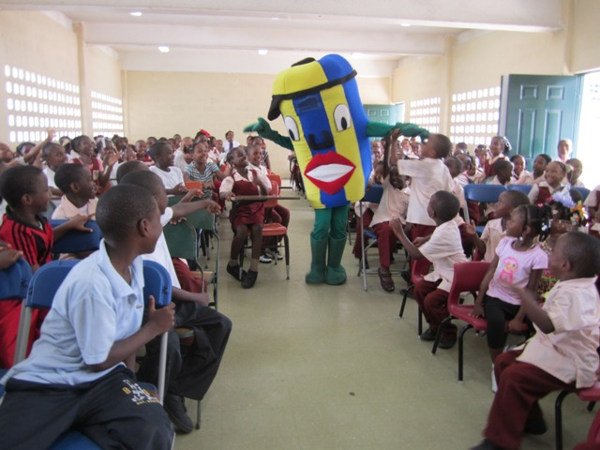
Kids get excited about nature
Primary schools across Saint Lucia are bubbling with excitement after being visited by a White-breasted Thrasher, an Iguana, a piece of Coral and “Tin Tin” as part of a series of activities that are being led by PCI Media Impact as part of My Island-My Community.
The primary school students had a chance to play, interact, sing and ask questions with the mascots that visited the schools as part of a campaign to raise awareness about the important role that nature plays in protecting the community from a changing climate as well as the actions that students can take.
The colorful mascots and students danced to a specially produced theme song and the visiting representatives shared information about the importance of protecting local mangrove and watershed areas, with particular attention to the benefits of the Mankòtè Mangrove, one of two RAMSAR sites on Saint Lucia, to the surrounding community.
Secondary school students were also in awe when popular recording artistes from Saint Lucia performed as their schools. The musicians performed their popular songs in a outdoor concert with the themes in the music addressing climate change and biodiversity.

In an effort to prepare the artistes to effectively address the climate change theme, artistes attended a half day seminar conducted by the coalition agencies and the Organisation of Eastern Caribbean States (OECS) Secretariat. At this activity the artistes worked toward a smooth execution of the school visitation exercise.

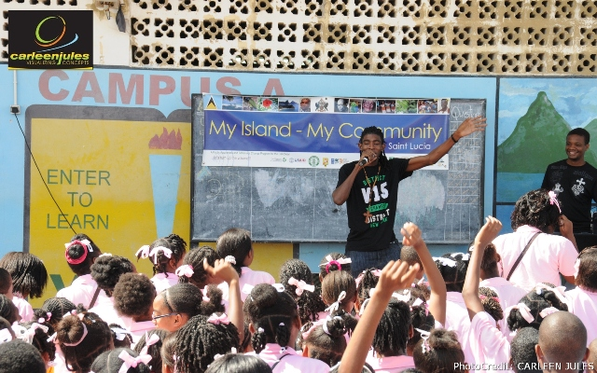
It is also expected that the exposure to information regarding climate change issues will influence their future musical writings. To date, Saint Lucian artistes namely; Ronald “Boo” Hinkson, “Scady P”, “Minelle”, “Nintus”, “Ambi”, “Monster” and “Q Pid” have confirmed their willingness to attend any school or community visits.

During the secondary school activities, students were engaged in discussion on climate change, biodiversity conservation and the role of mangroves in eco-system function, with professionals from the coalition, as well as with the visiting local artistes. Students were also treated to various memorabilia, promotional material on climate change.

The school visits will culminate in a community cleanup of the Mankòtè Mangrove on the 25th March 2013. This activity will bring together the students, friends and family together to take action to protect this precious natural resources. The cleanup will also include a number of local musicians, the mascots and promote behavior change towards climate change and biodiversity conservation.
Media Impact’s Alleyne Regis states, “In primary schools children are known to react positively to a mascot costume and hands-on activities. In secondary schools however, the approach must be different and so the visiting team adopted a different approach to the school visitation method where popular musicians helped convey messages pertaining to climate change”.
Through My Island - My Community, PCI Media Impact has been working closely with a coalition of stakeholders including: the Saint Lucia National Trust; Government of Saint Lucia’s Ministry of Agriculture, Lands, Fisheries and Forestry; Ministry of Environment [Sustainable Development and Environment Program], Rizzen FM, Folk Research Center, Radio St. Lucia, Caribbean Youth Environment Network, as well as a cadre of local volunteers all dedicated to the conservation and protection of Saint Lucia’s biodiversity.
My Island – My Community the need for accelerating adaptive measures that can reduce the islands’ vulnerability to the effects of climate change and help communities cope with the changes that are already taking place. These measures must be presented in a way that is intelligible and appealing to the average person, as individual actions contribute to achieving other key goals including better waste management, healthier forests and fisheries and improved water supplies. This new appreciation for the effects of climate change will encourage constituents to embrace adaptive measures such as the rehabilitation and conservation of natural sea defenses like mangroves and coral reefs as well as projects designed to build resilience against hurricanes.
My Island - My Community provides a clear vision of actions people can take to create a brighter future for their island and their community. It works because it is based on proven Entertainment-Education behavior change methodologies that reach into the hearts and minds of people and can be implemented at a scale to influence entire communities.
My Island - My Community is supported by a partnership of more than 60 national, regional and international organizations and governments that provide local knowledge and technical advice for a successful program including: Caribbean Community Climate Change Centre GEF Small Grants Programme, implemented by UNDP, Global Island Partnership, KfW on behalf of the German Financial Cooperation, Organization of Eastern Caribbean States, Population Services International, The Nature Conservancy and USAID and US Fish and Wildlife Service.
PCI-Media Impact is a leader in Entertainment-Education. For 27 years, Media Impact has empowered communities worldwide to inspire enduring change through creative storytelling. Working with our partners, Media Impact has produced more than 3,000 episodes of 75 productions. Together, these programs have reached more than 1 billion people in over 40 countries.

