Ragamuffin’s Arts Therapy Clinic for Children and Young People in Crisis – 2011 Update

The following provides a brief narrative report from the clinic therapist and organisation partners. September 2010 to February 2011 has already seen significant developments and growth in Ragamuffin’s Arts therapy work in Cambodia as the new clinic opens:

The Ragamuffin Project recruited and employed a team of Arts Therapists. One member of the team recently joined us from the US; a Cambodian/American Arts/Play Therapist, returning to Cambodia for the first time.
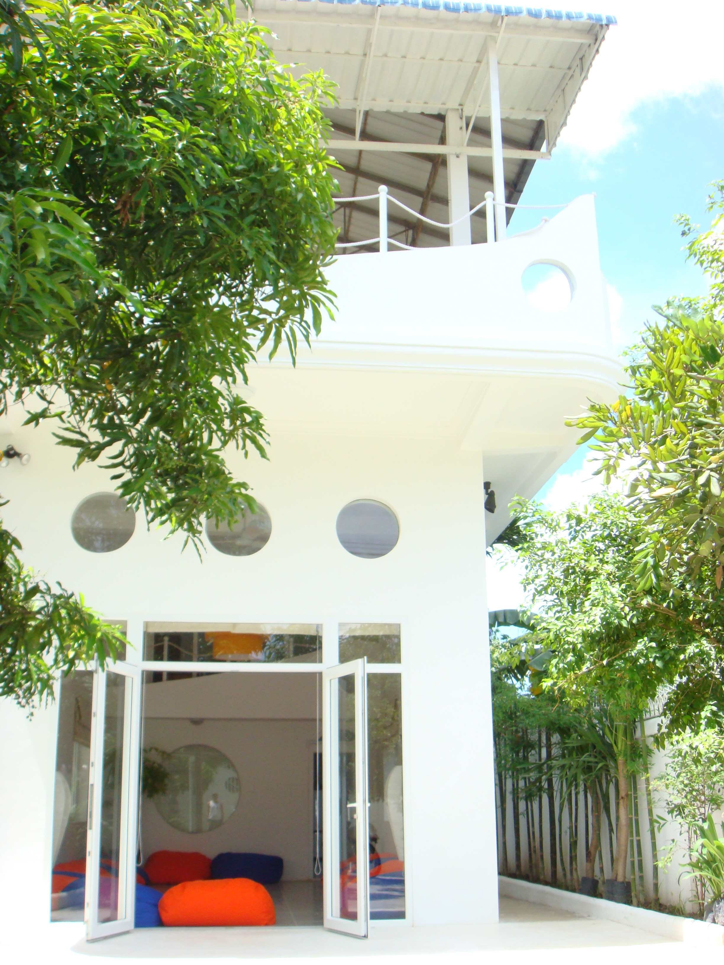
“I have been on the Ragamuffin team for only three weeks and yet, I feel as though I have always been a part of this team. Leaving the comforts of home was a difficult decision, but I feel honoured and privileged to work with such an amazing team that understands and stands true to the philosophy that art heals. Being here just reaffirms my belief that Cambodian people need Creative Arts Therapy to heal deep emotional and psychological wounds, to express their pain and to comfort their souls in times of hardship.“
(Chatti – Cambodian/American Arts/Play Therapist)
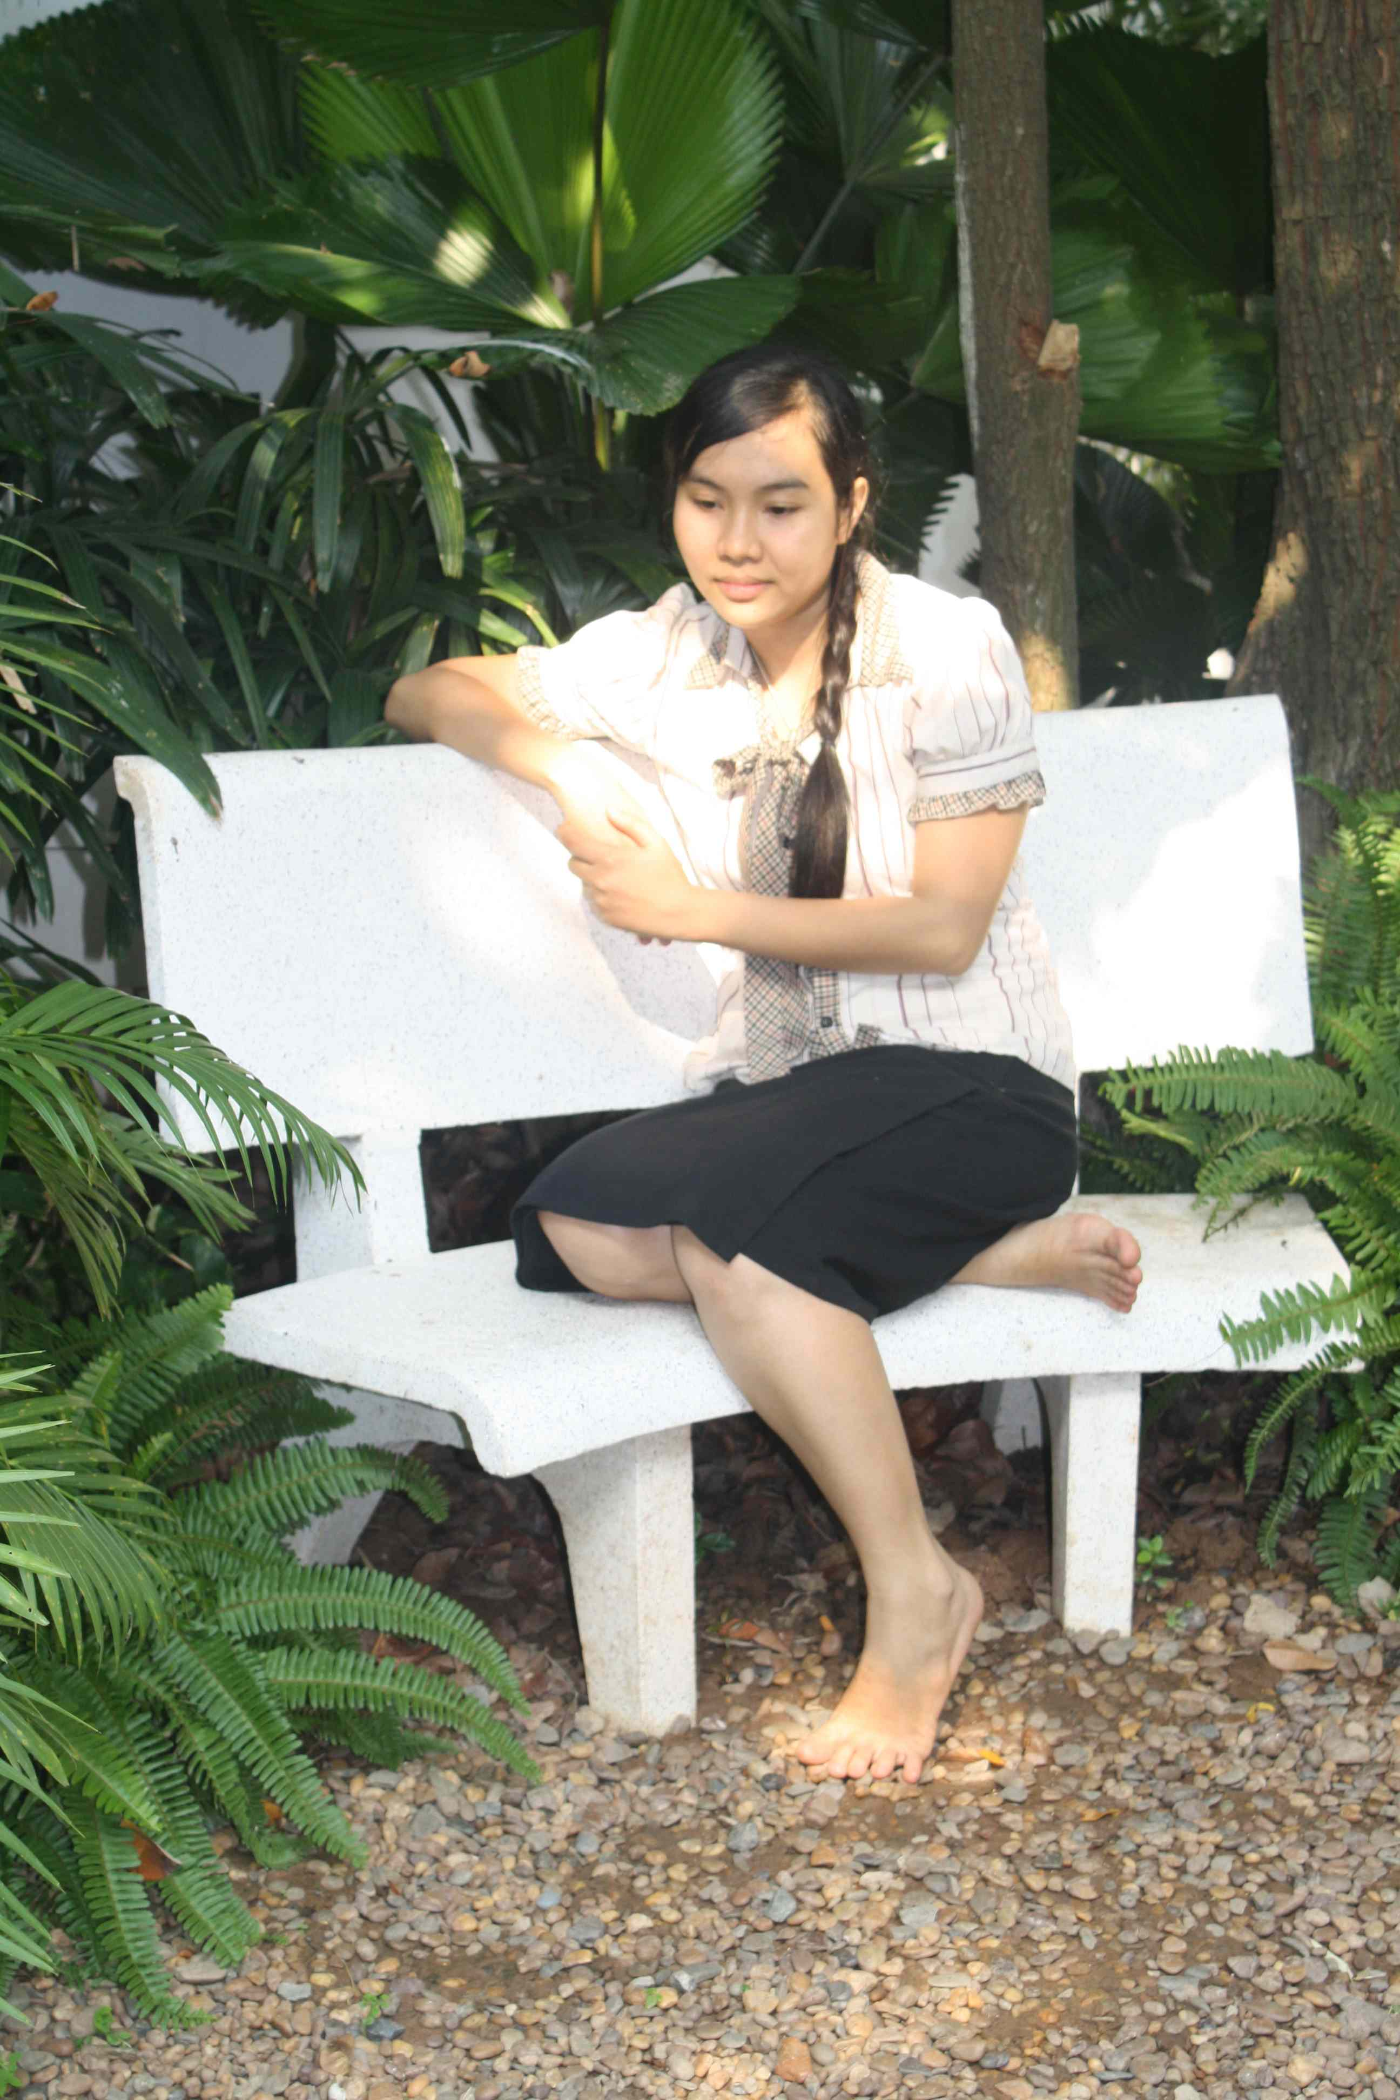
Ragamuffin House is a unique sanctuary for Creative Arts Therapy, Training and Supervision. The environment reflects an ethos of peace, safety, healing and playfulness. An outdoor meditation garden brings the symbols of nature to support anyone who comes for Arts therapy. For those who have lost their homes and land Ragamuffin has been like a bridge to their new lives.

“We have everything in Ragamuffin. It’s like a boat and a lake that provides us with life and the resources of nature and I feel so happy coming here to express all my sorrow in life. We feel safe and secure here. Ragamuffin can provide us with all the things we need to find our light inside. It gives us strength to commit to help ourselves in order to find our light, our true life and have a happy heart again - to realise that even though we have lost everything, seeds of hope can still grow in our hearts.” (Client from an Evicted Community)

Ragamuffin’s Arts Therapy Clinic for children and young people has now been set up. In partnership with six organisations, Ragamuffin’s Arts Therapists are working with children and young people with diverse needs and who are often from complex socio/economic backgrounds for example:

- Children who live with HIV and have lost one or both parents from the disease.
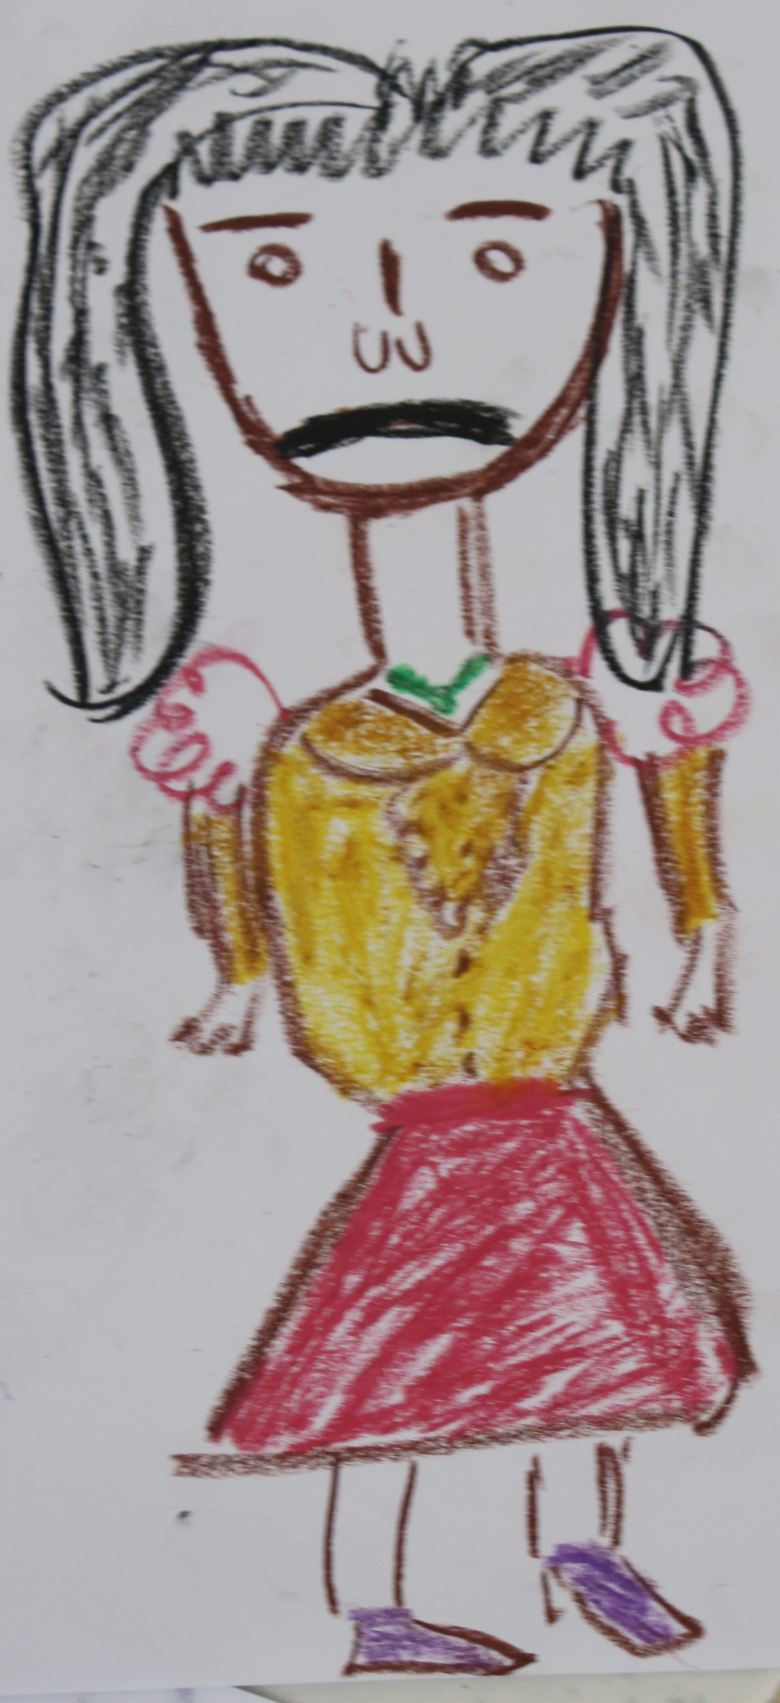
- Those who have experienced abuse or the violence of being trafficked and sexually exploited.
- Children who grow up in families where domestic violence and addictions are prevalent.
- Children in situations of poverty where they are forced to be involved in child labour to enable their family to survive
- Children whose home is the streets or beach and are at risk from being exploited
- Families who have been evicted from their land and have become refugees in their own country

“My client came in for first time and reported that she feels fine, she said that ” there is nothing in my past that bothers me “ Throughout the entire session, she tried to reassure me that nothing bad has happened to her. In the second session I asked her to draw a picture and she drew herself surrounded by different coloured hearts and she said “these are the hearts of all the bad people who have hurt me”. It was only through the creative medium that she was able to express her experiences, her pain, and so begin to consider how she might find hope for the future” (Panchakna Arts Therapist 2011).

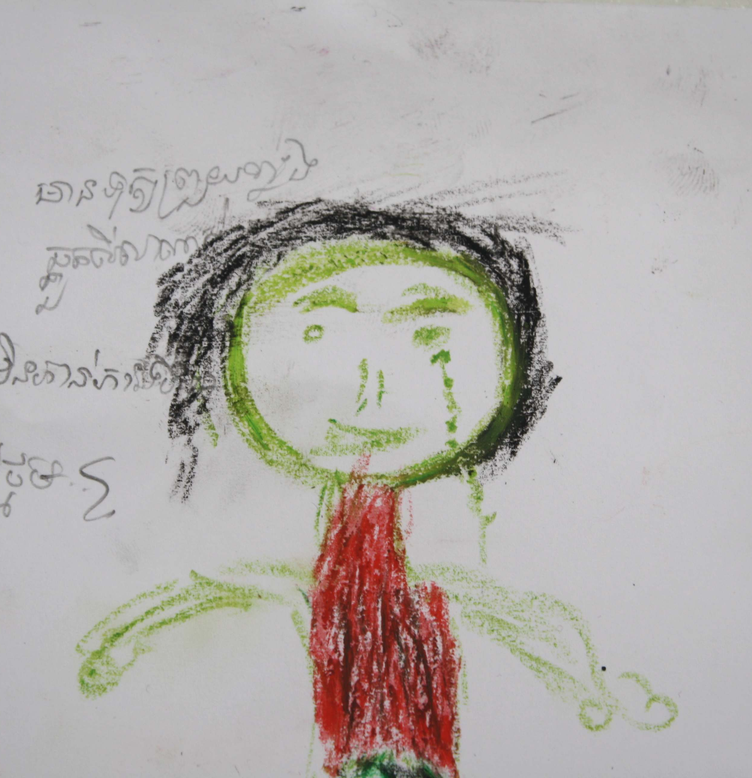
“My client is a 15 year old living with HIV. He speaks very little during the assessment session but I learned that he is embarrassed to let people know he is HIV+ for fear of rejection. In our first session, he did not speak at all. He sat in the room for an hour breathing heavily and barely moving. I let him know that it was okay to not want to do anything and we continued to breath together. In the second session, I learned a little more. I asked him if he likes drawing and he replied, “No but I like it here.” He did not draw but helped me sharpen the colour pencils. When the session ended he told me, “Thank you.” In the third session, he walked in with his shoulder back and said hello to me, which was quite unusual for this child who does not make eye contact and normally walks in dragging his feet. We spent the whole hour doing a puzzle together, sometimes speaking one or two words to each other and sometimes in silence. We passed puzzle pieces to each other and I felt like somehow we were making a connection. After the session I reflected back that making a puzzle is like building a relationship. The hard part is when you first start the puzzle and there is nothing there to hold it together, you have to have faith that it’ll all come together. Sometimes the pieces fit and sometimes they don’t. But eventually it’ll all come together, it becomes whole.”
(Chatti, Arts Therapist 2011)

“One of my clients used to suffer a lot with somatic problems, which were caused by psychological problems before she came to get therapy here. After I have worked with her for 6 sessions through healing arts therapy, she has started to feel more connected to her body and get relief from her physical and emotional pain.
Here is her quote “it is a peaceful place for me, I feel I am heard and healed. My body started to decrease the pain whenever I stepped into the room and expressed my feelings through my drawing and playing with all the toys. I could see my red heart come closer and closer to my body and I want them to be one ” (Samchet – Arts Therapist 2011)

“The most noticeable impact on both the group and individual sessions has been on participants' new found ability to express themselves and their feelings, alongside a more grounded outlook on life. We see improvements in mental health, physical health, success of livelihood and/or increased opportunities, and a renewed desire to help others in their community”. (LICHADO Director 2010)

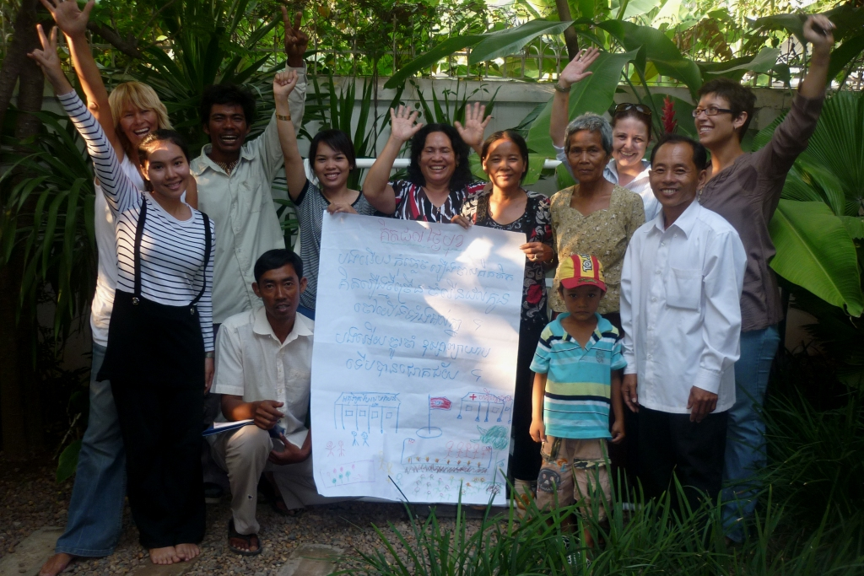
Working together with Partner Organisations

Ragamuffin’s Key Partners are:
- AFESIP (Kampong Cham Centre for Trafficked and sexually exploited girls)
- LICHADO (Canada) – Human Rights Organisation with a specific focus on communities evicted from their land and property.
- French and Cambodian Red Cross – Working with children and families who live with HIV/AIDS
- M’Lop Tapang – Centre for Street Children
- Enfants et Developpement – working with communities, families and children in crisis
- Indochina Starfish Foundation – alternative education provider for street and working children and children from challenging backgrounds.

"The close and regular training, direct services and supervision from the Ragamuffin team provides M’Lop Tapang staff with the knowledge, improved skills and confidence to listen, empathise and offer even the most traumatised child therapeutic emotional care in order to help them to feel safe and move forward positively in their lives.
(Maggie Eno Coordinator M’Lop Tapang 2011)

Working with Partner Organisations enables us to develop joined up services; strengthen the capacity of the organisation’s psychological services through training; develop policies and protocols for safeguarding children and provide programmes of individual and group Creative Arts Therapy. Ragamuffin’s Therapists provide a specialist service that works alongside social workers, caregivers and medical staff.

Feedback from Partner Organisations:

“The clinic offers our staff more support and supervision and allows us to refer cases where we are struggling to provide the services the child needs, e.g. situations where children have long term problems and are not recovering”. (M’Lop Tapang)

“The art therapy and counselling team feel more supported and less 'stuck' with difficult cases as they have Ragamuffin to refer to or seek advice and support from. This makes staff feel more confident and safe and less overwhelmed”. (M’Lop Tapang)
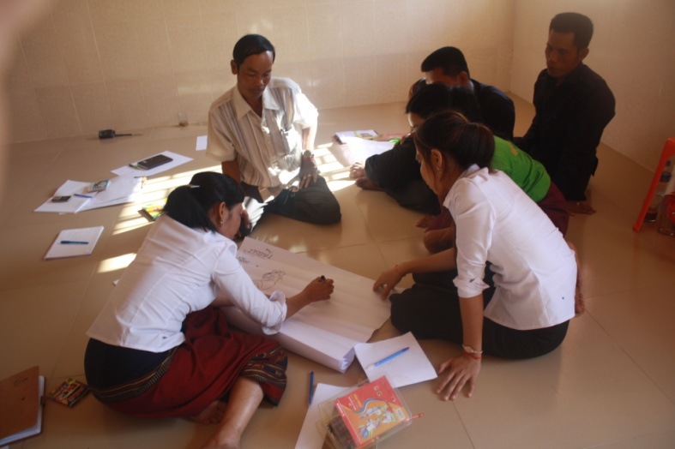
It's a long-term commitment which means that a real impact can be attained.
Partnership with a team that understands the cultures and the challenges specific to the country and the people
Expertise in an area where knowledge and qualified people are scare.
Expertise within National staff which means translation is not an issue
Support from a top to bottom level, i.e. capacity building regarding the development of individual children right up to support building, the process runs throughout the entire organisation.
A short-term financial investment into the development of the psychological services, which will result in long-term sustainable improvement. (AFESIP)

At the first training session held, a member of staff at the centre was quoted as saying "We are very happy that Ragamuffin is here and partnered with us. We don’t feel so isolated anymore because now the children will have therapists to see them every week. It will also relieve some of our stress regarding care''. (AFESIP)

“Already ISF have seen huge benefits from our partnership with The Ragamuffin Project. Some of ISF’s staff have already received the induction training from Ragamuffin and in addition to helping us understand the children we serve, this training also helped us to know the staff better. It was a great way to team build, while increasing our knowledge and awareness of some of the issues some of the children in our Education Programme are facing. Each of the staff who participated in the induction day training, without exception, commented on how useful, informative and powerful the training was. All are asking for more training and we look forward to building our staffs capacity through this relationship.

In addition to the staff capacity, the relationship will also provide Therapeutic sessions for some of the children in our Education Programme. One of our children has already started sessions and ISF are in the process of identifying more children who can benefit from the Arts Therapy. We believe that the Arts Therapy will have a significant impact on the children we serve given the circumstances these children are living in and the amount they have been through already in their short lives. So much has already been learned by the ISF staff and management and we look forward to what this partnership holds for us”. (Kate, Country Manager, ISF 2011)
Ragamuffin are also building the capacity of 8 key staff from the partnerships through our Foundation and Advanced Training Courses in the Healing Arts. This will build the capacity of the organisations to provide Arts Therapy whilst also increasing continuity of the care for young people. This is one trainee’s comment:

"The advanced course training is helping me explore new methods and create new ideas for working with my clients, especially when I have difficult cases or find myself 'getting stuck' with them.” (Sophy, Enfants et Developpement 2011)

Capacity building and de-briefing for staff is critical for those working on the frontline of care in ensuring they are themselves resources and sustained in their roles caring for vulnerable or traumatised children and young people:

- Thanks to the foundation course in Healing Arts (a year long course attended by the FRC social work project officer) and one training course conducted last year for the CRC staff/ volunteers working with children with HIV, the staff learnt and have been using new tools (creative techniques) to facilitate individual support, group discussions with children/ adolescents and for educational purposes. According to the topics discussed with children and the specific needs addressed, these creative tools gain the interest and attention of the children and motivate them to learn in a more creative way.
- Through this training the team also understood how to put the boundaries between their personal and professional lives, which is so critically important in protecting and caring for themselves to enable them to provide effective care for children/ adolescents with HIV.
- Within the emergency project (see below), Ragamuffin helped our team to debrief and discharge after a very tense and difficult period of caring for victims/ wounded people at Koh Pich (Kleio Iakovidou, Project Coordinator, French Red Cross 2011)

Responding to Emergencies - Koh Pich Bridge Stampede
During this time, Cambodia has suffered a tragedy. On November 22, 2010, during Cambodia’s most celebrated Water Festival, a stampede on Koh Pich Bridge in Phnom Penh killed 347 people and injured over 700. Working alongside organisations involved in frontline care, Ragamuffin has been providing Arts Therapy sessions for survivors and de-briefing for organisations responding to the emergency.

After such a shocking and unexpected event, people find themselves suddenly vulnerable and distressed. In particular, children and adolescents need to be protected after such events as they might be exposed to higher risks of developing different psychological reactions including trauma, grief and emotional difficulties. Giving them the opportunity to address their psychological and social needs is more than crucial as, if neglected, these may negatively evolve through time.

“I have been working with a child who experienced trauma reactions due to the incident at the Koh Pich bridge stampede. Our main goal is to not only decrease his symptoms, but also to build his inner strength so that he is able to self regulate his responses to cultural superstitious beliefs (ghosts). Since seeing the child, he has reported improvements in his symptoms. His mother also reported that after the first session, her son has begun to be himself again. Sessions involve using a child-centered approach in which the child leads the way during the session and has control over what he does. He has chosen to work with the sand tray, to draw, and to play the musical instruments. I feel that creative therapy will provide this child with a safe container in which to express his inner turmoil and struggles until his symptoms of distress have ceased.” (Chatti – Arts/Play Therapist)

“Throughout our collaboration with Ragamuffin INGO, we believe the Art Therapists of Ragamuffin have the technical expertise in cases of psychological suffering and trauma and a deep understanding of the Cambodian context; therefore, we believe Ragamuffin has the key professionals to facilitate the arts therapy programme for individuals and groups along with de-briefing for staff involved in frontline care” (Kleio Iakovidou Project Coordinator French Red Cross 2011).

"In partnership with FRC-CRC we are working with a large group of adolescents all of whom were caught up in the tragic Water Festival stampede which killed over 400 people last November. We are working together to help the young people identify and give space to the trauma symptoms they have been suffering since this event and to help develop their coping skills and capacity for resilience. Our input adds a creative-expressive element to the structure of the workshops which offer whole weekends of psychological support, exploration and identification of coping skills. Through the safe and holding structure of creative arts therapy we are able to provide a container for the over-spill of feelings, traumatic symptoms and re-telling of tragic events - something which our partner staff have expressed they found overwhelming during the initial workshops, with Ragamuffin's collaborative intervention being a helpful and holding structure for staff as well as clients. This input is important on another level too, as many of the young people we are worked with in this setting tell me they've not been able to express their trauma or suffering anywhere else in their lives. Not to family. Not at school. Not to any trained professionals. This is the first supportive, therapeutic, resilience building intervention many of them have had in the three months since the fatal stampede. The creative therapeutic input gives the young people space to play and connect with others as well as providing new, creative means of exploring traumatic experiences which are hard to bear, or hard to hear. When considering the art work produced, new aspects become apparent, such as which traumatic symptoms are most pervasive and how individuals' particular coping skills are manifest in their art and stories. Furthermore, the collective means of engaging in and sharing creative techniques and end products, facilitates a sense of support and individuals know they are not alone in their suffering." (Charlee, Arts Therapist 2011)

Ragamuffin’s Arts Therapy Clinic has now developed a policy and protocol for responding to emergencies in Cambodia and will work together with the National Disaster Management Committee and our Clinic Partners in the provision of any programmes of response.

‘Hand in Hand’ Ragamuffin Clinic Partners
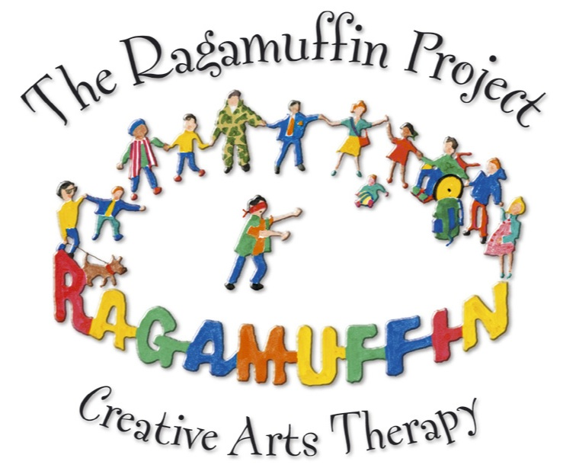

The Ragamuffin Project
- Art Therapy, Training, Supervision & Consultancy -
The Ragamuffin Project
Ragamuffin House 123a, St. 12BT, Sangkat Boeung Tumpun Khan Meanchey, Phnom Penh
Tel: 012 521 032/ 017 559 274 Email: ragamuffinproject@hotmail.com
Website: www.ragamuffin.org.uk
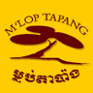
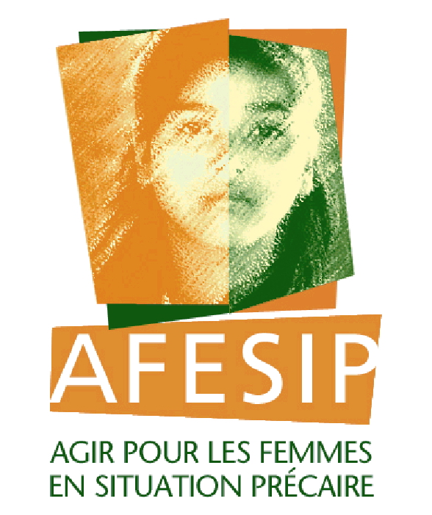
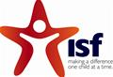
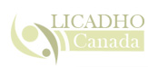
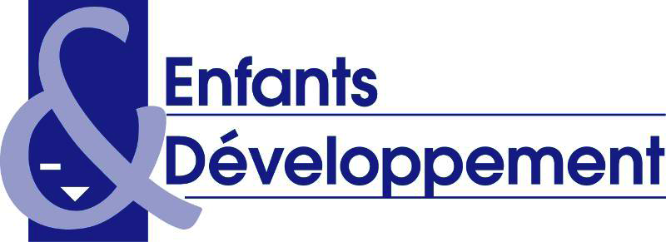
Croix-Rouge française Ì

