Purpose, Vision and Mission statement
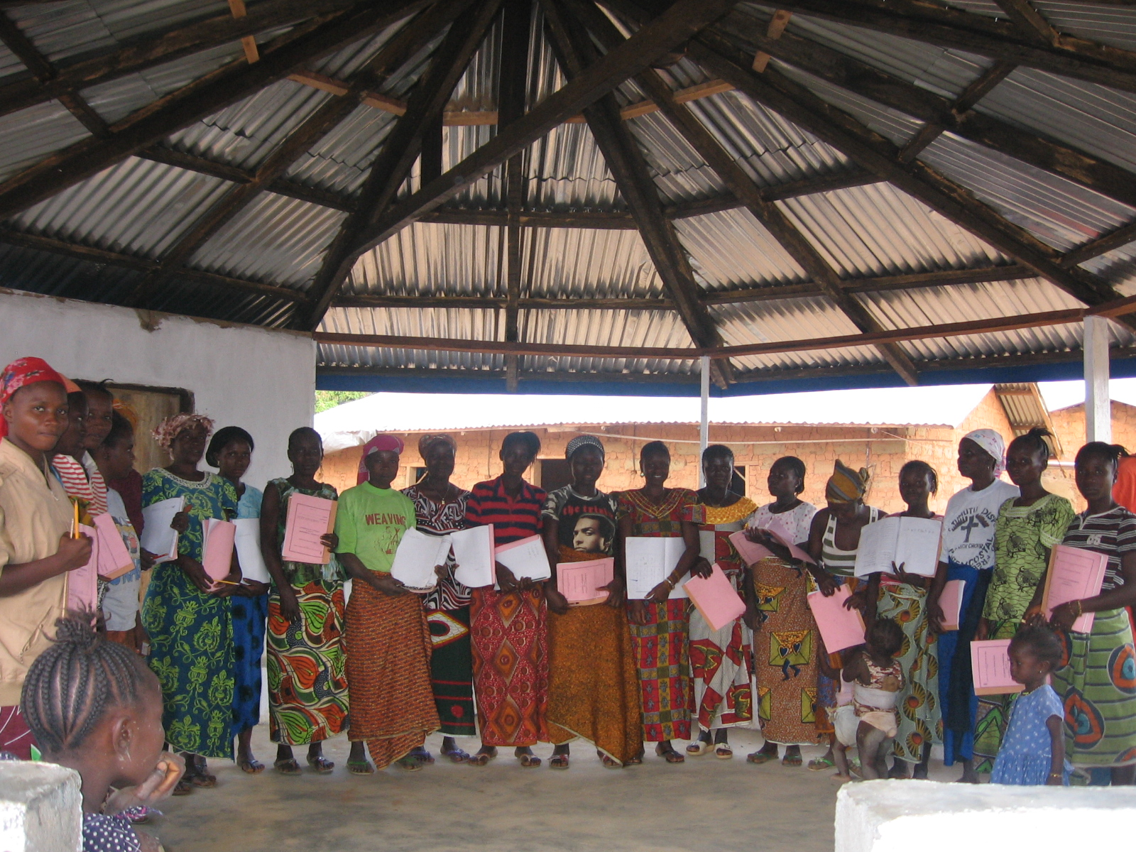
Rights and Rice Foundation (RRF) is a non - governmental organization registered with the overall aim of working for social justice and community empowerment in Liberia. The Vision of RRF is, “An equitable society characterized by respect for the rule of law and equal opportunities for all.” The Mission Statement is: “To promote social, economic and political rights through empowering people who suffer injustice and lack equal opportunities.”

Thematic areas of interventions for RRF are: (a) Human Rights, Democracy, Good Governance, Conflict Resolution and Peace Building; and (b) Community economic empowerment including Literacy, numeracy, life skills, participatory community development training, livelihood with emphasis on specially targeted groups - women and youth.
Our programming purposely links human, civil rights to economic, social and cultural rights. Our strategy is based on community empowerment and helping people discover their human talents and potentials, identify natural resources and fully participate in making decisions and taking positive actions that will transform their lives, their communities and the country.

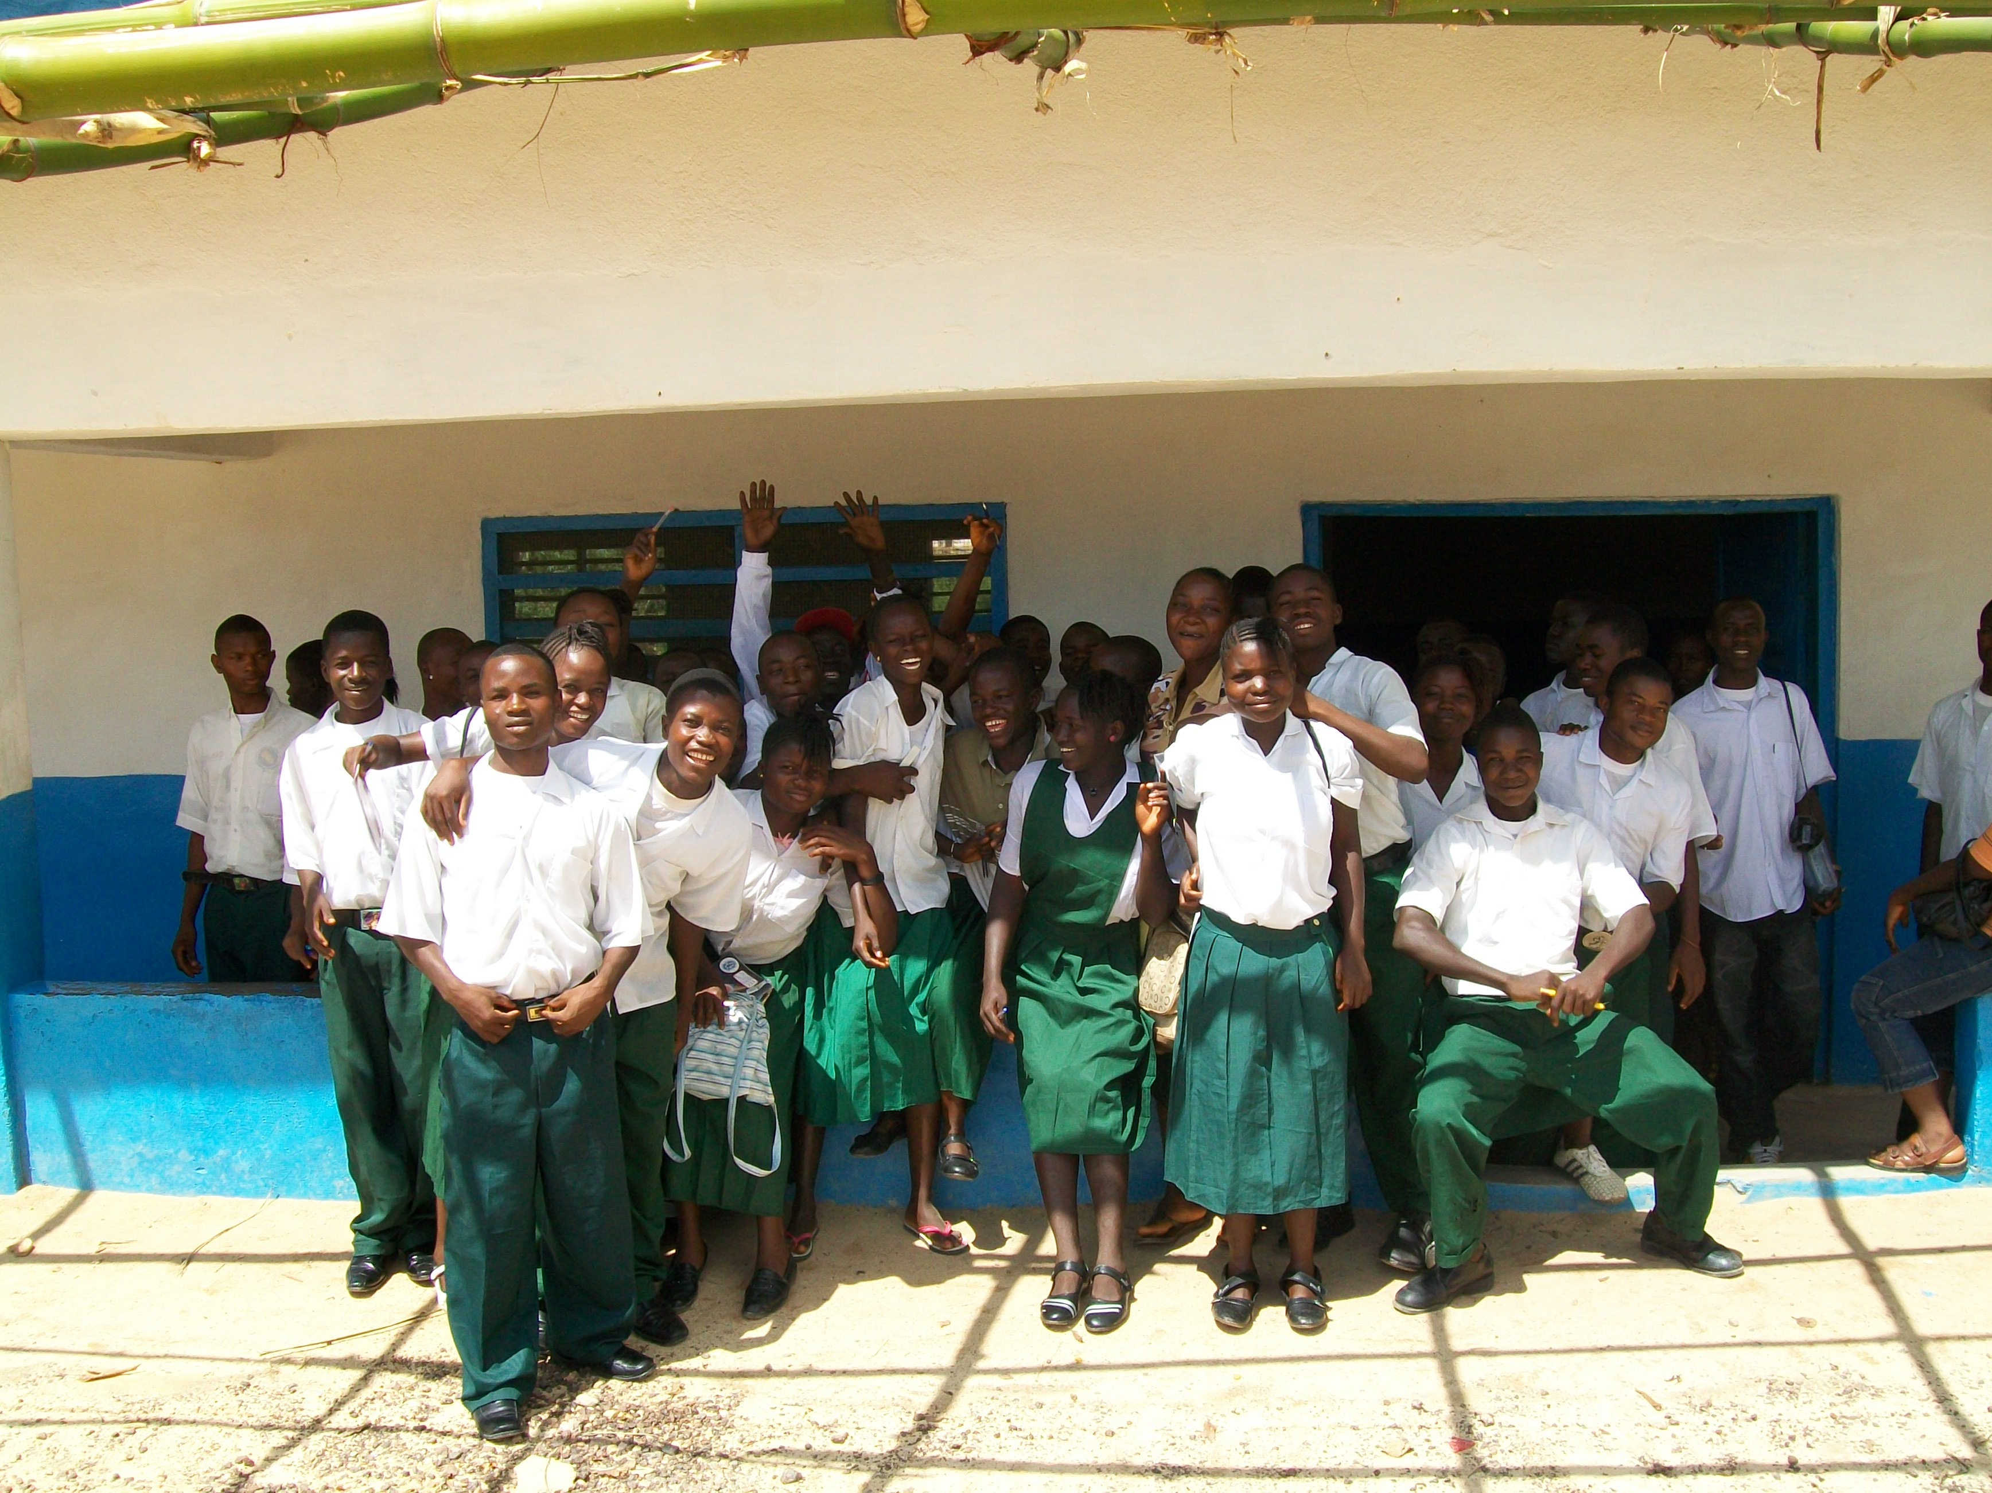
RRF now implements two major programs and one internship program: One is a conflict resolution, peace building, literacy and numeracy project; and the other is Democracy and Governance promotion. The former is sponsored by GTZ Ministry of Economic Cooperation and Development and the latter is sponsored by HUMANITY UNITED & TRUST AFRICA under their program for Liberia called the ‘Liberia Civil Society Initiative’ involving 10 local grantees .RRF also benefitted from three slots on the USAID funded internship program implemented through LCIP and a local NGO MAKING ENTERPRISE. Our three interns worked in the areas of Good governance; admin and finance; and project assistance. This internship is considered crucial for us as it helps to build up our capacity for further project implementation.
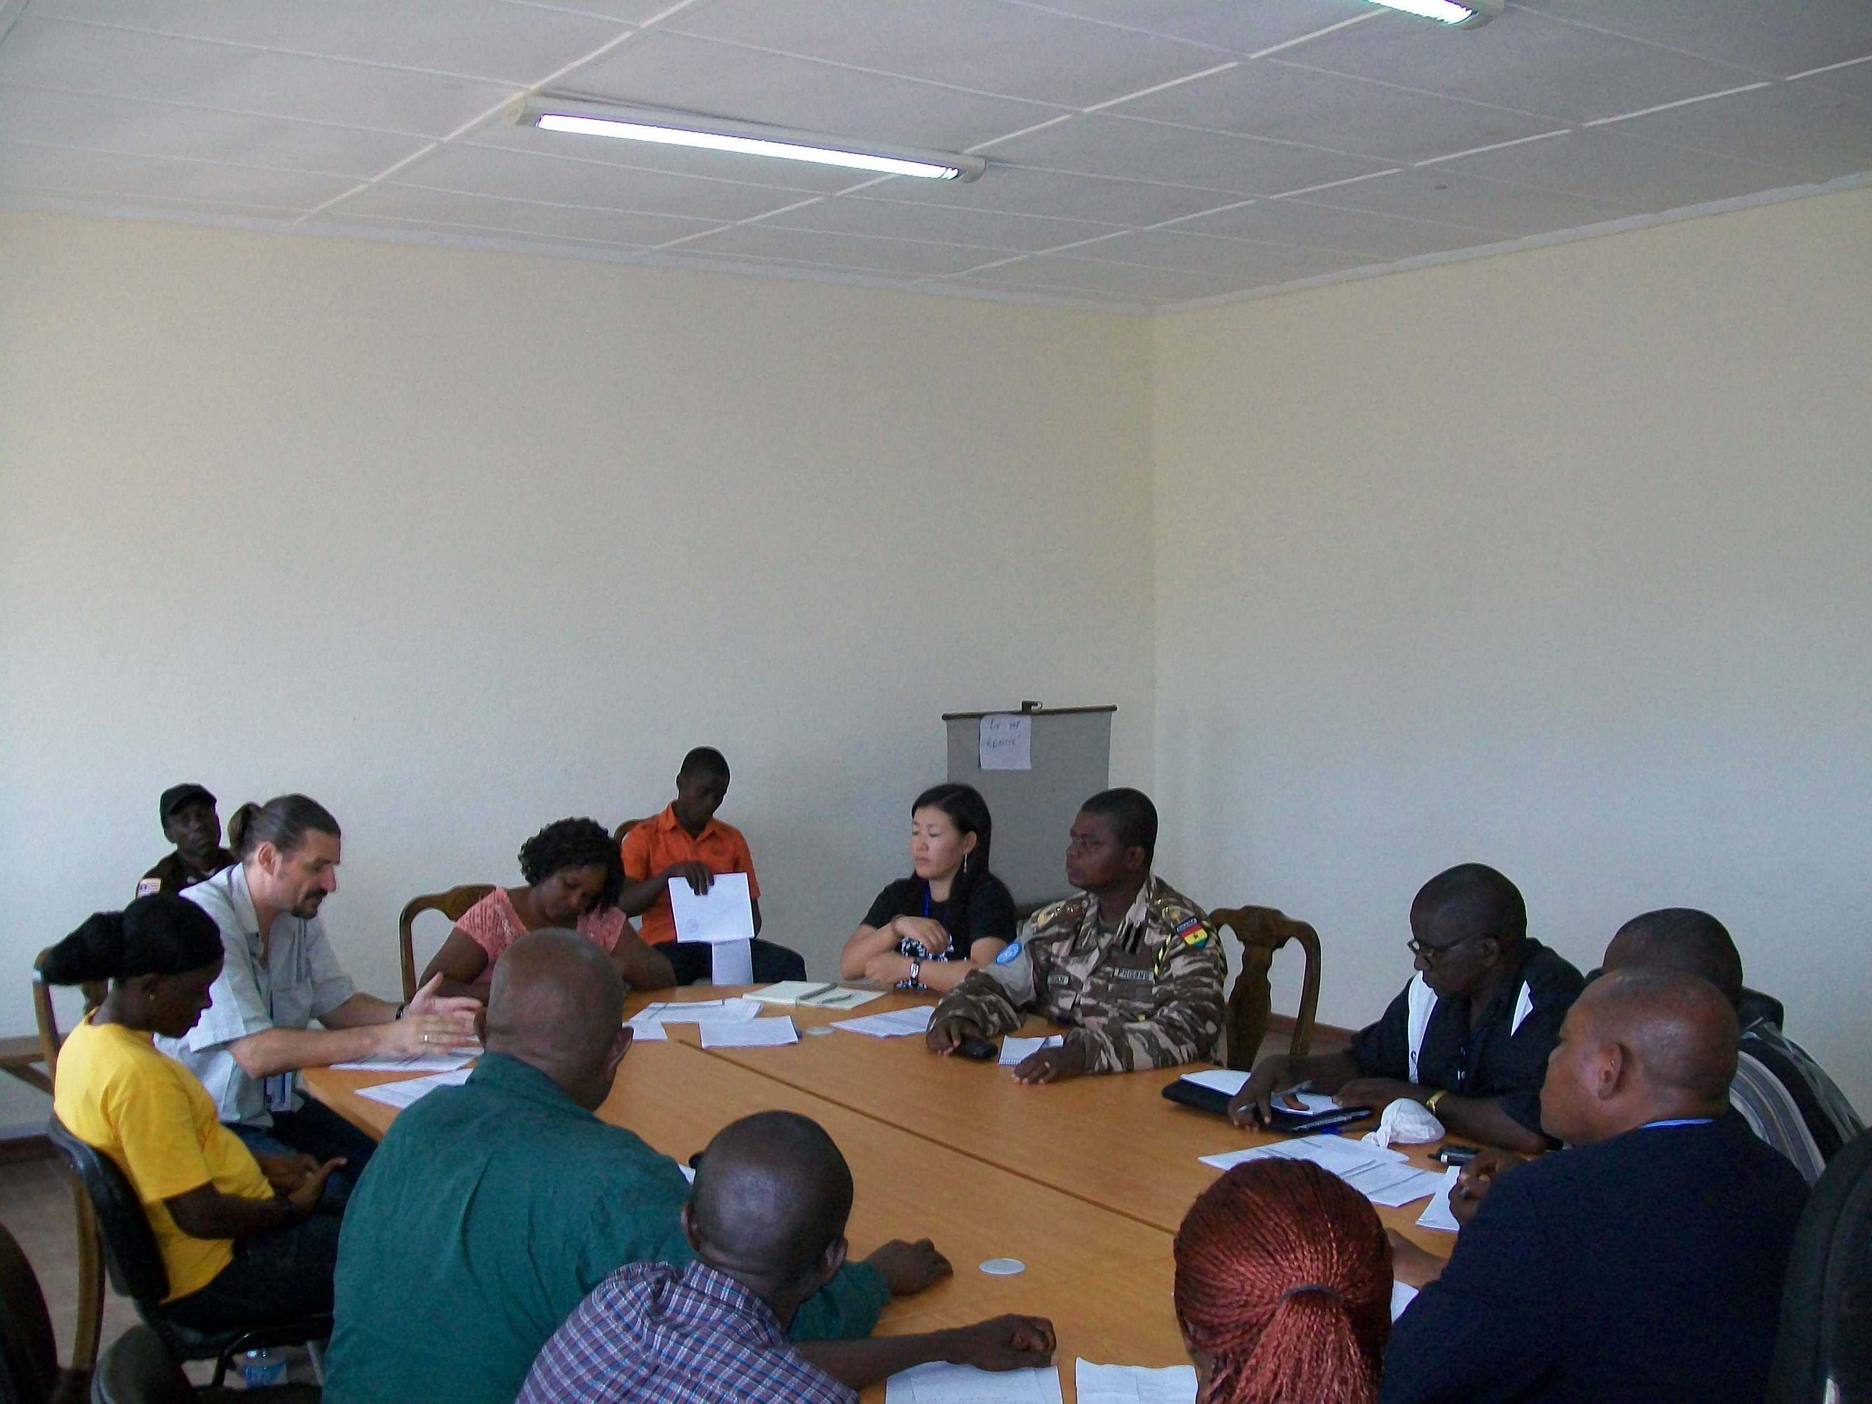
RRF currently network with a number of Civil Society and NGO forums, coalitions and networks including but not limited to the following: Liberia Civil Society Initiative, Transitional Justice Working Group (TJWG) Liberian coalitions for the International Criminal Court (LICICC), Liberia NGO Network (LINNK).Philanthropist Secretariat of Liberia. RRF is the current Chairman of the Transitional Justice Working Group, comprising 20 civil society organizations working on transitional justice issues.
RRF is headed by a Board of Directors, comprising 7 members; A Technical Advisory Committee (TAC) is being organized comprising 4 – 5 professionals who will provide technical guidance to the work of RRF; The Management Unit & Sub Offices in the field run the programs. An Annual General Review Meeting is held on a yearly basis, at which time Board members, staffs, and volunteers come together to review the RRF programs for the past year and plan for the coming year.

Photos: Upper left: a group of women who having completed RRF literacy project recently qualified for a micro credit scheme, because they meet criterion of being able to read and write. Middle : members of one of the Democracy and Governance school clubs; Bottom left: shows one of regular coordination meetings of Government, UN, NGO partners in which RRF is involved. RRF, Monrovia, February 19, 2010
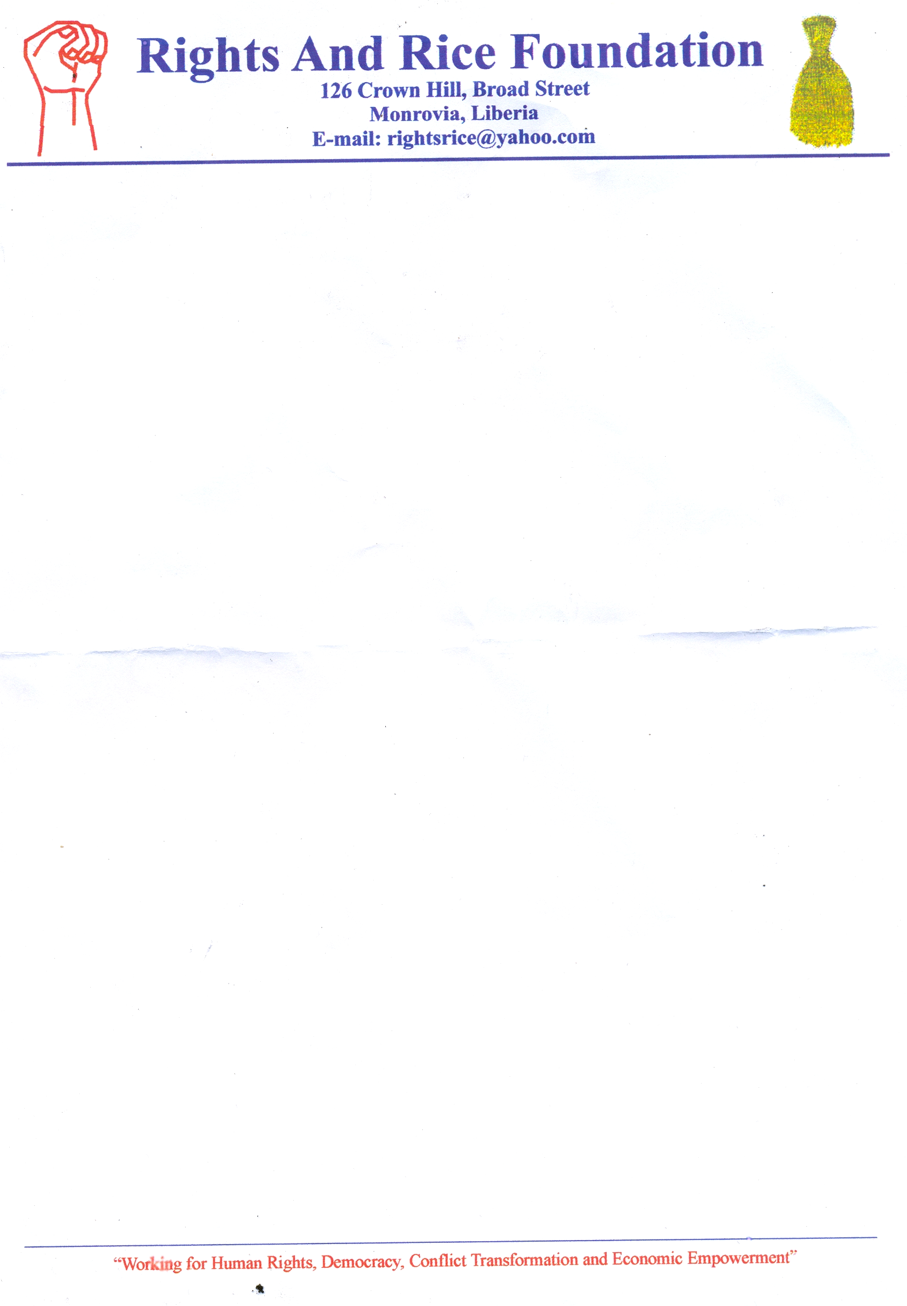
Rights & Rice Foundation
c/o YMCA Liberia, P. O. Box 3953, 126 Broad Street, Monrovia
Cell: 06549280; Email: rightsrice@yahoo.com
Working for social justice and economic empowerment in Liberia

Profile of Rights and Rice Foundation (RRF)
Purpose, Vision and Mission of RRF
Rights and Rice Foundation (RRF) is a non - governmental organization registered in Liberia with the overall aim of working for social justice and economic empowerment in our society. RRF Vision is, “An equitable society characterize by respect for the rule of law and equal opportunities for all.” The Mission Statement is: “To promote social, economic and political rights through empowering people who suffer injustice and lack equal opportunities.”

Program Strategy
The major strategy is based on community empowerment and helping people discover their human talents / potentials, identify natural resources and fully participate in making decisions and taking positive actions that will transform their lives, their communities and the country. As part of this strategy we help to build capacity of local NGOs and community based organizations. We combine awareness building, and skills development on rights, conflict transformation and democracy and governance to the critical issues of livelihood, community and economic improvement; this for us is a wholistic approach to people’s development. We bring to the new Liberian era of reconstruction, rehabilitation and development over two decades of humanitarian and development work and experience.

Program Thematic Areas of Intervention
Key sectorial / thematic areas of interventions for RRF are: (a) Human Rights, Democracy & Governance and Conflict Transformation; (b) Community empowerment which includes Literacy, Participatory community development processes, and economic empowerment activities including livelihood promotion, among others. Our programming purposely links human, civil rights to economic, social and cultural rights. Our strategy is rooted in our vast experience in community based work thereby informing county and national policies and programs. These thematic program areas will be reviewed during our planned strategy planning process planned for later in 2010.

Program Location
Headquartered in Monrovia, Liberia RRF has its first regional office based in Foya, Lofa County, strategically located in the district bordering Sierra Leone and Guinea. From this office we currently run a Peace Building and Reconciliation Program in 120 communities in Foya District, facilitating the establishment of community peace structures and training members of the structures for local conflict resolution and peace building initiatives, sponsored by the German Government through GTZ project, Support to Reconstruction of Western (SRWL) Lofa.

We are currently establishing two other sub offices: one in Bopolu / Tubmanburg, Gbarpolu or Bomi County in western Liberia and another in Zwedru, Grand Gedeh County in southeast Liberia.
Project Implementation

Crisis Prevention and Peace Building – 2007 to date
In September 2007 to date, the organization started implementation of a Crisis Prevention & Peace Building Project in Foya District of Lofa County, funded by the German Federal Ministry of Economic Cooperation and Development or BMZ through GTZ Support to Reconstruction of Western Lofa (GTZ SRWL) project. To date the project covers 120 communities and is aimed at expanding the space for inter and intra community dialogue and involvement of community people in conflict prevention, management, resolution and peace building. Local Community Peace Committees (CPCs) are elected in each community, comprising youth, elders and women, who are trained by Rights and Rice Foundation (RRF) staff members; the latter then follow up and work with the committees on a continuous basis for onward capacity building, documentation and management of local conflicts. The project targets 1080 direct beneficiaries and over 10,000 indirect beneficiaries. In 2009 RRF and the GTZ project for rehabilitation of poor rural households in Foya District (GTZ SRFL) entered into a 9 month grant (subsidy) agreement for implantation of a crisis prevention and literacy and numeracy project in 20 communities in Foya District, valued at $60,000.00 in cash and about $30,000 in kind (training materials, supplies and community facilitators’ stipends). This project initially for 9 months (March – November 2009) has been extended until February 2010. Previous subsidy grants from 2007 to 2009 amounted to around $US200,000.00

Democracy and Good Governance Project
In response to a proposal from RRF HUMANITY UNITED & TRUST AFRICA under their program for Liberia called the ‘Liberia Civil Society Initiative’ involving 10 local grantees approved a grant to RRF for implementation of the project, ‘Empowering Rural Liberians for Democracy Promotion and Good Governance’, which runs for period June 2009 – May 2010 and is valued at US$98,048.00. Reaching the districts of Kolahun, Vaahun and Foya in Upper Lofa County, this project plans to work with 30 communities in three districts of Lofa County, giving additional knowledge, deepening understanding on issues of and increasing participation of rural residents in helping to consolidate democratic practices and instituting good governance in Liberia.

Private Sector Internship Program (PSIP)
RRF applied for and benefitted from three slots on the USAID funded internship program implemented through LCIP and a local NGO MAKING ENTERPRISE. Our three interns worked in the areas of:-
Good governance; admin and finance; and project assistance. This internship is considered crucial for us as it helps to build up our capacity for further project implementation. We were involved for five months from August – November 2009.

Building Local Capacities Internally
RRF has undertaken a systematic program of capacity building for its staffs and volunteers. Among the various capacity building training offered were: How to undertake sensitization workshops; Organizing Community Committees; Conflict & Peace, Human Rights, Rights and Responsibilities of Liberian Citizens, Anti Rape and Inheritance Laws of Liberia, and training on Liberia’s Truth and Reconciliation Process. In addition the staffs and volunteers benefitted from week long training in participatory training techniques workshops, as well as training in Mediation Techniques; the latter sponsored by GTZ and facilitated by a Liberian group called Village Development Fund, in collaboration with American Bar Association. With this level of investment in human capacity development, RRF is suitably placed to undertake its activities.

STAFFING SITUATION
The staffing situation is as follows: On the GTZ Crisis Prevention and Peace Building project we have a total staff of 9; and on the Democracy and Governance Project we have 10. In the head office of Monrovia we have 8 staff members, making a total of 27 staffs. Volunteers are 12.
Locations of the staffs are 11 in Foya Lofa County; 2 in Voinjama, 4 Kolahun, 2 in Vaahun, 8 in Monrovia;
Location of volunteers: 5 in Foya, 3 in Monrovia, 2 in Bomi, Gbarpolu, and 2 in Grant Gedeh.

PROFESSIONAL SERVICES RENDERED BY RRF:
RRF has undertaken several professional services on behalf of local NGOs and international organizations including the following:
- Program Review and Assessments of an integrated agriculture project in Southeast Liberia for Diakonie Emergency Aid (DEA), an international German NGO in Liberia. April – June 2007.
- Participation in the Strategy Planning process of Lutheran World Federation / World Service, Liberia. 2008
- Evaluation of 5-year intervention in teacher training for elementary schools in Liberia, for U.S. based Friends of Liberia, 2007
- Evaluation of a Rural HIV / AIDS project in Nimba County, Liberia implemented by YMCA Liberia and sponsored by Y CARE International, London, England
- Capacity Building and Training of Staffs in Strategic Planning, for Community Union for Sustainable Development (CUSD), Liberia
- Capacity Building and Training of Staffs of Liberia Educators for Action and Peace (LEAP), a local educational NGO, in Liberia.
- Preparation Plans for Presentation of Programs on a visit to the U.S. of the Liberia NGO, National Ex-combatants Peace Building Initiative (NEPI), of Liberia.
- Evaluation of a 3 year “Post Crisis Youth Development and Capacity Building Project” in Liberia, implemented by YMCA Liberia and funded by Comic Relief through Y CARE International, London, England.
- Undertaking of a Tracer Study of EED funded preliminary impact study of an LOIC vocational training graduates over a 3 year period (2006 – 2008), sponsored by FAKT Consulting Firm, Stuttgart, Germany.

Networking and Collaboration
RRF works and plans to work with a number of Civil Society and NGO forums, coalitions and networks including but not limited to the following:
- Liberia Civil Society Initiative
- Transitional Justice Working Group (TJWG)
- Liberian Coalition for the International Criminal Court (LICICC)
- Liberia NGO Network (LINNK)

Governing Structure
RRF is headed by a Board of Directors, comprising 7 members; a Technical Advisory Committee (TAC) is being organized comprising 4 – 5 professionals who will provide technical guidance to the work of RRF; Management Unit comprising Office of the Executive Director, Program Office, Administrative, Logistic and Finance Office, Professional services Unit, Volunteers amd Members; Central and Regional Offices in Monrovia, Foya, Voinjama, Vaahun, Kolahun in Lofa County and Tubmanburg, Bopolu in Bomi and Gbarpolu Counties. Annual General Review Meeting is planned on yearly basis, at which Board members, staffs, and volunteers come together to undertake periodic review of the RRF programs and make plans for the coming year. A Strategic Planning is planned for the coming year (2010).

Updated November 2009
Monrovia, Liberia

