LITERACY GRADUATES BECOME PROUD VOTERS AND DECISION MAKERS
Kongbama is a Liberian town in Foya Statutory District, Lofa County, bordering the Republic of Sierra Leone, with an estimated population of 1000. Women make up 34 %, and men 66%. Illiteracy rate among women in this town is over 90%.

In May 2010 the community started the functional adult literacy program with Rights and Rice Foundation, targeting some 30 women who have had no exposure to any form of schooling. The first group of learners after ten months graduated from their first level of literacy in January 2011. They are now able to write all English alphabets, write numbers 1 – 100, recognize simple words and are able to write their names.

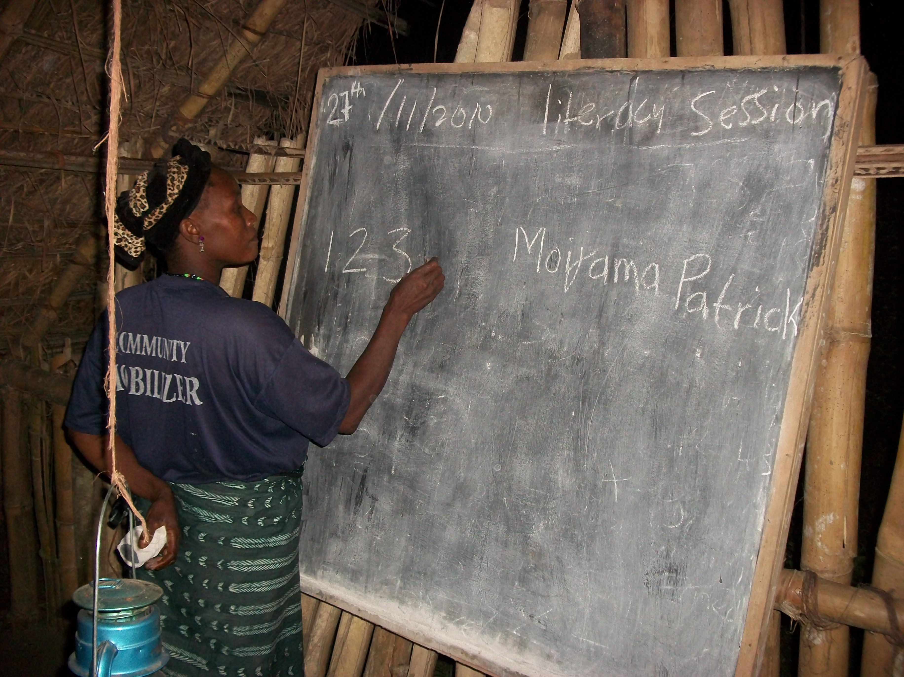
One of those who completed the first level of literacy Ms. Moijama Patrick went to register for the pending elections in Liberia in January 2011. As usual the registrars brought ink pad for her to use her finger tump. Ms. Patrick then asked for a pen and according to her, “I wrote my name myself; I will not use my finger print anymore to register and to vote.” Ms. Patrick said that she is now among the educated people of the world who can write their names; for this she is proud and thankful for the program.

In Kongbama town 30 literacy trainees who completed level one are now doing refresher training in preparation for advanced courses. In addition, another group of 11 learners have enrolled in the program.

According to Ma Taweh Nyumah, Kerosene custodian of the literacy class, this program is actually helping them the women gain high respect from their husbands and children. She said that in addition to writing her own name, she also writes her husband’s name, which makes him (husband) also very proud about the skills she is acquiring. Ma Nyumah’s husband said “…that if this program continues as we have planned, our women will do well at clinics, hospitals, homes, and in meetings concerning the development of the community’’

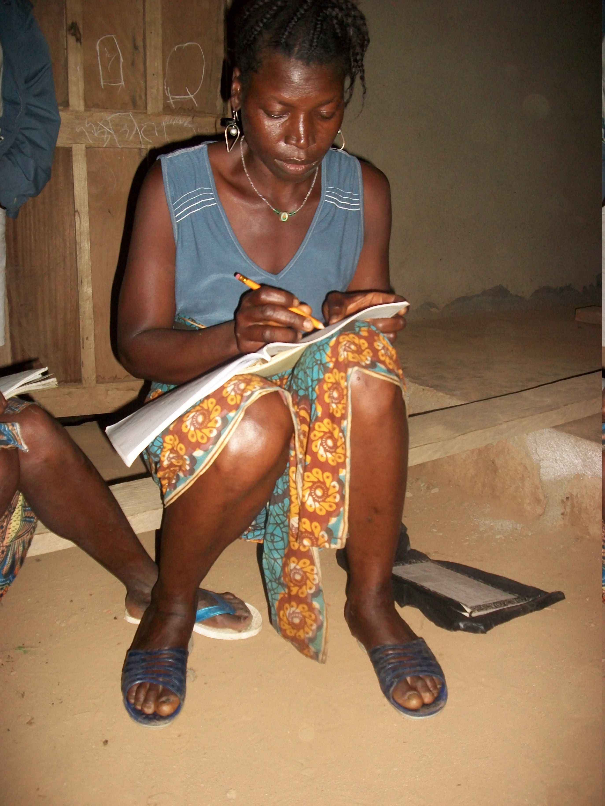
The town has two (2) trained literacy facilitators, two sets of training modules and a place to conduct their learning during evening sessions after their daily work. What they need is assistance in form of work books for the learners, kerosene for their lamps, stipend for their trainers at $25.00 each trainer per month. With this support literacy and democracy training will continue for some years to come, and the illiteracy level will dramatically decrease.

The graduates will ensure that their children and grand children will all go to school; they will be dignified and proud citizens who recognize numbers and read their prescriptions from the health centers; write their names; be able to better manage their family incomes and participate more actively in decision making on issues that affect their lives and those of their families.

The contribution of all of you, our donors / potential donors, regardless the amount, will bring about qualitative improvement in the lives of many rural Liberians and will contribute to the transformation of their lives, their communities and Liberia as a whole.

Rights and Rice Foundation
Liberia
June 9, 2011

