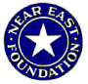
Near East Foundation, Sudan -
Community Health Center in Dar El-Salaam

The community of Dar El-Salaam El-Tawedat

The Dar El-Salaam El-Tawedat region is home to approximately 40,000 displaced persons who fled Sudan’s ongoing civil war or face acute drought or limited livelihood opportunities in their villages. Dar El-Salaam is located 40 Km outside of Khartoum, and the settlement area lacks basic services including little to no electricity, limited access to water, inadequate transport, and few available public services. These displaced biggest challenges are to build a new community in an unfamiliar and often hostile environment.

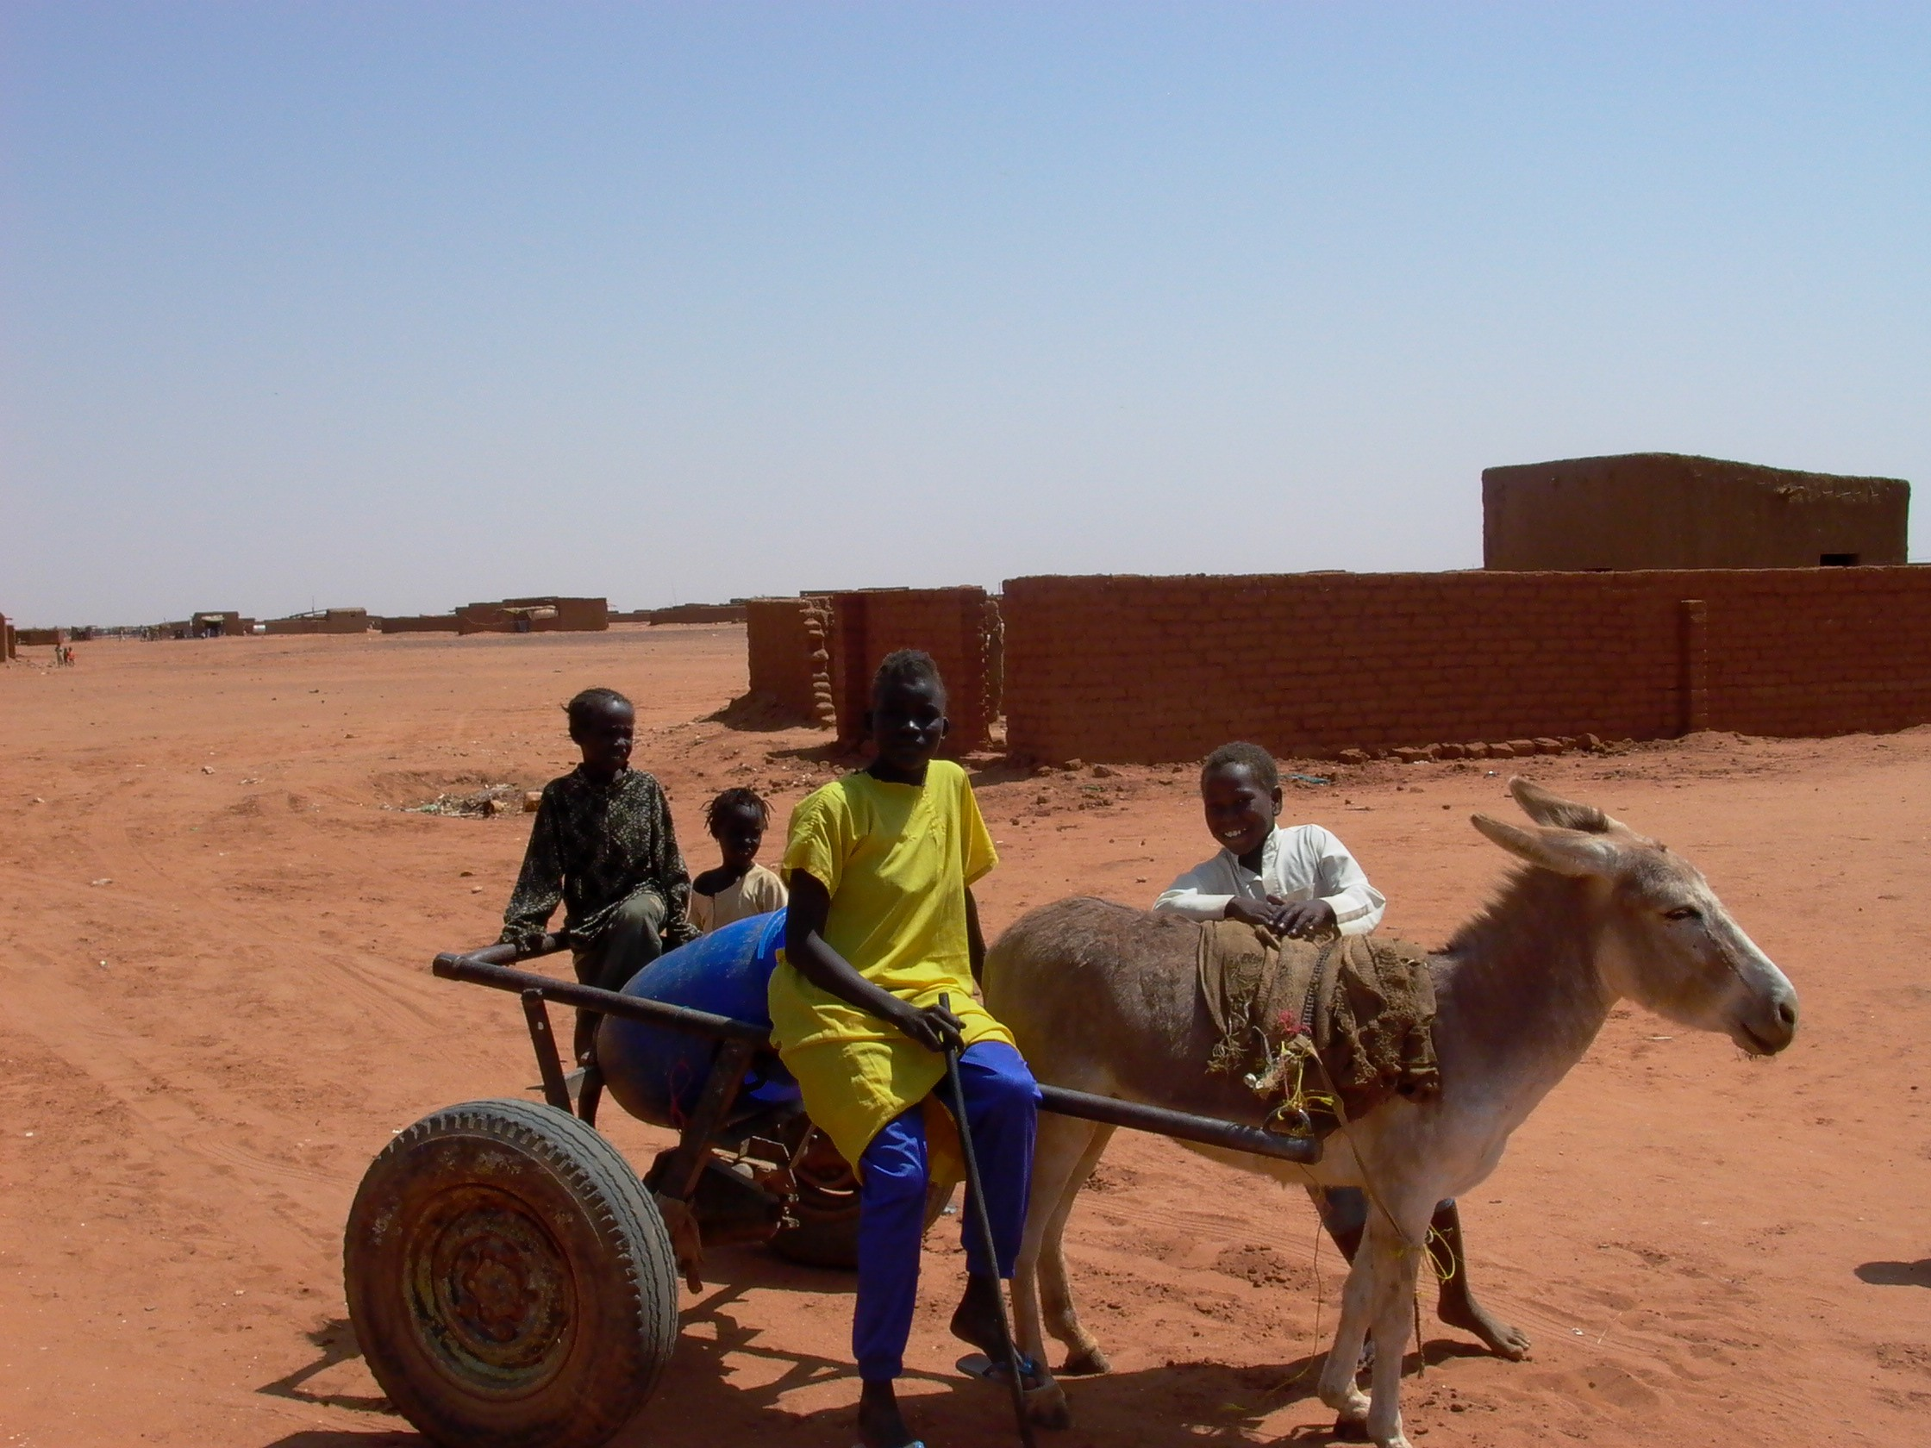
This community living in El-Salaam is largely rural, illiterate and unemployed. Malaria, yellow fever, and other endemic diseases, as well as parasitic infections, are widespread. Malnutrition is a constant problem particularly among infants, young children, and pregnant women. In addition, Dar Es-Salaam lacks public utilities and services, and housing is simple and crowded. The nearest medical clinic outside of Dar Es-Salaam is 15 kilometers away and the nearest elementary school, a government run facility is located one kilometer away. These services are poorly maintained and a majority of residents are unable to afford them.

The Community Health Center
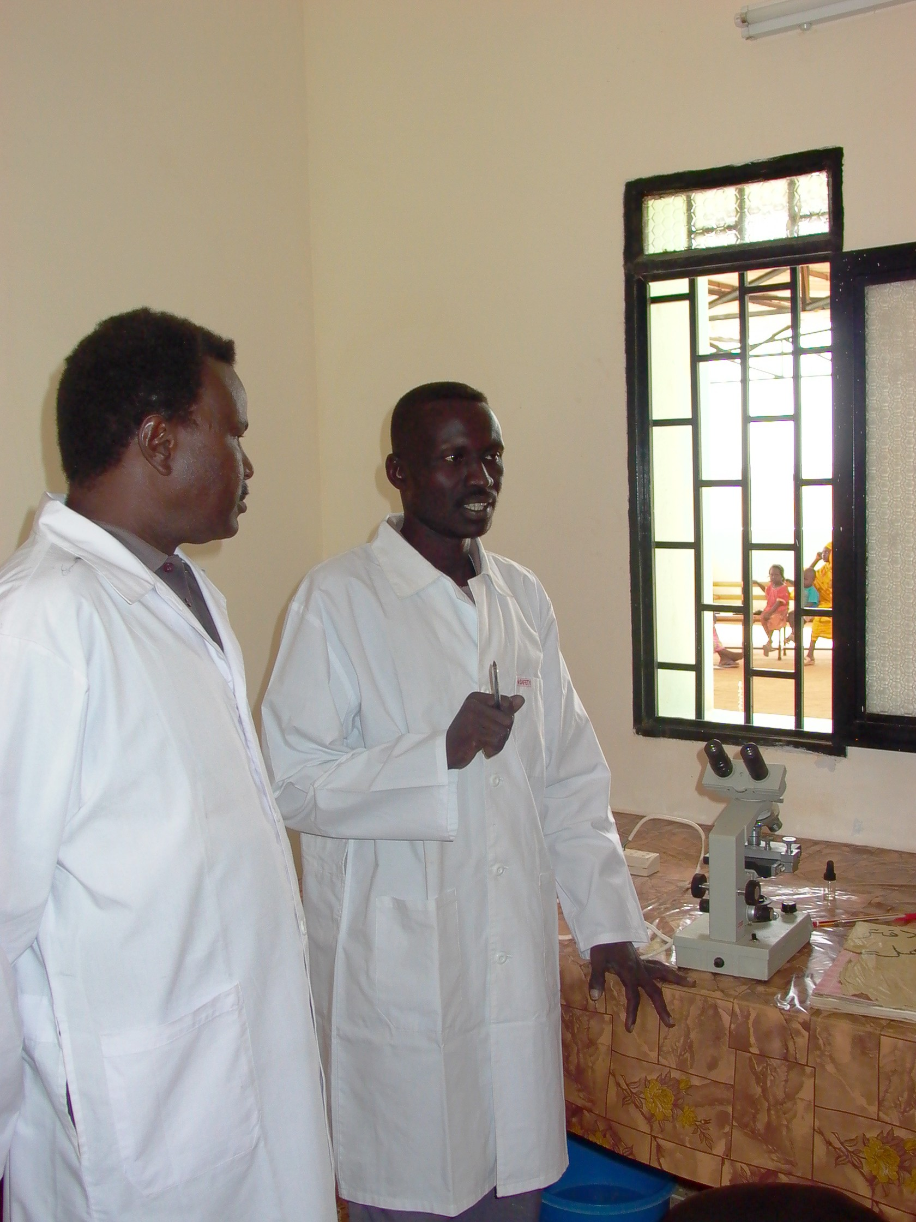
The Near East Foundation (NEF) has been running a health center since 2001, answering to the critical health needs of Dar El-Salaam. The center, the sole health care provider for this isolated area, addresses the many health problems that people face, primarily targeting women’s reproductive health issues.
NEF has been offering a range of curative, preventative and counseling services. The health services include Family Planning, Prenatal Care and Antenatal Care. The clinic also provides diagnosis, primary health care, laboratory tests, vaccinations, a pharmacy, and the center has expanded to add a labor and delivery facility. This women’s facility, a safe refuge for women of the community, is the first of its kind offering targeted education on women’s health including child rearing and HIV/AIDS awareness.

The Center’s sustainable approach

The health center adopts an integrated development approach to address the needs of the population, including planning activities such as income generation programs, child-rearing education support, and nutrition and water safety awareness campaigns. The center is sparingly staffed and equipped, and operates on an annual budget of $50,000. Approximately 1,000 patients visit the center monthly; health awareness and outreach efforts aim at increasing visits, but the poverty of the community and the modesty of the Center’s resources impose limits.

Project Results

Care for the community: This past year, from July 2008 to September 2009:
Over 5550 patients benefited from the health clinic;
1780 people received preventative vaccinations;
Over 5000 patients profited from the clinic’s pharmacy facilities.

Education: Nearly 6000 community members attended the clinic’s health education program, receiving training on nutrition, family planning and child rearing.



