

Project update January 2010
Project Title: Indonesia Earthquake; Emergency school for kids
By Asriadi - Team leader
On January 5, 2010, we have been carrying out activities to provide assistance for some students who are affected by earthquakes. We have received donation $23.10 from GlobalGiving donors and we have used to buy school supplies such as, purchase of school clothes, shoes and school bags. And we can not meet the needs of all students, because these funds are very limited, while there are many students who need help.
At the time of giving such assistance many students who wish to be granted the same relief, because they are also the average of the families affected by the earthquake, so that the equipment owned schools have all been destroyed and that none could be used.
At the time of the review team to Puspem do some student houses earthquake-stricken, his condition is very sad, because where they lived till now still a lot of sleeping under emergency tents and some schools did not get help repair the school so that children must learn under the tents.
As Anwar, one of which can help students said, "we are very sad and grateful for the assistance provided by the GlobalGiving through Community Development Study Center, to be honest this assistance is very useful for us. But still many of our friends that have not been able to help. We hope they can get help, and this assistance can be continued, because we really need it ".
The describe above shows how the assistance has been given to the children victims of the earthquake was much needed and eagerly awaited by the victims of the earthquake. Therefore, on behalf of earthquake victims in west sumatra hope to GlobalGiving and the donors to continue providing assistance to them.

Urgent need in this program are;
1. Support school improvement.
2. Assistance of school facilities, such as tables, chairs, blackboards, computers and etc.
3. Aid learning tools such as bags, lesson books, shoes and stationery.
4. Scholarships for orphan children of earthquake victims.

Please see the video when incident SR 7.3 earthquake in Padang, West Sumatra;
http://www.youtube.com/watch?v=reQqxqNa1Jk
Finally we would like to thank to GlobalGiving for relief has been granted, and we hope to provide assistance and support until they can live decent and children can continue study as usual.

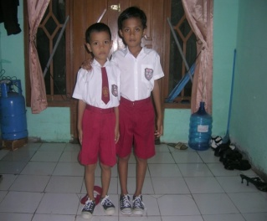  Anwar and Bobby of earthquake victims | 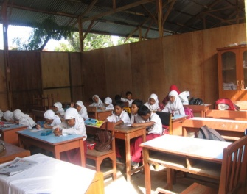  Onother children study in emergency school
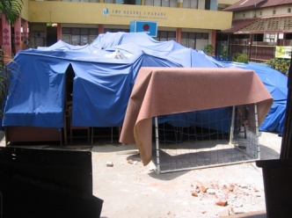  Emergency school in the tent | 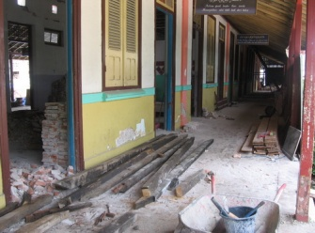  School children destroyed by the earthquake
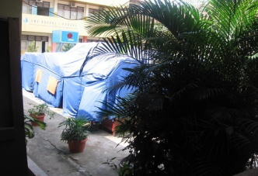  Emergency school in the tent | 