Self Help Group Program

Annual Report (April 2010 to March 2011)

Submitted to

Global Giving

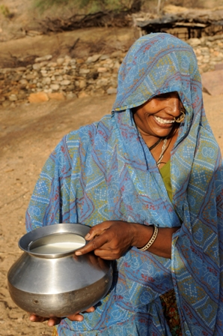

SEVA MANDIR

Udaipur Rajasthan, India

info@sevamandir.org
www.sevamandir.org

Savings and Credit programme (SHGs)

The women empowerment programme of Seva Mandir focuses on bringing women together for creating a common platform of mutual trust and support. The Self Help Group program is an extension of the Women’s Empowerment program under which, the women save up small amounts every month in SHGs (Self Help Groups). They borrow small loans from their SHGs which help overcome their dependency on traditional money lenders for petty credit needs. The SHG also allows women to set up small business for earning some cash. Besides the financial autonomy, the SHG extends a platform for these women to discuss social issues. It strengthens their solidarity, builds their confidence and allows them a space to unload and deliberate solutions.

In the last two years the efforts have been made in strengthening the smooth functioning of SHGs. In collaboration with PRADAN we organized a number of trainings and workshops for staff members as well as the members of SHGs (women and accountants). The trainings helped the participants learn skills of auditing of SHGs, profit distribution, qualitative monitoring, standardization of SHG norms and streamlining MIS (monitoring information system). This year the SHGs took a step ahead and began to contribute towards the costs for audit and book keeping. The groups are happy at this self-reliance they are achieving gradually.

1 Current status of SHGs

Name of Block | No of SHGs |  | Membership
Name of Block | Mar-10 | Mar-11 | Mar-10 | Mar-11
Urban | 60 | 80 | 1192 | 1588
Badgaon | 60 | 66 | 963 | 1034
Girwa | 52 | 64 | 842 | 995
Jhadol | 109 | 108 | 1479 | 1423
Kherwara | 135 | 117 | 1982 | 1684
Kumbhalgarh | 78 | 93 | 1086 | 1257
Total | 494 | 528 | 7544 | 7981

At present there are 528 SHGs with a membership of 7981. During this period 53 new SHGs were formed and 19 SHGs were closed down on account of improper functioning. There are 152 accountants maintain records for these SHGs. Till date, the records for 528 SHGs have been fully computerized.

Financial Status of SHGs: (in INR)

Name of Block | Savings | Cash in hand | Cash at bank | Loan outstanding
Urban | 8,317,842 | 42,772 | 966,070 | 8,139,740
Badgaon | 3,343,943 | 131,961 | 972,646 | 2,837,733
Girwa | 1,165,598 | 179,555 | 524,163 | 453,604
Jhadol | 1,521,052 | 211,729 | 1,315,063 | 830,379
Kherwara | 3,767,589 | 359,117 | 1,996,595 | 2,356,004
Kumbhalgarh | 939,959 | 189,796 | 248,145 | 556,344
Total | 19,055,983 | 1,114,930 | 6,022,682 | 15,173,804

The net owned fund of SHGs till March 2011 is Rs. 21,186,489 (USD 470,811). The total savings stands at Rs. 19,055,983 (USD 423,466), cash at bank Rs. 6,022,682 (USD 133,837) cash in hand Rs. 1,114,930 (USD 24,776) and the loan outstanding Rs. 15,173,804 (USD 337,195).

The savings to loan ratio is almost 1:1 which indicates that members are rotating all their savings for credit. It is 1:2 in Girwa which reflects need of greater loan rotation in this block.

The cash at bank is 28.42 % of the total funds. It is highest in Jhadol (81.30 %) and Kherwara (45.10 %) block and lowest in Urban (10.60 %) and Kumbhalgarh (25.00%) block. This indicates that members are still not using their funds, though there is ample demand for the credit. This issue will be addressed through regular monitoring of SHGs and motivating members to follow group values and norms.

The total cash in hand is 5.3 % of the net owned fund. It is highest in Kumbhalgarh (19.10 %) and Girwa (14.60 %) and lowest in Urban (0.50%) and Badgaon block (3.50%).

Performance of SHGs on the basis of main indicators

Name of Block | Meeting Regularity (%) | Attendance Regularity (%) | Saving Regularity (%) | Principal Repayment (%) | Interest Repayment (%) | Portfolio at Risk (%)
Urban | 97 | 94 | 89 | 95 | 100 | 5
Badgaon | 84 | 82 | 75 | 73 | 100 | 30
Girwa | 97 | 83 | 81 | 82 | 97 | 21
Jhadol | 91 | 75 | 71 | 74 | 69 | 24
Kherwara | 95 | 80 | 74 | 69 | 97 | 31
Kumbhalgarh | 100 | 88 | 86 | 85 | 96 | 25

The performance of SHGs measured on the basis of six main indicators – meeting regularity, savings regularity, attendance regularity, principal repayment, interest repayment, and safe portfolio shows that Urban block outperforms other blocks on all indicators. Interest repayment rate is 95 to 100% for all blocks except for Jhadol. The portfolio at risk is very high for Kherwara and Badgaon Block.

Profit distribution

In order to make the accounts in SHGs transparent and robust, a system of annual internal audit was introduced last year. On the basis of audit, profit distribution is processed.

After the audit in March 2010, for the first time, during April – June 10, profit distribution was done in all the SHGs. For this initially the criteria for profit distribution was discussed with the groups and it was decided that since it was being done for the first time, it should be based on total savings of members. The members received a profit of Rs. 2,385,169 (USD 53,004) from their SHGs.

The process of profit distribution has greatly contributed in strengthening SHGs by making them realize importance of financial discipline and increasing the size of their SHG funds. The 152 SHGs have raised the amount of their savings per month and 114 SHGs have raised the honorarium for their accounts.

In the month of March 2011, the second audit was initiated. For this a refresher training of trained local accountants was conducted from 25 to 27th February 2011. A total of 25 accountants participated in this training. The audit and profit distribution will be completed by the end of May 2011.

Linkage with financial institutions

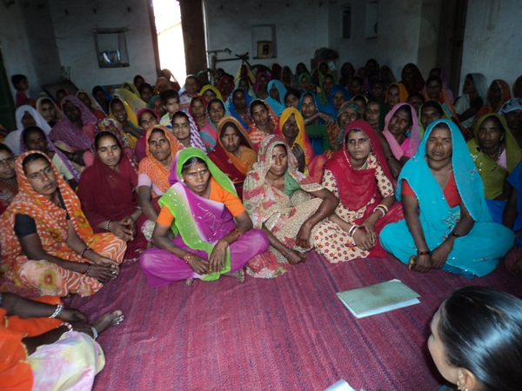
SHGs are formally recognized by the Government and therefore it is mandatory for each SHG to have a bank account. Every year, banks carry out a procedure known as grading, under which SHGs performance is graded based on some guidelines. Grading helps monitor the SHGs and also makes an SHG eligible to avail financial support from the Government through schemes such as SGSY (Swarna Jayanti Swarojgar Yojna).

Under this scheme on first grading when a SHG performs well, the Government gives the SHG funds equivalent to the existing amount in their own bank account. This doubles the savings of the women. The Grading is very competitive and therefore very few SHGs get through the first grading.

Under the second grading, on clearing it, the SHG can take a loan from the bank for their proposal/businesses. The Second grading is useful in supporting larger projects. The women of BPL (Below Poverty Line) could be granted 15-20% waiver on the repayment.

In Kherwara four SHGs viz. Santoshi, Dashama, Shakti (village Gogarwara) and Lakshmi (village Dama Talab) and in Jhadol block three SHGs viz. Shakti (village Umaria), Laxmi (Village Malpur) and Shakti (village Dadawali) qualified for the first grading and were linked with the bank under SGSY (Swarna Jayanti Swarojgar Yojna) scheme of the Government.

2 Capacity building of SHGs

a. Campaigns
During this period 85 campaigns (one day each) were organized in all blocks, in which 2,556 women from 174 SHGs participated. These campaigns mainly focused on the concepts of SHGs, performance indicators and addressing the specific problems of the SHGs. These campaigns have proved very effective in improving performance of SHGs in terms of meetings, attendance, savings and repayment.

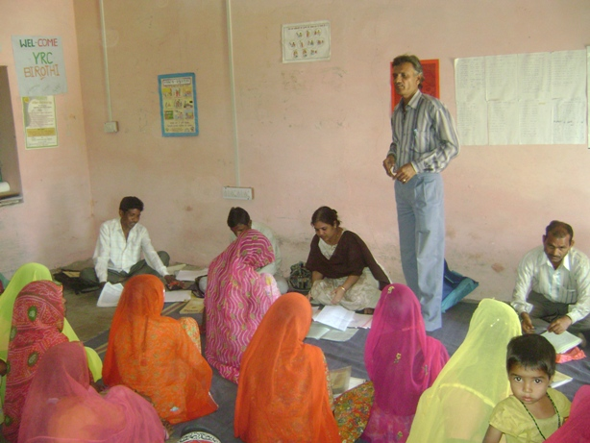
b. Training of accountants
Envisioning the SHG programme, it was deliberated to make the accounting system sustainable in future. During the reporting period the accountants were grouped into different categories based on their skills. This will enable us in strengthening their capacities accordingly. Therefore, 6 training programmes were organized focusing on enhancing the skill for accountancy. The trainings were facilitated by the staff members.

In addition, regular monthly meetings at the zone level were also organized to refrain the tips for accountancy. During these meetings, the efforts were also made to ensure the flow of data from village to block offices.

3 Capacity building of staff

a. Workshop on vision development
In order to develop the vision of the SHG programme, two workshops were conducted with the staff members. The first workshop held from the 27th to 29th of April 2010 and the other held from16th to 20th June 2010. The workshops were facilitated by Mr. Vijay from PRADAN.

On the 26th July 2010, the first draft of the vision document was shared with the Executive Council of Seva Mandir. The members of the council appreciated the vision and gave their suggestions, which have been incorporated in the document. The document will be used a guideline in development of SHG programme.

b. Training on SHG concepts and facilitation skills
A training of the staff members involved in implementation of SHG programme was held during 21st to 24th September 2010. A total of 34 staff including 27 staff members from the Zones, 7 participants from the Blocks and 1 person from the Head Quarter participated in the training. The training focused on imparting knowledge on basic SHG concepts and facilitation skills (for facilitation of the group meetings). The training was facilitated by Mr. Bijoy and Mr. Sanjay from PRADAN. Various participatory methods like role plays, games and group discussions were used in the training.

c. Cluster formation training
A two-day training on SHG cluster-formation (The grouping of a couple of SHGs in the same cluster) was organized from 27 to 28 December 2010. The objective of the training was to understand the need of forming clusters, processes involved in cluster formation and formulate action plan for the same. In total 31 staff members including zonal staff and SHG coordinators participated in the training. The training was facilitated by Mr. Bijay from Pradan.

e. SHG Program review meeting
A two day meeting was organized from 10th to 11th February 2011, at Kotra block to discuss the status of SHGs and explore ways of strengthening the SHG's in this block. SHG coordinators from all the other Blocks and staff members of Kotra Block also participated in the meeting. The meeting was facilitated by Mr. Bijay from PRADAN; Ms. Swati Patel and Mr. Prabhulal Salvi, from Seva Mandir.

In addition, a one-day meeting with staff members involved in the SHG programme was organized on the 29th November 2010. The meeting was facilitated by Mr Bijay from PRADAN and it focused on the progress in the last six months based on the performance indicators, cluster formation, monitoring format, accounting system and NRLM (National Rural Livelihoods Mission). There were 6 staff members who participated in this meeting.

f. Course in Rural Entrepreneurship, Administration and Management (CREAM)

Seva Mandir has collaborated with a team of consultants for a short course (6 months) on Rural Entrepreneurship, Administration and Management. It’s a curriculum designed and taught by industry professionals, NGO Leaders and academicians. It’s a part time MBA program designed for rural businessmen and employees of NGO’s running various livelihood projects.

As a part of this course, a two day assessment workshop was organized on 8th to 9th February 2011 in Udaipur. Thirty five entrepreneurs from different enterprises (created and supported by Seva Mandir) including Dal Mill, Fisheries, Soy processing, Goatery, Handicraft, Ornamental fisheries, Vegetable cultivation, Daliya-making (Coarsely grounded Wheat) participated in the workshop. The purpose of this workshop was to screen and select the final list of participants for this course. A group of 20 entrepreneurs were selected after screening the test.

The first session of the course held between 22nd to 27th March 2011 with a focus on basic mathematics and business accounting. The 21 people (including 10 SHG coordinators) from all the 7 blocks of Seva Mandir attended the session. It was very useful session for them to improve mathematical skills required for business accounting. The second sets of sessions were conducted in the month of April 2011.

4 Achievements

During the reporting period a number of achievements were made in SHG program. They are-
- Vision of the SHG programme was reviewed and revised
- Enhanced capacities of 7 Co-coordinators and 27 zonal level staff members through various trainings and meetings organized during the reporting period.
- Audit and profit distribution process was initiated for all the SHGs. For this, a group of 25 selected local accountants were trained and they became a resource for auditing the SHGs. The group members of these SHGs paid for the audit fees on their own, which explains the self reliance for these groups.
- The accounts of all SHGs were computerized during the reporting period.
- The process of strengthening of accounting system was started. The accountants were grouped into different categories based on their skill sets. They received trainings as per their skills and knowledge.
- The qualitative monitoring was launched for the SHGs.
- The standardization of SHG norms and streamlining of MIS was done.
- 152 SHGs have increased their monthly savings for each member and the 114 SHGs raised the accountant’s honorarium indicating the significance of keeping books in better shape.

5 Learning’s

During the reporting period many lessons learnt are -

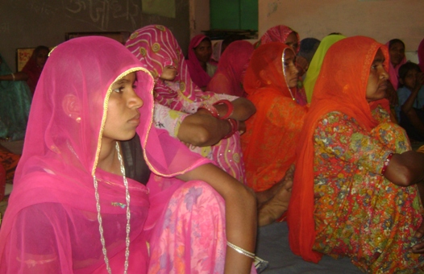
- It is very important to standardize norms in SHGs to ensure financial discipline. Also the staff members as well as the members of SHGs should be persuaded about the rationale behind these norms.
- In order to ensure the continuous improvement in the performance of indicators for SHGs, an effective monitoring system needs to be in place.
- Audit and Profit distribution should be followed on a regular basis. It will help the SHGs members realize the importance of savings. Loaning and keeping robust accounts.

5 Challenges

- In the tribal settlements the houses are far apart, as a result, women find it very difficult to attend monthly meetings on a scheduled time. Therefore, regular attendance of the members is a big challenge.
- The portfolio at risk for many SHGs is high because of the delay in repayments of the loans borrowed. In some groups/SHGs motivating the members for repayment in time hasn’t been of much help. In such groups reducing the portfolio at risk is a challenge.
- Marketing is a big challenge in microenterprises that have been undertaken by some SHGs. For example - the marketing and sale of soy products is still challenging because the product isn’t popular yet mostly because of its taste for people who are used to the milk products.

6 Future plans
- In selected areas SHGs will be federated at the village level. The purpose of federating the SHGs is to create a platform to share and learn from each other’s experiences. It will also help building a peer pressure for addressing issues affecting the lives of women in this region.
- Efforts will be made to strengthen the accounting systems.
- Regular trainings will be organized for the staff members and SHGs to strengthen the functioning of SHGs.
- The SHG database “Mcfinancier’ will be regularly monitored and analyzed for tracking the gaps in the performance of the SHGs.

7 Micro Enterprise (Case in Point - Soy Processing at Kaya Village)

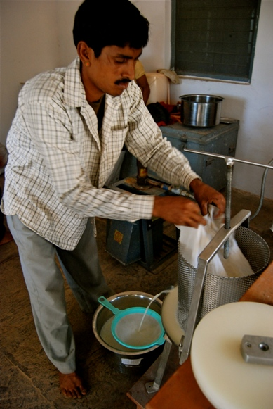
During the reporting period a full time professional was appointed to expand and strengthen the micro enterprise. The necessary equipments needed for the smooth functioning of the business which includes the pressing assembly, cold storage and packing machine was purchased. The idea of making soy fortified biscuits (with by-product) was dropped as it was realized that the by product is rich only in fiber and not in protein. Besides a lot of efforts were directed towards marketing of soy produce. As of today, a number of individuals, hotels, educational institutions, hospitals have become our buyers of Soy Products. The activities undertaken during this period are as follows:

a. Operations Handling
The Soy microenterprise is managed by three youths – 2 full time and 1 part time form village Kaya. The part time young man’s services are required when there is bulk order (more than 6 kg) on a particular day. The full time young men are responsible for procuring the raw material, making tofu, soymilk and delivering the produce to various locations.
On an average they work for 20 days in a month and are paid a daily wages @ Rs. 100 per day. A volunteer Kishore (from USA – AIF fellow) is also working on the project. His main responsibility is to expand the customer-base by visiting hotels, colleges and making presentations on the benefits of using tofu.

b. Purchase of additional equipments

The equipments such as cold-storage, tofu-pressing-assembly and a plastic-sealing-machine were purchased. The cold-storage can hold 50 litres of soymilk and around 100 Kg of tofu which helps in extending the shelf life of the products. The tofu-pressing-assembly effectively presses the coagulated soymilk, quickly converting it into tofu. Earlier it took 1 hour to prepare one batch (2 Kgs) of tofu. Now with the help of the machine it takes only 30 minutes. This helps saving 1.5 to 2 hours of total production time, in case 3-4 batches of tofu are prepared.

c. Market Awareness

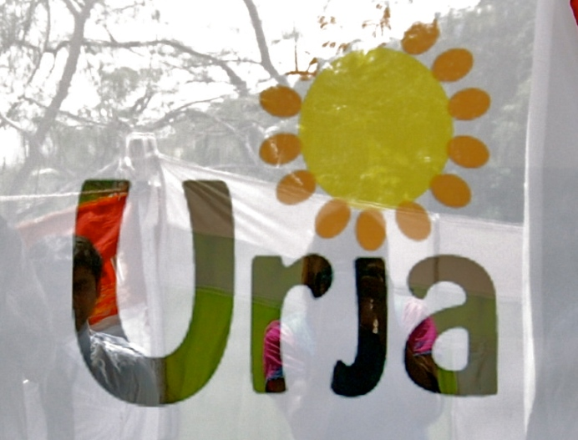
i) Development of logo, punch line and pamphlets
To build a Brand for our Product a logo and a punch line was developed by a design consultant. The logo (Urja) has a sun and beans representing energy with the punch line ‘Urja Piyo, Healthy Jiyo’. Besides, attractive pamphlets and unique information brochure was designed both in Hindi and English language. These have been distributed to all the possible buyers.

ii) Presentations
We have approached many reputed educational institutions in Udaipur city including Central Public School, Delhi Public School, Vidya Bhawan, Indo American School and Singhania University and made presentations to create an interest for our product. We received orders from the American hospital and Singhania University.

iii) Promotional events

In order to introduce Soy products to the people of Udaipur a Kiosk was set up during the trade fair organized by the Rotary Club on 24th October 2011. During the event, the production of tofu and a dish ‘tofu chilly’ was exhibited to promote sales. People showed immense interest in the product and a sale of Rs. 1,100 was made. The fair also provided insights into marketing possibilities for the product.

Furthermore, a weekly kiosk was set up within Seva Mandir premises to also attract people from neighboring residential areas. The kiosk has been doing very well in providing the staff members and neighbors an easy access to our products.

d. Production and marketing
During the reporting period the Soy products were mainly supplied to Seva Mandir run Seasonal Residential Learning Camp (for working children of rural areas), Trident hotel, American hospital, a local vendor and a few Seva Mandir employees.

In total 800 litres of soy milk and 198 Kg of tofu has been sold with a sale of Rs. 35,800 (USD 795). Of the 222.5 Kgs produced in the last half year we managed to sell 198 Kgs of tofu. Of the remaining 24 Kgs, 11 Kgs was wasted due to its short shelf life and the rest 13 Kgs was used as samples at various places.

In the financial year 2010 – 2011, the enterprise suffered a net loss of just Rs. 7,829. Thus the youths have managed to cover up our operational and raw material expenses to some extent. But further investments in buying assets would be necessary for expansion of this business.

e. Future plans
In order to increase the shelf life of soy products from two to seven days, a table top vacuum packaging machine would be purchased. The total cost of this machine is about Rs. 65,000 (USD 1,444).

In addition, extensive market awareness will be done to increase the customer base for our product. For this, the colleges such as the Pacific College, Geetanjali College of Medicine and Pharmacy, Agricultural College of Udaipur, and corporate offices like Rajasthan State Mines and Minerals (RSMM), Miraj Industries Ltd. will be contacted. Besides once a week the kiosk at Seva Mandir premises will be continued to create more awareness in the locale. Furthermore efforts will made to develop linkages with different retail outlets. More Kiosks will also be set up in different parts of the city for the sale of soy produce.

Seva Mandir also works in a few slums of Udaipur city. These settlements come under the Urban Block of our work area. The rest five are rural areas of Udaipur and Rajsamand Districts of Rajasthan State.
Santoshi, Dashama, Shakti, Lakshmi, are the names of the SHGs
Urja – the literal meaning is Energy
It means – drink ‘energy’ live healthily

