The Hunger Project-Uganda

Executive Summary
This reporting period covers activities from July-December 2010 (Quarters 3 and 4). Activities were implemented within the context of The Hunger Project’s (THP’s) global strategic direction. The focus was on the three strategic pillars: mobilization, empowering women and partnership with local governments. All programs were implemented according to the Epicenter Strategy in all 11 epicenters in the eight districts of operation. Six of these epicenters, Mbarara, Iganga, Kiboga, Mpigi, Wakiso and Kiringente, have been declared self-reliant; the Mbale Epicenter has just entered phase three; Kiruhura Epicenter is in phase three; and Namayumba, Bulamagi and Kenshunga are in phase one.

The programs implemented included food production and food security; HIV/AIDS and gender inequality; health and nutrition; water, sanitation and environment; Vision, Commitment and Action Workshops (VCAWs); functional adult literacy program (FALP) classes and early childhood education; microfinance and women’s empowerment; and Mbale Epicentre construction. Some activities were implemented through partnerships with other like-minded organizations. The most effective partnerships included those with MildMay, Catholic Relief Services (CRS), Ford Foundation, Bead for Life and the district local governments.

The key achievements registered during the Quarter 3 of 2010 included: mobilization of local materials to complete the Mbale Epicenter structures and the L-shaped building being almost ready for inauguration; Mbale District local government made budget estimates to construct a two-stance pit latrine for medical staff quarters, placenta pit, beds for the Health Unit, delivery beds, water tank, filing cabinets, and other items as per the signed Memorandum of Understanding; hosting the Senior Microfinance Program Officer (MFPO) from THP Global Office, Marie Mintalucci; Registration of Mbarara Savings and Credit Cooperative (ME-SACCO or rural bank) becoming the sixth government-recognized and women-owned and managed rural bank of THP-Uganda; and final agreements with Namirembe Diocese (Church of Uganda) and Wakiso District local government to implement the Epicenter Strategy in Namayumba were in final stages. Namirembe diocese donated five acres of land for epicenter establishment, and processing of the 49-year lease offer for land for the Namayumba Epicenter was in the final stages. Local material mobilization was in progress, spearheaded by the local community leaders and the church.

The key achievements registered during Quarter 4 of 2010 included: (i) completion and subsequent inauguration of Mbale Epicenter in a public assembly; the epicenter is now in phase three of the Epicenter Strategy; (ii) inauguration of Mbarara’s SACCO in a public assembly, becoming the sixth government-recognized and women-owned and managed rural bank of THP Uganda (see photo above); (iii) THP-Uganda hosted a team of eight investors from Australia who appreciated THP-Uganda’s Epicenter Strategy for the end of hunger and poverty and pledged continued support; and (iv) through continuous follow-up, THP-Uganda realized the presidential pledge of a motor vehicle (truck) to support Mpigi Epicenter.

Details on Progress
Achievement | Measurement
Food security improvements. | - In Quarter 3, epicenters contributed towards the seed input revolving fund to procure improved seed for their partners. Improved maize seed – Longe 5 and Beans (K132) – were procured and distributed to partners to boost food production and food security both at the household and community level.  - Monitoring of partners’ gardens to establish the germination rate of beans and maize seed was done. The germination rate for maize and beans was 30 percent and 95 percent respectively and some food has been stored in the epicenter food banks by the partners.  - Vegetable demonstration gardens were established at the epicenters in partnership with East African Seed Company to increase the adoption rate of production of improved vegetable seed, which would subsequently contribute towards improved nutrition.  - At Kiringente Epicenter, a 60-banana demonstration garden was set up in partnership with Kiringente Sub County National Agriculture Advisory Services (NAADS program) to act as both a demonstration and a source of improved banana suckers.  - In Kiboga, cassava stems multiplication has been scaled up in partnership with Catholic Relief Services (CRS Uganda) to increase farmers’ access to disease-free and high-yield cassava variety MH97/2961 so as to increase cassava production and food security.  - Sensitization of farmers on cassava production and cassava diseases through radio talk shows was conducted by THP-Uganda and CRS, and a total of 59 bags of disease-resistant cassava stems (variety MH/97.2961) were distributed to partners to increase cassava production at both household and community levels.  - A one-acre maize demo garden was established at Iganga Epicenter in partnership with the Uganda National Agricultural Inputs and Dealers Association (UNADA) for learning and demonstration purposes.  - Partners have received training in agribusiness; crop agronomy; and post-harvest handling of maize, beans and groundnuts conducted by THP-Uganda staff and the sub-county extension workers.  - Two planning meetings were held with Agro Ways Warehouse (a Uganda Commodity Exchange Warehouse) and the World Food Programme (WFP) to discuss payments for maize supplied by our partners for bulk marketing in Iganga and Bulamagi Epicenters. Partners received UGX 46,925,600 (US$19,250) from the sale of 107,982 kgs of maize.  - The sudden and unpredictable weather patterns, including excessive rains and thunderstorms, coupled with poor soil, are still affecting the partners’ output. The maize and beans were mainly affected. Drought-resistant crops like yams should be encouraged in order for partners to be more food secure.
HIV/AIDS awareness increased. | - HIV/AIDS and Gender Inequality Workshops were conducted to sensitize partners on the role of gender in the spread and prevention of HIV/AIDS. Other aspects handled included the dangers of contracting HIV, overcoming stigma, voluntary counseling and testing and male involvement in the fight against HIV/AIDS. Informational and educational communication material was also given to the partners.  - Kiboga Epicenter participated in the commemoration of the international World AIDS Day in Kiboga and Kyankwazi districts. The HIV/AIDS and Gender Inequality strategy was shared with partners by specialized HIV/AIDS animators.  - Epicenters continued to participate in the District AIDS Committee Quarterly meetings (DAC) where THP-Uganda’s HIV/AIDS and Gender Inequality strategy was shared with other development partners.  - Through the Mild May partnership, 60 HIV-positive children, orphans and vulnerable children in Kiboga Epicenter received scholastic material support which included: books, pens, pencils, geometric sets and rulers.  - Iganga and Wakiso Epicenters, in partnership with the District Health Department and Islamic Medical Association of Uganda (IMAU), conducted mass awareness campaigns on prevention of mother-to-child transmission of HIV/AIDS where the partners were encouraged to be tested, so as to know their status.  - IMAU has sustained its partnership with Wakiso Epicenter Health Unit in providing voluntary counseling and testing, anti-retroviral therapy and treatment of infected people.  - In partnership with the Ministry of Health, 30 animators were identified in Namayumba Epicenter and trained for a week about malaria prevention and control and prevention of stigmatization amongst people living with HIV/AIDS (PLWHA).

Increased access to health services. | - Epicenter Health Units have improved partners’ access to health services in epicenter areas. Cost-free health services were provided to partners for the following issues: dental care, treatment of malaria, eye infections, intestinal worms, sexually transmitted infections, injuries, skin diseases, urinary tract infections, oral diseases and conditions, family planning services and condom distribution.  - Epicenter Health Units have continuously received drugs from the district local government and payment of the medical staff on a monthly basis. In Quarter 3, Wakiso Epicenter received an additional registered nurse posted by the district local government to reduce the patient-nurse ratio at the Health Unit.  - Hand-washing campaigns in Mbarara and Kiruhura Epicenters were conducted in order to reduce fecal-related diseases and promote sanitation in homes by encouraging hand washing with soap.
Child and maternal health improved. | - The epicenter Health Units have greatly contributed to the reduction of infant mortality and maternal mortality rates in epicenter areas. Children under the age of five years continuously access health services such as immunization against the fatal diseases, de-worming and malaria treatments.  - The epicenter Health Units, in partnership with the Ministry of Health, participated in the national de-worming drive, where children 1-14 years old were de-wormed and infants of six months to five years received vitamin A supplements.  - Five live births were recorded at Iganga Health Unit, 136 mothers were immunized at the epicenter in Quarter 3, 86 women and 64 men received family planning education and services, and awareness on health issues was provided to 139 women and 71 men.  - Treated mosquito nets were distributed to pregnant mothers and children under the age of five in Mpigi, Kiringente and Kiruhura Epicenters in partnership with the Global Fund project under the Ministry of Gender, Labour and Social Development to prevent the spread of malaria.
Increased awareness of sanitation, hygiene and environmental protection. | - Trainings on household sanitation, hygiene, pit latrine construction and construction of tippy taps were conducted in Mbarara and Kiruhura Epicenters.  - Hand-washing animators in Mbarara Epicenter received training kits from the district, which comprised training posters, a hand-washing handbook and a red apron that identifies the individual as a hand-washing ambassador. Sixty households have been mobilized by the animators to make tippy taps for hand washing, place them strategically and ensure that they wash with soap, not only after visiting the latrines.  - 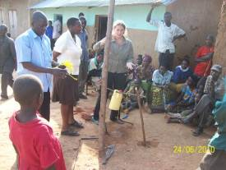In addition to open defecation sensitization, THP-Uganda staff continued to sensitize partners on how human waste can get into the body if hands are not washed properly. A tippy tap to illustrate how hand washing can be made easy and more accessible was constructed together with the partners.  Photo: WHO tippy tap demonstration at epicenter  - Mbarara district (including Mbarara Epicenter) was one of 10 districts selected by the World Health Organization (WHO) to pioneer the implementation of the tippy taps as a way of encouraging people to wash hands using soap to reduce disease incidence such as diarrhea, dysentery, cholera, typhoid and other related diseases.  - Epicenters are providing safe drinking water to partners through the boreholes constructed in partnership with the district local government. This is happening in Kiboga, Iganga and Kiringente Epicenters.  - In Mpigi Epicenter, timber tree seedlings were planted as contribution towards environment sustainability and demonstration to partners that land unsuitable for agriculture can be put to use by planting trees.  - Tree nursery beds were established in Kiboga, Iganga, Kiruhura and Mpigi Epicenters to provide affordable tree seedlings to partners.  - In Mbale Epicenter, ten partners were identified by the National Forestry Research Institute to host demonstrations for fodder tree nurseries and woodlots. Meanwhile, the Farm Income Enhancement and Forestry Conservation Project provided the partners with assorted tree seedlings.
Changed mindsets, increased literacy and improved access to early childhood education. | - VCAWs were continuously delivered to partners focusing on the five steps of ending hunger and poverty. The workshops were conducted by THP-Uganda staff and animators.  - Through FALP, partners have acquired writing, reading and numeracy skills. In Kiboga Epicenter, instructors are processing registration as an association to be able to lobby for support from the district and other development stakeholders.  - The epicenter nursery schools continued to provide early childhood education to children in all the epicenters. This has provided a very strong foundation for the children joining the primary section.
Women’s economic empowerment achieved. | - Wakiso Rural Bank in partnership with a local community-based organization, called A-Z, identified a group of PLWHAs who have been considered for loans to enable them to invest in income-generating activities (IGAs) as a way of improving their welfare.  - Coupled with the above, the rural bank acquired a new motorcycle for the loans officer as an asset to improve on the efficiency of the operations of the bank in the community, especially in loan recoveries.  - Kiboga Rural Bank received a new motorcycle, a computer set and printer from the Uganda Prosperity for All Program through the Uganda Credit and Savings Cooperative Union as support to government-recognized SACCOs contributing to eradication of hunger and extreme poverty through the Microfinance Program (MFP).  - Mbarara Rural Bank (MESACCO) received official government recognition on August 25, 2010, becoming the sixth rural bank in THP-Uganda. The celebrations to mark the official inauguration took place at the Epicenter on December 8, 2010, with a turnout of over 500 partners, who exhibited various IGAs in which they are engaged.  - New loan products were introduced by the rural banks, which included: agricultural loans, market day loans, and motorcycle loans. Discussions to start up solar loans to improve on rural lighting are in progress.  - Presence of the satellite banks in Kiboga, Wakiso, Iganga, Mpigi and Kiringente Epicenters has led to increased membership, shares and access to affordable rural financial services.  - THP-Uganda hosted the Senior Microfinance Program Officer rom the Global Office, Marie Mintalucci, who visited and interacted with partners from different epicenters.
Program consolidation, village and local government partnerships enhanced | - 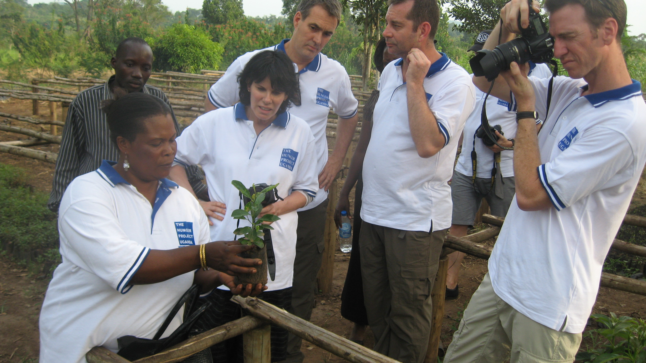THP-Uganda hosted a team of eight investors from Australia, who appreciated THP’s Epicenter Strategy for the end of hunger and poverty and pledged continued support.  Photo: Animator Mrs. Lydia Jjemba of Namayumba Epicenter explains grafting of fruit tree seedlings to THP investors.  - A memorandum of understanding between Namirembe Diocese – Church of Uganda, Wakiso District local government and THP-Uganda to implement the Epicenter Strategy in Namayumba in Wakiso District entered its final stages. Namirembe diocese has so far donated land equivalent to five acres for epicenter establishment. Meanwhile, material mobilization by the local community and the church are underway.  - The National Agricultural Advisory Services (NAADS) continued to extend agricultural extension services and establishment of demonstration projects targeting partners.  - THP-Uganda staff and epicenter committee members participated in several policy engagement workshops organized by the sub-county and the district.  - An epicenter received a team from Uganda Microfinance Support Center (UMSC) Mbale office, who were on a fact-finding mission regarding the epicenter MFP. The epicenter committee will continue lobbying for supplementary support from UMSC to boost the MFP of the epicenter.

Objective Not Achieved | Reasons/Lessons Learned
Official inauguration of Mbale Epicenter delayed. | Mobilization of local materials to complete the Mbale Epicenter structures extended to Quarter 3 due to challenges in local materials mobilization. While Mbale District Local Government committed to meet the cost of power installations, construction of a two-stance pit latrine for medical staff quarters, placenta pit, beds for the health center, delivery beds, water tank, filing cabinets and other items, bureaucratic procurement processes delayed the implementation of their commitment as per the signed MOU. However, processing of the 49-year lease offer for the epicenter land is in its final stages.
Challenges of increasing food production to guarantee food security. | Supply of poor seeds by East Africa Seed Company to our partners leading to poor crop germination and harvests especially for maize. East Africa Seed Company is to resupply our partners with maize this season at the same cost

Partnerships
In addition to maintaining the existing partnerships with other development agencies and the Government of Uganda both at central and local levels, initiatives to develop new partnerships were undertaken as follows:

- THP-Uganda is part of the network of international and United Nations agencies that operate in the country in the area of Food Security and Livelihoods (FSAL). Monthly meetings for dialogue and information sharing are held under the auspices of the Food and Agriculture Organization (FAO) and WFP. These meetings focus on the open exchange of ideas on both government and donor policies, in addition to finding better ways of program implementation.
- A broader strategic partnership agreement with Child Fund Uganda for joint implementation of programs in various sectors of interest to both organizations was signed. Implementation will start in 2011 in Kiboga Epicenter.
- Follow-up is underway on formalizing a partnership agreement with Netherlands Development Organization (SNV) and Heifer International to implement a domestic bio-gas program in our epicenters. We hope that this will enhance the already existing partnership with Uganda Dairy Development Program/Heifer-Uganda, which is active with partners for accessing heifers and continued training in productive dairy-keeping methods.
- Finalizing a partnership agreement with FIT Uganda Ltd towards capacity building for the rural banks, especially the development of a Business Development Centre (BDC) for building the capacity of the rural banks at a fee met by the banks themselves, as a sustainable way to ensure proper continuity and growth of the rural banks as they start to become more complex in their operations.
- Ford Foundation continued to play a key role in the improvements of the MFP. However, the contract expires in June 2011 and there is a need to follow-up with the foundation for the possibility of extension of the contract and/or scale-up.
- In Mbale Epicenter, THP is to partner with Malaria and Other Child Illness (MACIS) NGO Secretariat under the auspices of AMREF and the Ministry of Health to access treated mosquito nets, water and sanitation training manuals and actual training for partners.
- Wakiso Epicenter established a partnership with Marie Stopes-Uganda, which assists with training on Health, sanitation and environment. Sixty-five village health teams from five parishes were given refresher training on HIV/AIDS.
- Partnership with the Islamic Medical Association of Uganda (IMAU) in Wakiso Epicenter continued through provision of treatment for people living with HIV/AIDS and prevention of mother-to-child transmission of HIV.
- In Kiboga, THP-Uganda is implementing a four-year cassava project in partnership with Catholic Relief Services and the National Agriculture Research Organization, with a major objective of increasing food production and food security at both household and community level. To date, 48 farmer groups have received training on cassava diseases and control and a total of 2,726 individual farmers have received improved disease free cassava stems in the epicenter area. The project will end in September 2011.

Broader Awareness and Advocacy
THP-Uganda’s Epicenter Strategy and HIV/AIDS and Gender Inequality trainings working to halt the spread of HIV/AIDS were published in the Uganda’s Annual HIV & AIDS success story magazine in December 2010.

Recent Innovations
- A partnership with the Uganda Cooperatives Savings and Credit Union (UCSCU) was initiated. All rural banks are to be mobilized to sign a Memoranda of Understanding with UCSCU so as to access other services such as quarterly technical supervision, low interest on loans to the rural bank, and annual audit of expenses.
- Rural banks began providing an agricultural loan product in the epicenters. This loan product will go a long way to extend loans to partners in relation to seasonality and program of action according to the specific enterprise selection. It is hoped that this new product will result in more profitability to the banks as well as ensuring higher membership at the bank, as partners’ needs will be met more comprehensively.
- In order to improve partners’ access to MFP, satellite banks (kiosks) manned by the Village Loan Committees were set up in remote epicenter areas. This has motivated the partners to save more and also to make timely loan repayments.
Profile of a Leader in the Community
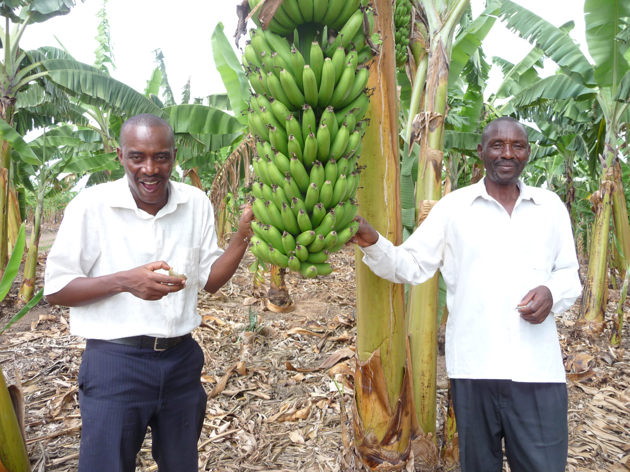Mathew Bamwanga, the Chairperson of the Kiruhura Epicenter committee, is 60 years old and a resident of Kitura sub-county, Kiruhura district.

Mathew moved from Bushenyi district to Kiruhura district to acquire a bigger piece of land (measuring 20 acres) because the land he owned did not allow him to implement extension agriculture. He acquired the 20 acres of land in Kiruhura, but experienced more challenges as the land was drier compared to the land in Bushenyi district, leading to crop failure.

When THP-Uganda started trainings in Kiruhura district in 2007, he attended the VCAWs and was elected as a member of the epicenter committee through democratic elections held by the community.

When the epicenter moved to phase two and all catalytic programs were introduced, he was one of the partners to receive improved, early maturing, high-yielding and drought-resistant beans. He received 10 kgs and managed to harvest 400 kgs, which was his highest harvest recorded compared to the previous seasons.

He sold 300 kgs at UGX 1,500 (.62¢US) per kg, earning him UGX 350,000 (US $145), which he used to buy two acres of land currently planted with pineapples. The pineapple business has improved his daily income.

The following planting season, Mathew received 30 kgs of improved, early maturing, high-yielding and drought-resistant beans from THP-Uganda and harvested 1,000 kgs, allowing him to contribute 90 kgs to the epicenter food bank. He again sold 700 kgs out of 1,000 kilograms at UGX 1,000 (.41¢US) per kg, earning him UGX 700,000 (US $300). He used the money to purchase four acres of land, where he established a banana plantation for feeding his family.

He is proud of THP-Uganda and appreciates the trust relationship he has established with his community members. Currently, Mathew is the chairperson-elect of Kiruhura Epicenter.

He has been elected in his parish as National Agriculture Advisory Services (NAADS) chairperson, and he has encouraged partners to move towards investing in high-yield exotic cattle breeds as a way of increasing their household income.

He lobbied the NAADS program in his parish, and it has now started giving out the improved seeds to the members for planting.

Monitoring and Evaluation
Through the people-centered monitoring and evaluation (M&E) methodology, THP-Uganda has contributed to improving the lives of partners by building their capacity to create, lead and monitor their own actions to achieve the Millennium Development Goals (MDGs).

Epicenters have research teams that have been selected to identify the major concerns and problems, then to initiate research, take action to learn more and proceed to a new research project. The teams periodically collect data on different program components through observation, interviewing partners and focus group discussions. Their research is then displayed on the statistics boards in the epicenters.

THP-Uganda is also in the process of developing the Theory of Change (TOC) model to guide and assist in monitoring and evaluation of THP-Uganda work focusing on the organizational strategies, immediate outcomes, intermediate outcome and long-term outcomes for five years and 15 years. A draft TOC diagram has been developed in consultation with the Global Office and ActKnowledge consultants, based in New York; the process is still on-going.

The Project Officers of Iganga, Mbale and Kiboga Epicenters participated in an M&E Capacity Assessment workshop for civil-society organizations engaged in health activities in the mid-western region. The training was facilitated by the Malaria and Childhood Illness NGO Secretariat (MACIS). The following modules were covered: overview of M&E, linking project design to M&E, setting up a functional M&E system, data quality and data use.

Quarter 1 and Quarter 2 (2011) Priorities
- Priority is given to Mbale and Kiruhura Epicenters for implementing the catalytic programs, although all epicenters will continue with their programs as planned.
- Construction of Namayumba Epicenter building in partnership with Namayumba community and Wakiso District Local Government.
- Work towards improving the MFP by strengthening the operations of the rural banks through a business development center to provide business information services and technical assistance as they continue to grow in number and scope. This will be supported with financial partnerships with like-minded organizations.
- Consolidate epicenter components where they are lacking, especially constructing bigger food banks in epicenters that were constructed before the new model of separate rural food banks was initiated.
- Implementing new partnerships, seeking new ones as well as maintaining the existing ones, for possible funding opportunities, especially with the Government of Uganda for the Epicenter Strategy and Microfinance Support Center for the rural banks. We are hopeful that some of the partnerships we have entered into might result in some funding opportunities, though it should be noted that our core programs depend on realistic budget support. Henceforth, continued budget shortfalls, if not addressed, may become a big hindrance to the achievement of these plans and objectives.
- Development of THP-Uganda training manuals in partnership with a team of students from Columbia University.

