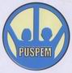
Project Title: Relief for West Java of Earthquake Victims
Reported by: Center for Community Development Studies
Summary
On January 17, 2010, we have been carrying out activities to provide assistance for the development of non-formal education for children of earthquake vivtims in West Java. The funds we received from GlobalGiving donors of $ 646.59 we have used to buy school supplies emergency needs such as building our study location, purchase of textbooks, benches, blackboards, etc.
At the giving help many students who wish to be given assistance because they are also the average of the families affected by the earthquake, so that the equipment owned schools have all been destroyed and that none could be used.
At the time of the review team to Puspem do some student houses earthquake-stricken, his condition is very sad, because where they lived till now still a lot of damaged and not getting home improvement assistance.
Pak Nur, volunteers who become teachers in this program that this assistance is very useful for children because our children can continue their education and not much play. Many thanks to the donors for all your help. We hope you will continue to help us so that this educational program can continue.
The picture above shows how the assistance has been given to the children victims of the earthquake was much needed and eagerly awaited by the victims of the earthquake.
Finally we would like to thank GlobalGiving donations for relief has been granted, and we hope to provide assistance and support until they can live decent and study as usual.

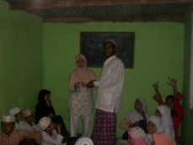 | 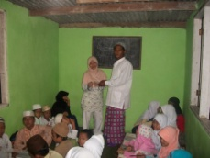
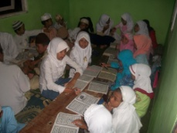 | 