EWB-USA PA State Newsletter
Sept 2011: Volume 2, Issue 1

Building International Communities
This August, three Pittsburghers made the trek up to Tingo Pucara in the Cotopaxi Region of Ecuador. Their task? To complete the second implementation trip for a water pumping system in the village.
Settled in the breathtakingly picturesque altitude of the Andes mountains, Tingo Pucara is an indigenous village with approximately 100 inhabitants painstakingly eking out a living off of the land. Water is a precious commodity, hard to come by in the peaks of these mountains. Villagers spend hours collecting water from a variety of distant sources to survive.
The team, all members of the EWB Pittsburgh Professional chapter, consisted of two professional engineers, Bob Stachel and Steven Trate, and one Pitt public health

graduate student, Barb
Pavliakova. Their goals were to
oversee the construction of the
water storage tank and to collect
baseline health and socio-
“We spent eight days working alongside the most industrious people I have ever come across.”
–Barb Pavliakova, EWB- Pittsburgh Professionals

economic data to use in evaluation of the project. Community involvement is a requisite component of any EWB project and a necessity for a project that hopes to succeed and be sustainable. In Tingo, the community is more than involved; they absorb themselves in the project. The manual labor
involved with the construction of the tank was immense, and accomplished with barely any use of electric tools—save for one small saw and a drill. This was a project constructed through the sweat and grit of a community, of 12 year old girls hauling gravel in wheelbarrows to the site, of women tying rebar while babies slept tied to their backs, and of old seasoned men working leveling walls with a piece of string and a rock.
Bob, Steven, and Barb left on that eighth day, as the concrete was being poured into the forms of the wall, confident that the three EWB chapters in the Pittsburgh region had designed the residents of Tingo a water tank that would survive at least the next 200 years.
They also left with something else, the knowledge of what true teamwork and community looks like. It looks like Tingo Pucara.

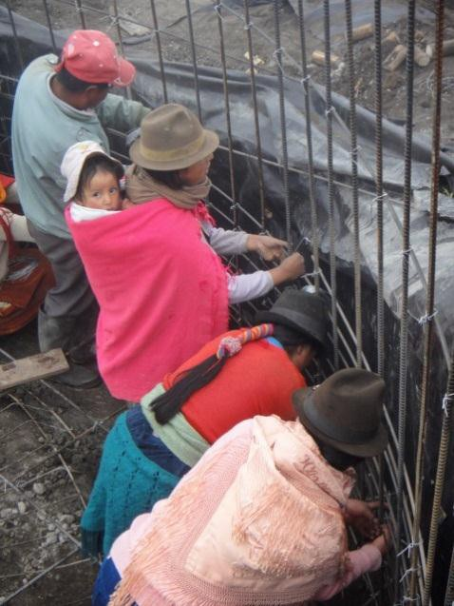
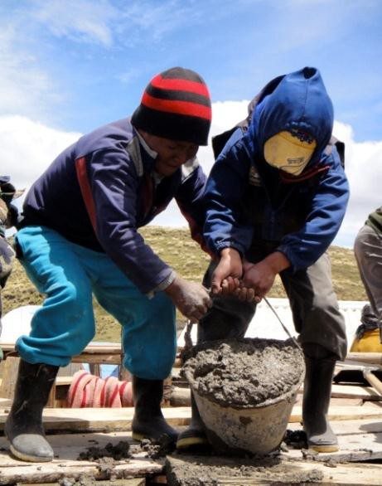
Page 1
A special thanks to Barb Pavliakova for sharing information on her chapter!

