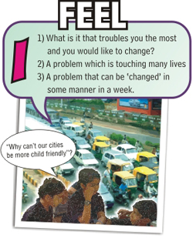

1. Make teams with not more than 5 students per team
2. Ask them to discuss about what issues bother them and would like to see changed
3. These issues can be as simple as cleaner toilets to as audacious as ‘creating child friendly cities’ – every idea is important
Teacher tip – let children ‘feel’ that changing lives is not only about ‘others’ but about how ‘their’ lives will be changed by ‘caring’ about issues and seeing that ‘they’ can be the change

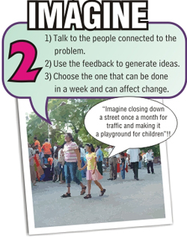
1. Once the issue is selected, get students to ‘engage’ with the people connected to the issue – for eg – if it is garbage in their society that bothers them, get students to speak to the society owners who dispose garbage, the help who takes it out, to the municipal corporation etc… to understand how to ’design’ a solution that really will make the desired impact and change.
2. From all the ideas generated, get the students to select the one that will have the maximum impact following the criteria listed…
Teacher tip – get children to go beyond the ‘obvious’ or the ‘first answer’. Encourage them to think of change ‘beyond’ money. Celebrate their ideas and help them see that changing lives can be meaningful and fun – also, keep helping them see how ‘they are being changed in the process’..
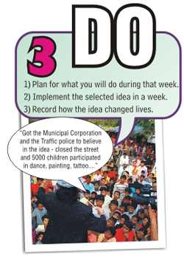

Each school now selects the ONE idea that they all feel has potential for most change and can get as many students involved in the implementation
2. Once the plan is shared with all ( parents too ) the children go and DO!!
Teacher tip – please remember to ‘document’ the story. You can identify a student team to document or older students who might do this for you. Do remember to get sound bites of the students before, during and after the ‘DO’….for more, do go onto our website to see the template of how to document
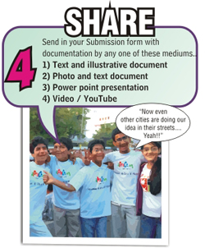

1. The documented story of change is now shared with us…
2. Each school fills up the submission form and adds their chosen form of documentation from the list suggested.
Teacher tip – help the children add their challenges, their favorite moment, their learnings, and how they not only ‘were the change’ but how ‘they were changed’…

